XPATH
XPATH_01: Difference between Absolute-Xpath and Relative-Xpath
XPATH_02: Write an Xpath with text function.
XPATH_03: Xpath with text and contains function.
XPATH_04: Xpath with following
XPATH_05: Xpath with following-sibling
XPATH_06: All Axes functions and there syntax
XPATH_07: Write an Dynamic Xpath that is used to get all the values from the webTable
XPATH_08
Write an method that will take the parameter as a string and find the Xpath with the help of that String. Do the below task to understand it better
Launch the Amazon application
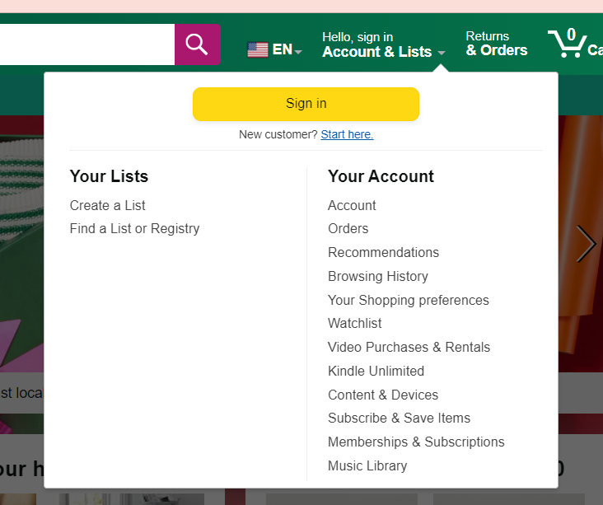

XPATH_09
Write an single Xpath that will return all the links from the footer page of the Instagram page
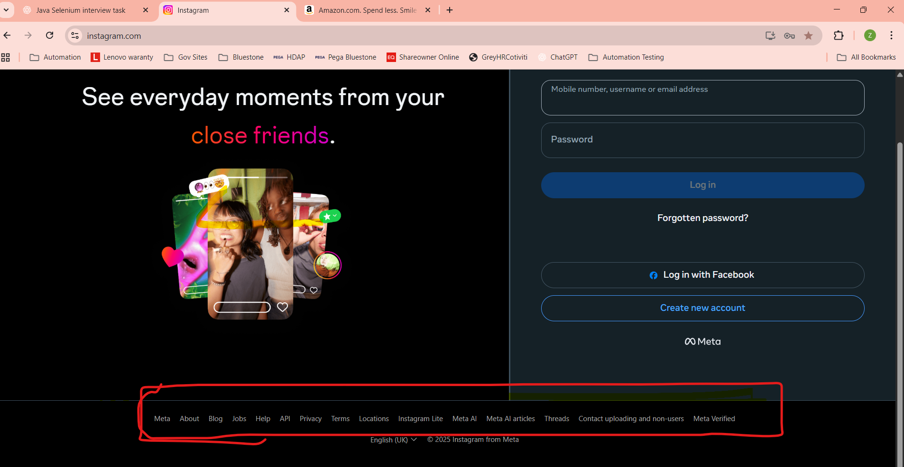

Drop Down List Related: DDL
DDL_TASK_01
Create an ArrayList in Java with expected dropdown values in the same order.
  - Pick one title
  - Dr.
  - Mr.
  - Mrs.
  - Ms.
  - Proof.
  - Other
- Now launch the url https://www.tutorialspoint.com/selenium/practice/select-menu.php
- Get all the values from the select one drop down list and store in to the other ArrayList
- Compare both ArrayLists (size + values) and print:
- “Dropdown matches expected list”
- OR print the mismatching value(s)
- Select each value one by one from the dropdown using a loop.
- Print the selected value each time.
DDL_Task_02 How do you verify that a dropdown is sorted alphabetically? Write a common method that is used to check if all the values in the Drop-down list are sorted or not. The input parameters for that method should be a downlist WebElement.
DDL_Task_03: Write a method that is used to find the count of links from the given webpage. And also check if the links are broken are not.
DDL_TASK_04: Write a code to select multiple values from the below multiselect drop down list.
Launch the url : https://www.tutorialspoint.com/selenium/practice/select-menu.php
Select Multiple values from that.
DDL_TASK_05: Write a code to check if the given drop down supports multi select or not.

WINDOW_HANDLES
WindowHandle_01: Lauch the Instagram url. Find all the links and store them in List. Now click on each link. Now it will open all the windows. Print the title of each window.
WindowHandle_02:
- Launch the https://www.instagram.com/
- Click on the Jobs. It will open new tab. Now on the new tab click on login.
- Once you click on login it will open new tab. Enter your user name and password in that and login to the account
WindowHandle_03: Different between getwindowhandle and getwindowhandles. Also talk about difference between quit and close.
WindowHandle_04:
- Launch the https://www.instagram.com/
- Click on Meta, About , Blog and Jobs.
- Now close Parent window, Meta Window. Jobs Window. And keep only the Blog window.
- HINT: Think about Driver.close();
IFRAMES

Automation
AutomationTask_01: Write test cases that are used to test the below calculator functionality
https://testsheepnz.github.io/BasicCalculator.html#main-body

