1. Open the “CMakeLists.txt” file in the project root directory, usually the “build ” folder and “CMakeLists.txt” exist in the same folder

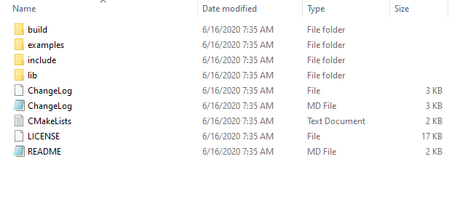

1. Open and modify the “CMakeLists.txt” file

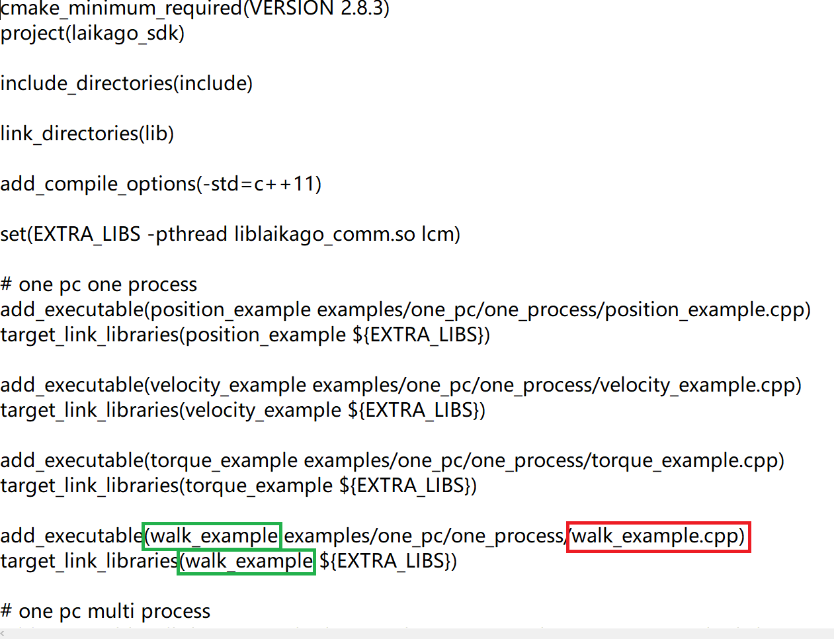

1. In the above file walk_example(in the green box) is name of the executable file generated for “examples/one_pc/one_process/walk_example.cpp”
2. Now cd build cmake ../ & make
3. And then sudo ./ walk_example