power on the dog

connect the dog to wifi: vision_1000， password is vison708

open the terminal to find the IP address: ifconfig -a

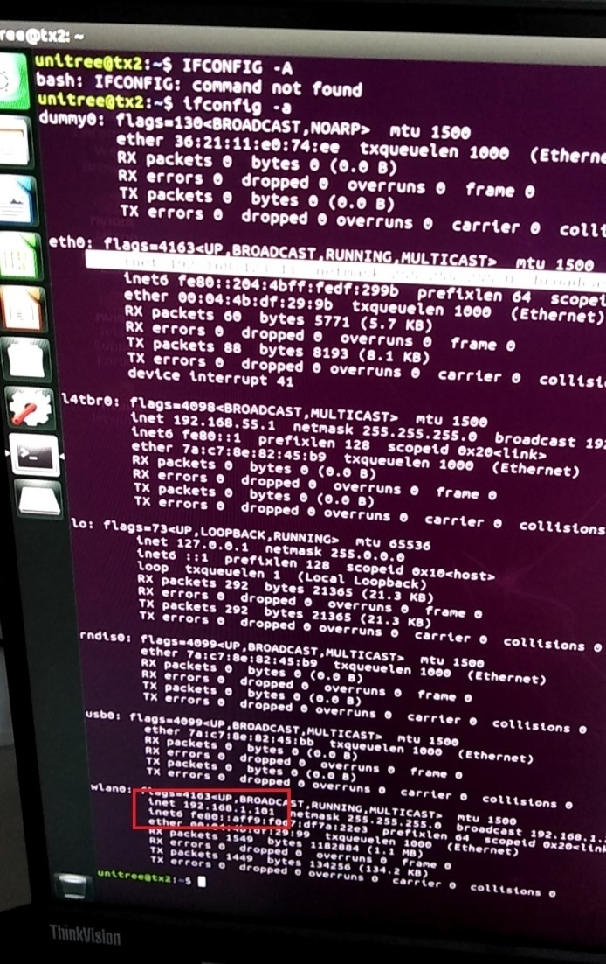

In a Pc:

connect to wifi: vision_1000 (wifi network)

In the terminal of a pc:

ssh unitree@192.168.1.255

Password is 123

Where unitree is the user name of the dog(Pc) and 123 is its password