https://github.com/zakiyanjum/ABC-1611

Git task1 and task2

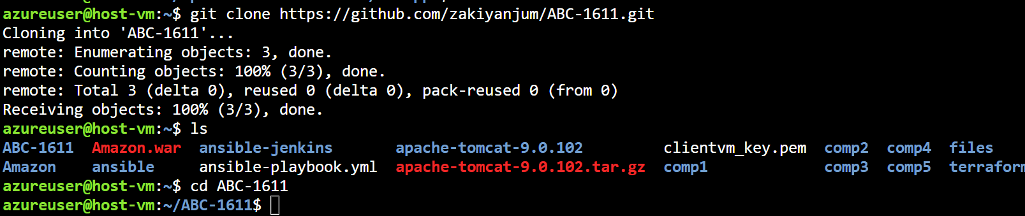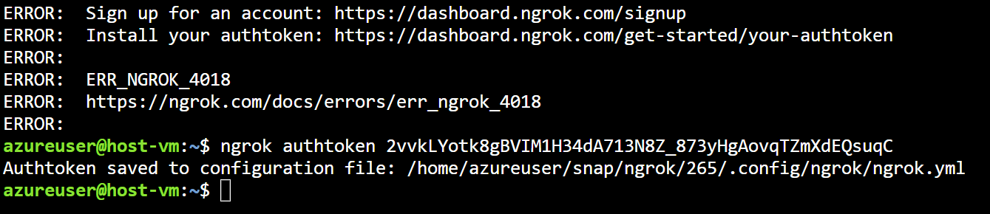

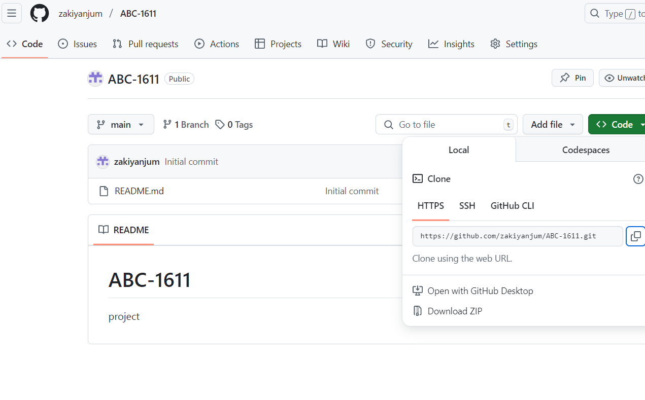

2. pipeline

pipeline {

agent any

environment {

GIT_REPO = 'https://github.com/zakiyanjum/Amazon.git'

REMOTE_USER = 'azureuser'

REMOTE_HOST = '172.184.200.167'

REMOTE_PATH = '/home/azureuser/apache-tomcat-9.0.102/webapps'

ARTIFACT_NAME = 'amazon.war'

SSH_KEY = credentials('ssh')

}

stages {

stage('Clone from Git') {

steps {

echo 'Cloning repository...'

git url: "${GIT_REPO}", branch: 'master' // or 'master' or your branch name

}

}

stage('Build the Project') {

steps {

echo 'Building the project...'

dir('Amazon') {

sh 'mvn clean package' // or gradle, npm, etc.

}

}

}

stage('Push Artifact to Remote Server') {

steps {

echo 'Pushing artifact to remote server...'

sh """

sh 'scp Amazon-Web/target/Amazon.war azureuser@172.184.200.167:/tmp/ && echo "WAR file transferred successfully."'

"""

}

}

stage('Deploy to Tomcat') {

steps {

echo 'Deploying application to Tomcat...'

sh """

ssh ${REMOTE_USER}@${REMOTE_HOST} '

sudo systemctl stop tomcat

sudo mv /tmp/${ARTIFACT_NAME} ${REMOTE_PATH}/

sudo systemctl start tomcat

'

"""

}

}

}

}

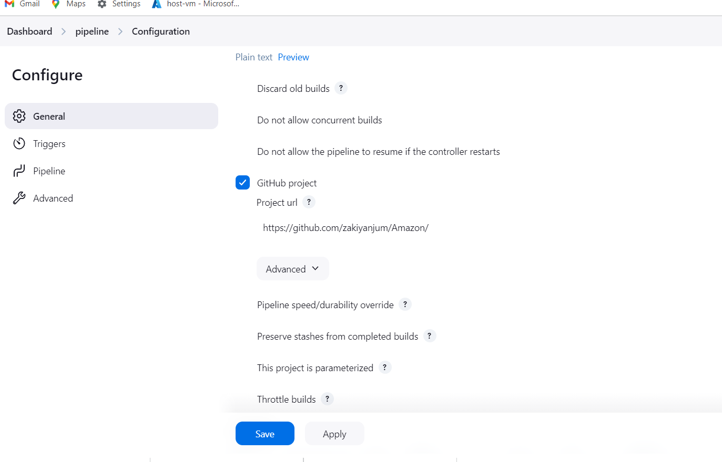

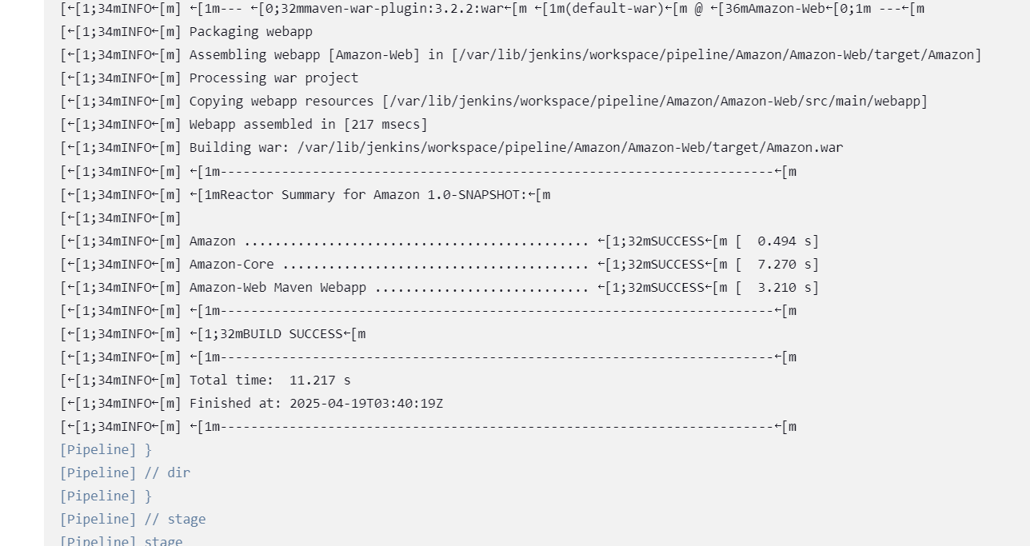

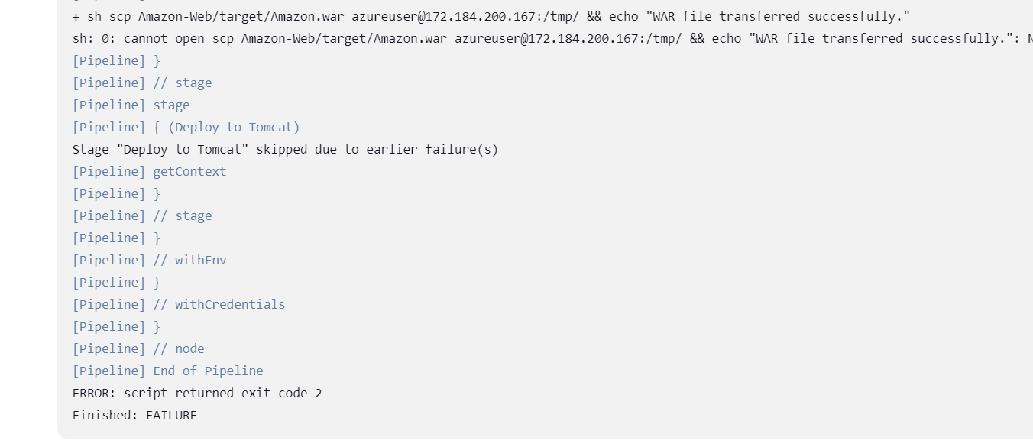

5.setting up webhook

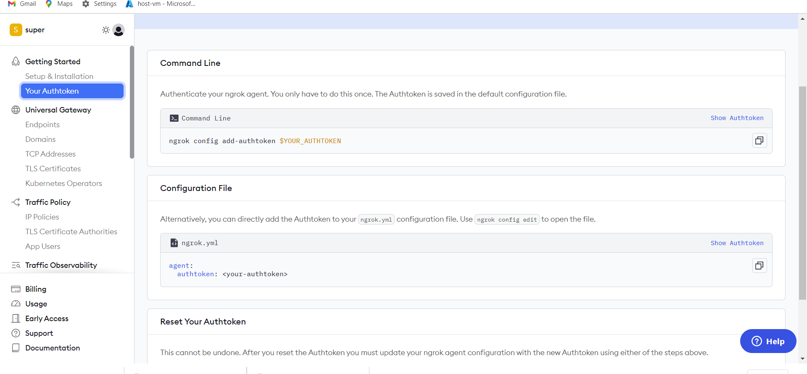

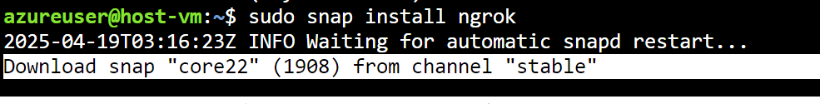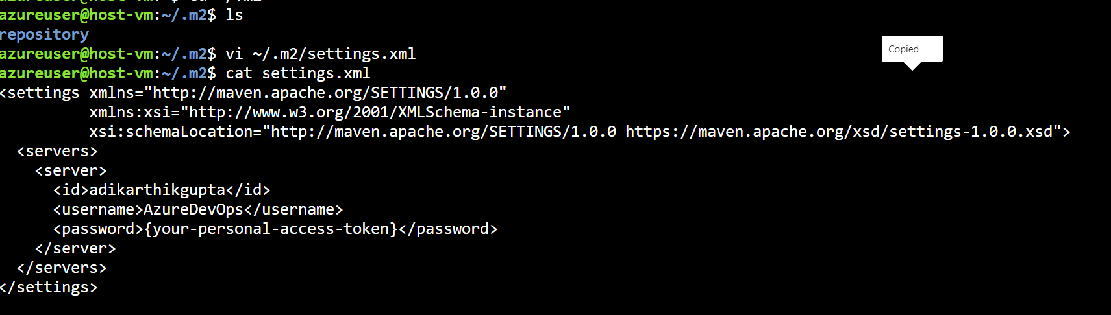

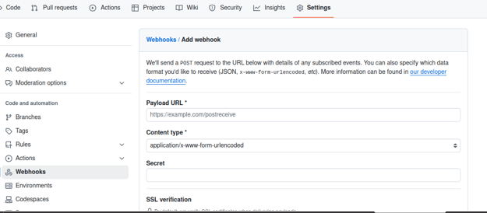

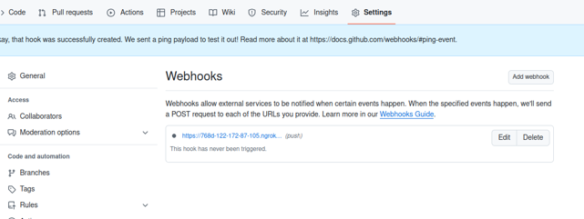

4.maven archetype

