Software Requirements
Specification
COSC 70: Software Engineering II
VenueVue: An Internet-Independent, Locally
Networked, Offline-First Point-of-Sale and
Recipe-Driven Inventory System for
Nearby Caféé
NEARBY CAFÉÉ
Document Revision No.:
Revision 1.0 (Production-Aligned Baseline)
Date of Issue:
NOVEMBER 4, 2026
Project Manager/Group Members:
Zapico, Zaki
Roquid, Jenny Lyn
Gregorio, Rhea Mae
Libao, John Vincent
Table of Contents
1. Introduction
1.1 Purpose and Scope
1.2 Overall System Description
2. System Requirements
2.1 User Characteristics and Roles
2.2 Functional Requirements
2.2.1 System Features
2.2.2 Business Rules
2.3 System Modules and Functions
2.4 Non-Functional Requirements
2.4.1 Performance and Usability
2.4.2 Security and Reliability/Availability
2.4.3 Maintainability and Scalability
3. System Models and Diagrams
3.1 System Workflow
3.2 Use Case Diagram
3.3 Use Case Descriptions
3.4 Activity Diagram
3.5 Data Flow Diagram (DFD)
3.6 Entity-Relationship Diagram (ERD)
4. Data Requirements
4.1 Data Validation Rules
4.2 Data Security and Privacy Requirements
4.3 Data Retention and Backup Requirements
5. Definition of Terms
6. References
Document Revision History
Version | Date | Author(s) | Reason for Changes
0.1 | Sep 21, 2026 | Roquid, J. L. | Initial Software Requirements Specification draft.
0.9 | Oct 27, 2026 | Zapico, Z., Gregorio, R., Libao, J. V. | Architecture alignment and edge server model integration.
1.0 | Nov 04, 2026 | Zapico, Z., Roquid, J., Gregorio, R., Libao, J. V. | Approved Baseline: Fully aligned with Nearby Caféé physical shop setup in Intramuros near LPU, dual cash/e-wallet payments, BIR 12% VAT calculations, Z-reading, multi-section CSV/Excel exports, FIFO batch lots, cup scaling, and Web Audio register chime.

1. Introduction
1.1 Purpose and Scope
The purpose of this Software Requirements Specification (SRS) document is to provide a complete, rigorous, and verifiable description of the functional, non-functional, interface, and data requirements for VenueVue: An Internet-Independent, Locally Networked, Offline-First Point-of-Sale (POS) and Recipe-Driven Inventory System. This specification serves as the formal contractual and technical baseline between the software engineering team CTRL + STAY, the industry client Nearby Caféé, and academic evaluators at Cavite State University.

Operational Scope: Nearby Caféé is an active, physical specialty coffee shop situated on Legaspi St., Intramuros, Manila, operating in the immediate vicinity of Lyceum of the Philippines University (LPU Manila). Serving university students, faculty, administrative personnel, and historic district visitors, the café experiences acute customer surges during student passing intervals and dismissal hours. The system scope encompasses the following core operational boundaries:
1. High-Speed Counter Register: Supporting cash tendering with exact cash shortcuts (Alt+E) alongside reference-verified Philippine cashless e-wallets (GCash, Maya, QR Ph / Card), customer name and cup note capturing, repeat last order capabilities, and synthesized Web Audio chime feedback.
2. Atomic Recipe Deduction Engine: Server-authoritative bill of materials (BOM) deduction executing under row-level database locking, converting beverage variant sales into exact component deductions (espresso beans in grams, dairy and syrups in millilitres, and cups/lids in units).
3. 1-Click Recipe Cup Scaling: Proportional automatic scaling of recipe ingredient quantities across standard 12oz, 16oz, and 22oz beverage sizes.
4. FIFO Batch Lot Management: Intake tracking utilizing auto-generated delivery and lot codes (DEL-..., LOT-...), expiration date monitoring, opened-stock tracking, waste recording, and a 1-click supplier reorder list clipboard export formatted for Viber and Messenger.
5. Financial Reporting & Compliance: Automated BIR-compliant 12% Value Added Tax (VAT) computations, End-of-Day Z-Readings that strictly isolate Physical Cash in Drawer from Digital E-Wallets, multi-section structured CSV reports, and native styled Microsoft Excel (.xlsx) workbooks.
6. Local Edge Network Independence: 100% operational availability on an isolated Wi-Fi Local Area Network (LAN) without WAN/Internet dependency, supported by client-side IndexedDB persistence, UUIDv4 transaction keys, and SHA-256 idempotency enforcement.
1.2 Overall System Description
VenueVue is engineered around a local edge client-server architecture designed specifically to overcome Intramuros' infrastructure vulnerabilities, where historic masonry walls and telecommunication congestion frequently degrade public cellular reception and cause broadband dropouts. A designated shop laptop functions as the authoritative edge host, running an offline Apache 2.4, PHP 8.2, and MariaDB 10.4+ (InnoDB) stack. Front-of-house counter tablets and barista devices connect to this host over a local Wi-Fi hotspot broadcasting on the local subnet (192.168.137.x).
Client devices execute a touch-optimized React 18 Single Page Application (SPA) served directly from the host. When orders are rung up, the client creates an order record in local browser IndexedDB storage and transmits it to the PHP REST API. The MariaDB database acquires exclusive row locks (SELECT ... FOR UPDATE) on affected ingredient rows, verifies stock availability, commits the sale, records line items, and logs stock movements within a single ACID transaction. If the local Wi-Fi network experiences a temporary disruption, orders remain durable in client IndexedDB and automatically synchronize upon reconnection without duplicate recording.
2. System Requirements
2.1 User Characteristics and Roles
VenueVue strictly enforces two user roles with differentiated privileges:
1. Barista (Counter / Cashier Role): The Barista operates front-of-house counter tablets. Their access is restricted exclusively to the Register interface. Capabilities include searching drinks (/), selecting size/temperature variants, adding customer names and cup notes (e.g. 'Sarah - Less sweet'), recording exact cash (Alt+E) or digital payments (GCash, Maya, QR Ph) with reference numbers, confirming orders, viewing/printing receipts, repeating last orders, and monitoring the local pending queue. Baristas are strictly blocked from management tabs, cost structures, and reports.
2. Owner / Administrator Role: The Owner/Admin possesses full supervisory and configuration authority. Accessible via the Management interface, capabilities include Catalogue Management (creating products, setting prices, configuring variants, uploading images, 1-click cup scaling), Stock Operations (intake batches, expiration tracking, waste recording, 1-click supplier reorder clipboard export), Staff Administration (generating usernames and strong passwords), Audit History (viewing stock movements and void logs), and Financial Reports (viewing Z-Readings, 12% VAT summaries, cash drawer reconciliations, and exporting multi-section CSV and styled Excel .xlsx workbooks).
2.2 Functional Requirements
2.2.1 System Features
Feature Identifier | System Feature Description
SF-01: Multi-Tender Register | Allows baristas to ring up drinks, filter by category, enter cup notes, apply exact cash (Alt+E), or capture GCash/Maya reference numbers with instant Web Audio chime feedback upon confirmation.
SF-02: Atomic Recipe Deduction | Server atomically verifies and deducts raw ingredient quantities (grams, ml, pieces) from active stock under row-level database locks upon host sale confirmation.
SF-03: 1-Click Cup-Size Scaling | Enables managers to duplicate an existing beverage recipe and automatically scale ingredient quantities proportionally based on fluid ounce volume ratios (12oz, 16oz, 22oz).
SF-04: FIFO Batch Lot Tracking | Tracks stock intake via unique delivery/lot codes (DEL-..., LOT-...), monitors expiration dates, enforces First-In, First-Out depletion, and records spoiled/expired waste.
SF-05: Supplier Reorder Tool | Identifies ingredients at or below minimum threshold levels and provides a 1-click button copying a cleanly formatted procurement list directly to the clipboard for Viber/Messenger.
SF-06: Offline IndexedDB Queue | Preserves unsent orders in browser IndexedDB during Wi-Fi dropouts; background sync transmits records upon reconnection using UUIDv4 idempotency to prevent duplicate charges.
SF-07: Financial Z-Reading & VAT | Automatically extracts 12% VAT (Gross, Net, VAT), computes daily totals, and produces an End-of-Day Z-Reading isolating Physical Cash in Drawer from Digital E-Wallets.
SF-08: Multi-Section Excel / CSV | Generates professional multi-section CSV reports and native styled OpenXML Microsoft Excel (.xlsx) workbooks containing executive summaries, SKU performance, and cashier audits.
SF-09: RBAC & Staff Generator | Enforces server-side role segregation; provides auto-suggested usernames and 1-click cryptographically strong temporary password generation for baristas.
SF-10: Cryptographic Backup & Restore | Provides owner-triggered database snapshot exports with an automated preflight integrity verification and safe restore routine.
2.2.2 Business Rules
Rule Identifier | Operational Business Rule Specification
BR-01: Internet Independence | Core cashiering, inventory deduction, and reporting must operate 100% locally on LAN without requiring active WAN/Internet connectivity.
BR-02: All-or-Nothing Deduction | A sale cannot be partially confirmed; if any ingredient in a recipe is insufficient or inactive, the entire transaction rolls back cleanly.
BR-03: FEFO/FIFO Inventory Depletion | Active batches must be depleted chronologically by expiration date; opened containers must be prioritized before sealed units.
BR-04: Philippine VAT Compliance | All retail menu prices are VAT-inclusive at 12%. The server extracts Net Sales via intdiv(Gross * 100 + 56, 112) / 100 and allocates rounding adjustments to the last item.
BR-05: Cash Drawer Isolation | End-of-day cash reconciliation must strictly separate physical cash collected from cashless e-wallet transactions (GCash/Maya) to prevent drawer discrepancies.
BR-06: Strict Role Isolation | Barista sessions cannot access Management endpoints (/management, /api/management/*). Any unauthorized administrative access attempt returns HTTP 403.
BR-07: Idempotent Key Enforcement | Every order submission carries a unique UUIDv4 key; replayed keys return the committed receipt without re-deducting stock or recording duplicate revenue.
2.3 System Modules and Functions
1. Authentication & Role Guard Module: Handles secure login, role routing (Owner -> Management, Barista -> Register), session token management, login throttling (max 5 failed attempts per 5 minutes), and staff password generation.
2. Register & POS Checkout Module: Provides real-time drink search (/), category filtering, basket calculations, exact cash shortcuts (Alt+E), GCash/Maya reference capture, customer cup note entry, Web Audio chime synthesis, and receipt printing.
3. Catalogue & Recipe Scaling Module: Manages products, size/temperature variants, local product images, bill of materials recipes, and 1-click cup-size scaling (12oz, 16oz, 22oz).
4. Inventory, Batch Lot & FIFO Module: Handles delivery intakes, batch lot numbering (DEL-..., LOT-...), expiration tracking, opened-container monitoring, waste recording, low-stock threshold alerts, and 1-click supplier reorder clipboard export.
5. Offline Sync & Idempotency Module: Manages client IndexedDB pending queues, background connectivity detection, automatic re-submission, and server SHA-256 payload deduplication.
6. Financial Reports & Export Module: Aggregates daily sales, computes 12% VAT splits, generates Z-Readings with drawer breakdown, and produces multi-section CSV and native styled OpenXML Excel (.xlsx) workbooks.
7. Audit Trail & Disaster Recovery Module: Maintains immutable audit logs of cashier actions, stock adjustments, and voids, while providing owner-triggered encrypted database backups and verified preflight restoration.
2.4 Non-Functional Requirements
2.4.1 Performance and Usability
1. Latency: Local host checkout confirmation latency shall not exceed 500ms under concurrent 3-tablet load. Client-side basket adjustments, drink searches, and exact cash calculations shall execute in under 50ms.
2. Counter Ergonomics: High-contrast, dark-mode counter theme designed for low-fatigue viewing; touch targets maintain a minimum dimension of 44x44 pixels; keyboard hotkeys allow complete mouse-free operation (/ for search, Esc to clear, Alt+E for exact cash, Space/Enter to dismiss).

2.4.2 Security and Reliability/Availability
1. Credential Security: User passwords hashed using Bcrypt; new credentials enforce a minimum of 12 Unicode characters; session tokens use cryptographically secure pseudo-random 32-byte strings with expiration timeouts.
2. Availability & Reliability: The local edge server architecture guarantees 99.9% uptime during shop hours, isolated from external ISP failures. Database integrity is protected via ACID transactions; power outages on the laptop host are buffered by battery operation.

2.4.3 Maintainability and Scalability
1. Zero-Dependency Engine: The backend is built in standard vanilla PHP 8.2 without heavy external frameworks or third-party Composer packages, ensuring effortless maintenance and long-term stability.
2. Extensibility: Schema auto-migrations automatically update database structures upon version increments; frontend Vite build produces lightweight reproducible static assets.
3. System Models and Diagrams
3.1 System Workflow
Figure 3.1 illustrates the operational workflow at Nearby Caféé, mapping the progression from student order arrival to recipe depletion and reporting:

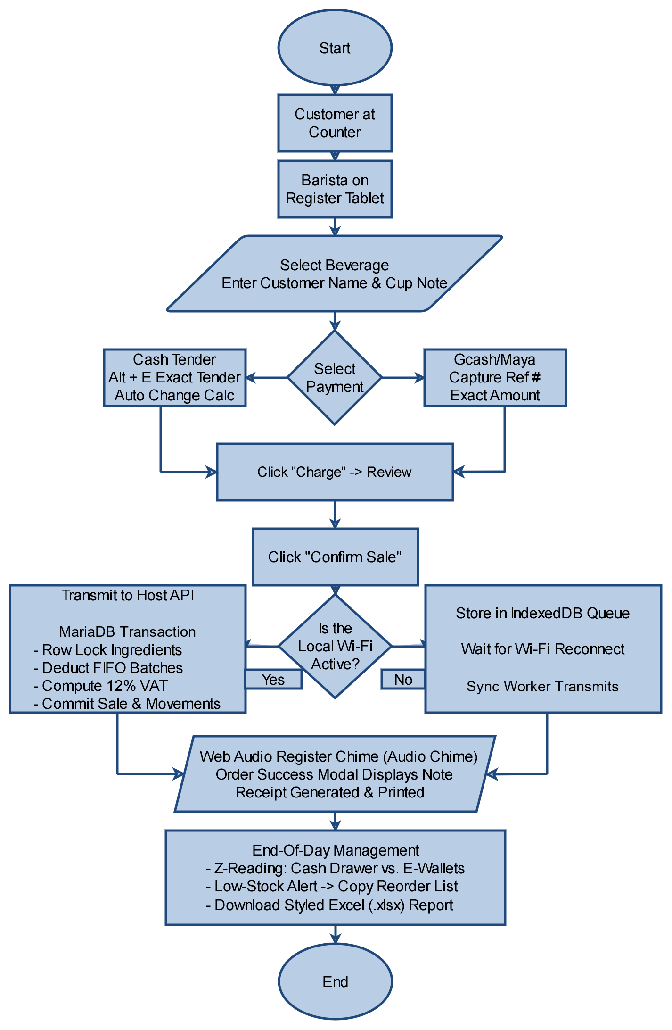
3.2 Use Case Diagram
Figure 3.2 illustrates the primary use case boundaries between the Barista and the Owner/Admin:
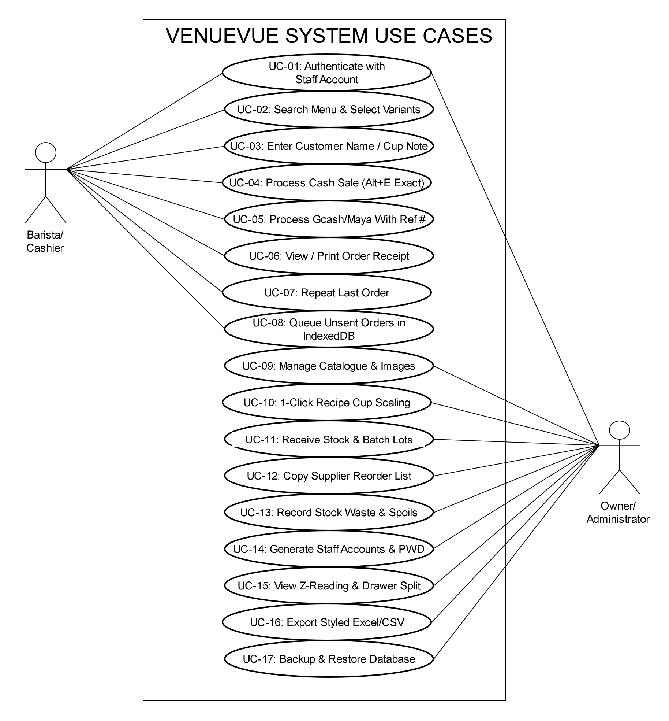
3.3 Use Case Descriptions
The following structured specifications detail critical use case executions:
Use Case UC-04/05: Process Multi-Tender Order with Customer Note
Specification Field | Use Case Details
Use Case ID | UC-04/05
Use Case Name | Process Multi-Tender Order with Customer Note and Chime Feedback
Primary Actor | Barista (Cashier)
Preconditions | Barista is authenticated; local host is active; active menu variants exist.
Trigger | Customer places a beverage order at the counter.
Basic Flow | 1. Barista presses '/' to focus search bar or clicks category pills (e.g. 'Espresso').  2. Barista selects variant size/temperature (e.g. 'Spanish Latte 16oz Iced').  3. Barista enters optional customer name/note in basket (e.g. 'Sarah - Table 4 - Less sweet').  4. For Cash: Barista clicks 'Exact' (Alt+E) or bill presets (P100, P500); system calculates change.  For GCash/Maya: Barista clicks payment chip, enters customer reference #, auto-filling exact total.  5. Barista clicks 'Charge', reviews order totals, and clicks 'Confirm sale'.  6. Host server acquires row locks, deducts FIFO ingredient batches, and commits transaction.  7. System plays dual-tone Web Audio chime (880 Hz -> 1318.5 Hz) and opens Success Dialog with note banner.  8. Barista presses Spacebar/Enter to clear modal or clicks 'Print / View Receipt'.
Alternate Flows | 4a. Local Wi-Fi partition: Order is written to IndexedDB as 'submitted' with UUIDv4 key; background worker retries automatically upon reconnection.  6a. Insufficient stock: Host rolls back transaction and returns HTTP 409 INGREDIENT_UNAVAILABLE; barista notifies customer.
Postconditions | Sale record created; recipe ingredients depleted; stock movements logged; receipt available.

Use Case UC-10: 1-Click Recipe Duplication and Cup-Size Scaling
Specification Field | Use Case Details
Use Case ID | UC-10
Use Case Name | 1-Click Recipe Duplication and Proportional Cup-Size Scaling
Primary Actor | Owner / Administrator
Preconditions | Owner is authenticated; at least one base variant recipe exists (e.g. 16oz).
Trigger | Owner creates a new size variant (e.g. 22oz) and needs to configure ingredient quantities.
Basic Flow | 1. Owner navigates to Management -> Catalogue -> Recipes.  2. Owner selects target variant without recipe (e.g. 'Caramel Macchiato 22oz Iced').  3. System displays 'Copy existing recipe' bar detecting source variants of the same product.  4. Owner selects source variant (e.g. '16oz Iced') and checks 'Scale quantities by cup size (16oz -> 22oz)'.  5. Owner clicks 'Copy recipe'; system computes ratio (22/16 = 1.375) and scales all ingredients proportionally.  6. Owner reviews quantities, fine-tunes if necessary, and clicks 'Save recipe'.  7. System commits recipe rows to database and displays confirmation notice.
Alternate Flows | 4a. Non-scalable units: Packaging pieces (cups, lids) remain fixed at 1 unit while liquids/beans scale.
Postconditions | Target variant is marked recipe-ready and becomes immediately available on the Register.

Use Case UC-12: Low-Stock Detection and Supplier Reorder Clipboard Export
Specification Field | Use Case Details
Use Case ID | UC-12
Use Case Name | 1-Click Supplier Reorder List Clipboard Export for Viber/Messenger
Primary Actor | Owner / Administrator
Preconditions | Owner is authenticated; one or more active ingredients have eligible stock <= minimum stock.
Trigger | Owner reviews stock levels before placing daily supplier procurement orders.
Basic Flow | 1. Owner opens Management -> Overview dashboard.  2. System detects low-stock items and renders 'Stock alerts' panel with 'Copy supplier reorder list' button.  3. Owner clicks '[Reorder List] Copy supplier reorder list'.  4. System formats low-stock items into a clean, bulleted message containing current stock, minimum threshold, and estimated order quantity.  5. System invokes navigator.clipboard.writeText() and displays green notification: 'Copied supplier reorder list (X items) to clipboard!'.  6. Owner opens Viber or Messenger chat with ingredient supplier and pastes (Ctrl+V) the procurement message directly.
Alternate Flows | 2a. Zero low-stock items: System displays 'No stock alerts' and hides the reorder copy button.
Postconditions | Formatted reorder text is in clipboard; zero database modifications.

3.4 Activity Diagram
Figure 3.3 illustrates the swimlane activity diagram across Customer, Barista/Tablet, Host Server, and Database:
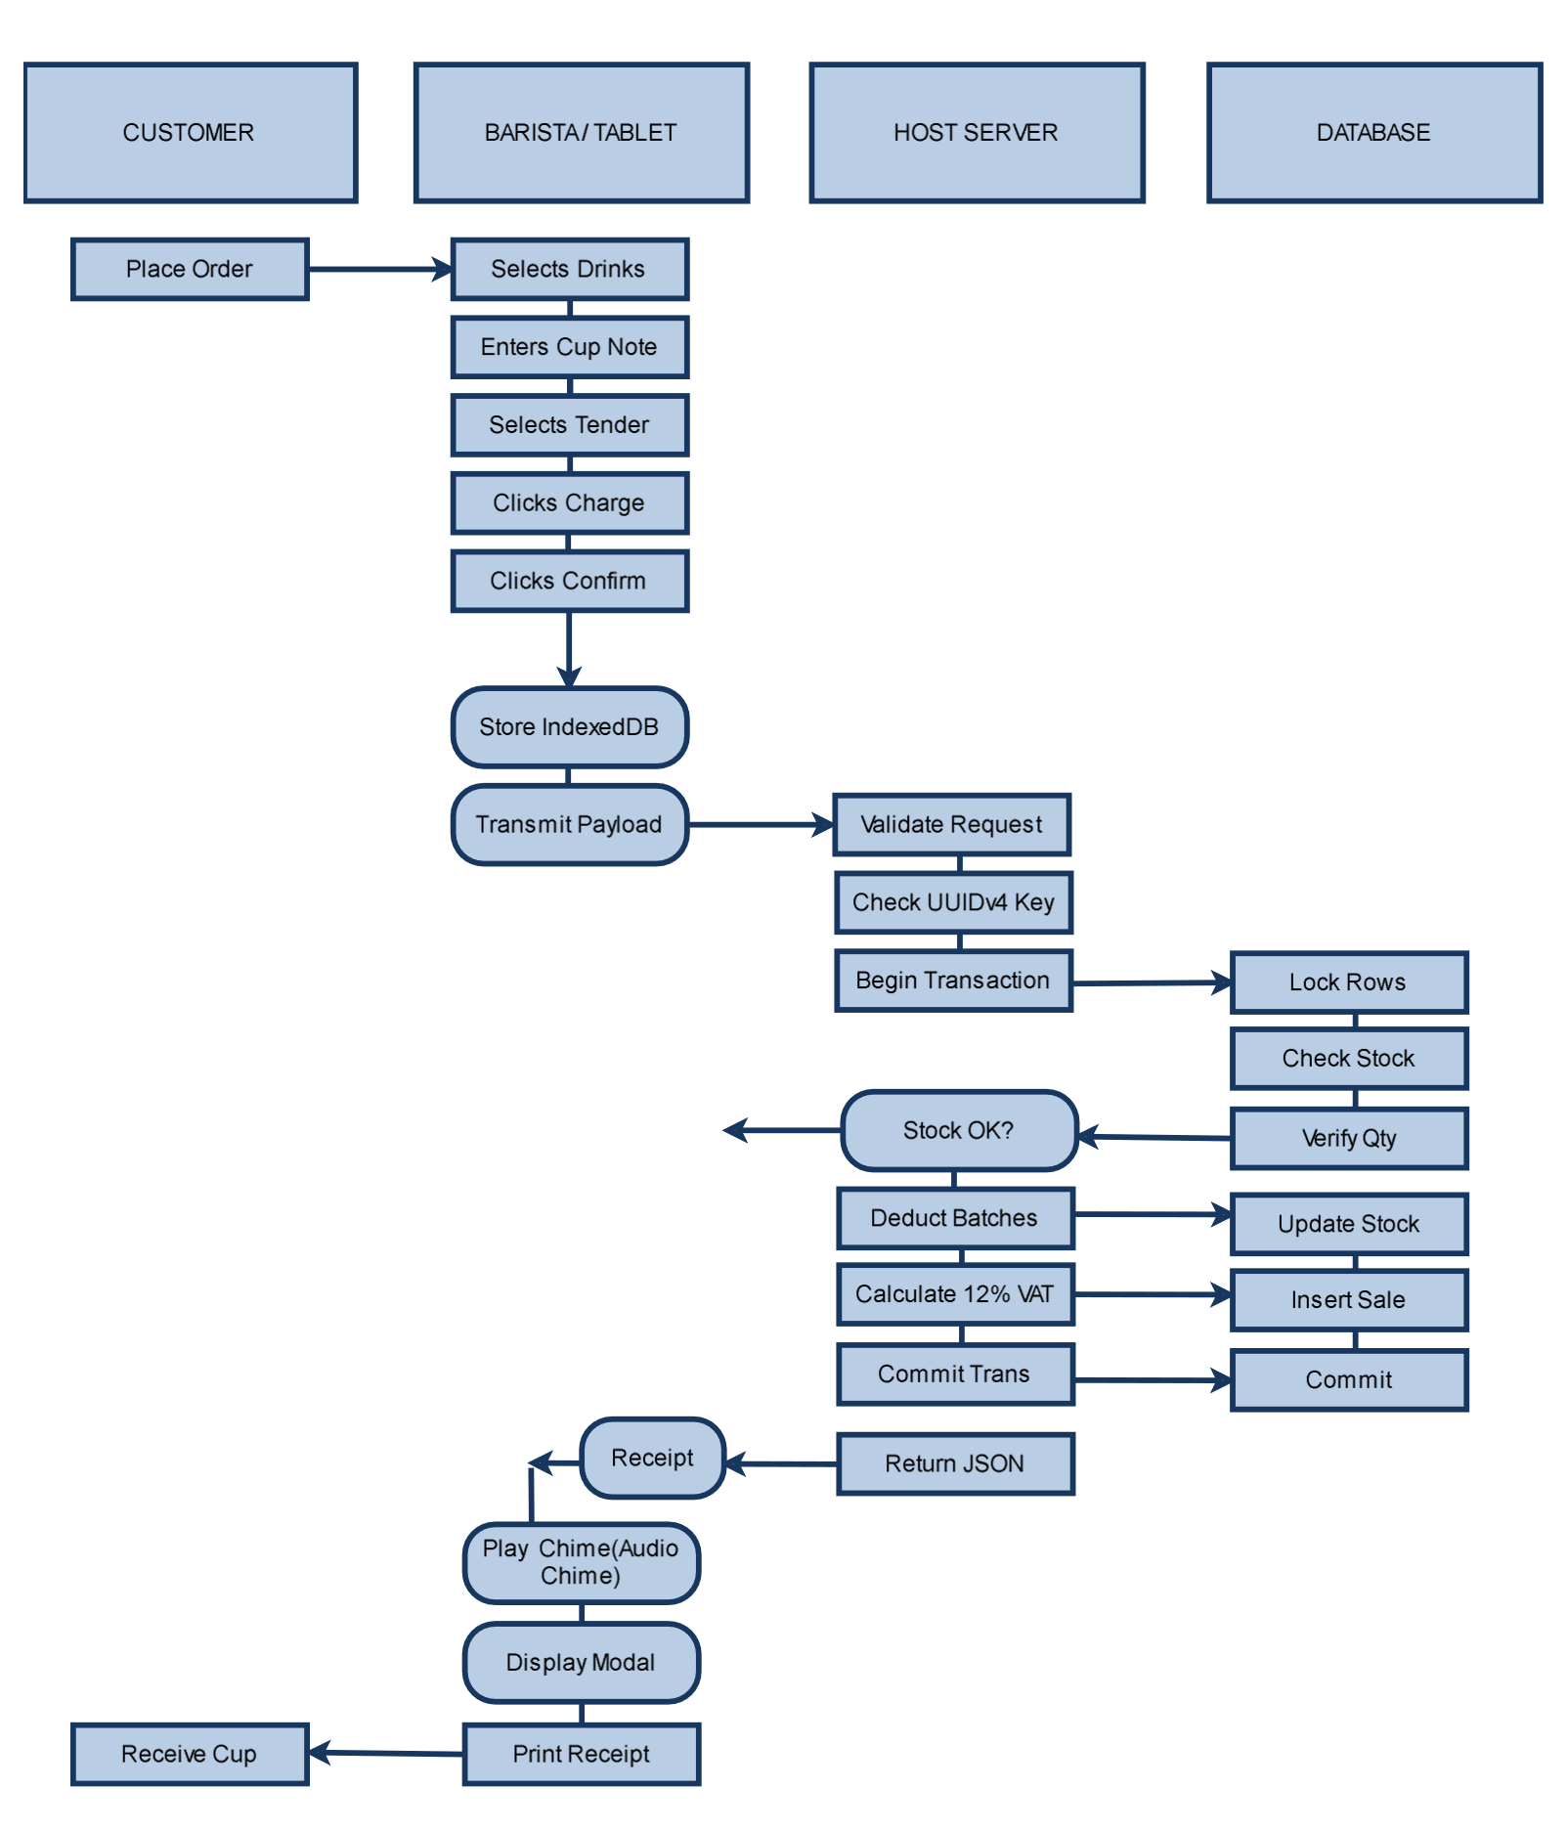

3.5 Data Flow Diagram (DFD)
Figure 3.4 illustrates the Level 0 Context DFD and Level 1 Detailed DFD:
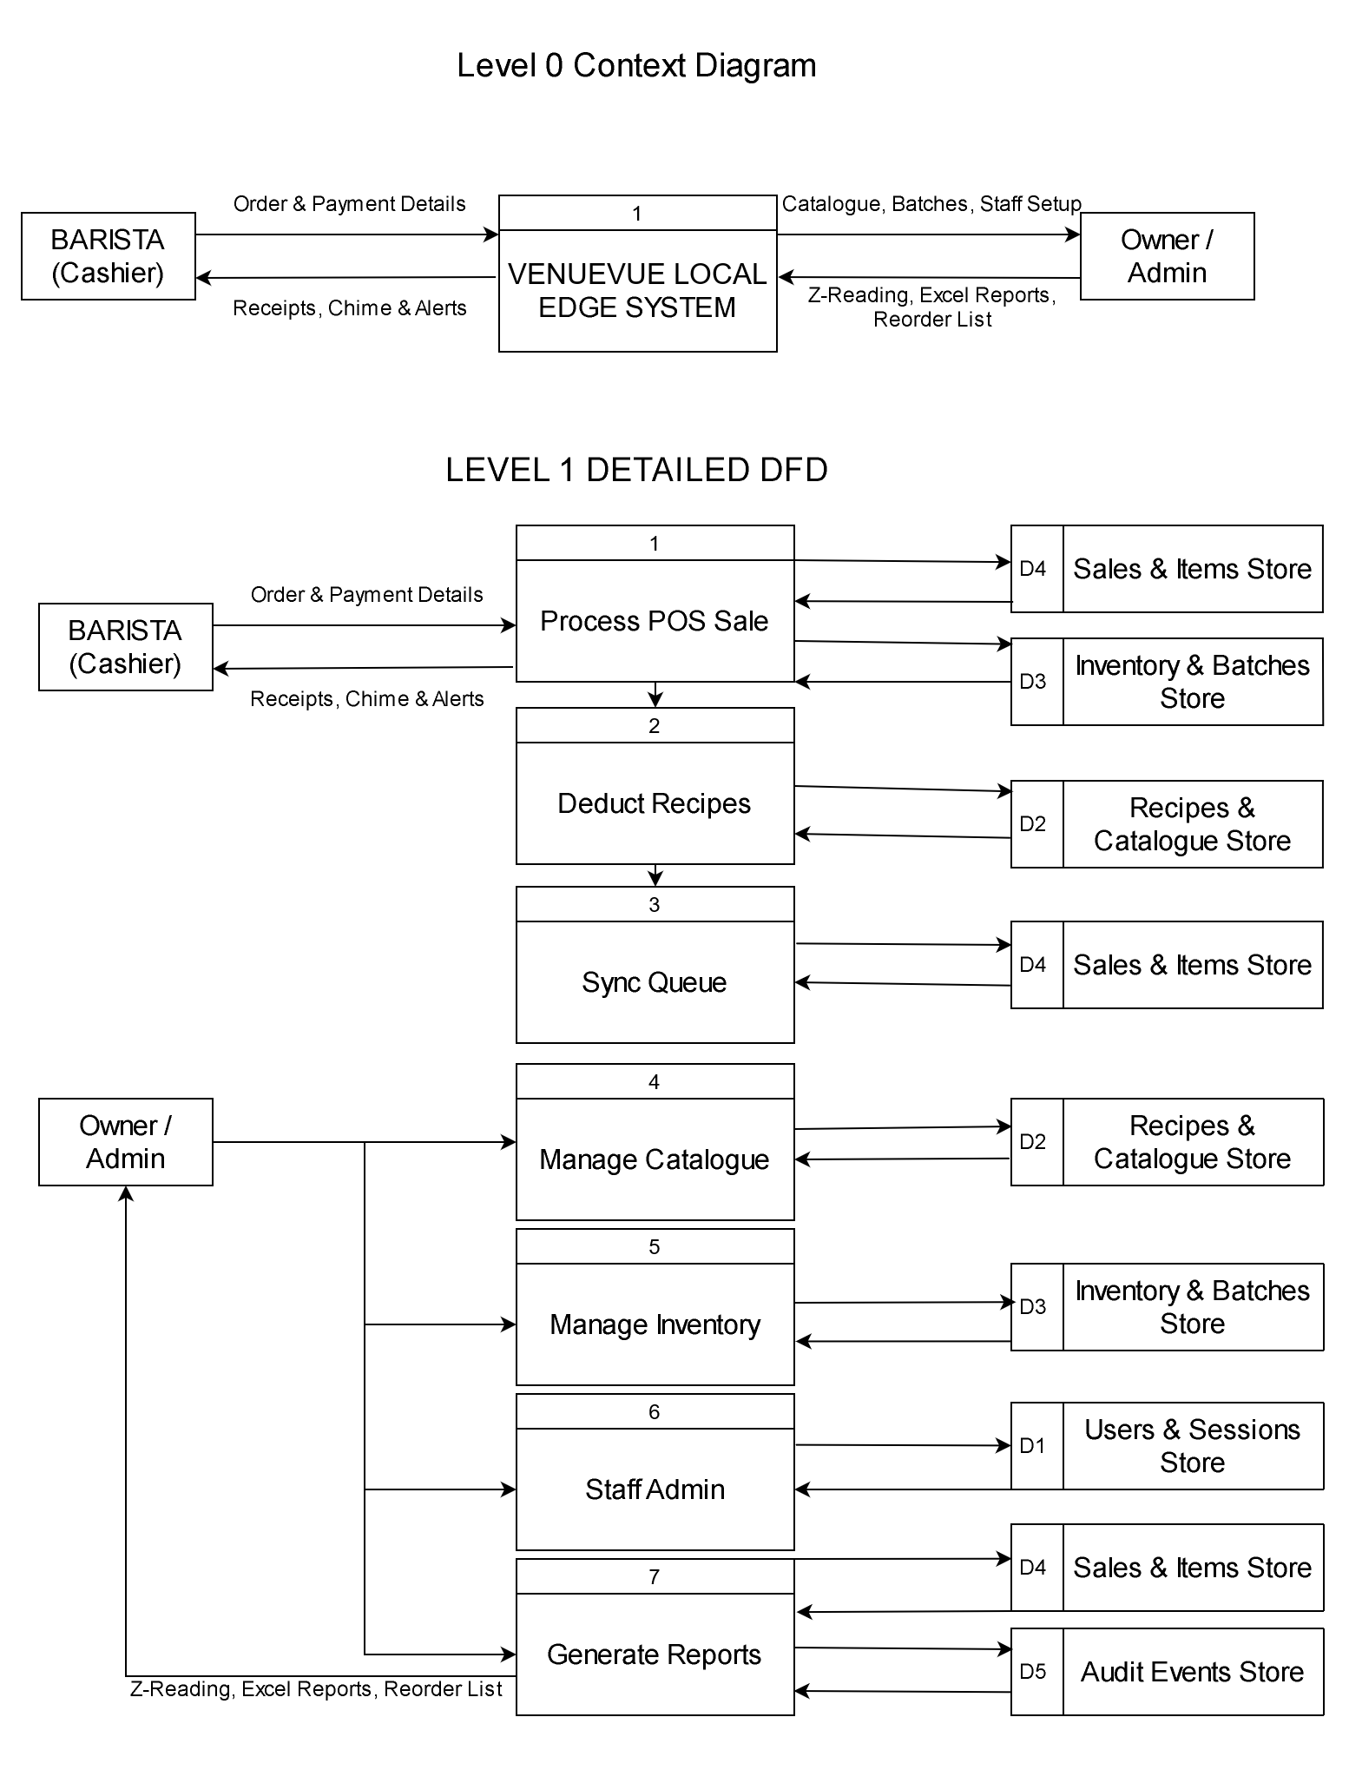
3.6 Entity-Relationship Diagram (ERD)
Figure 3.5 details the 14-table relational database schema supporting transactional integrity, FIFO inventory, and financial reporting in MariaDB (InnoDB):

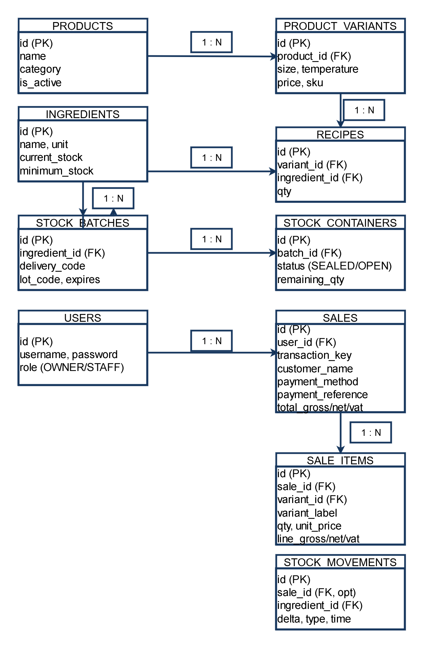
4. Data Requirements
4.1 Data Validation Rules
Data Entity | Validation Rule & Enforcement Constraint
Monetary Values | All price, cash tender, gross, net, and VAT fields must be positive numeric decimals with exactly 2 decimal places, bounded to <= 9,999,999.99.
Ingredient Quantities | Ingredient stock levels and recipe quantities must be numeric values with exactly 3 decimal places (e.g. 18.500 g, 220.000 ml).
Customer Name / Cup Note | Optional string field with a maximum length of 100 characters; leading and trailing whitespace stripped; XSS sanitized.
Payment Reference | Required for non-cash tenders (GCash, Maya, QR Ph / Card) if provided; alphanumeric string between 4 and 80 characters.
Batch & Lot Codes | Auto-formatted strings adhering to DEL-YYYYMMDD-XXXX and LOT-YYYYMMDD-XXXX format (maximum 60 characters).
UUIDv4 Transaction Keys | Standard 36-character canonical lowercase UUID string (e.g. 8-4-4-4-12 hex format) generated via crypto.getRandomValues().

4.2 Data Security and Privacy Requirements
1. Customer Privacy Minimization: VenueVue does not collect, process, or store sensitive customer personally identifiable information (PII). Customer names entered for cup callouts are stored only as operational order references and may be left blank.
2. Payment Security: The system does not integrate direct credit card processing and never handles credit card PANs, CVVs, or bank credentials. Digital payments capture only customer-provided transaction reference numbers for manual audit matching.
3. Password and Token Security: Administrative and staff passwords are encrypted using Bcrypt with default cost parameters; plaintext passwords are never logged or transmitted over unencrypted channels. Session tokens expire upon logout or after 24 hours of inactivity.
4. Database Network Isolation: MariaDB runs on localhost binding (127.0.0.1:3306), completely inaccessible from external LAN tablet clients. Clients interact exclusively with the hardened PHP REST API over HTTP/HTTPS.
4.3 Data Retention and Backup Requirements
1. Audit Log Immutability: System audit events (audit_events, audit_details) and stock movement logs (stock_movements) are append-only. No application user, including the Owner, can delete or alter audit history records through the interface.
2. Sales Data Retention: Sales records are retained permanently for business compliance and reporting. Voided transactions are soft-flagged with void_reason, voided_by, and voided_at timestamps rather than deleted, preserving auditability.
3. Cryptographic Backup & Restoration: The Owner can trigger an encrypted database snapshot at any time. The backup file contains a complete SQL dump paired with a SHA-256 verification hash. Preflight restoration validates schema versions before executing table updates.
5. Definition of Terms
Term / Acronym | Technical and Operational Definition
POS | Point-of-Sale: The computerized counter hardware and software used to record transactions and checkout customer purchases.
Offline-First | A software architecture where application features execute primarily on local device/edge resources without requiring Internet connectivity.
Local Edge Host | A central physical computer running on-premise server software (Apache/PHP/MariaDB) that acts as the single source of truth on the local LAN.
BOM (Bill of Materials) | A recipe specification linking a finished beverage variant to specific quantities of raw ingredients in exact units (grams, ml, pieces).
FIFO / FEFO | First-In, First-Out / First-Expired, First-Out: Inventory depletion logic ensuring older or sooner-expiring ingredient batches are consumed first.
Z-Reading | The official end-of-day financial report summarizing gross revenue, net sales, 12% VAT remittance, and cash drawer reconciliations.
Idempotency | A software property guaranteeing that re-transmitting the exact same transaction request multiple times results in exactly one state change.
IndexedDB | A standard, low-level browser API for client-side storage of significant amounts of structured data, including files and object stores.
Web Audio API | A high-performance browser audio processing subsystem utilized to dynamically synthesize sound effects (e.g. register chimes) without media files.
OpenXML (.xlsx) | An open, XML-based spreadsheet file format standardized under ECMA-376, natively readable by Microsoft Excel and spreadsheet software.

6. References
1. digabloPos. (n.d.). Offline mode: Sell without interruption, even without internet. Retrieved October 24, 2026, from https://digablopos.com/en/features/offline-mode
2. ECMA International. (2021). ECMA-376: Office Open XML File Formats (SpreadsheetML and Zip Packaging). Standard ECMA-376.
3. Lavu. (n.d.-a). Best restaurant POS with offline mode. Retrieved October 24, 2026, from https://lavu.com/restaurant-pos/offline-mode
4. Lavu. (n.d.-b). Inventory: Link ingredients to menu items. Retrieved October 24, 2026, from https://support.lavu.com/en/knowledge/inventory-link-ingredients-to-menu-items
5. MDN Web Docs. (2026). IndexedDB API: Working with Client-Side Offline Storage. Mozilla Developer Network.
6. Oracle Corporation. (2026). MySQL 8.4 Reference Manual: InnoDB Locking and Transaction Model (How to Minimize and Handle Deadlocks). Oracle Documentation.
7. OWASP Foundation. (2025). REST Security & Transaction Idempotency Cheat Sheet. Open Web Application Security Project.
8. Peddlr Philippines, Inc. (n.d.). POS. Retrieved October 24, 2026, from https://www.peddlr.io/features/pos
9. W3C. (2024). Web Audio API: High-Performance Client-Side Audio Synthesis. World Wide Web Consortium Recommendation.

