**\*\*\* Lab 10 \*\*\***

**A. Programming Exercise 10-1 (Pet Class), page 578**

**Output:**

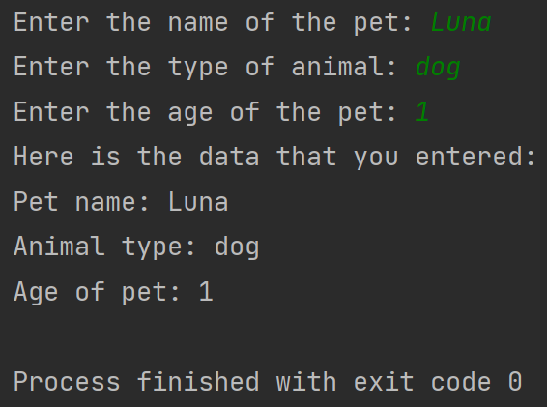

**B. Programming Exercise 10-3 (Personal Information Class), page 579**

**Output:**

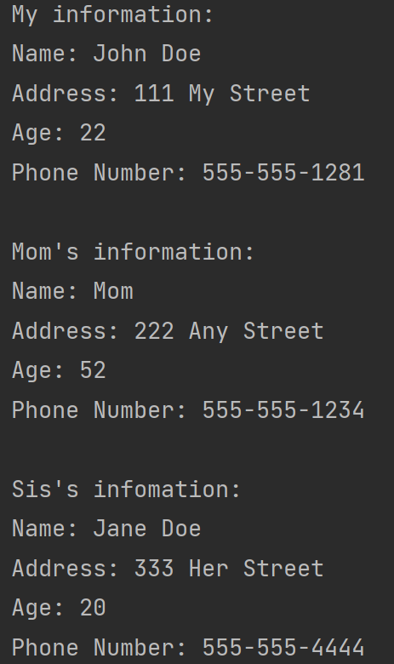

**C. Programming Exercise 10-4 (Employee Class), page 579**

**Output:**

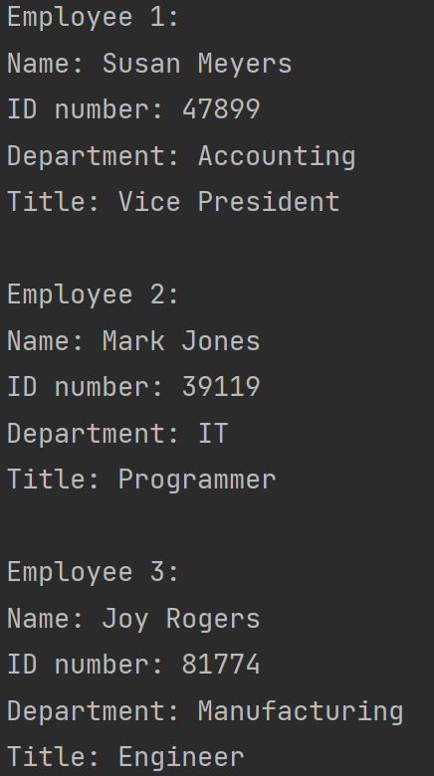

**Extra Credit: Programming Exercise 10-6 (Patient Charges), page 580**  
**Output:**

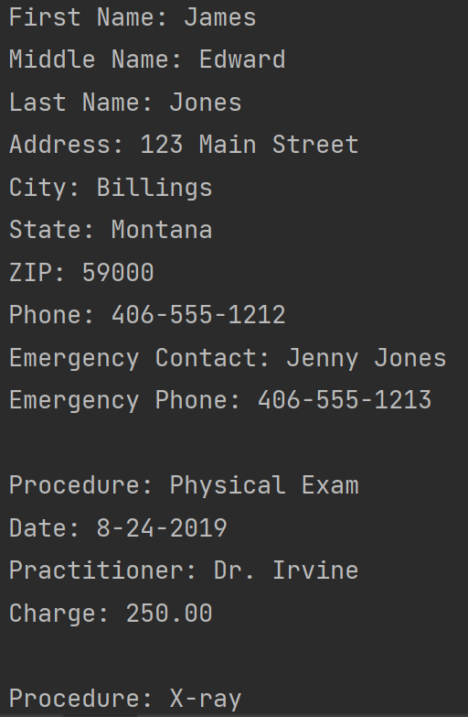

**There is more output…**

**Note:** Zip your work and name the file Lab10_yourfirstname_yourlastname.zip.   
Your zip file should have the following:

* Lab10a.py
* Lab10b.py
* Lab10c.py
* Lab10-extra-credit.py