**\*\*\* Lab 2 \*\*\***

**A. Programming Exercise 2-5 (Distance Traveled), page 114** You also need to create a flow chart (use draw.io) and source code.

**Output:**

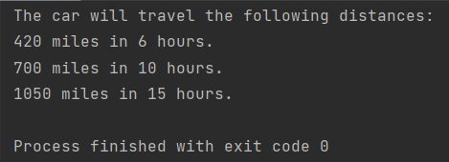

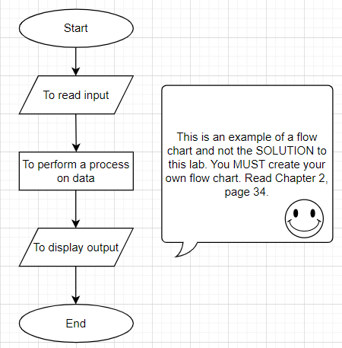

**B. Programming Exercise 2-8 (Tip, Tax, and Total), page 115  
Output:**

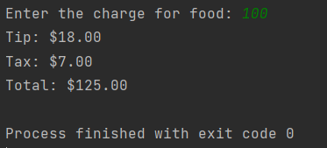

**C. Programming Exercise 2-12 (Stock Transaction Program), page 115  
Output:**

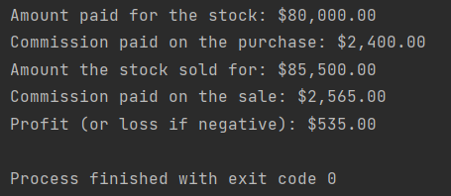

**Extra Credit: Programming Exercise 2-15 (Turtle Graphics Drawings)**  
**Output:**

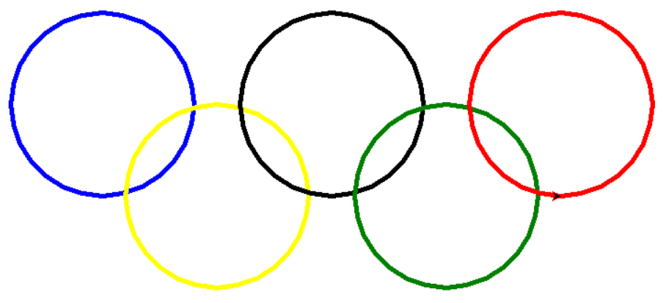

**Note:** Zip your work and name the file Lab2_yourfirstname_yourlastname.zip.   
Your zip file should have the following:

* Lab2a.py
* Lab2aFlowChart.drawio
* Lab2b.py
* Lab2c.py
* Lab2-extra-credit.py