**\*\*\* Lab 3 \*\*\***

**A. Programming Exercise 3-1 (Day of the Week), page 161  
Output:**

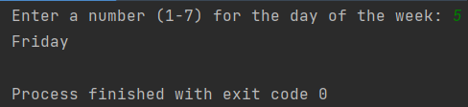

**B. Programming Exercise 3-3 (Age Classifier), page 162  
Output:**

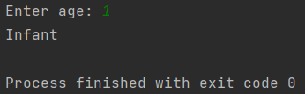

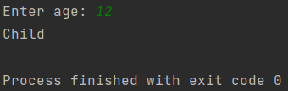

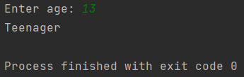

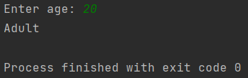

**C. Programming Exercise 3-12 (Software Sales), page 164**

* Add the “Discount Given” to the output. The percentage should not have decimals. Match the output below.

**Output:**

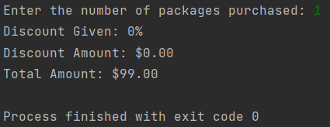

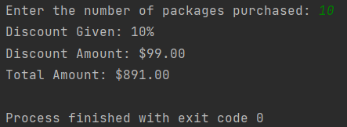

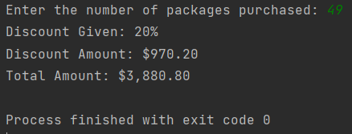

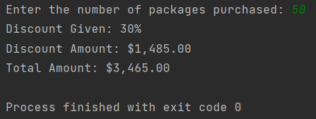

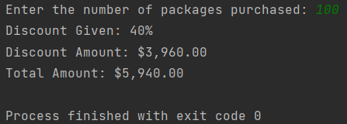

**Extra Credit: Programming Exercise 3-16 (February Days), page 165**  
**Output:**

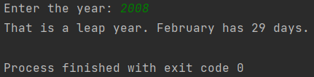

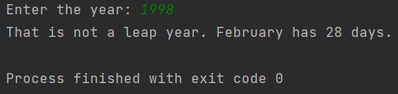

**Note:** Zip your work and name the file Lab3_yourfirstname_yourlastname.zip.   
Your zip file should have the following:

* Lab3a.py
* Lab3b.py
* Lab3c.py
* Lab3-extra-credit.py