**\*\*\* Lab 4 \*\*\***

**A. Programming Exercise 4-1 (Bug Collector), page 213  
Output:**

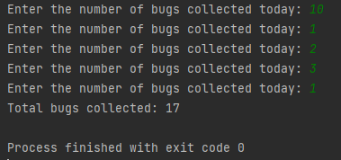

**B. Programming Exercise 4-12 (Calculating the Factorial of a Number), page 215  
Output:**

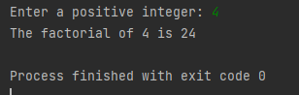

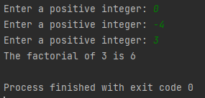

**C. Programming Exercise 4-14 (Draw a pattern), page 216**

**Output:**

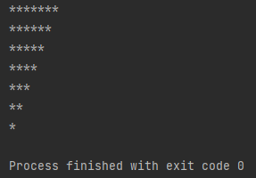

**Extra Credit: Programming Exercise 4-18 (Turtle Graphics: Hypnotic Pattern), page 217**  
**Output:**



**Note:** Zip your work and name the file Lab4_yourfirstname_yourlastname.zip.   
Your zip file should have the following:

* Lab4a.py
* Lab4b.py
* Lab4c.py
* Lab4-extra-credit.py