**\*\*\* Lab 5 \*\*\***

**A. Programming Exercise 5-4 (Automobile Costs), page 295  
Output:**

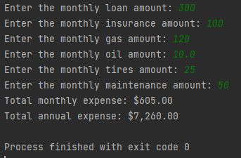

**B. Programming Exercise 5-12 (Maximum of Two Values), page 296  
Output:**

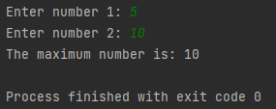

**C. Programming Exercise 5-16 (Odd/Even Calculator), page 297**

**Output:**

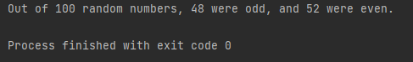

**Extra Credit: Programming Exercise 5-21 (Rock, Paper, Scissors Game), page 298**  
**Output:**

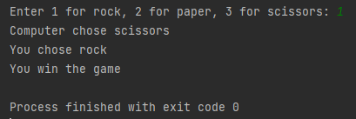

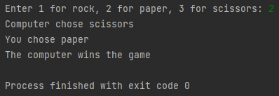

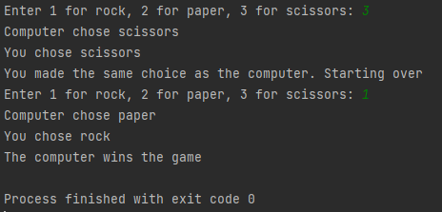

**Note:** Zip your work and name the file Lab5_yourfirstname_yourlastname.zip.   
Your zip file should have the following:

* Lab5a.py
* Lab5b.py
* Lab5c.py
* Lab5-extra-credit.py