**\*\*\* Lab 6 \*\*\***

**A. Programming Exercise 6-3 (Line Numbers), page 358**

* Make sure you provide an input file.

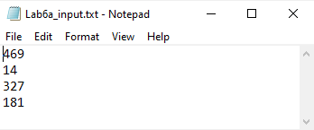

**Output:**

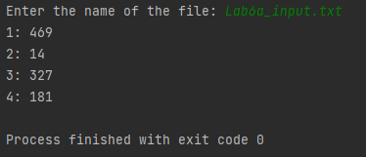

**B. Programming Exercise 6-7 (Random Number File Writer), page 358  
Output:**

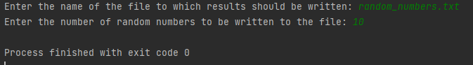

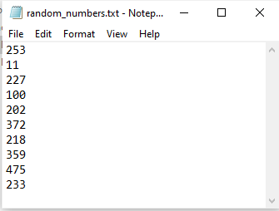

**C. Programming Exercise 6-8 (Random Number File Reader), page 358**

* Use the random_numbers.txt file created in lab B

**Output:**

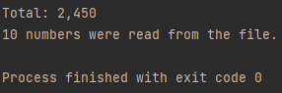

**Extra Credit: Programming Exercise 6-11 (Personal Web Page Generator), page 359**  
**Output:**

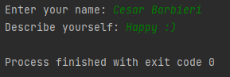

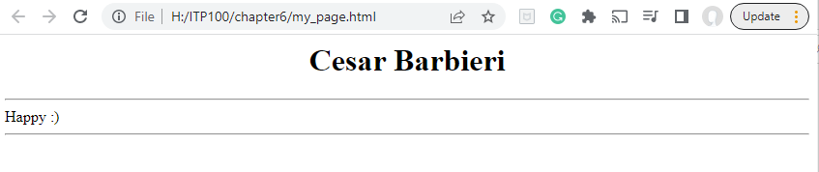

**Note:** Zip your work and name the file Lab6_yourfirstname_yourlastname.zip.   
Your zip file should have the following:

* Lab6a.py
* Lab6b.py
* Lab6c.py
* Lab6-extra-credit.py