**\*\*\* Lab 7 \*\*\***

**A. Programming Exercise 7-2 (Lottery Number Generator), page 426**

**Output:**

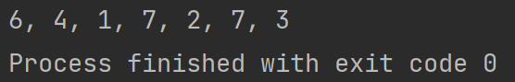

**B. Programming Exercise 7-4 (Number Analysis Program), page 426  
Output:**

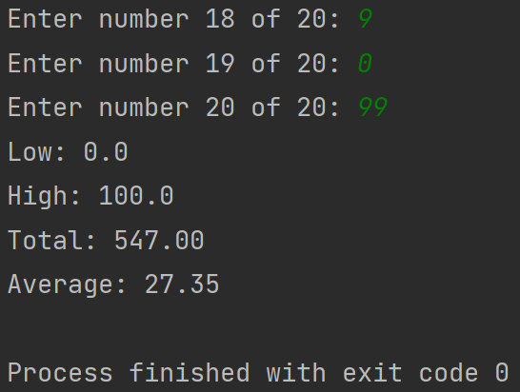

**C. Programming Exercise 7-6 (Larger Than n), page 427**

**Output:**

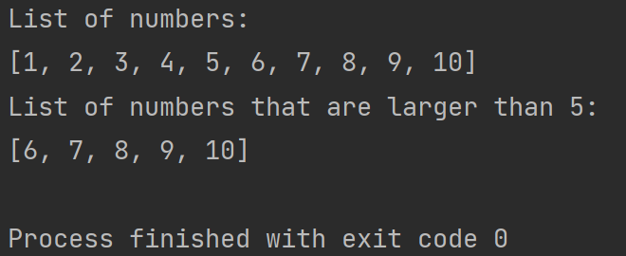

**Extra Credit: Programming Exercise 7-11 (Lo Shu Magic Square), page 428**  
**Output:**

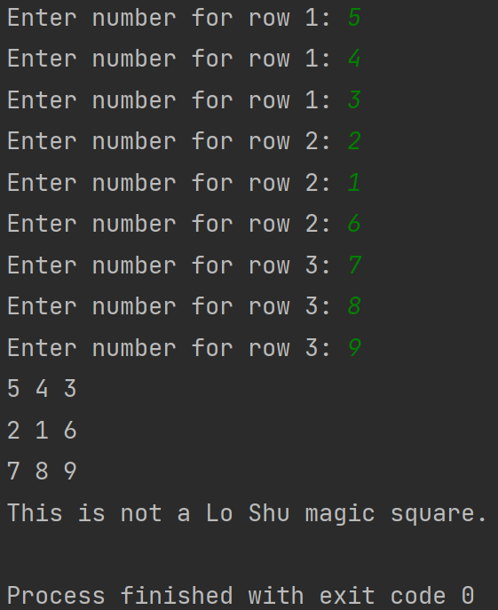

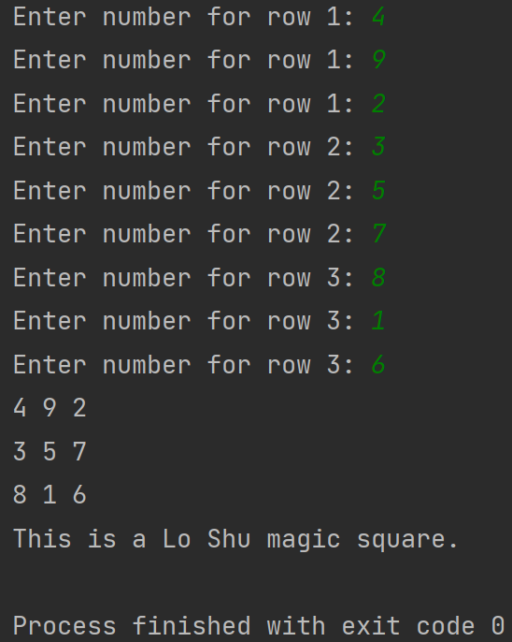

**Note:** Zip your work and name the file Lab7_yourfirstname_yourlastname.zip.   
Your zip file should have the following:

* Lab7a.py
* Lab7b.py
* Lab7c.py
* Lab7-extra-credit.py