**\*\*\* Lab 8 \*\*\***

**A. Programming Exercise 8-4 (Morse Code Converter), page 462**

**Output:**

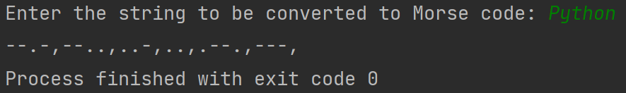

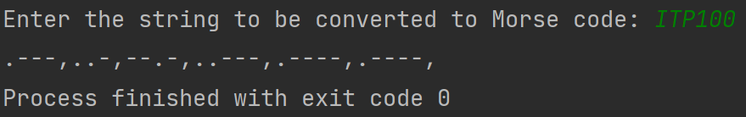

**B. Programming Exercise 8-5 (Alphabetic Telephone Number Translator), page 463  
Output:**

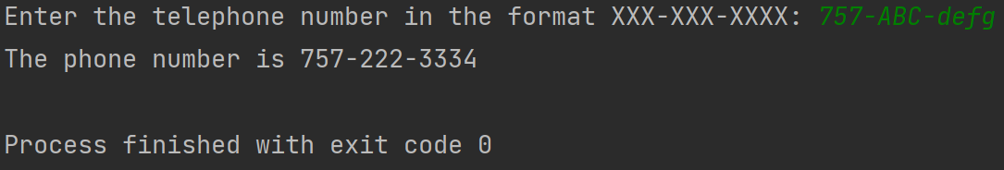

**C. Programming Exercise 8-8 (Sentence Capitalizer), page 463**

**Output:**

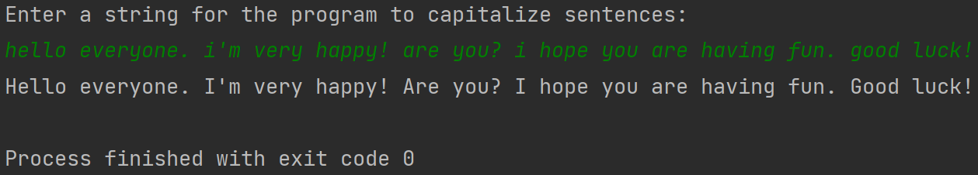

**Extra Credit: Programming Exercise 8-10 (Most Frequent Character), page 464**  
**Output:**

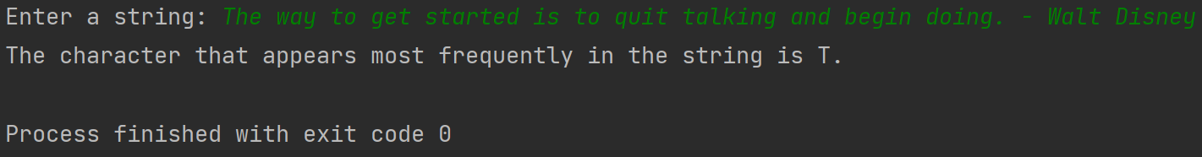

**Note:** Zip your work and name the file Lab8_yourfirstname_yourlastname.zip.   
Your zip file should have the following:

* Lab8a.py
* Lab8b.py
* Lab8c.py
* Lab8-extra-credit.py