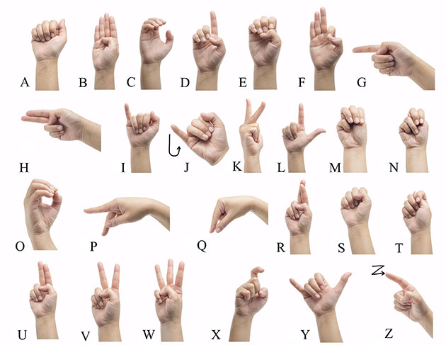

## Signing the manual alphabet

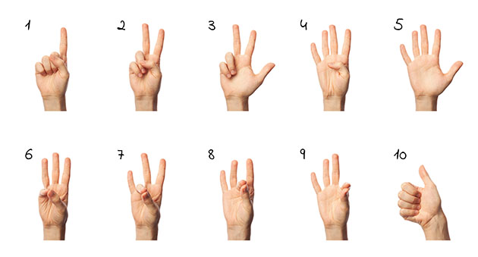

# Signing numbers 1 through 10

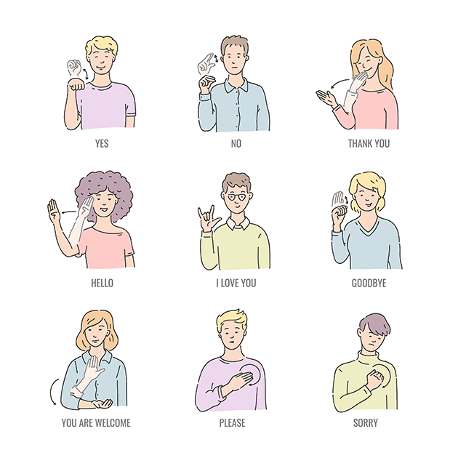

# Signing essential expressions

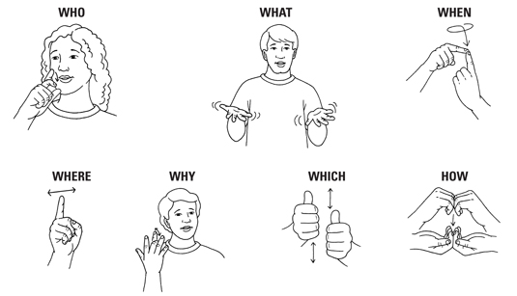

## One-word questions in American Sign Language

**ASL-American Sign Language:**

**Fingerspelling:**

The American manual alphabet and numbers

ASL possesses a set of 26 signs known as the [American manual alphabet](https://en.wikipedia.org/wiki/American_manual_alphabet), which can be used to spell out words from the English language.[[50]](https://en.wikipedia.org/wiki/American_Sign_Language#cite_note-cxxiv-55) Such signs make use of the 19 handshapes of ASL. For example, the signs for 'p' and 'k' use the same handshape but different orientations. A common misconception is that ASL consists only of fingerspelling; although such a method ([Rochester Method](https://en.wikipedia.org/wiki/Rochester_Method)) has been used, it is not ASL.[[33]](https://en.wikipedia.org/wiki/American_Sign_Language#cite_note-cxxv-37)

Fingerspelling is a form of [borrowing](https://en.wikipedia.org/wiki/Borrowing_(linguistics)), a linguistic process wherein words from one language are incorporated into another.[[33]](https://en.wikipedia.org/wiki/American_Sign_Language#cite_note-cxxv-37) In ASL, fingerspelling is used for [proper nouns](https://en.wikipedia.org/wiki/Proper_nouns) and for technical terms with no native ASL equivalent.[[33]](https://en.wikipedia.org/wiki/American_Sign_Language#cite_note-cxxv-37) There are also some other loan words which are fingerspelled, either very short English words or abbreviations of longer English words, e.g. *O-N* from English 'on', and *A-P-T* from English 'apartment'.[[33]](https://en.wikipedia.org/wiki/American_Sign_Language#cite_note-cxxv-37) Fingerspelling may also be used to emphasize a word that would normally be signed otherwise.[[33]](https://en.wikipedia.org/wiki/American_Sign_Language#cite_note-cxxv-37)

**Syntax**

ASL is a [subject–verb–object](https://en.wikipedia.org/wiki/Subject%E2%80%93verb%E2%80%93object) (SVO) language, but various phenomena affect that basic word order.[[51]](https://en.wikipedia.org/wiki/American_Sign_Language#cite_note-Neidle_2000_59-56) Basic SVO sentences are signed without any pauses:[[26]](https://en.wikipedia.org/wiki/American_Sign_Language" \l "cite_note-Valli_2005_84-30)

*FATHER*

*LOVE*

*CHILD*

"The father loves the child."[[26]](https://en.wikipedia.org/wiki/American_Sign_Language#cite_note-Valli_2005_84-30)

However, other word orders may also occur since ASL allows the [topic](https://en.wikipedia.org/wiki/Topic_(linguistics)) of a sentence to be moved to sentence-initial position, a phenomenon known as [topicalization](https://en.wikipedia.org/wiki/Topicalization" \o "Topicalization).[[52]](https://en.wikipedia.org/wiki/American_Sign_Language#cite_note-57) In [object–subject–verb](https://en.wikipedia.org/wiki/Object%E2%80%93subject%E2%80%93verb) (OSV) sentences, the object is topicalized, marked by a forward head-tilt and a pause:[[53]](https://en.wikipedia.org/wiki/American_Sign_Language" \l "cite_note-Valli_2005_86-58)

*CHILDtopic,*

*FATHER*

*LOVE*

"The father loves the child."[[53]](https://en.wikipedia.org/wiki/American_Sign_Language#cite_note-Valli_2005_86-58)

Besides, word orders can be obtained through the phenomenon of subject copy in which the subject is repeated at the end of the sentence, accompanied by head nodding for clarification or emphasis:[[26]](https://en.wikipedia.org/wiki/American_Sign_Language" \l "cite_note-Valli_2005_84-30)

*FATHER*

*LOVE*

*CHILD*

*FATHERcopy*

"The father loves the child."[[26]](https://en.wikipedia.org/wiki/American_Sign_Language#cite_note-Valli_2005_84-30)

ASL also allows [null subject](https://en.wikipedia.org/wiki/Null_subject) sentences whose subject is implied, rather than stated explicitly. Subjects can be copied even in a null subject sentence, and the subject is then omitted from its original position, yielding a [verb–object–subject](https://en.wikipedia.org/wiki/Verb%E2%80%93object%E2%80%93subject) (VOS) construction:[[53]](https://en.wikipedia.org/wiki/American_Sign_Language" \l "cite_note-Valli_2005_86-58)

*LOVE*

*CHILD*

*FATHERcopy*

"The father loves the child."[[53]](https://en.wikipedia.org/wiki/American_Sign_Language#cite_note-Valli_2005_86-58)

Topicalization, accompanied with a null subject and a subject copy, can produce yet another word order, [object–verb–subject](https://en.wikipedia.org/wiki/Object%E2%80%93verb%E2%80%93subject) (OVS).

*CHILDtopic,*

*LOVE*

*FATHERcopy*

"The father loves the child."[[53]](https://en.wikipedia.org/wiki/American_Sign_Language#cite_note-Valli_2005_86-58)

Those properties of ASL allow it a variety of word orders, leading many to question which is the true, underlying, "basic" order. There are several other proposals that attempt to account for the flexibility of word order in ASL. One proposal is that languages like ASL are best described with a [topic–comment](https://en.wikipedia.org/wiki/Topic%E2%80%93comment) structure whose words are ordered by their importance in the sentence, rather than by their syntactic properties.[[54]](https://en.wikipedia.org/wiki/American_Sign_Language#cite_note-59) Another hypothesis is that ASL exhibits [free word order](https://en.wikipedia.org/wiki/Free_word_order), in which syntax is not encoded in word order but can be encoded by other means such as head nods, eyebrow movement, and body position.[[51]](https://en.wikipedia.org/wiki/American_Sign_Language#cite_note-Neidle_2000_59-56)

**ISL-**