### **Re:** Covid-19: Excess Mortality in US

**Date:** 5/13/2020

**Authors:** Zak Raicik, FSA, Junaid Bhatti, Ph.D., Matt Gabriel, FSA

**Overview**

COVID-19 is spreading around the globe at a rapid rate. The death toll in US on May 12 (just three months) after the report of first case stands over 80,000 deaths. The continued spread of COVID-19 in the US will create excess deaths. The purpose of this memorandum is **to provide a framework to estimate the excess mortality in the United States (US) as a result of the COVID-19 pandemic**.

Under current assumptions, it is **estimated that general population excess mortality is between 0% and 30 % depending on age and gender.** A detailed breakdown can be found later in this memo.

**Model Overview & Design**

We use a compartment model to simulate how COVID-19 will spread[1]. The model assumes that the population can be in 1 of 6 compartments at any point in time which are 1. Susceptible, Infectious, Exposed, Reported, Asymptomatic, and Recovered/Removed. A visual representation of the model is shown below.

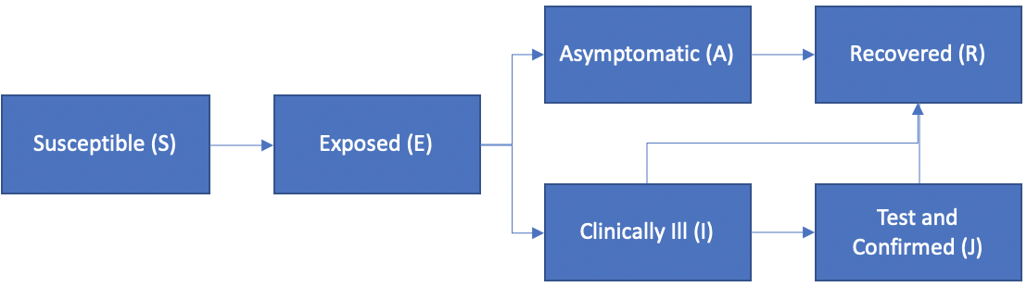

The projected number of deaths depends on how quickly the population is moving through the different compartments. The rate at which the population moves between compartments is dictated by a set of nine assumptions. One key assumption is the reproductive number, denoted R0, which represents the number of people an infected person will infect before recovery (or death). Social distancing and shelter in place measures are aimed at reducing this number. With that being said, it is changing constantly, and is not known with certainty.

**Approach & Results**

The first step to estimate excess mortality is to fit a curve to confirmed cases. Since R0 is changing over time, we elected to fit different curves to different time windows. The smaller fitted curves from each time window were then combined. This approach allows us to understand how assumptions are changing over time as a result of public health positions. Specifically, we can get an estimate of R0 before the lockdown and in subsequent time windows after the lockdown. The chart below shows how our fitted model compares to actual confirm case counts.

|  |  |
| --- | --- |
|  | A few key observations:   * The fit is very strong. * The R0 values align with public health decisions. The green box is the period before the lockdown, which is where R0 is the highest. * The decreasing value of R0 reflects the effective social distancing |

The chart below used the fitted model to forecast **cumulative** confirmed COVID-19 cases under two scenarios. The green line represents the forecast using the fitted R0 from the most recent time window. The blue line represents the forecast using a higher R0 which reflects relaxed stay at home orders. Note that this forecast assumes no improvements in testing or treatment, which is conservative. A forecast for daily confirmed cases using the assumptions that create the green line can be found in exhibit 1 of the appendix.

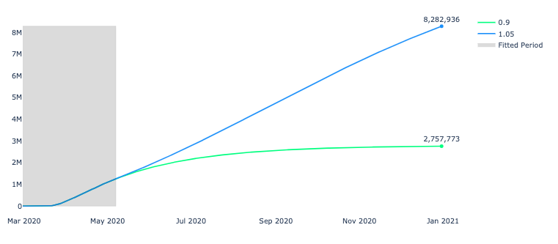

The observed death rate as a percentage of confirmed cases has been relatively constant, which means we can multiply the estimated number of confirmed cases by the death rate to generate a forecast for the cumulative number of deaths through 2020. A forecast for daily deaths using the assumptions that create the green line can be found in exhibit 2 of the appendix.

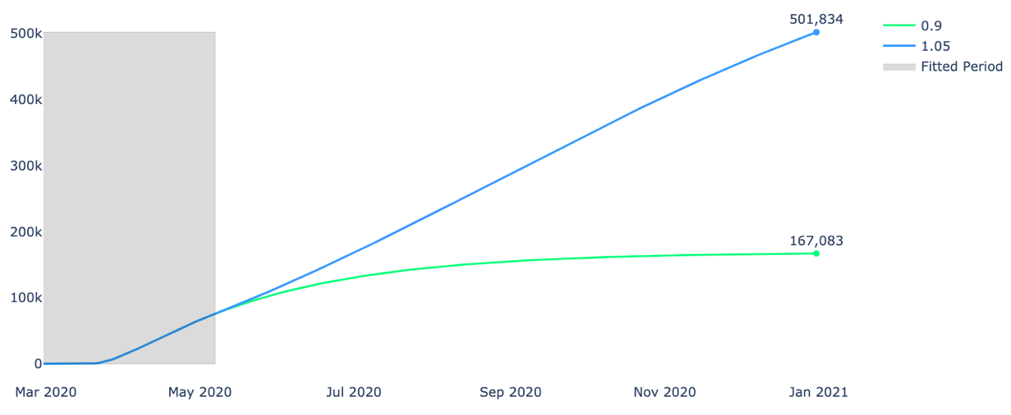

Most expert models limit forecasts to August 2020. The widely relied upon IHME model forecasts 147K deaths at this date[2]. Our forecast based on the most recent fitted period (green line) also forecasts 147K deaths at that point in time. This helps us to validate our forecasts, while maintaining the ability to extend the forecasts further than August and test different scenarios.

The cumulative death numbers shown above can be distributed across age and gender buckets based on experience from New York City. For example, in NYC roughly 30% of deaths are males ages 75 and older. Our forecast above estimates 167k deaths at the end of 2020, which means we estimated roughly 50k (157K*30%) of those deaths will be males ages 75 and older. We repeat this calculation to estimate the number of deaths in each age and gender bucket under each scenario.

Furthermore, we use 2017 US mortality rates to estimate the number of non-COVID19 related deaths for each age/gender group. We can add the forecasted number of COVID-19 deaths to the estimate for non-COVID19 deaths to get an estimate for the total number of deaths in each age gender buckets. At this point, we can divide the estimated total deaths with COVID by the total deaths without COVID to get an estimate for excess mortality in the US general population. Note that this assumes all COVID deaths are excess and none of these individuals would have died from other causes.

The chart below shows estimates for excess mortality under each scenario for each age and gender.

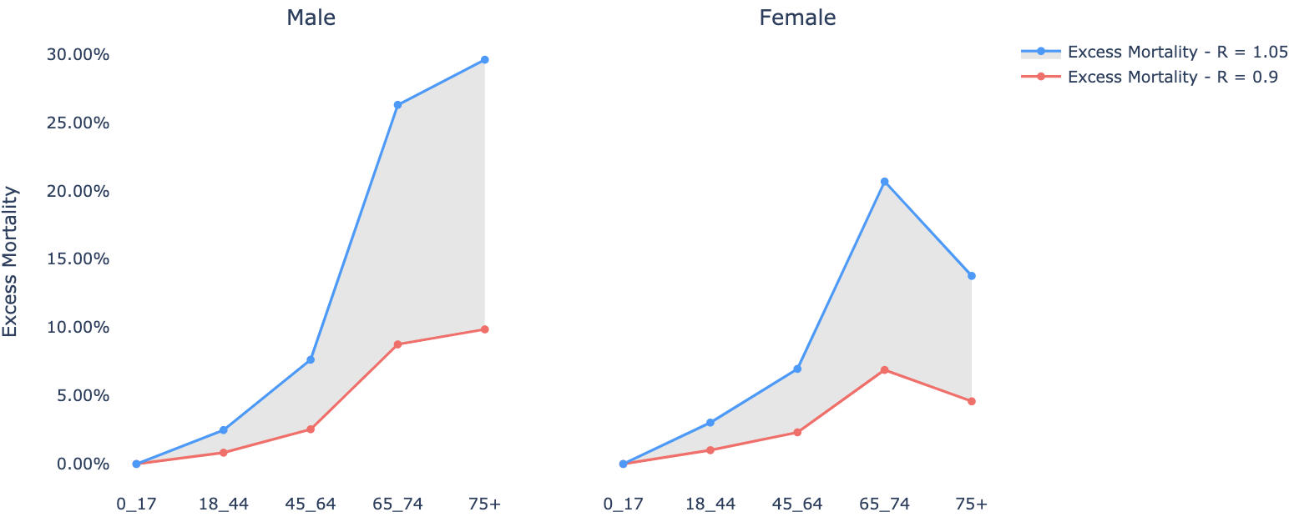

**Next Steps**

Going forward, we plan to:

* Continue to update the fitted model with additional data as time passes. This will provide additional insights into how we can expect the disease to spread as social distancing measures are relaxed.
* Brainstorm ways to identify how to map these general population results to an insured population
* Explore model fits at the state level to see if we can generate insights

**Appendix**

*Exhibit 1*

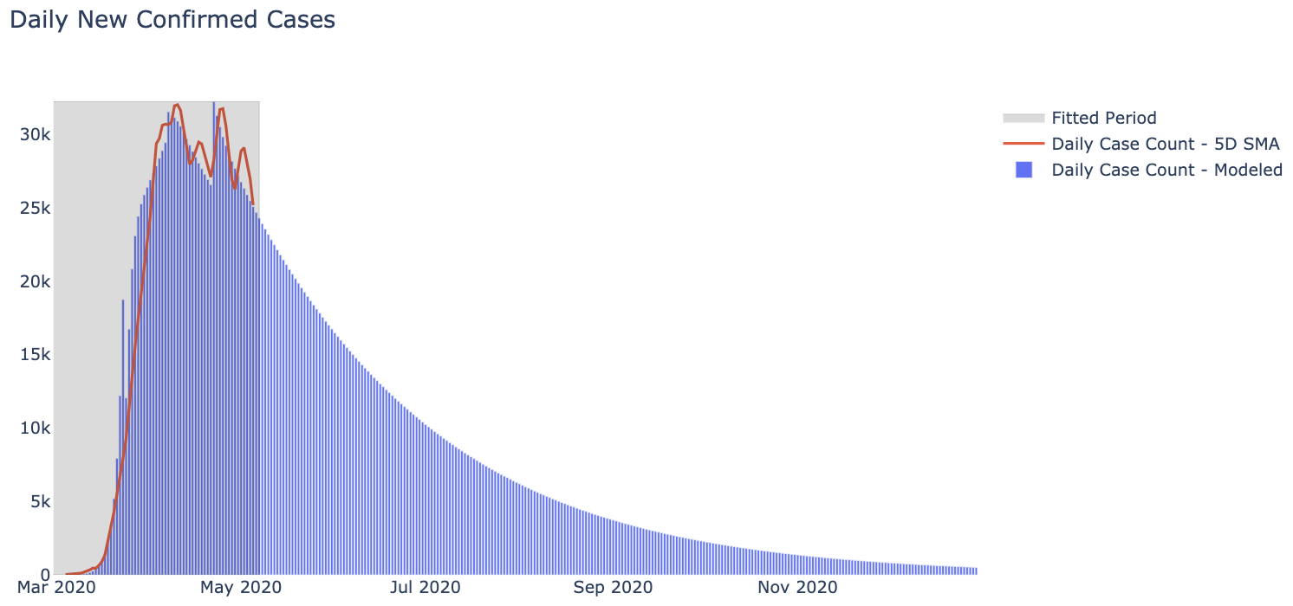

*Exhibit 2*

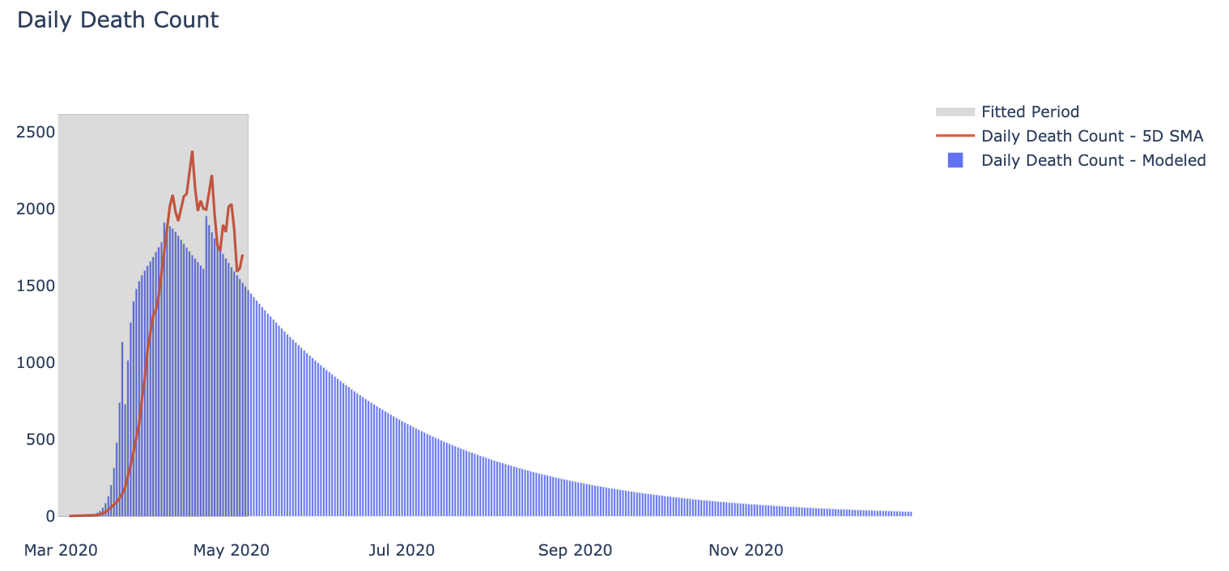

1. Information about the compartment model can be found here, including required assumptions<https://www.ncbi.nlm.nih.gov/pmc/articles/PMC6332839/>
2. IHME model estimates can be found here <https://covid19.healthdata.org/united-states-of-america>