CSC 453 Database Technologies 901/910

Assignment 1 (4/3)
Due 5:45pm, Friday 4/11.
Reading: In Elmasri and Navathe (sixth edition), Sections 1.1-1.9, Sections 2.1-2.2, Section 7.1, Sections 3.1-3.3, Sections 4.1-4.4, and Section 5.4. Also read the posted Course Syllabus and CDM Oracle Tutorial, and DePaul's Academic Integrity Policy.
Your task in this assignment is to set up a connection to cdmoracledb.cti.depaul.edu with SQLDeveloper and write an SQL script to create and populate a small database consisting of four linked relations.
Steps:
0. First, verify your CSTCIS username at https://accountactivate.cdm.depaul.edu/. Run SQLDeveloper and create a new connection to cdmoracledb.cti.depaul.edu (140.192.30.211). Change your password using the command ALTER USER username IDENTIFIED BY newpassword. (You fill in your own username and newpassword.) I strongly recommend that try to establish a connection to cdmoracledb.cti.depaul.edu as soon as possible so that you have time to work out any problems that arise with your account and password.
Next, write a script to do the following (I recommend that you do this one part at a time, testing the partial results by running the script in SQLDeveloper and inspecting the tables):

1. Create a relational database schema consisting of the four relation schemas given in the diagram below, representing various entities recorded by a furniture company. Define all necessary attributes, domains, and primary and foreign keys.
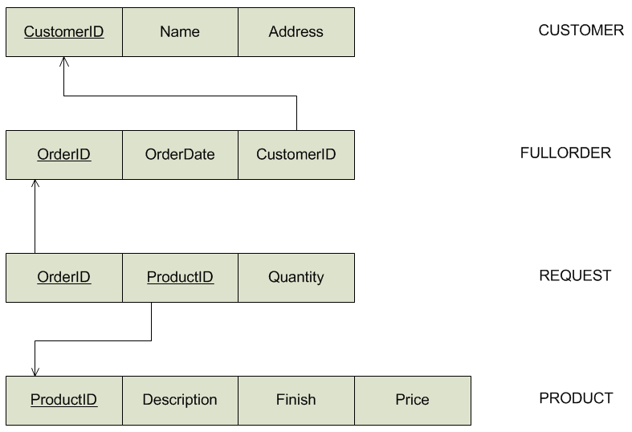
You should assume the following: Each CustomerID is a number with at most three digits, each OrderID is a number with at most four digits, and each ProductID is a number with at most two digits. Each Name is at most 32 characters long, and each Address is at most 16 characters long. Each Quantity is a positive whole number between 1 and 100, inclusive. Each Description is at most 30 characters long, and each Finish is at most 10 characters long. Each Price is a non-negative value (zero is allowed) representing a price in dollars and cents that cannot exceed 999.99.
In order to avoid conflicts, include DROP TABLE commands for all four tables before your CREATE TABLE statements. Either drop tables containing foreign keys before the tables containing the referenced primary keys, or use CASCADE CONSTRAINTS. Verify that the tables have been defined correctly before going on to the next step.

2. Populate the database as follows:
CUSTOMER:

CUSTOMERID NAME ADDRESS
---------------------- ------------------------------ --------------------
2 CASUAL FURNITURE PLANO, TX
6 MOUNTAIN GALLERY BOULDER, CO

FULLORDER:

ORDERID ORDERDATE CUSTOMERID
---------------------- ------------------------- ----------------------
1006 24-MAR-10 2
1007 25-MAR-10 6
1008 25-MAR-10 6
1009 26-MAR-10 2

PRODUCT:

PRODUCTID DESCRIPTION FINISH PRICE
---------------------- ------------------------------ ---------- ----------
10 WRITING DESK OAK 425
30 DINING TABLE ASH 600
40 ENTERTAINMENT CENTER MAPLE 650
70 CHILDRENS DRESSER PINE 300

REQUEST:

ORDERID PRODUCTID QUANTITY
---------------------- ---------------------- ----------------------
1006 10 4
1006 30 2
1006 40 1
1007 40 3
1007 70 1
1008 70 1
1009 10 1
1009 40 1
Remember to insert the records containing primary key values before inserting the records containing the foreign keys that reference those values.

3. Display the contents of each table by adding four statements of the form SELECT * FROM TABLE_NAME ; to the end of your script.
4. Include a comment at the top of the script file giving your name, the course number and your section number, the assignment number, and the date of submission, e.g.:
/*
YourName
CSC 453 Section YourSection
Assignment 1
SubmissionDate, 2014
*/
5. Run the complete script and save the contents of the output window to a text file. Be sure that that the contents of the four tables are displayed correctly by your script. (Clear the window before running the script to that only the output of the last run of the script is displayed and saved.)
6. Submit two files to the Assignment 1 dropbox: (1) The .sql file containing Steps 1-4 and (2) the text file containing the output generated by your script in Step 5.

Remarks:
1. There are tools within SQLDeveloper that allow you to build tables row-by-row without writing your own CREATE and INSERT statements and will automatically generate SQL code that would build the table. You may not use these table creation and code generation tools to complete the assignment; you must write the CREATE statements to create the tables yourself and include these statements in your script.
2. For all assignments, it is your responsibility to make sure that the files you have uploaded are readable and in the correct locations. You should always check that you can successfully download your submitted files back from the course web site to be sure that they have been uploaded correctly.
3. Please remember that all work must be completed individually, and without copying from any posted examples.
Eric J. Schwabe – 04/03/14

