CSC 553 Advanced Database Topics
Assignment 4
Due on Sunday, May 17th
- Write some SQL parsing code (it will be very basic for now, but we will extend it further in latter homeworks and reuse it for part of the project). Your code, written in your language of choice, should accept a SQL file with queries as input and output the list of clauses (SELECT, FROM, GROUP BY, HAVING). You can ignore ORDER BY.

Given a file with SQL queries separated by semicolon:

SELECT A, B
FROM T1, T2

WHERE T1.PK = T2.FK AND A > 5;

SELECT Z

FROM T1, T2, T3
WHERE T1.PK = T3.FK
GROUP BY Z;

Your code should output (you can assume that columns and tables are separated by a comma and you can ignore table aliasing such as FROM Table1 AS MyTable, Table2).

Query #1:

SELECT (2 columns): A, B
FROM (2 tables): T1, T2
WHERE: T1.PK = FK AND A > 5

Query #2:

SELECT (1 column): Z
FROM (3 tables): T1, T2, T3
WHERE: T1.PK = T3.FK
GROUP BY (1 column): Z

  - For your reference, here’s a short list of basic Linux commands: http://mally.stanford.edu/~sr/computing/basic-unix.html

  - Login to your Amazon EC2 Instance and install MySQL (you would need to click “y” to confirm. sudo refers to administrator privileges command). It should not interfere with Hadoop if you happen to also be in CSC555 course and using the same instance, though I’d recommend stopping Hadoop (bin/stop-all.sh) while running and timing MySQL.

sudo yum install mysql
sudo yum install mysql-server

(turn on auto start for the database)
sudo chkconfig mysqld on
(start database back end now)
sudo service mysqld start

(set root password to “root”, feel free to change it)
mysqladmin -u root password root
(create a database called csc553_db using the root account. Use “root” or whichever password you have created in the previous step)
mysqladmin -u root -p create csc553_db
(sign in as root, using the same password)
mysql -u root -p

(Use the following commands in MySQL prompt to create permissions for ec2-user in the database. First step gives ec2-user access to the DB and second step allows loading data from file.)
GRANT SELECT, INSERT, UPDATE, DELETE, CREATE, DROP, INDEX, ALTER, LOCK TABLES, CREATE TEMPORARY TABLES ON csc553_db.* TO 'ec2-user'@'localhost' IDENTIFIED BY 'password1';

GRANT FILE ON *.* TO 'ec2-user'@'localhost';

FLUSH PRIVILEGES;

exit

(Last step before moving on is to install a compiler by running the following command)
sudo yum install gcc

  - Get the data generator at http://www.cs.brown.edu/~alexr/CSC553/dbgen.zip. You can get it using wget utility (i.e. wget http://www.cs.brown.edu/~alexr/CSC553/dbgen.zip). Extract the archive using unzip dbgen.zip. Then run make in dbgen directory (you can change to dbgen directory by running cd dbgen and use pwd to check current directory) to compile the data generator and you are ready to generate some data. You can use the following command to generate part table (also discussed in the README, p stands for part, c stands for customer, l stands for lineorder, d for dwdate and s for supplier). For example, ./dbgen -s 1 -T c to generate scale1 customer table. Either copy the data files somewhere (e.g., /tmp/), or note down the current path to these files. Do not forget to rename date.tbl to dwdate.tbl (using mv date.tbl dwdate.tbl).

  - Download the SSBM schema that is located at http://www.cs.brown.edu/~alexr/CSC553/SSBM_schema_mysql.sql
You can download the file using wget directly to your linux instance, and you can load the schema into MySQL by running the following command (you can also paste the CREATE TABLE statements into MySQL prompt, but this is faster). The “<” serves as a redirect, sending contents of SSBM_schema_mysql.sql to mysql.
mysql -p --database=csc553_db < SSBM_schema_mysql.sql
Now, let’s load the data that we have generated in step c). Here are the commands you can use:
First, allow read access to user home directory by running
chmod a+rx /home/ec2-user/

mysql -p --database=csc553_db -e "LOAD DATA INFILE '/home/ec2-user/dbgen/dwdate.tbl' INTO TABLE dwdate FIELDS TERMINATED BY '|'"

if you got bored typing in a password, you can load tables without password using:

mysql -ppassword1 --database=csc553_db -e "LOAD DATA INFILE '/home/ec2-user/dbgen/customer.tbl' INTO TABLE customer FIELDS TERMINATED BY '|'"

Each of the above commands is a single line command and assume that you have placed SSBM data into /home/ec2-user/dbgen/ directory. “|” is the data field separator used by the SSBM generator (i.e., Field1|Field2|Field3).

  - Load the rest of the tables and then you should be able to execute some queries. For this assignment you can focus on the first queries (Q1.1) only, which can be downloaded at http://www.cs.brown.edu/~alexr/CSC553/SSBM_original_queries_flight1_Q1.1.sql. The command line you can use to run it is:

You can execute each query by running:
time mysql -ppassword1 --database=csc553_db < SSBM_original_queries_flight1_Q1.1.sql

“time” will output the time it took to execute the query. The first part (mysql -ppassword1 --database=csc553_db) connects to your database and the latter part (< SSBM_original_queries_flight1_Q1.1.sql) redirect the contents of the SQL file to MySQL.

Execute the same query again – does the runtime of all queries remain the same or not?
Report both runtimes.

  - Finally, create an index (best you can think of) to improve Q1.1 and re-time this query once again.

- Consider a join of relation r and relation s. Suppose that schema for r is (Name, YearOfBirth, Profession) and schema for relation s is (Year, Month, Week, HoroscopeText). Given that n_{r} = 1000 and V(YearOfBirth, r) = 42 and
n_{s} = 500 and V(Year, s) = 10

  - What are the two different estimates for the size of join result of r ⋈_{YearOfBirth=Year} s?

  - Which one is more accurate?

- Recall that an equi-width histogram splits the value range into X equal ranges and fills in each bucket with a count of values within each particular range. An equi-height histogram adjusts the bucket sizes in such a way that every bucket contains the exact same number of values.
Given the following data:
[1, 5, 6, 7, 8, 12, 15, 25, 26, 27, 28, 29, 36, 37, 39, 42]

  - Construct an equi-width histogram (with 4 buckets)

  - Construct an equi-height histogram (also with 4 buckets)

  - Given an equi-width histogram from a), update it to reflect insertion of 16,17,18 and 21

  - Given an equi-height histogram from b), update it to reflect insertion of 16,17,18 and 21

- Consider the following histogram that represents Hours column 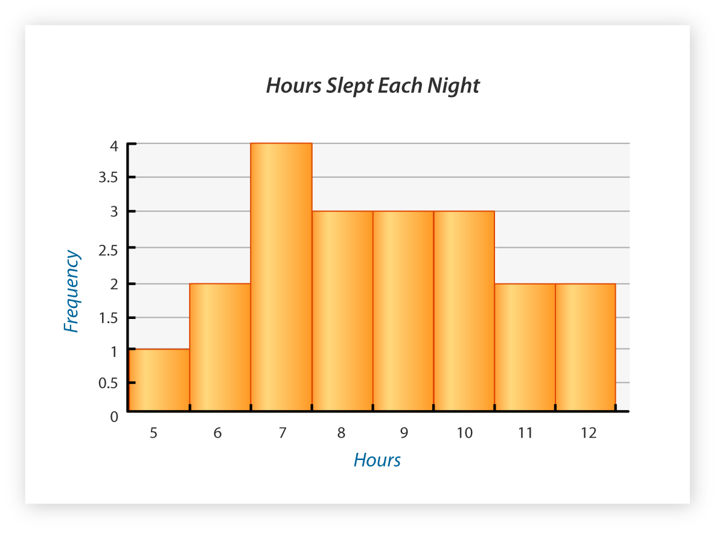
  - What is the answer to SELECT MAX(Hours) FROM SleepTable?

  - What is the answer to SELECT DISTINCT Hours FROM SleepTable?

  - What is the answer to SELECT COUNT(*) WHERE Hours = 11?

  - What is the answer to SELECT COUNT(*) WHERE Hours BETWEEN 7 and 10?

Submit a single document containing your written answers. Be sure that this document contains your name and “CSC 553 Assignment 4” at the top.

