**Practical – 2**

Windows

To install Android Studio on Windows, follow these steps:

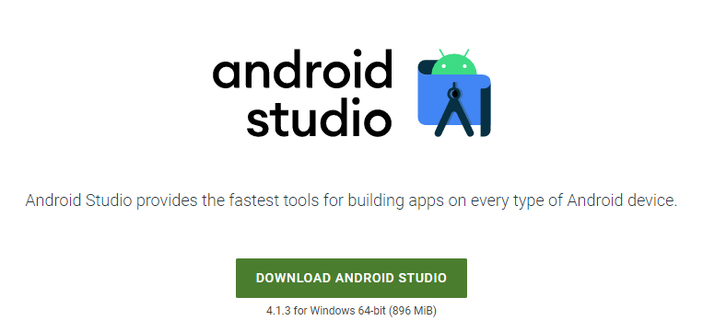

If you downloaded an .exe file (recommended), double-click to launch it.

If you downloaded a .zip file:

Unpack the .zip.

Copy the android-studio folder into your Program Files folder.

Open the android-studio > bin folder.

Launch studio64.exe (for 64-bit machines) or studio.exe (for 32-bit machines).

Follow the Setup Wizard in Android Studio and install any recommended SDK packages.

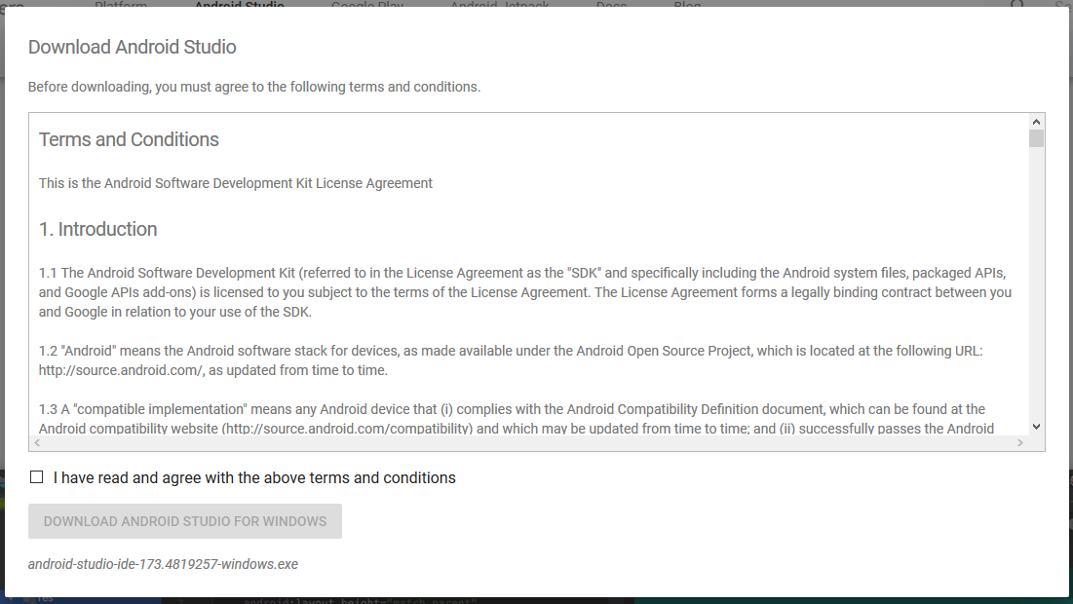

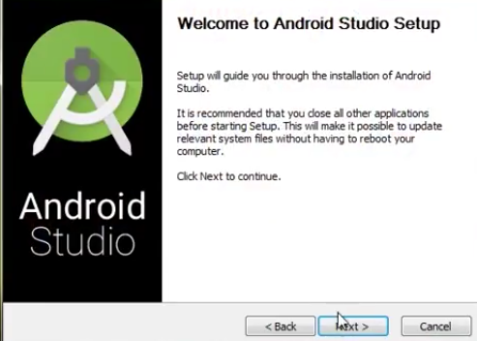



These Steps are for Windows Operating System.

Similar Steps are available from Android Studio’s Official Website i.e. <https://developer.android.com/studio/install>

Android Architecture Diagram as shown below

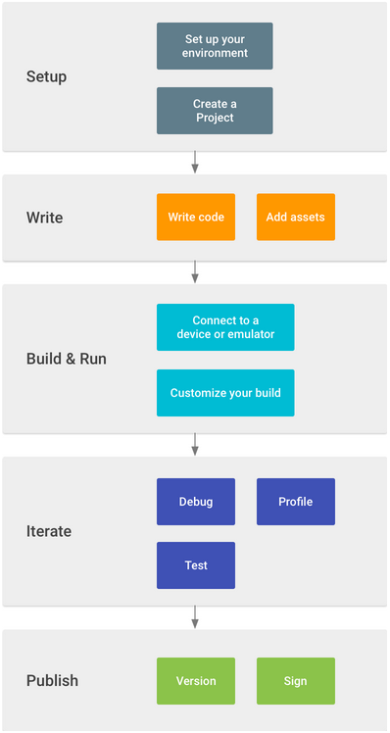

**AndroidManifest.xml**

The AndroidManifest.xml file contains information of your package, including components of the application such as activities, services, broadcast receivers, content providers etc. This is the required xml file for all the android application and located inside the root directory. It performs some other tasks like:

o It is responsible to protect the application to access any protected parts by providing the permissions.

o It also declares the android API that the application is going to use.

o It lists the instrumentation classes. The instrumentation classes provide profiling and other information. These information’s are removed just before the application is published etc.

The activity_main.xml file is where we style what the user sees and interacts with when they are viewing the welcome page of our app. As the filename specifies, layouts in Android are written in eXtensible Markup Language (XML).

**Java Class**

A class is a user-defined blueprint or prototype from which objects are created. It represents the set of properties or methods that are common to all objects of one type. In general, java class declarations can include components like modifiers, class keywords, class name, interfaces and body.

**By:**

Devdeepsinh Zala [20BCM015]