**Practical – 5**

Practical 5A

Aim: Develop a native calculator application.

*MainActivity.java file:*

package com.example.practical_5a;  
  
import androidx.appcompat.app.AppCompatActivity;  
  
import android.os.Bundle;  
import android.renderscript.Script;  
import android.view.View;  
import android.widget.Button;  
import android.widget.TextView;  
  
import com.fathzer.soft.javaluator.DoubleEvaluator;  
  
public class MainActivity extends AppCompatActivity {  
  
 private Button btn1, btn2, btn3, btn4, btn5, btn6, btn7, btn8, btn9, btn0, btnAdd, btnSub, btnMul, btnDiv, btnEqual, btnClear, btnDot, btnmod, btnbck;  
 private TextView txt;  
 private double result;  
  
 public void setinit(){  
 btn0 = findViewById(R.id.*b0*);  
 btn1 = findViewById(R.id.*b1*);  
 btn2 = findViewById(R.id.*b2*);  
 btn3 = findViewById(R.id.*b3*);  
 btn4 = findViewById(R.id.*b4*);  
 btn5 = findViewById(R.id.*b5*);  
 btn6 = findViewById(R.id.*b6*);  
 btn7 = findViewById(R.id.*b7*);  
 btn8 = findViewById(R.id.*b8*);  
 btn9 = findViewById(R.id.*b9*);  
 btnAdd = findViewById(R.id.*bplus*);  
 btnSub = findViewById(R.id.*bsub*);  
 btnMul = findViewById(R.id.*bmul*);  
 btnDiv = findViewById(R.id.*bdiv*);  
 btnEqual = findViewById(R.id.*beql*);  
 btnClear = findViewById(R.id.*bcls*);  
 btnDot = findViewById(R.id.*bdot*);  
 btnmod = findViewById(R.id.*btnmod*);  
 btnbck = findViewById(R.id.*btnback*);  
 result = 0;  
  
 txt = findViewById(R.id.*mainscr*);  
 }  
  
 @Override  
 protected void onCreate(Bundle savedInstanceState) {  
 super.onCreate(savedInstanceState);  
 setContentView(R.layout.*activity_main*);  
 setinit();  
  
 btn0.setOnClickListener(new View.OnClickListener() {  
 @Override  
 public void onClick(View v) {  
 String a = txt.getText().toString();  
 txt.setText(a+"0");  
 }  
 });  
 btn1.setOnClickListener(new View.OnClickListener() {  
 @Override  
 public void onClick(View v) {  
 String a = txt.getText().toString();  
 txt.setText(a+"1");  
 }  
 });  
 btn2.setOnClickListener(new View.OnClickListener() {  
 @Override  
 public void onClick(View v) {  
 String a = txt.getText().toString();  
 txt.setText(a+"2");  
 }  
 });  
 btn3.setOnClickListener(new View.OnClickListener() {  
 @Override  
 public void onClick(View v) {  
 String a = txt.getText().toString();  
 txt.setText(a+"3");  
 }  
 });  
 btn4.setOnClickListener(new View.OnClickListener() {  
 @Override  
 public void onClick(View v) {  
 String a = txt.getText().toString();  
 txt.setText(a+"4");  
 }  
 });  
 btn5.setOnClickListener(new View.OnClickListener() {  
 @Override  
 public void onClick(View v) {  
 String a = txt.getText().toString();  
 txt.setText(a+"5");  
 }  
 });  
 btn6.setOnClickListener(new View.OnClickListener() {  
 @Override  
 public void onClick(View v) {  
 String a = txt.getText().toString();  
 txt.setText(a+"6");  
 }  
 });  
 btn7.setOnClickListener(new View.OnClickListener() {  
 @Override  
 public void onClick(View v) {  
 String a = txt.getText().toString();  
 txt.setText(a+"7");  
 }  
 });  
 btn8.setOnClickListener(new View.OnClickListener() {  
 @Override  
 public void onClick(View v) {  
 String a = txt.getText().toString();  
 txt.setText(a+"8");  
 }  
 });  
 btn9.setOnClickListener(new View.OnClickListener() {  
 @Override  
 public void onClick(View v) {  
 String a = txt.getText().toString();  
 txt.setText(a+"9");  
 }  
 });  
 btnDot.setOnClickListener(new View.OnClickListener() {  
 @Override  
 public void onClick(View v) {  
 String a = txt.getText().toString();  
 txt.setText(a+".");  
 }  
 });  
 btnAdd.setOnClickListener(new View.OnClickListener() {  
 @Override  
 public void onClick(View v) {  
 String a = txt.getText().toString();  
 txt.setText(a+"+");  
 }  
 });  
 btnSub.setOnClickListener(new View.OnClickListener() {  
 @Override  
 public void onClick(View v) {  
 String a = txt.getText().toString();  
 txt.setText(a+"-");  
 }  
 });  
 btnMul.setOnClickListener(new View.OnClickListener() {  
 @Override  
 public void onClick(View v) {  
 String a = txt.getText().toString();  
 txt.setText(a+"*");  
 }  
 });  
 btnDiv.setOnClickListener(new View.OnClickListener() {  
 @Override  
 public void onClick(View v) {  
 String a = txt.getText().toString();  
 txt.setText(a+"/");  
 }  
 });  
 btnClear.setOnClickListener(new View.OnClickListener() {  
 @Override  
 public void onClick(View v) {  
 txt.setText("");  
 result = 0;  
 }  
 });  
 btnEqual.setOnClickListener(new View.OnClickListener() {  
 @Override  
 public void onClick(View v) {  
 String exp = txt.getText().toString();  
 DoubleEvaluator ev = new DoubleEvaluator();  
 result = ev.evaluate(exp);  
  
 txt.setText(Double.*toString*(result));  
 }  
 });  
 btnmod.setOnClickListener(new View.OnClickListener() {  
 @Override  
 public void onClick(View v) {  
 String a = txt.getText().toString();  
 txt.setText(a+"%");  
 }  
 });  
 btnbck.setOnClickListener(new View.OnClickListener() {  
 @Override  
 public void onClick(View v) {  
 String a ,a1 ;  
 a = txt.getText().toString();  
 if(!a.equals("")) {  
 a1 = a.substring(0, a.length() - 1);  
 txt.setText(a1);  
 }  
 }  
 });  
 }  
}

*activity_main.xml file:*

<?xml version="1.0" encoding="utf-8"?>  
<androidx.constraintlayout.widget.ConstraintLayout xmlns:android="http://schemas.android.com/apk/res/android"  
 xmlns:app="http://schemas.android.com/apk/res-auto"  
 xmlns:tools="http://schemas.android.com/tools"  
 android:layout_width="match_parent"  
 android:layout_height="match_parent"  
 tools:context=".MainActivity">  
  
 <TextView  
 android:id="@+id/mainscr"  
 android:layout_width="380dp"  
 android:layout_height="50dp"  
 android:background="#808080"  
 android:gravity="right"  
 android:hint="CALCULATOR"  
 android:textSize="35sp"  
 app:layout_constraintBottom_toBottomOf="parent"  
 app:layout_constraintEnd_toEndOf="parent"  
 app:layout_constraintHorizontal_bias="0.498"  
 app:layout_constraintStart_toStartOf="parent"  
 app:layout_constraintTop_toTopOf="parent"  
 app:layout_constraintVertical_bias="0.056" />  
  
 <Button  
 android:id="@+id/b0"  
 android:layout_width="70sp"  
 android:layout_height="80sp"  
 android:backgroundTint="#989696"  
 android:text="0"  
 android:textSize="44sp"  
 app:cornerRadius="40dp"  
 app:layout_constraintBottom_toBottomOf="parent"  
 app:layout_constraintEnd_toEndOf="parent"  
 app:layout_constraintHorizontal_bias="0.36"  
 app:layout_constraintStart_toStartOf="parent"  
 app:layout_constraintTop_toTopOf="parent"  
 app:layout_constraintVertical_bias="0.97" />  
  
 <Button  
 android:id="@+id/bdot"  
 android:layout_width="70sp"  
 android:layout_height="80sp"  
 android:backgroundTint="#989696"  
 android:text="."  
 android:textSize="44sp"  
 app:cornerRadius="40dp"  
 app:layout_constraintBottom_toBottomOf="parent"  
 app:layout_constraintEnd_toEndOf="parent"  
 app:layout_constraintHorizontal_bias="0.639"  
 app:layout_constraintStart_toStartOf="parent"  
 app:layout_constraintTop_toTopOf="parent"  
 app:layout_constraintVertical_bias="0.97" />  
  
 <Button  
 android:id="@+id/bcls"  
 android:layout_width="70sp"  
 android:layout_height="80sp"  
 android:backgroundTint="#989696"  
 android:text="CLS"  
 android:textSize="44sp"  
 app:cornerRadius="40dp"  
 app:layout_constraintBottom_toBottomOf="parent"  
 app:layout_constraintEnd_toEndOf="parent"  
 app:layout_constraintHorizontal_bias="0.09"  
 app:layout_constraintStart_toStartOf="parent"  
 app:layout_constraintTop_toTopOf="parent"  
 app:layout_constraintVertical_bias="0.485" />  
  
 <Button  
 android:id="@+id/b7"  
 android:layout_width="70sp"  
 android:layout_height="80sp"  
 android:backgroundTint="#989696"  
 android:text="7"  
 android:textSize="44sp"  
 app:cornerRadius="40dp"  
 app:layout_constraintBottom_toBottomOf="parent"  
 app:layout_constraintEnd_toEndOf="parent"  
 app:layout_constraintHorizontal_bias="0.09"  
 app:layout_constraintStart_toStartOf="parent"  
 app:layout_constraintTop_toTopOf="parent"  
 app:layout_constraintVertical_bias="0.611" />  
  
 <Button  
 android:id="@+id/b8"  
 android:layout_width="70sp"  
 android:layout_height="80sp"  
 android:backgroundTint="#989696"  
 android:text="8"  
 android:textSize="44sp"  
 app:cornerRadius="40dp"  
 app:layout_constraintBottom_toBottomOf="parent"  
 app:layout_constraintEnd_toEndOf="parent"  
 app:layout_constraintHorizontal_bias="0.36"  
 app:layout_constraintStart_toStartOf="parent"  
 app:layout_constraintTop_toTopOf="parent"  
 app:layout_constraintVertical_bias="0.611" />  
  
 <Button  
 android:id="@+id/b9"  
 android:layout_width="70sp"  
 android:layout_height="80sp"  
 android:backgroundTint="#989696"  
 android:text="9"  
 android:textSize="44sp"  
 app:cornerRadius="40dp"  
 app:layout_constraintBottom_toBottomOf="parent"  
 app:layout_constraintEnd_toEndOf="parent"  
 app:layout_constraintHorizontal_bias="0.639"  
 app:layout_constraintStart_toStartOf="parent"  
 app:layout_constraintTop_toTopOf="parent"  
 app:layout_constraintVertical_bias="0.611" />  
  
 <Button  
 android:id="@+id/b4"  
 android:layout_width="70sp"  
 android:layout_height="80sp"  
 android:backgroundTint="#989696"  
 android:text="4"  
 android:textSize="44sp"  
 app:cornerRadius="40dp"  
 app:layout_constraintBottom_toBottomOf="parent"  
 app:layout_constraintEnd_toEndOf="parent"  
 app:layout_constraintHorizontal_bias="0.09"  
 app:layout_constraintStart_toStartOf="parent"  
 app:layout_constraintTop_toTopOf="parent"  
 app:layout_constraintVertical_bias="0.738" />  
  
 <Button  
 android:id="@+id/b5"  
 android:layout_width="70sp"  
 android:layout_height="80sp"  
 android:backgroundTint="#989696"  
 android:text="5"  
 android:textSize="44sp"  
 app:cornerRadius="40dp"  
 app:layout_constraintBottom_toBottomOf="parent"  
 app:layout_constraintEnd_toEndOf="parent"  
 app:layout_constraintHorizontal_bias="0.36"  
 app:layout_constraintStart_toStartOf="parent"  
 app:layout_constraintTop_toTopOf="parent"  
 app:layout_constraintVertical_bias="0.738" />  
  
 <Button  
 android:id="@+id/b6"  
 android:layout_width="70sp"  
 android:layout_height="80sp"  
 android:backgroundTint="#989696"  
 android:text="6"  
 android:textSize="44sp"  
 app:cornerRadius="40dp"  
 app:layout_constraintBottom_toBottomOf="parent"  
 app:layout_constraintEnd_toEndOf="parent"  
 app:layout_constraintHorizontal_bias="0.639"  
 app:layout_constraintStart_toStartOf="parent"  
 app:layout_constraintTop_toTopOf="parent"  
 app:layout_constraintVertical_bias="0.73" />  
  
 <Button  
 android:id="@+id/b1"  
 android:layout_width="70sp"  
 android:layout_height="80sp"  
 android:backgroundTint="#989696"  
 android:text="1"  
 android:textSize="44sp"  
 app:cornerRadius="40dp"  
 app:layout_constraintBottom_toBottomOf="parent"  
 app:layout_constraintEnd_toEndOf="parent"  
 app:layout_constraintHorizontal_bias="0.09"  
 app:layout_constraintStart_toStartOf="parent"  
 app:layout_constraintTop_toTopOf="parent"  
 app:layout_constraintVertical_bias="0.856" />  
  
 <Button  
 android:id="@+id/b2"  
 android:layout_width="70sp"  
 android:layout_height="80sp"  
 android:text="2"  
 android:textSize="44sp"  
 app:cornerRadius="40dp"  
 app:layout_constraintBottom_toBottomOf="parent"  
 app:layout_constraintEnd_toEndOf="parent"  
 app:layout_constraintHorizontal_bias="0.36"  
 app:layout_constraintStart_toStartOf="parent"  
 app:layout_constraintTop_toTopOf="parent"  
 app:layout_constraintVertical_bias="0.856"  
 android:backgroundTint="#989696" />  
  
 <Button  
 android:id="@+id/b3"  
 android:layout_width="70sp"  
 android:layout_height="80sp"  
 android:backgroundTint="#989696"  
 android:text="3"  
 android:textSize="44sp"  
 app:cornerRadius="40dp"  
 app:layout_constraintBottom_toBottomOf="parent"  
 app:layout_constraintEnd_toEndOf="parent"  
 app:layout_constraintHorizontal_bias="0.618"  
 app:layout_constraintStart_toStartOf="parent"  
 app:layout_constraintTop_toTopOf="parent"  
 app:layout_constraintVertical_bias="0.856" />  
  
 <Button  
 android:id="@+id/bplus"  
 android:layout_width="70sp"  
 android:layout_height="80sp"  
 android:backgroundTint="#989696"  
 android:text="+"  
 android:textSize="44sp"  
 app:cornerRadius="40dp"  
 app:layout_constraintBottom_toBottomOf="parent"  
 app:layout_constraintEnd_toEndOf="parent"  
 app:layout_constraintHorizontal_bias="0.903"  
 app:layout_constraintStart_toStartOf="parent"  
 app:layout_constraintTop_toTopOf="parent"  
 app:layout_constraintVertical_bias="0.856" />  
  
 <Button  
 android:id="@+id/bsub"  
 android:layout_width="70sp"  
 android:layout_height="80sp"  
 android:backgroundTint="#989696"  
 android:text="-"  
 android:textSize="44sp"  
 app:cornerRadius="40dp"  
 app:layout_constraintBottom_toBottomOf="parent"  
 app:layout_constraintEnd_toEndOf="parent"  
 app:layout_constraintHorizontal_bias="0.903"  
 app:layout_constraintStart_toStartOf="parent"  
 app:layout_constraintTop_toTopOf="parent"  
 app:layout_constraintVertical_bias="0.73" />  
  
 <Button  
 android:id="@+id/bdiv"  
 android:layout_width="70sp"  
 android:layout_height="80sp"  
 android:backgroundTint="#989696"  
 android:text="/"  
 android:textSize="44sp"  
 app:cornerRadius="40dp"  
 app:layout_constraintBottom_toBottomOf="parent"  
 app:layout_constraintEnd_toEndOf="parent"  
 app:layout_constraintHorizontal_bias="0.903"  
 app:layout_constraintStart_toStartOf="parent"  
 app:layout_constraintTop_toTopOf="parent"  
 app:layout_constraintVertical_bias="0.486" />  
  
 <Button  
 android:id="@+id/bmul"  
 android:layout_width="70sp"  
 android:layout_height="80sp"  
 android:backgroundTint="#989696"  
 android:text="*"  
 android:textSize="44sp"  
 app:cornerRadius="40dp"  
 app:layout_constraintBottom_toBottomOf="parent"  
 app:layout_constraintEnd_toEndOf="parent"  
 app:layout_constraintHorizontal_bias="0.903"  
 app:layout_constraintStart_toStartOf="parent"  
 app:layout_constraintTop_toTopOf="parent"  
 app:layout_constraintVertical_bias="0.611" />  
  
 <Button  
 android:id="@+id/beql"  
 android:layout_width="70sp"  
 android:layout_height="80sp"  
 android:backgroundTint="#989696"  
 android:text="="  
 android:textSize="44sp"  
 app:cornerRadius="40dp"  
 app:layout_constraintBottom_toBottomOf="parent"  
 app:layout_constraintEnd_toEndOf="parent"  
 app:layout_constraintHorizontal_bias="0.903"  
 app:layout_constraintStart_toStartOf="parent"  
 app:layout_constraintTop_toTopOf="parent"  
 app:layout_constraintVertical_bias="0.97" />  
  
 <Button  
 android:id="@+id/btnmod"  
 android:layout_width="70sp"  
 android:layout_height="80sp"  
 android:backgroundTint="#989696"  
 android:text="%"  
 android:textSize="44sp"  
 app:cornerRadius="40dp"  
 app:layout_constraintBottom_toBottomOf="parent"  
 app:layout_constraintEnd_toEndOf="parent"  
 app:layout_constraintHorizontal_bias="0.639"  
 app:layout_constraintStart_toStartOf="parent"  
 app:layout_constraintTop_toTopOf="parent"  
 app:layout_constraintVertical_bias="0.485" />  
  
 <Button  
 android:id="@+id/btnback"  
 android:layout_width="70sp"  
 android:layout_height="80sp"  
 android:backgroundTint="#989696"  
 android:text="←"  
 android:textSize="40sp"  
 app:cornerRadius="40dp"  
 app:layout_constraintBottom_toBottomOf="parent"  
 app:layout_constraintEnd_toEndOf="parent"  
 app:layout_constraintHorizontal_bias="0.36"  
 app:layout_constraintStart_toStartOf="parent"  
 app:layout_constraintTop_toTopOf="parent"  
 app:layout_constraintVertical_bias="0.485" />  
</androidx.constraintlayout.widget.ConstraintLayout>

*AndroidManifest.xml*

<?xml version="1.0" encoding="utf-8"?>  
<manifest xmlns:android="http://schemas.android.com/apk/res/android"  
 xmlns:tools="http://schemas.android.com/tools">  
  
 <application  
 android:allowBackup="true"  
 android:dataExtractionRules="@xml/data_extraction_rules"  
 android:fullBackupContent="@xml/backup_rules"  
 android:icon="@mipmap/ic_launcher"  
 android:label="@string/app_name"  
 android:roundIcon="@mipmap/ic_launcher_round"  
 android:supportsRtl="true"  
 android:theme="@style/Theme.Practical_5A"  
 tools:targetApi="31">  
 <activity  
 android:name=".MainActivity"  
 android:exported="true">  
 <intent-filter>  
 <action android:name="android.intent.action.MAIN" />  
  
 <category android:name="android.intent.category.LAUNCHER" />  
 </intent-filter>  
  
 <meta-data  
 android:name="android.app.lib_name"  
 android:value="" />  
 </activity>  
 </application>  
  
</manifest>

*Screenshot:*

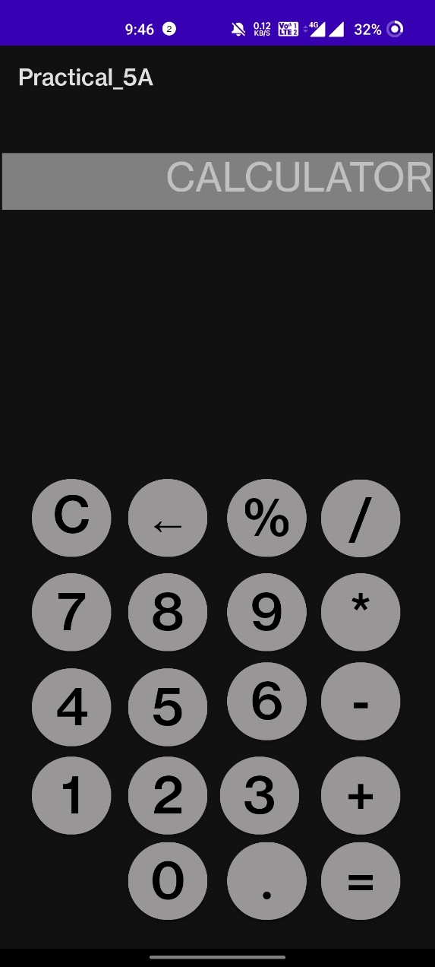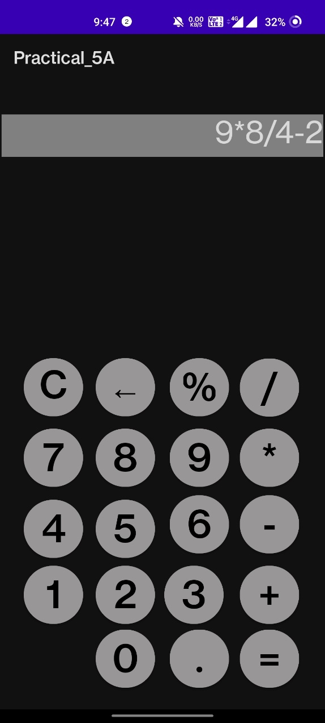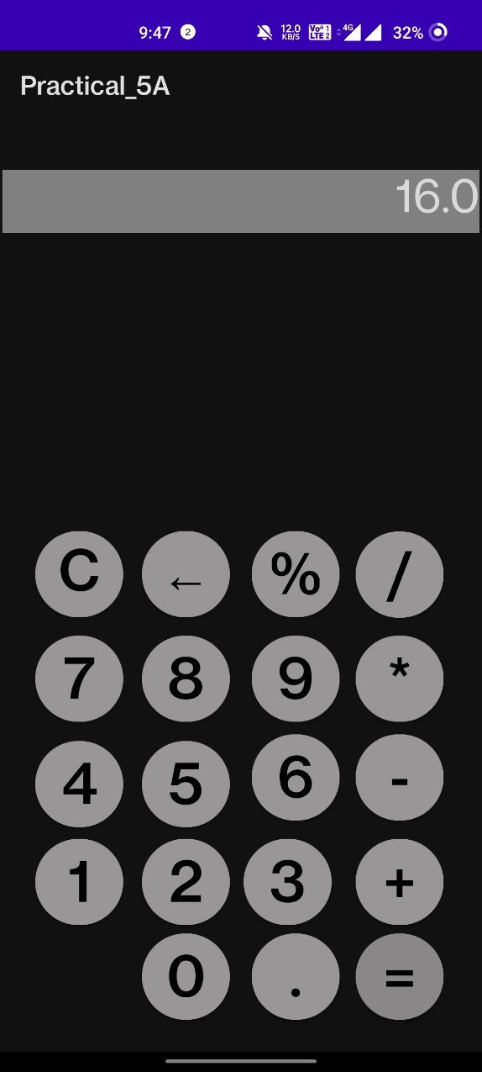

Practical 5B

Aim: Create an application that takes the name from a text box and shows a hello message along with the name entered in text box, when the user clicks the OK button

*Activity_main.java file:*

package com.example.practical_5b;  
  
import androidx.appcompat.app.AppCompatActivity;  
  
import android.content.Intent;  
import android.os.Bundle;  
import android.view.View;  
import android.widget.Button;  
import android.widget.TextView;  
  
import org.w3c.dom.Text;  
  
public class MainActivity extends AppCompatActivity {  
  
 private TextView txt,txt2;  
 private Button btn;  
  
 @Override  
 protected void onCreate(Bundle savedInstanceState) {  
 super.onCreate(savedInstanceState);  
 setContentView(R.layout.*activity_main*);  
  
 txt = findViewById(R.id.*edttxt*);  
  
 btn = findViewById(R.id.*btn*);  
 btn.setOnClickListener(new View.OnClickListener() {  
 @Override  
 public void onClick(View v) {  
 Intent it =new Intent(MainActivity.this,secondact.class);  
 it.putExtra("name",txt.getText().toString());  
 startActivity(it);  
 }  
 });  
 }  
}

*secondact.java file:*

package com.example.practical_5b;  
  
import androidx.appcompat.app.AppCompatActivity;  
  
import android.os.Bundle;  
import android.widget.TextView;  
  
public class secondact extends AppCompatActivity {  
  
 @Override  
 protected void onCreate(Bundle savedInstanceState) {  
 super.onCreate(savedInstanceState);  
 setContentView(R.layout.activity_secondact);  
  
 Bundle et = getIntent().getExtras();  
 String a = et.getString("name");  
  
 TextView txt = findViewById(R.id.txt);  
 txt.setText(txt.getText().toString()+" "+a);  
 }  
}

*activity_main.xml file:*

<?xml version="1.0" encoding="utf-8"?>  
<androidx.constraintlayout.widget.ConstraintLayout xmlns:android="http://schemas.android.com/apk/res/android"  
 xmlns:app="http://schemas.android.com/apk/res-auto"  
 xmlns:tools="http://schemas.android.com/tools"  
 android:layout_width="match_parent"  
 android:layout_height="match_parent"  
 tools:context=".MainActivity">  
  
 <EditText  
 android:id="@+id/edttxt"  
 android:layout_width="wrap_content"  
 android:layout_height="wrap_content"  
 android:layout_marginTop="116dp"  
 android:ems="10"  
 android:inputType="textPersonName"  
 android:hint="@string/name"  
 app:layout_constraintEnd_toEndOf="parent"  
 app:layout_constraintHorizontal_bias="0.497"  
 app:layout_constraintStart_toStartOf="parent"  
 app:layout_constraintTop_toTopOf="parent" />  
  
 <Button  
 android:id="@+id/btn"  
 android:layout_width="wrap_content"  
 android:layout_height="wrap_content"  
 android:text="@string/ok"  
 app:layout_constraintEnd_toEndOf="parent"  
 app:layout_constraintStart_toStartOf="parent"  
 app:layout_constraintTop_toBottomOf="@+id/edttxt" />  
  
</androidx.constraintlayout.widget.ConstraintLayout>

*AndroidManifest.xml*

<?xml version="1.0" encoding="utf-8"?>  
<manifest xmlns:android="http://schemas.android.com/apk/res/android"  
 xmlns:tools="http://schemas.android.com/tools">  
  
 <application  
 android:allowBackup="true"  
 android:dataExtractionRules="@xml/data_extraction_rules"  
 android:fullBackupContent="@xml/backup_rules"  
 android:icon="@mipmap/ic_launcher"  
 android:label="@string/app_name"  
 android:roundIcon="@mipmap/ic_launcher_round"  
 android:supportsRtl="true"  
 android:theme="@style/Theme.Practical_5B"  
 tools:targetApi="31">  
 <activity  
 android:name=".secondact"  
 android:exported="false">  
 <meta-data  
 android:name="android.app.lib_name"  
 android:value="" />  
 </activity>  
 <activity  
 android:name=".MainActivity"  
 android:exported="true">  
 <intent-filter>  
 <action android:name="android.intent.action.MAIN" />  
  
 <category android:name="android.intent.category.LAUNCHER" />  
 </intent-filter>  
  
 <meta-data  
 android:name="android.app.lib_name"  
 android:value="" />  
 </activity>  
 </application>  
  
</manifest>

*Screenshot:*

