Zeeshan Alam

1001577559

**Development Phase I: Search**

As I discussed earlier in other project phases my topic for the project is Job Search, it’s a mobile application specifically android for now which might change in near to both android and iOS Application. The name for the android application is Bolt, which will help people search for their jobs according to their compatibility and their choices.  
  
**Previous Sketches:**

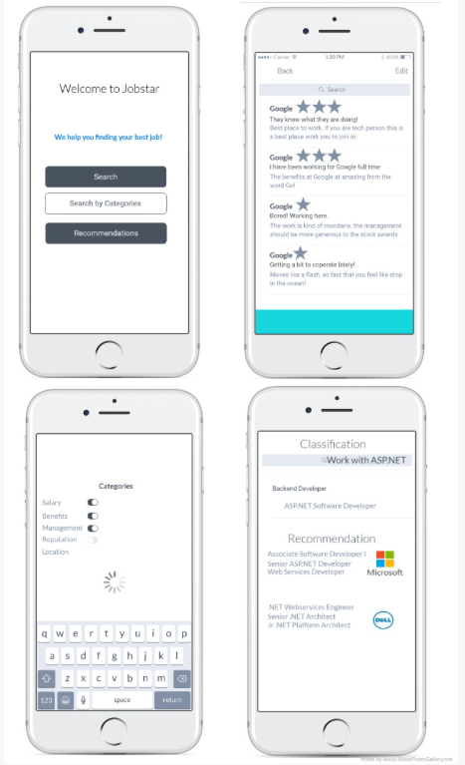

For the search feature I have developed backend python web service which is going to cater all the search logic using TFID. I have used SKlearn and NLTK package to help me develop the search engine on python backend. The mobile application is made in android-sdk built in Java programming language.

**Android Screen-shot:**

References:

<https://medium.freecodecamp.org/how-to-process-textual-data-using-tf-idf-in-python-cd2bbc0a94a3>

<https://towardsdatascience.com/tfidf-for-piece-of-text-in-python-43feccaa74f8>

<https://scikit-learn.org/stable/modules/generated/sklearn.feature_extraction.text.TfidfVectorizer.html>

<https://github.com/Heetmadhu/Movie-Recommendation/blob/master/MovieSearch.ipynb>