**Module (jQuery Basic, Effects & Advanced) – 5**

**1.** What is jQuery?

ANS : jQuery is a JavaScript Library.

jQuery greatly simplifies JavaScript programming.

jQuery is easy to learn.

2. How to Apply CSS Using jQuery, How to Add Class and Remove Class in

jQuery , jQuery Animation?

ANS :

Apply CSS :

<!DOCTYPE html>

<html lang="en">

<head>

    <meta charset="UTF-8">

    <meta name="viewport" content="width=device-width, initial-scale=1.0">

    <title>Document</title>

    <link rel="stylesheet" href="https://cdnjs.cloudflare.com/ajax/libs/jquery/3.7.0/jquery.min.js">

</head>

<body>

<h2>This is a heading</h2>

<p style="background-color:#ff0000">Hello.</p>

<p style="background-color:#00ff00">My Name is Mahesh.</p>

<p style="background-color:#0000ff">I am a full stack developer.</p>

<button>Return background-color of p</button>

<script>

$(document).ready(function(){

  $("button").click(function(){

    alert("Background color = " + $("p").css("background-color"));

  });

});

</script>

</body>

</html>

Output:

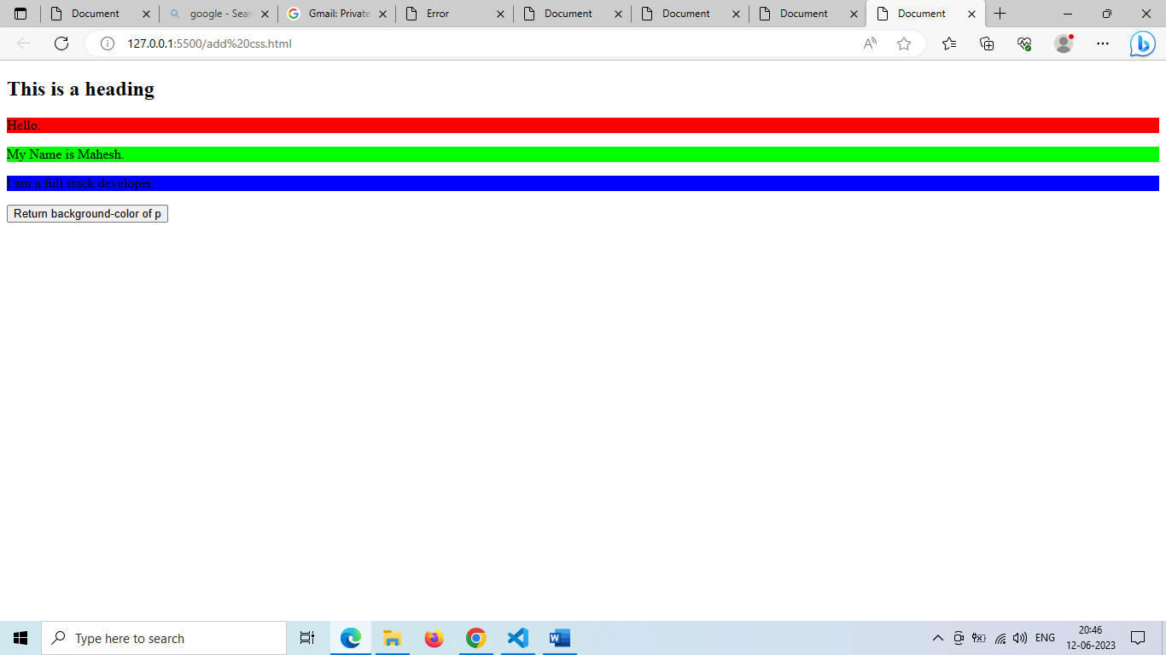

Add class :

<!DOCTYPE html>

<html lang="en">

<head>

    <meta charset="UTF-8">

    <meta name="viewport" content="width=device-width, initial-scale=1.0">

    <title>Document</title>

    <link rel="stylesheet" href="https://cdnjs.cloudflare.com/ajax/libs/jquery/3.7.0/jquery.min.js">

</head>

<body>

    <h1>Mahesh Zala</h1>

    <h2>MAnoj Patel</h2>

    <p>this is first paragraph</p>

    <p>This is another paragraph.</p>

    <div>This is some important text!</div><br>

    <button>Add classes to elements</button>

<script>

    $(document).ready(function(){

      $("button").click(function(){

        $("h1, h2, p").addClass("blue");

        $("div").addClass("important");

      });

    });

    </script>

    <style>

    .important {

      font-weight: bold;

      font-size: xx-large;

    }

    .blue {

      color: blue;

    }

    </style>

</body>

</html>

Output :

Remove Class :

<!DOCTYPE html>

<html lang="en">

<head>

    <meta charset="UTF-8">

    <meta name="viewport" content="width=device-width, initial-scale=1.0">

    <title>Document</title>

    <link rel="stylesheet" href="https://cdnjs.cloudflare.com/ajax/libs/jquery/3.7.0/jquery.min.js">

</head>

<body>

<h1 class="blue">Heading 1</h1>

<h2 class="blue">Heading 2</h2>

<p class="blue">This is a paragraph.</p>

<p>This is another paragraph.</p>

<button>Remove class from elements</button>

<script>

    $(document).ready(function(){

      $("button").click(function(){

        $("h1, h2, p").removeClass("blue");

      });

    });

    </script>

    <style>

    .blue {

      color: blue;

    }

    </style>

</body>

</html>

Output :

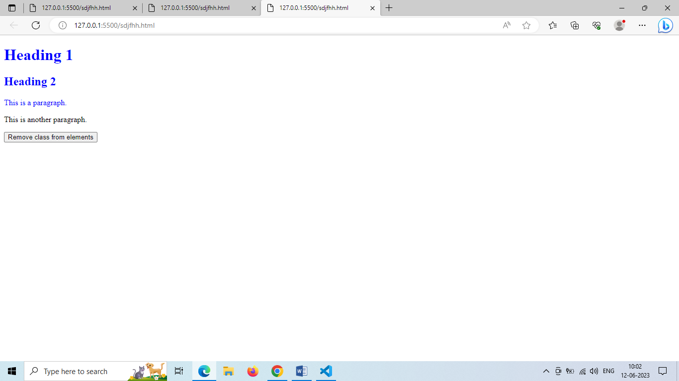

3. How to create slider with animation?

ANS :

<!DOCTYPE html>

<html lang="en">

<head>

    <meta charset="UTF-8">

    <meta name="viewport" content="width=device-width, initial-scale=1.0">

    <title>Document</title>

    <link rel="stylesheet" href="https://cdnjs.cloudflare.com/ajax/libs/jquery/3.7.0/jquery.min.js">

</head>

<style>

#panel, #flip {

    padding: 5px;

    text-align: center;

    background-color: #e5eecc;

    border: solid 1px #c3c3c3;

  }

  #panel {

    padding: 50px;

  }

  </style>

<body>

    <div id="flip">Click to slide up Pannel</div>

    <div id="panel">Hellow Tops</div>

<script>

    $(document).ready(function(){

      $("#flip").click(function(){

        $("#panel").slideUp("slow");

      });

    });

    </script>

</body>

</html>

Output :

