**EXPERIMENT NO: 6 Date: / /**

**TITLE:** Write a program to implement k-Nearest Neighbour algorithm to classify the iris data set. Derive confusion matrix and observe different elements of matrix. Inspect model accuracy, sensitivity, specificity and prediction. Print both correct and wrong predictions

**OBJECTIVE:** To learn and understand k-Nearest Neighbour algorithm.

**THEROY:**

**K-Nearest Neighbor Algorithm**

Given a new item:

1. Find distances between new item and all other items

2. Pick k shorter distances

3. Pick the most common class in these k distances

4. That class is where we will classify the new item

Training algorithm:

For each training example (x, f (x)), add the example to the list training examples Classification algorithm:

Given a query instance xq to be classified,

Let x1 . . .xk denote the k instances from training examples that are nearest to xq

Return

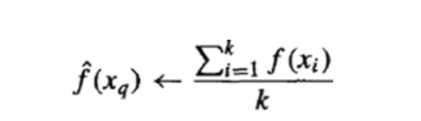

Where, f(xi) function to calculate the mean value of the k nearest training examples.

**Data Set:**

Iris Plants Dataset: Dataset contains 150 instances (50 in each of three classes) Number of Attributes: 4 numeric, predictive attributes and the Class.

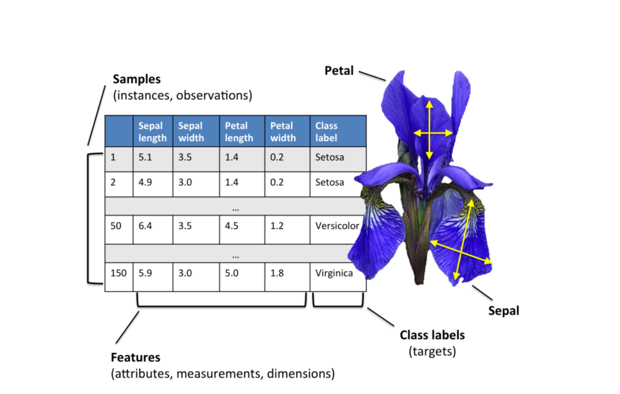

**Program and Output:**

* **Importing libraries,**

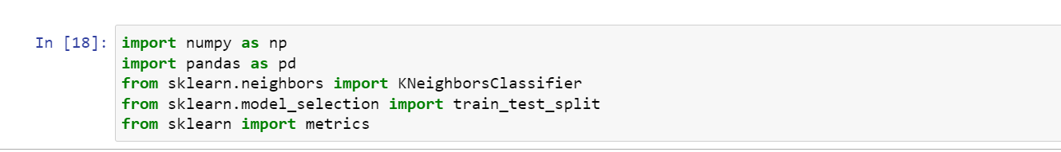

* **Read dataset to pandas sdataframe and give column name:**

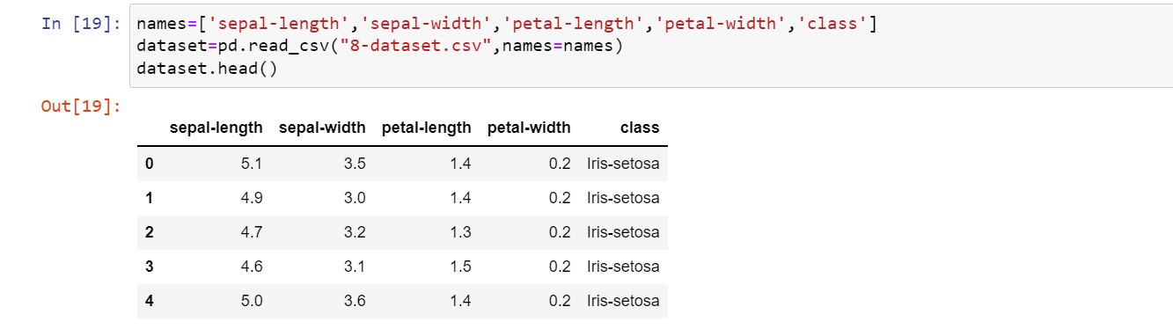

* **Divide the data set:**

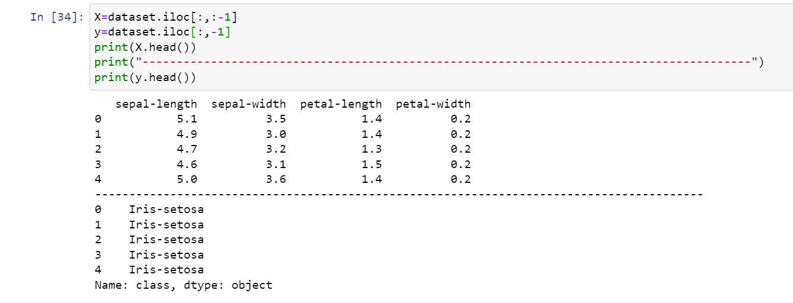

* **Split data into trainingset and teastset:**



* **Predicting testdataset**



* **Printing result:**

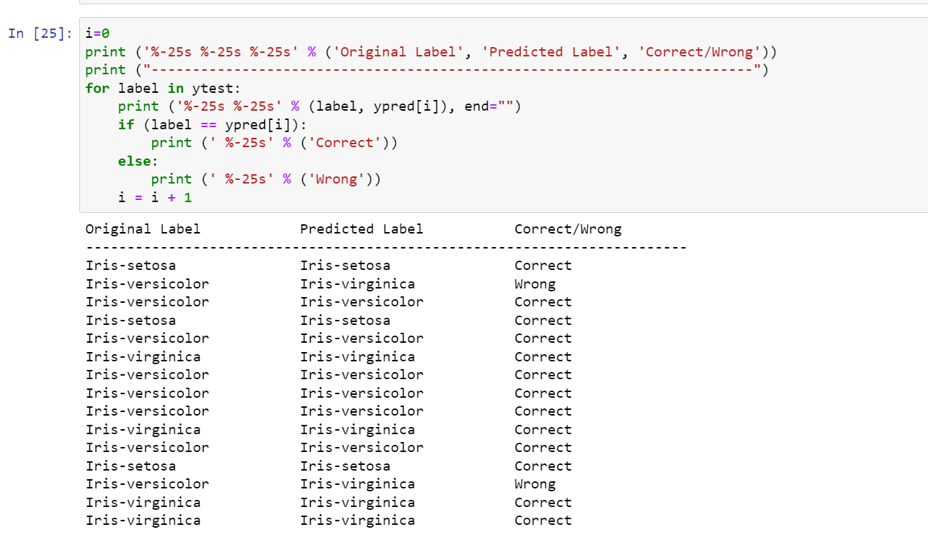

* **Confusion Matrix:**

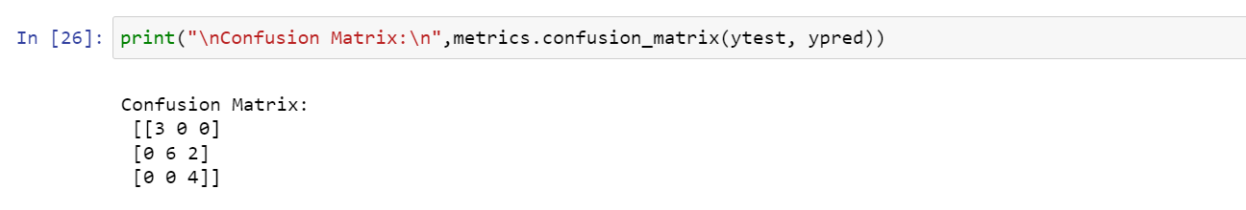

* **Classification Report:**

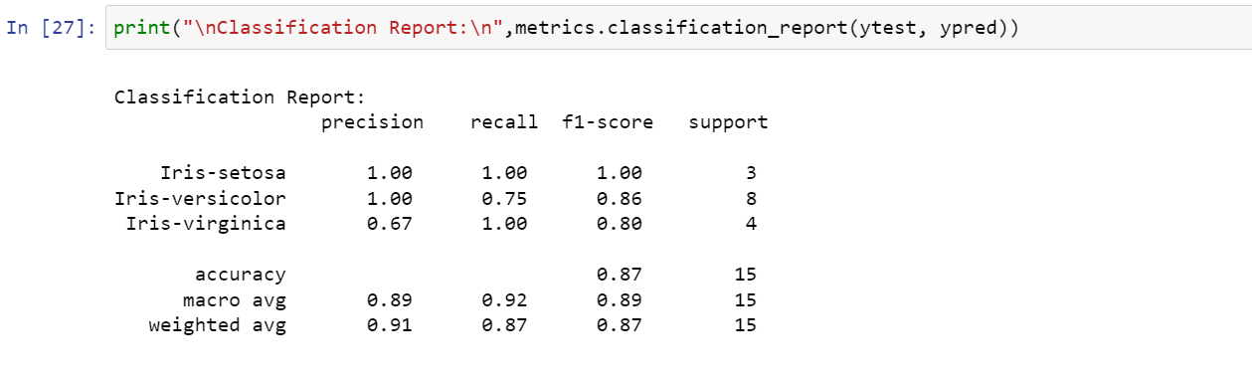

* **Accurancy of classifier:**

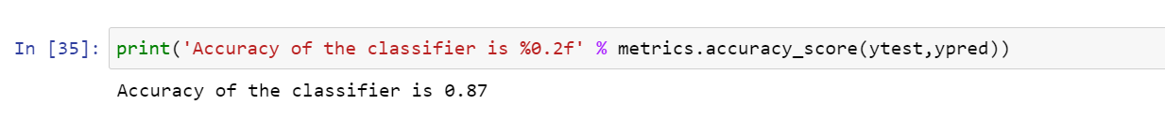

**Rubrics**

|  |  |  |  |  |
| --- | --- | --- | --- | --- |
| **Viva** | **Documentation of Program** | **Correctness of Program** | **Timely Completion** | **Total** |
|  |  |  |  |  |

**Signature**