Semester Championship Documentation

*Vehicle Mechanics Fundamentals*

Zalán Demeter | VERF1U

# General

## My goal

First, let me explain the strategy chosen. I have decided that I don't want to tune the car for a specific type of track and win those races, but I want to achieve an average best setting for all tracks. Thus, when optimizing the car, I always aimed to minimize the total lap time for all tracks.

## Tools

I have recorded the actual parameters and costs in tabular form to keep track of the results. Including simulated lap times, improvement rates, total lap times, total improvement, and deviation of improvements for each track. The table contains brief information on changes, conclusions, and decisions for the current setting. In the first phase of setting up the car, I used only this to narrow down the range of settings to those that were probably optimal.

## Development stages

In the first phase, I wanted to find an initial setup where all costs are used for one component. From this setting, I can think backwards to develop the setting further. In the next phase, I have logically combined the parameters in proportion to the improvements in the initial settings, further narrowing the range of possible good settings. Once I had narrowed down the possible settings and got an idea of the impact of the parameters, in the third phase I used the corresponding Optimum Lap diagrams to investigate the effects of the changes, make decisions and find the best setting.

## Development cost table

|  |  |  |  |  |  |
| --- | --- | --- | --- | --- | --- |
| *Development cost table* | | Step | | Cost | Default |
|  |  | step unit | dimension | $/step | value |
| **Tire Data** |  |  |  |  |  |
|  | Longitudinal Friction | 0.005 | - | 10.00 M | 2.100 |
|  | Lateral Friction | 0.005 | - | 20.00 M | 1.950 |
| **Aero Data** |  |  |  |  |  |
|  | Aero Efficiency | 0.010 | - | 5.00 M | 2.000 |
| **Scaling factors** | |  |  |  |  |
|  | Power factor | 0.100 | % | 1.18 M | 100.000 |
| **General** |  |  |  |  |  |
|  | Weight | 0.500 | kg | 1.20 M | 743.000 |
| *The available budget for the team is* | | | 100.00 M | | |

# First development stage

# Second development stage

# Third development stage

For this stage I choose two tracks to perform my analysis (Spa and Monaco). These two tracks were chosen based on the improvement percentage in lap times with the second stage setup. I choose the tracks with the biggest and the smallest improvements to carry out my analysis and to save time. These tracks have significantly different characteristics as well, so they will be perfect candidates to evaluate the setups. This means that in this stage of my development I will make decisions and visualize diagrams from these two tracks.

# Iteration 1

This setup change caused the following behavior on Spa: the top speed of the car was slower, but the reduced weight allowed higher cornering speed in the simultaneous corners where top speed was not the limiting factor. The following snippet from the track demonstrates this effect.

In Monaco this is a favorable setup as it is a street circuit where corners dominate not top speed. The following shows us that the newer setup could achieve higher speeds in consecutive turns than the previous. Although this setup works for Monaco, overall, there are more tracks where the previous setup works better. It might be beneficial to reduce the top speed slightly and increase cornering speed, but with a less aggressive change in aero efficiency.

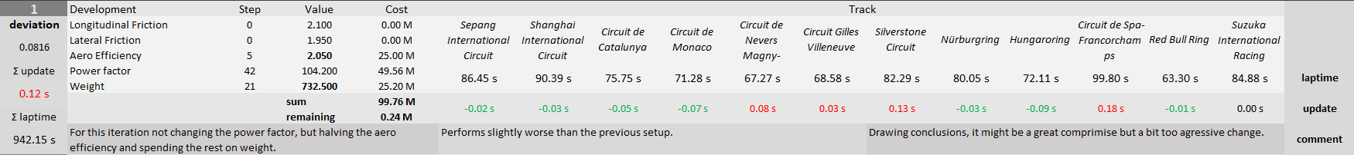

# Iteration 2

The above-mentioned change turned out to be not beneficial considering all tracks, it had less of a bad effect on the overall lap time, but it did not improve. The negative effect was halved compared to the previous iteration. The diagrams show the same behavior as the previous iteration, but the change is less visible as it is a less aggressive jump in parameters.

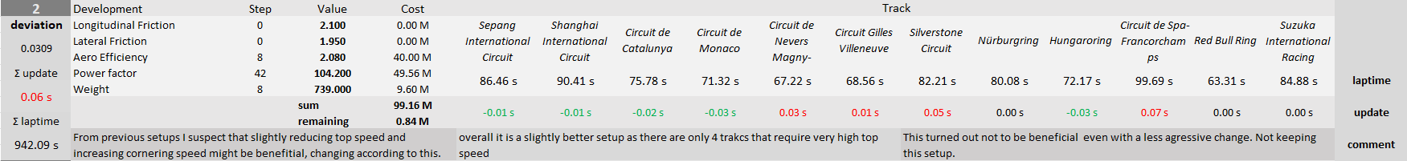

# Iteration 3

In the third iteration I reverted the aero efficiency to its second stage value and reduced the weight at the cost of the power factor. This resulted in the same overall lap time as the stage two setup, but it separated the performance on different tracks more. It might be beneficial to have a setup that works better on most of the tracks and performs slightly worse on the rest but overall, it stays relatively the same. This could mean that there is a higher probability to win races and fall behind on other only slightly. This resulted in improved lower speed performance while staying relatively at par on high-speed tracks like Spa, but in Monaco where top speed is less important it proves to be more consistent in low-speed areas thus performing better.

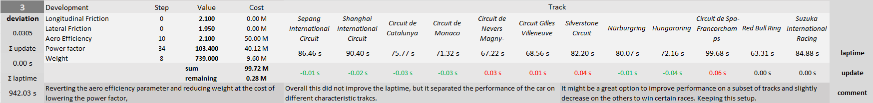

# Iteration 4

I tried reducing the weight a bit more aggressively at the additional cost of losing power, to increase performance on the above selected good performing tracks and widen the gap between different types of tracks. This iteration did not work as I intended it. It did not really improve the performance on the tracks that I wanted it to, but also increased lap time on the other tracks.

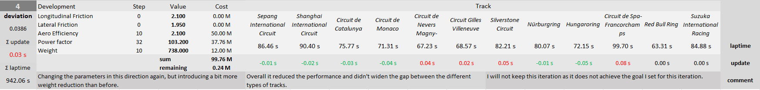

# Iteration 5

I tried increasing cornering speed by a different measure, with increasing the lateral friction coefficient. This is a very costly parameter, so I had to make a compromise in aero efficiency and power factor as well. This resulted in less top speed and the car did not have enough power even in the low-speed cornering sections of Monaco. As the car became power limited rather than being grip limited in almost all sections of the track.

# Decision

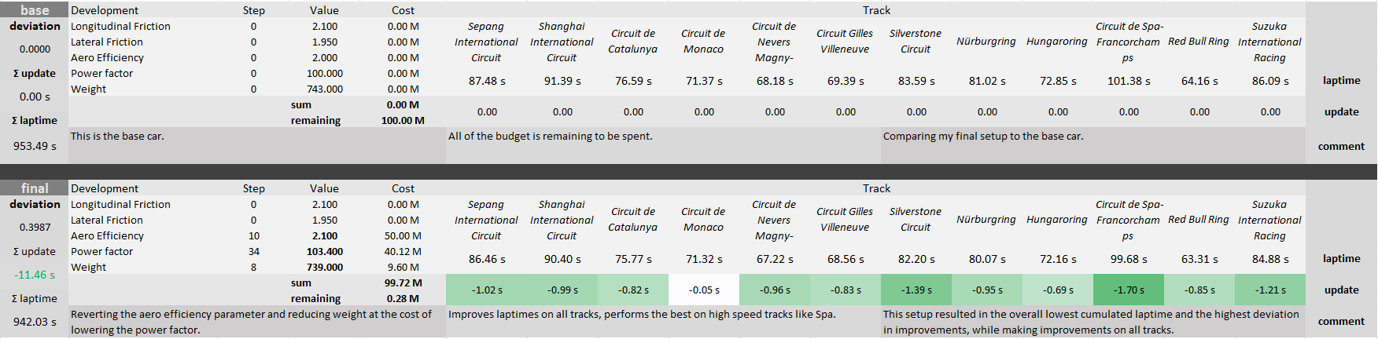From my analysis I concluded that spending a big chunk of the budget on improving the friction coefficients is not beneficial. Coming from this I tried to achieve an optimal setup by only changing the other three parameters. My chosen setup spends 10 steps on Aero Efficiency as it is one of the most important factors in achieving high top speeds, 34 steps on power factor which is the second most important parameter and 8 steps on weight reduction to increase cornering speed, acceleration, and braking performance. There was another setup that had the same overall lap time, but I choose this in the end to have a setup that could potentially win some of the races and only fall behind on the other tracks only a little.