RIDE DATA PREPROCESSING AND FEATURE ENGINEERING PROJECT REPORT

1. Introduction

Data preprocessing is one of the most important stages in Data Science and Machine Learning. In real-world transportation systems, data collected from ride-booking applications is often incomplete, inconsistent, and contains missing values. Such raw transportation data cannot be directly used for analysis or machine learning model development because it usually contains invalid records, duplicate entries, inconsistent fare values, missing trip information, and abnormal ride patterns.

The main purpose of this project is to collect transportation ride-related data from multiple different data sources, clean and preprocess the data, apply feature engineering techniques, visualize transportation demand patterns, and generate a final structured dataset ready for future machine learning and transportation analytics applications.

This project demonstrates practical implementation of preprocessing techniques commonly used in real-world transportation analytics pipelines. The complete workflow helps transform raw ride data into a structured format suitable for analytical processing.

Transportation platforms generate large volumes of operational data every day. Before this data can be used for analysis, it must go through preprocessing operations such as missing value handling, invalid record cleaning, feature transformation, scaling, encoding, and feature engineering.

This project demonstrates how transportation datasets can be converted into valuable analytical information and used for business intelligence or predictive analytics systems.

2. Project Objective

The major objectives of this project are:

• To collect transportation-related ride data from multiple different sources.

• To merge ride datasets stored in CSV, JSON, SQL, and database systems.

• To identify missing values and incomplete transportation records.

• To apply preprocessing techniques for improving data quality.

• To remove incorrect or invalid transportation records.

• To detect and treat abnormal outlier values present in trip data.

• To apply feature engineering techniques and create additional useful ride-related analytical features.

• To analyze ride demand behavior using graphical visualizations.

• To generate a final structured dataset suitable for machine learning.

• To improve understanding of real-world preprocessing workflow used inside transportation systems.

The final objective of this project is to prepare clean transportation data suitable for business analytics, predictive modeling, and machine learning applications.

3. Data Sources Used

The project uses multiple types of transportation-related data sources.

A. Riders Dataset (CSV File)

This dataset contains rider-related information collected from transportation users.

Columns included:

• rider_id

• rider_name

• age

• gender

• signup_date

• membership_type

The raw riders dataset intentionally contains incomplete values in some columns so preprocessing techniques can be applied.

This dataset represents customer information generated inside transportation booking systems.

B. Trips Dataset (JSON File)

This dataset stores ride transaction information.

Columns included:

• trip_id

• rider_id

• ride_distance

• fare_amount

• pickup_time

• drop_time

• payment_mode

• trip_status

The trips dataset stores operational ride activity generated during transportation booking.

It represents transaction-level transportation data required for analytics.

C. City Zones Dataset (SQL File)

Transportation route and zone information was stored using SQL files.

Columns included:

• zone_id

• zone_name

• traffic_level

• region_type

• route_category

This dataset helps simulate route-based transportation analytics.

D. Database Source (SQLite Database)

A SQLite database was used to simulate real-world transportation data storage systems.

Additional information included:

• route traffic information

• transportation zone category

• operational ride area classification

• traffic behavior information

This demonstrates database integration skills used during preprocessing.

4. Libraries Used

The following Python libraries were used during project development.

• Pandas

• NumPy

• Matplotlib

• SQLite3

• Scikit-Learn

• SciPy

• Sweetviz

• Warnings

These libraries helped perform data loading, cleaning, preprocessing, visualization, database operations, feature engineering, and report generation.

Pandas library was used for handling structured datasets.

NumPy helped perform numerical operations and mathematical calculations.

Matplotlib was used to create graphical visualizations and ride analytics charts.

Scikit-Learn provided preprocessing techniques such as imputation, encoding, and feature scaling.

SQLite3 helped establish database connections and import structured transportation data.

SciPy provided outlier treatment functions.

Sweetviz generated automated data summary reports.

Together these libraries created a complete end-to-end preprocessing workflow.

5. Data Collection and Loading Process

The first stage of the project involved loading transportation data from multiple file sources.

Different file formats were intentionally used to simulate real-world transportation systems where data is stored in multiple independent systems.

CSV files were loaded using Pandas DataFrame.

JSON files were imported using JSON data loading functions.

SQL files were executed and converted into structured records.

Database information was imported using SQLite connection.

Each dataset was inspected using multiple analytical functions.

Functions used during inspection included:

• head()

• shape

• columns

• info()

• describe()

These functions helped understand dataset structure and identify possible quality issues before preprocessing operations began.

Proper data loading is one of the most critical steps because future preprocessing operations depend entirely on correctly imported source data.

The project successfully demonstrated integration of multiple transportation data sources into one processing environment.

6. Data Merging Process

After loading all transportation datasets, the next important step involved merging multiple datasets together.

The riders dataset was merged with trip transaction dataset using rider_id as the common key.

The merged transportation dataset was then connected with route and traffic zone dataset using zone-related identifiers.

Database information containing additional transportation operational data was attached to the final merged dataset.

This created one complete transportation analytics dataset containing:

• rider information

• trip transaction records

• fare-related ride data

• payment information

• transportation route details

• traffic zone information

• operational transportation metadata

The purpose of data merging was to combine multiple independent transportation systems into one centralized analytics dataset.

This process demonstrates how modern transportation companies combine customer information, operational ride data, and route-related information into unified analytical systems.

The merged dataset then became ready for preprocessing and data cleaning operations.

7. Problems Found in Raw Data

After examining the raw transportation dataset, several data quality problems were identified.

Major issues found:

• Missing values in rider age column

• Missing membership information in rider records

• Missing values inside trip-related columns

• Incomplete payment mode information

• Incorrect fare amount entries

• Zero distance rides with charged fare amount

• Duplicate transportation records

• Inconsistent categorical values

• Abnormal extreme ride values

• Different data formats requiring integration

These issues made preprocessing necessary before performing analytics.

If these problems were ignored, transportation analysis would become inaccurate and machine learning models would produce unreliable predictions.

Identifying raw data issues before preprocessing is one of the most important stages in data science workflow.

The inspection process helped identify which cleaning methods should be applied to improve dataset quality.

This project successfully demonstrated practical identification of real-world transportation data quality problems.

8. Missing Value Handling

Missing values were identified using different inspection methods.

Functions used:

• isnull()

• sum()

• info()

After detecting missing values, multiple preprocessing techniques were applied.

Numerical Missing Values

Numerical columns included:

• age

• fare_amount

• ride_distance

Method used:

SimpleImputer using Mean Strategy

Reason:

Mean imputation helps preserve numerical distribution while replacing missing values with statistically meaningful replacement values.

Categorical Missing Values

Categorical columns included:

• gender

• membership_type

• payment_mode

Method used:

SimpleImputer using Most Frequent Strategy

Reason:

Most frequent imputation replaces missing categorical values using the category that appears most often inside the dataset.

Trip Missing Values

Trip-related missing values were handled using advanced imputation.

Method used:

KNNImputer

Reason:

KNNImputer predicts missing values using nearest neighboring records and improves prediction accuracy.

Handling missing values improved overall consistency of transportation data and prevented future analytical errors.

9. Data Visualization and Analysis

After preprocessing transportation data, graphical visualization techniques were applied to analyze ride demand behavior and transportation usage patterns.

Two major visualizations were created during this project.

A. Ride Demand by Hour

Observation:

The Ride Demand by Hour graph was created to analyze transportation demand behavior during different time periods throughout the day.

The graph helps identify peak transportation hours and shows how ride booking activity changes over time.

The analysis helps understand customer transportation behavior and identify periods where ride demand becomes significantly high.

This type of analysis is useful for transportation companies because it helps optimize vehicle availability and improve operational planning.

Purpose:

To identify peak ride booking hours and analyze customer transportation demand behavior.

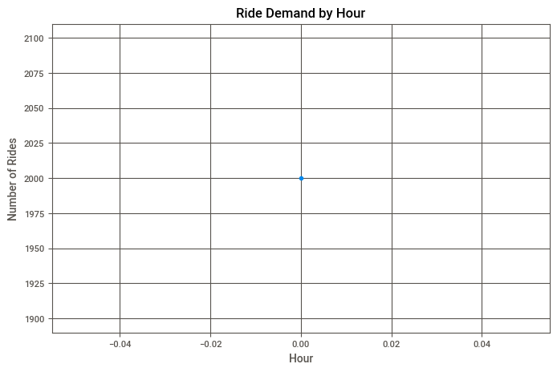

B. Surge vs Non-Surge Ride Pattern Analysis

Observation:

This visualization compares surge rides and non-surge rides generated during transportation booking activity.

The graph helps analyze differences between normal ride conditions and high-demand ride conditions.

During surge periods, transportation demand becomes significantly higher and fare patterns change.

This visualization helps identify how transportation demand changes during high-traffic operational conditions.

The graph provides valuable business insights related to pricing behavior and customer booking activity.

Purpose:

To compare ride demand behavior during surge and non-surge operational conditions.

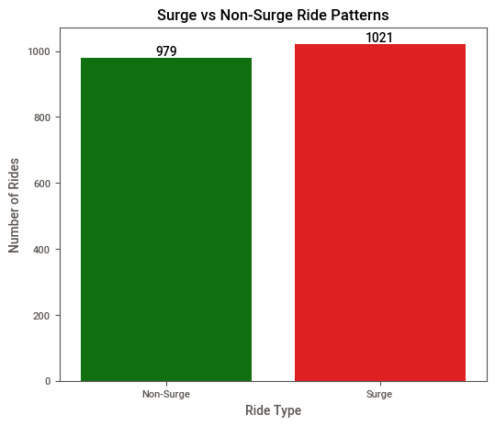

10. Invalid Data Cleaning

After initial preprocessing, invalid records inside transportation data were identified and removed.

Several incorrect records were found.

Major invalid records included:

• Negative fare amount values

• Zero distance rides with charged fare values

• Inconsistent trip status values

• Incorrect payment mode entries

These records reduce overall dataset reliability and create incorrect analytical results.

Invalid fare records were removed because transportation systems cannot logically generate negative pricing.

Zero distance rides with active fare amount were removed because they represent inconsistent operational behavior.

Removing invalid records improved overall transportation data quality.

This step ensured only logically correct transportation transactions remained inside the dataset.

Invalid data cleaning is critical because inaccurate raw records directly affect machine learning performance and business analytics accuracy.

11. Outlier Detection and Treatment

Outliers are abnormal numerical values that differ significantly from normal observations.

Transportation datasets frequently contain extreme values caused by unusual ride distance, abnormal pricing, or operational errors.

Several outlier detection techniques were applied.

Methods used:

• Z-Score Method

• IQR Method

• Winsorization Technique

Z-Score method helped identify values significantly different from mean distribution.

IQR method detected values falling outside expected interquartile ranges.

Winsorization reduced the effect of extreme numerical values by limiting abnormal observations.

Purpose:

To reduce the influence of extreme ride-related numerical values and improve dataset stability.

Outlier treatment improves future model performance and helps generate balanced analytical results.

Handling abnormal values is a critical preprocessing step in real-world transportation analytics.

12. Date and Time Transformation

Transportation data contains large amounts of date and time information.

Raw timestamps were transformed into analytical features that can be used for transportation demand analysis.

Several date and time transformation techniques were applied.

Transformations performed:

• DateTime Conversion

• Hour Extraction

• Day of Week Extraction

• Month Extraction

DateTime conversion standardized raw timestamp values.

Hour extraction helped analyze transportation demand behavior during different hours of the day.

Day of week extraction helped identify transportation usage patterns across weekdays.

Month extraction helped support long-term transportation trend analysis.

Time-based analytical features improve business intelligence and help transportation companies optimize operational planning.

This transformation process converted raw timestamps into valuable analytical information.

13. Feature Engineering

Feature engineering is one of the most important stages in data science because it helps create additional useful information from existing raw data.

After cleaning transportation data, several new features were created to improve analytical value.

New features created during this project included:

• Average Ride Distance Per Rider

• Average Ride Fare Per Rider

• Peak Hour Detection

• Days Since Signup

• Ride Cancellation Rate

• Surge Flag Detection

Average ride distance feature helped identify transportation usage behavior of customers.

Average fare feature helped analyze spending patterns and transportation revenue trends.

Peak hour detection helped identify high-demand operational periods.

Days since signup helped analyze customer activity duration.

Ride cancellation rate helped understand service reliability and customer cancellation behavior.

Surge flag detection identified transportation demand during high traffic periods.

Purpose:

To create additional business-related transportation features useful for analytics and future machine learning models.

Feature engineering improves dataset quality and increases predictive capability.

This process transforms ordinary raw transportation data into valuable business intelligence information.

14. Data Transformation Techniques

Several mathematical and preprocessing transformations were applied to improve numerical distribution inside transportation data.

Techniques used:

• Binning Transformation

• Log Transformation

• Square Root Transformation

Binning transformation converted ride frequency values into grouped categories.

This helps classify customers based on transportation usage behavior.

Log transformation helped normalize highly skewed numerical distributions such as fare amount and ride distance.

Square root transformation helped reduce numerical variation and improve feature balance.

Purpose:

These transformations help normalize numerical distributions and reduce irregular data behavior.

Normalized data performs better during machine learning model training and predictive analytics.

Data transformation improves overall consistency and analytical quality of the dataset.

This project demonstrates how raw transportation values can be mathematically transformed into more stable analytical features.

15. Feature Scaling

Machine learning algorithms perform better when numerical values remain inside similar ranges.

Transportation datasets contain numerical columns with very different value ranges.

Example:

Ride distance may range between small and large distance values.

Fare amount may vary significantly depending on ride conditions.

Age values remain inside completely different numerical ranges.

To solve this problem, feature scaling techniques were applied.

Methods used:

• StandardScaler

• MinMaxScaler

StandardScaler standardizes numerical values using mean and standard deviation.

MinMaxScaler transforms numerical values between zero and one.

Purpose:

To normalize numerical transportation data and improve machine learning compatibility.

Feature scaling prevents algorithms from giving higher importance to large numerical values.

This step significantly improves future model performance.

16. Final Output Generated

After completing preprocessing and feature engineering, the final transportation dataset was exported successfully.

Final output generated:

Processed Transportation Dataset CSV File

The final dataset became:

• Clean

• Structured

• Consistent

• Missing-value free

• Outlier treated

• Machine learning ready

• Suitable for predictive analytics

The dataset now contains cleaned transportation records, transformed numerical values, encoded categorical information, and additional engineered analytical features.

The final output can be used for future machine learning model development and transportation analytics systems.

Generating final clean dataset is the ultimate goal of preprocessing workflow.

This project successfully created a high-quality transportation analytics dataset ready for future advanced applications.

17. Automated Report Generation

Automated data reporting was also performed during project implementation.

Tool used:

Sweetviz Library

Sweetviz generated automated HTML-based analytical report showing dataset summary and data quality information.

The generated report provided:

• Missing value analysis

• Column summary

• Numerical feature comparison

• Distribution analysis

• Data quality statistics

Automated reporting saves time and helps quickly understand dataset behavior.

It provides fast analytical overview before performing advanced machine learning tasks.

This step demonstrates modern automated reporting techniques used in professional data science projects.

Automated analytical reports improve preprocessing efficiency and reduce manual inspection workload.

18. Best Methods Applied

The most effective preprocessing methods used in this transportation analytics project were:

• Mean Imputation for numerical missing values

• Most Frequent Imputation for categorical missing values

• KNN Imputation for trip-based missing values

• Invalid Record Removal

• Z-Score Outlier Detection

• IQR Outlier Detection

• Winsorization

• Label Encoding

• One Hot Encoding

• Ordinal Encoding

• Feature Engineering

• Log Transformation

• Square Root Transformation

• StandardScaler

• MinMaxScaler

These methods significantly improved final dataset quality.

Using multiple preprocessing techniques created a highly reliable transportation analytics dataset.

Combining these methods demonstrates practical real-world preprocessing workflow used in production-level data science systems.

19. Conclusion

This project successfully demonstrated complete end-to-end data preprocessing and feature engineering using multiple transportation-related data sources including CSV files, JSON files, SQL files, and SQLite database systems.

The raw transportation dataset initially contained missing values, incomplete records, inconsistent trip information, abnormal ride values, invalid fare entries, duplicate transportation records, and multiple formatting problems.

These issues were solved using preprocessing techniques such as missing value handling, KNN imputation, invalid record removal, outlier treatment, encoding techniques, date transformation, feature scaling, and advanced feature engineering.

The project also included transportation demand analysis using graphical visualizations showing ride demand by hour and surge versus non-surge transportation behavior.

The final processed transportation dataset became fully cleaned, structured, consistent, and ready for future machine learning, predictive analytics, transportation intelligence systems, and business decision-making applications.

This project provided practical understanding of real-world preprocessing workflow and demonstrated how raw transportation operational data can be transformed into valuable analytical information.

The knowledge gained from this project can be applied in ride-booking systems, logistics analytics, mobility applications, and intelligent transportation management systems.

20. References

The following references were used during project development.

• Python Official Documentation

• Pandas Documentation

• NumPy Documentation

• Scikit Learn Documentation

• SciPy Documentation

• SQLite Documentation

• Matplotlib Documentation

• Sweetviz Documentation

• Machine Learning Preprocessing Concepts

• Data Science Workflow Concepts

• Transportation Analytics Research Materials

END OF PROJECT REPORT

