- What is Customer Churn? Why is predicting churn valuable for a business like Jio or Airtel?

Churn Flow:
👤 Customer → 📊 Churn Prediction → ⚠️ High Risk → 🎁 Retention Offer → ❤️ Customer Retained
Customer Churn refers to a situation where a customer stops using a company's products or services. In the telecom industry, churn may occur when a customer switches from one telecom provider to another.
CUSTOMER
│
┌──────────┴──────────┐
↓ ↓
STAYS LEAVES
(Non-Churn) (Churn)
│ │
│ Churn Prediction
│ │
└──────────┬──────────┘
↓
Retention Action
↓
Discount / Better Plan
Predicting customer churn is valuable because it helps companies such as Jio or Airtel identify customers who are likely to leave. The company can then take preventive actions such as offering discounts, better plans, personalized offers, or improved customer support.
Example: If a customer has low usage, frequent complaints, and a high monthly bill, a churn prediction model can identify the customer as high-risk.
Business Value:
- Reduces customer loss.
- Improves customer retention.
- Reduces the cost of acquiring new customers.
- Helps create personalized retention offers.
- Increases long-term customer revenue.
- 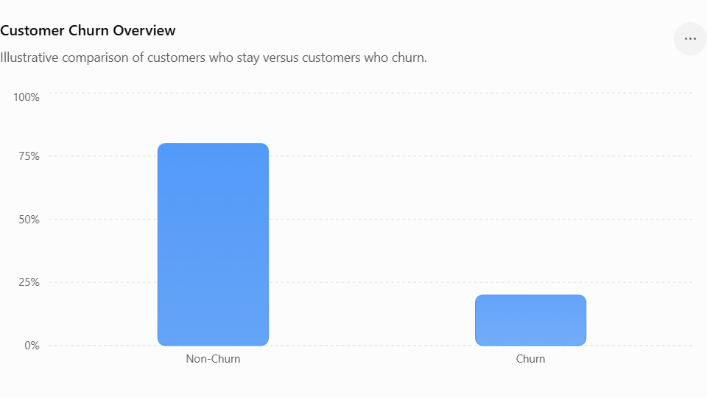

2. Define the four cells of a Confusion Matrix (TP, TN, FP, FN). In the churn context — what is the business cost of a False Negative? What about a False Positive?
A Confusion Matrix evaluates the performance of a classification model by comparing actual outcomes with predicted outcomes.
TermMeaningChurn Example
TP – True Positive | Actual churn and predicted as churn | Customer will leave and model correctly identifies them
TN – True Negative | Actual non-churn and predicted as non-churn | Customer stays and model correctly predicts they will stay
FP – False Positive | Actual non-churn but predicted as churn | Customer will stay, but model incorrectly identifies them as likely to leave
FN – False Negative | Actual churn but predicted as non-churn | Customer leaves, but model fails to identify them

Business Cost
False Negative (FN):
This can be very costly because the company fails to identify a customer who is actually going to churn. The company loses the customer and potentially loses future revenue.
False Positive (FP):
This usually has a lower cost. The company may unnecessarily provide a discount or retention offer to a customer who was not actually going to leave.
Therefore, in many churn applications, reducing False Negatives is important because losing a customer can be more expensive than offering an unnecessary retention incentive.

Confusion Matrix Diagram
PREDICTED
Churn No Churn
┌─────────┬───────────┐
Actual │ TP │ FN │
Churn │ Correct │ Missed │
├─────────┼───────────┤
Actual │ FP │ TN │
No Churn │ Wrong │ Correct │
└─────────┴───────────┘
Important for business:
FN = Customer actually churns but model says "No Churn" → Customer is lost.

3. What is Class Imbalance? Does the Telco Churn dataset have it? How does SMOTE address it?
Class Imbalance occurs when one class contains significantly more observations than another class.
For example:
- Non-Churn: 80%
- Churn: 20%
Here, the churn class is the minority class.
The Telco Churn dataset commonly contains more non-churn customers than churn customers, so the target variable is typically imbalanced.

How SMOTE addresses Class Imbalance
SMOTE (Synthetic Minority Over-sampling Technique) creates new synthetic examples for the minority class instead of simply duplicating existing observations.
For example, if there are fewer churn customers, SMOTE generates synthetic churn observations based on existing minority-class observations.
Benefits of SMOTE:
- Increases minority-class representation.
- Helps the model learn the minority class better.
- Can improve Recall for churn customers.
- Reduces the tendency of the model to predict the majority class.
Important: SMOTE should be applied only to the training data, not to the test data, to avoid data leakage.

Class Imbalance + SMOTE
BEFORE SMOTE
Non-Churn ████████████████████ 80%
Churn █████ 20%

↓ SMOTE

AFTER SMOTE
Non-Churn ████████████████████
Churn ████████████████████
SMOTE → Minority class ke synthetic customers create karta hai.

4. Briefly explain how each of the 4 algorithms works — KNN, Naive Bayes, SVM, Decision Tree

Four Algorithms Diagram
CHURN PREDICTION
│
┌─────────────┼─────────────┐
↓ ↓ ↓
KNN Naive Bayes SVM
│ │ │
Similar Probability Best Boundary
Customers Based / Margin
│ │ │
└─────────────┼─────────────┘
↓
Decision Tree
│
IF → ELSE Rules
↓
Churn / No Churn

1. KNN – K-Nearest Neighbors
KNN predicts a customer's class by looking at the K most similar customers in the training data.
For example, if most of the nearest customers are churners, KNN predicts that the new customer is also likely to churn.
Key idea: Similar customers tend to have similar outcomes.

2. Naive Bayes
Naive Bayes uses Bayes' theorem to calculate the probability that a customer belongs to a particular class.
It assumes that features are conditionally independent of each other.
For example, it can calculate the probability that a customer will churn based on factors such as contract type, tenure, monthly charges, and payment method.
Key idea: Predict the class with the highest probability.

3. SVM – Support Vector Machine
SVM finds the best decision boundary (hyperplane) that separates different classes.
It tries to create the largest possible margin between the classes.
For churn prediction, SVM can find a boundary that separates customers likely to churn from customers likely to stay.
Key idea: Find the best separating boundary with maximum margin.

4. Decision Tree
A Decision Tree makes predictions using a sequence of if–else decision rules.
For example:
Contract = Month-to-month?
↓
Yes
↓
Monthly Charges > ₹500?
↓
Yes
↓
High Churn Risk
The tree repeatedly splits the data based on important features until it reaches a prediction.
Key idea: Make decisions using a series of simple rules.

5. When would you choose Precision over Recall as your primary metric? Give a churn-specific answer.
Precision measures how many customers predicted as churners are actually churners.
Precision = \frac{TP}{TP + FP}
I would choose Precision over Recall when the cost of incorrectly targeting a customer is high.

Churn-specific example:
Suppose a telecom company offers an expensive retention package, such as a large discount or premium benefits, to customers predicted to churn.
If the model has low precision, many customers who were never going to leave will receive expensive offers. This increases the company's retention cost unnecessarily.

Precision vs Recall Diagram
CHURN MODEL
│
┌──────────┴──────────┐
↓ ↓
PRECISION RECALL
│ │
"Predicted churners "Actual churners
me kitne correct?" me kitne pakde?"
│ │
↓ ↓
Avoid unnecessary Avoid missing
offers/discounts customers

