**2nd Progress Report**

**BonaRes Centre for Soil Research**

Reporting period: 01.07.2017-30.06.2018

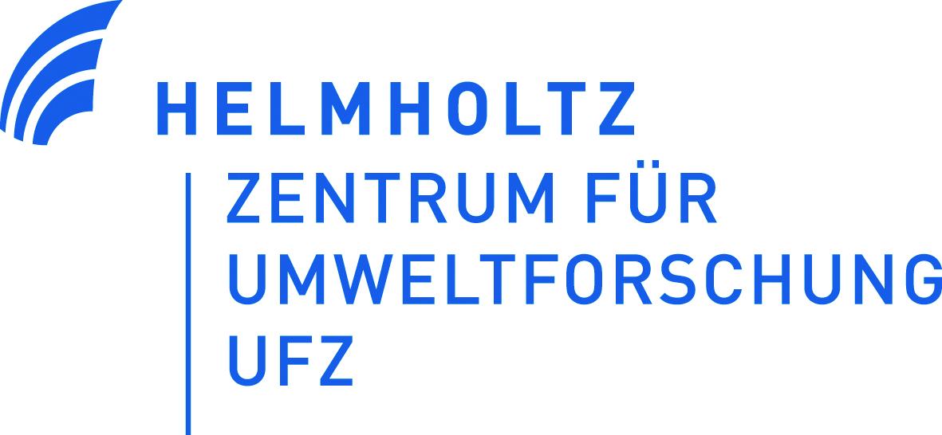 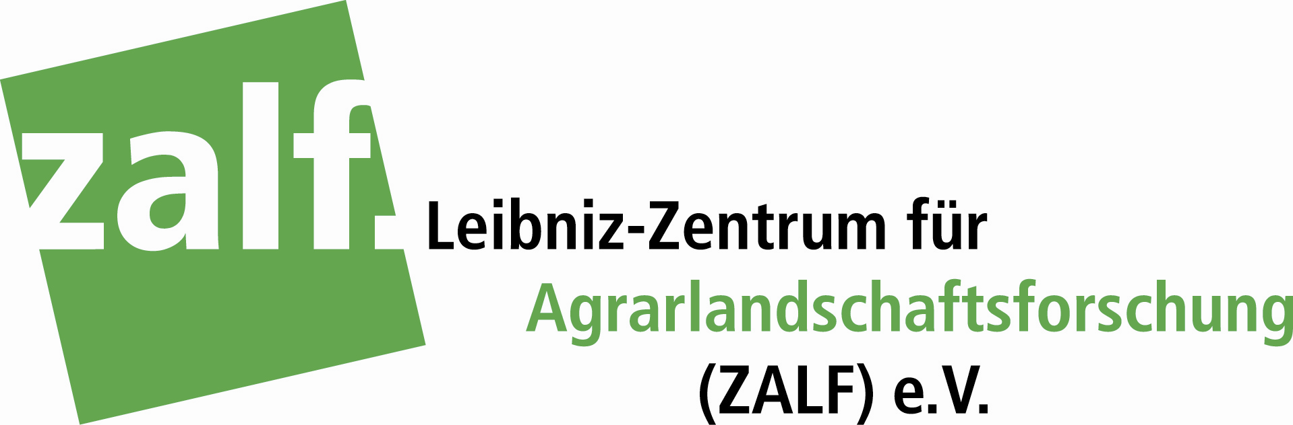

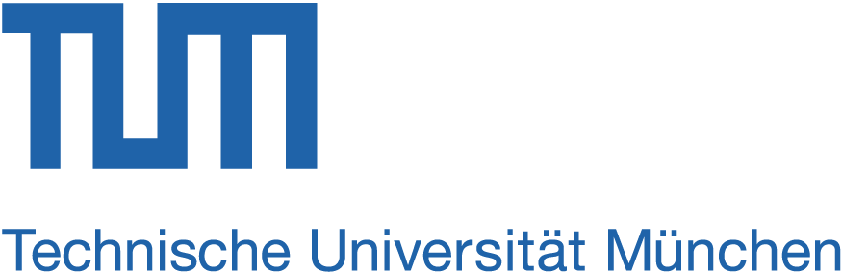 

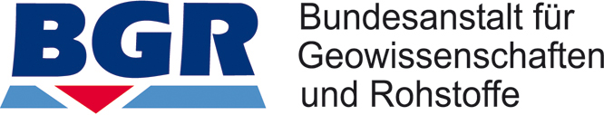

**1. General information about the collaborative project**

Title: „BonaRes (Modul B): BonaRes-Zentrum für Bodenforschung“

Coordination: Prof. Hans-Jörg Vogel (project leader)

Dr. Ute Wollschläger (project coordinator)

Helmholtz Centre for Environmental Research – UFZ,

Dept. Soil System Science

Theodor-Lieser-Str. 4, 06120 Halle (Saale)

Funding period: 01.07.2015 - 30.08.2018

**2. Background and goals of the BonaRes Centre**

The funding measure **"Soil as a Sustainable Resource for the Bioeconomy – BonaRes"** is an initiative of the Federal Ministry of Education and Research (BMBF) under the "National Research Strategy BioEconomy 2030". **BonaRes is motivated by the need to safeguard essential functions of soil while maintaining and even increasing the productivity („fertility“) of soils for biomass production.**

Funding of BonaRes is intended for a total duration of nine years split into three funding periods of three years each. It provides a unique opportunity to **establish an interdisciplinary community of soil and social scientists and the diverse spectrum of involved stakeholders** (farmers, policy makers, civil society, etc.) aiming at sustainable soil management. This requires target-oriented coordination with respect to communication, scientific integration and technical support. In Module A, ten research consortia, including 5 to 12 partners each, are funded. They cover a wide range of different aspects of how agricultural management (farming systems, cropping systems, tillage, fertilization, use of amendments and pest management) may alter soil functions through soil processes ranging from biological processes and nutrient dynamics to mechanical aspects of soil compaction. Each of the projects also includes research on the assessment and governance of soil functions and management practices. The **BonaRes Centre for Soil Research** is the **coordinating project**, Module B, having the dedicated mission to **support the various actors towards a systemic approach** on soil functioning embedded in our terrestrial environment and in our society. The activities of the BonaRes Centre are structured along four tasks:

1. Coordination and communication
2. Provision of soil-related research data, including the data from the German long-term agricultural field experiments, through a central repository
3. Modelling soils as complex systems to predict the impact of soil management on soil functions, which will be linked to assessment and governance strategies in a socio-economic context.
4. Implementation of a web-based infrastructure for information and science-based decision support.

Herewith, the BonaRes Centre provides essential services to the scientific community and is intended to substantially foster and stimulate scientific progress: It **coordinates the scientific exchange** between all projects funded within the BonaRes initiative and beyond and organizes **outreach activities** and **public relations work**. The BonaRes Centre implements a **soil-focused data repository on research data and those from long-term field experiments**. Also a **literature database** with special focus on soil processes and soil functions is being developed. All this, together with the scientific progress within the BonaRes program is made available through a **web-portal**.

A special scientific challenge of the BonaRes Centre lies in the consolidation of existing and newly generated knowledge on soil processes and their complex interactions. One major focus is on understanding the significance of biotic soil factors interacting within a physically and chemically highly heterogeneous environment. In collaboration with the Module A projects, the ultimate goal is to **develop science-based model** tools that are in the position to predict the impact of soil management on soil functions considering the local conditions in terms of soil type, land use and climate. The aspired **systemic approach** needs to also **consider its interaction with the social and economic system**, since the social and economic context of farming has an obvious impact on the natural environment. Soil management strategies designed to optimize natural soil functions need to be assessed against the background of farm level and societal targets including resource use efficiency, ecosystem services and sustainable development goals (SDGs). In addition to this, respective governance instruments must be proposed. In this way, an important contribution to the sustainable balancing of interests between economy and ecology is expected. BonaRes focuses mainly on national research, however, with a clear expectation that promising new solutions can be adapted and transferred to other parts of the world.

**3. Contribution of the project partners to the achievement of the consortium goals (1-3 bullet points each)**

**Helmholtz Centre for Environmental Research – UFZ**

* Overall coordination of the BonaRes Centre and lead of work packages coordination and communication (WP1)
* Lead of work package Models & Tools (WP3), with a focus on the natural sciences part (knowledge portal, integrated modeling, and indicators) and governance
* participation in the development of the BonaRes Portal (WP4) with a focus on the Knowledge and Service Portals.

**Leibniz-Zentrum für Agrarlandschaftsforschung (ZALF)**

* Management of the BonaRes Data Centre (WP2)
* Lead of work package BonaRes Portal (WP4) with a focus on the implementation of the entire portal, as well as the contents of the Data and Service Portals
* Organization of the scientific activities in the field of sustainability assessment in WP3 and Foresight & Demand analysis in WP1

**Technische Universität München (TUM)**

* Contributions to all activities of work package Models & Tools (WP3) (knowledge portal, integrated modeling, and indicators) with scientific expertise in biogeochemical processes

**Senckenberg Gesellschaft für Naturforschung (SMNG)**

* Provision of expertise on soil biological, esp. zoological processes in WP3
* Contribution to the BonaRes Data Centre (WP2)by linking the zoological database ‘Edaphobase’ to the BonaRes database

**Federal Institute for Geosciences and Resources (BGR)**

* Contribution to the BonaRes Data Centre (WP2) by participation in national and international standardization activities with relevance for BonaRes and in the development and adjustment of tools for standardization and homogenization of soil data

**All project partner PIs** contribute to the coordination of the BonaRes Centre (WP1) as they are being members of the operational Management Board which is the steering board for all activities of the BonaRes Centre.

**4. Activities and main scientific and technical results**

**Work package 1: Coordination (3 pages)**

**Task 1.1 Quality Management**

**Task 1.2 Community Building**

**Task 1.3: Foresight & Demand Analysis**

**Task 1.4: Outreach and Perpetuation**

**Work package 2: Data Centre (4 pages)**

The BonaRes Data Centre brings together data from soil research – mainly from Module A projects – and provides it for general use in a standardized form as part of a networking data infrastructure. In addition, the long-term field experiments in Germany are a further focus. The access to other freely available external data from the subject areas soil properties, topography, land use, climate and socio-economics is also supported. The Data Centre is a service provider for the necessary infrastructure and for the basic support of the system.

**Task 2.1: Standards**

The BonaRes Centre, represented by the BGR, participates in national and international standardization activities in the field of soil description, classification and data (exchange) formats. The BGR staff is member of the working group of the Technical Committee “Soil Quality” of the International Standardization Organization (ISO TC190) developing and refining international standards for “Field soil description” (ISO 25177) and “Digital exchange of soil-related data” (ISO 28258). In May 2018 the first ISO/TC190/WG2 meeting took place in Paris: Correction of technical issues (especially in regard to the data model) of EN ISO 28258 Soil Quality - Digital Exchange of Soil-Related Data resulted in an Amendment of the International Standard (Project leader: E. Eberhardt) and to launch the publication of the current version.

At the national level, the BGR is strongly involved in the revision of the German Soil Survey Guideline, the most common standard for soil description and classification in Germany. Results from the update of the guidelines will influence the development of the BonaRes soil data structure.

Due to numerous external queries, the report “Overview of relevant standards for the BonaRes-Program” was published in September 2017 (DOI: 10.20387/BonaRes-FK84-PCR9). This overview is a “living document” and it was continuously updated and extended (recently some 600 standards) during the reporting period. Updates were made in close cooperation with Module-A projects and the Data Centre was always able to inform and give access to recommended laboratory methods, field books, code lists, licenses, vocabularies and other standards in soil- and agricultural science and data management. A new DOI version was prepared at the end of the reporting period.

It is aimed to provide interoperability with other national and international data repositories and accessibility and re-usability of research data from the very beginning. To fulfill this central premise, established and accessible standards are strongly recommended for data acquisition, -management and -provision. In this sense, the standard metadata concepts of INSPIRE and DataCite were used to set-up of the BonaRes Metadata Schema (see Task 2.3).

Metadata schema and other used standards for the data life stages were presented (oral and posters) and discussed with experts in the fields of soil, agriculture, long-term field experiments and research data management during various national and international conferences i.e. the biannual Meeting of the German Soil Science Society Göttingen (Sep 2017), Linked Open Data in Agriculture Berlin (Sep 2017), BonaRes Conference Berlin (Feb 2018), RDA Plenary Meeting and IGAD pre-meeting Berlin (March 2018), General Assembly of the European Geoscience Union Vienna (Apr 2018), and The Future of Long-Term Experiments in Agricultural Science, Rothamsted Research (May 2018).

The BonaRes Data Centre is the contact partner for the Module-A-project for all questions during all research data stages from data acquisition to data provision for external user. From spring 2018 on code lists were compiled and kept current for plant varieties, crop types and agricultural machineries. Unique codes for plant varieties (compiled by the German Federal Plant Variety Office) are downloaded automatically once per months from the open data portal *govdata*. Codes for crop types are provided by the FAO (Indicative Crop Classificaton, ICC) and machineries are classified and encoded by the German Kuratorium für Technik und Bauwesen in der Landwirtschaft, KTBL).

In August 2017 the first international network activity to the national soil data repository in Russia took place. In two video conferences with colleagues from the platform Soil-Geographic Data Base, Moscow Lomonosov State University, preconditions and possibilities of metadata cross-harvesting were discussed. In September the results of this progress were summarized in a chapter of the book “Novel Methods and Results of Landscape Research in Europe, Central Asia and Siberia” (Hoffmann et al. in press).

In 2018 contacts and networking to colleagues in Rothamsted were established and extended by workshops (RDA Plenary Meeting and Rothamsted conference) and individual working group visits. Cornerstones for a future cooperation were prepared according to international standardizations in (meta)data collection and data storage from long-term field experiments (LTFE) within relational data bases. A closer collaboration in the global LTFE network GLTEN was agreed.

In the second project phase the extension and improvement of the FAO thesaurus Agrovoc is planned as collaboration of WP2 and WP3 with the international FAO Agrovoc team. In June 2018 staff member of both work packages attended to the Agrovoc Editors Meeting to introduce to structures and plans and to learn and understand workflows of editing.

**Task 2.2: Data Acquisition**

With the release of the metadata editor in 2017, the organization and implementation of two data workshops with the module A projects took place. During the one-day workshops, the data transfer workflow to the data center was elucidated and the use of the metadata editor was explained in detail accompanied with practical exercises. The participants were given the opportunity to describe their own data with metadata. There were many opportunities for discussion at these events. The data center is taking suggestions for improving its service as far as possible. In preparation for the data workshops (11.7. Berlin and 7.9. In Göttingen), the participants of nine module A projects handed over research data to the data center. These data form the basis of the BonaRes database. Due to several reasons (e.g. new employees, completed sampling, sufficient capacity) it became necessary to organize a 3rd data workshop in Müncheberg (1.3.2018) while there are already pre-registrations and expressions of interest for another workshop, which will take place in autumn 2018.

By the end of the reporting period, 153 records are under processing at the data centre. Of the 153 datasets, 118 come from the A projects, 3 from the BonaRes Centre, 31 from LTFE and one from an external research project. The claim of the data centre is to provide descriptive metadata for all research data. These are typically provided immediately after a quality assurance review process, as research data is embargoed. In order to make the entry of the metadata particularly user-friendly, some metadata is already created by the data centre after the acceptance of the research data and sent to the authors. The tools for data harmonization and quality assurance, developed by BGR, will be integrated in the quality assurance review workflow in the next phase. The Conformity key has been enhanced to run also in 64 bit Office environments; the new version will be published in September 2018.

We have compiled an overview of long-term field experiments in Germany that is based on a literature review, the results of the online survey and direct contacts with LTFE operators. Information about research topic, contact person, website, experimental setup and analyzed parameters has been collected. With this database, we have set up a GIS-based web-information system about LTFEs in Germany. Various aspects of the long-term field experiments like duration, kind of experiment or data about soil functions, are presented in thematic maps. With this interactive application, users can obtain all available information for each site. The database has been improved together with the LTFE operators as part of the community building activities of the BonaRes Centre. The inventory of long-term field experiments in Germany was continued. Further information on climate, soil or cultivation areas were collected and will be added in the overview map of LTFEs soon.

One result of the workshop in 2017 in Berlin was that there is a need to better integrate LTFE operators with their expertise in agronomy and carrying out field experiments into the BonaRes activities so that they perceive BonaRes as a joint effort and beneficial also for their experiments. This is also due to the fact that far less LTFE operators are partners in the BonaRes projects than initially foreseen. As a solution we proposed a new position for scientific networking of LTFE operators for the second funding phase of the BonaRes Centre. With Prof. B. Honermeier as the head of this new position and as a new partner of the BonaRes Centre there was close cooperation for the implementation of this position. The next BonaRes LTFE workshop in Spring 2019 will be held at University of Giessen together with the IOSDV/ILTE-conference.

The LTFE networking made progress through the attendance of different conferences, meetings and personal communications. International networking could be initiated through the attendance of the Rothamsted Conference “The Future of Long-Term Experiments in Agricultural Science”. On a return visit from Rothamsted scientists a small workshop was held at ZALF in Müncheberg. The Rothamsted Scientists evinced interest to attend the BonaRes LTFE workshop in spring 2019.

Due to contacts established at the Rothamsted Conference (e.g. with a PI from IITA in Africa) and an overall interest from foreign LTFE holders to show their LTFE on the BonaRes LTFE overview map, the fact sheet for LTFE was revised, translated into English and extended. It shall be published via the BonaRes series soon.

The provision of LTFE data started in the first funding phase. Contracts were concluded as follows: Dauerdüngungsversuch Dikopshof (University of Bonn), Langzeit-Düngungsversuch Darmstadt (Forschungsring e.V.), Hohes Feld- Bodenbearbeitung (University of Göttingen), Garte-Süd-Bodenbearbeitung (Reinshof, University of Göttingen), Phosphordüngungsstrategien (University of Rostock), IOSDV-Versuch Dülmen (YARA). Extensive communication with the trial holders was necessary to transfer the data into the database scheme. Before publication some more quality checks and conversations are necessary. Standards were applied where suitable. Two further contracts (Göttinger E-Feld and LTFE in Seehausen) were postponed into the second funding phase due to the limitation of financial and personnel resources. The publication of research data and the description with metadata of the long-term field experiment V140 (ZALF, Müncheberg) is now completed.

**Task 2.3: Data Base and Data Provision**

For the BonaRes projects we have implemented in 2016 a central exchange platform (own cloud). Each of the Module A projects has 500GB of storage available since going online with the BonaRes portal. This is used not only to provide data internally within the Module A projects, but also to transfer data to the Data Centre. By the end of the reporting period, 211 BonaRes employees (BonaRes Centre and A projects) had registered for the BonaRes internal area and stored a total of 4653 files.

A Report on available soil data for German agricultural areas was written (Milestone D2.4) which gives information about the accessibility, reusability and possibly existing limitations of validity of soil related geospatial data. The data sources were evaluated on the basis of the FAIR-principles which concern requirements for the Findability, Accessibility, Interoperability and Reusability of research data and data infrastructures (Wilkinson, M. D. et al. 2016). This was presented at the BonaRes 2018 Conference in Berlin in oral form and at the EGU General Assembly 2018 in Vienna as a poster. The report serves as a basis for future data provision for the BonaRes projects.

The Bonares Data Centre is working with con terra GmbH for implementing metadata editor and data portal. After a test period from internal (ZALF) and external sites (BGR, SGN) of the functionality and usability of the data portal and suggested improvements the data portal and metadata editor are online available. Bonares metadata editor combines internationally recognized standards for the description of geodata and research data (INSPIRE, DataCite 4.0) and is extended with metadata elements regarding datasets internal relationships and describes about data fields. The current version of the schema contains 43 metadata elements, of which 21 are mandatory and 22 elements are optional (DOI: 10.20387 / BonaRes-5PGG-8YRP). The metadata schema is attached to DataCite standard which enables the assignment of a Digital Object Identifier (DOI), a permanent identification code to the research data. The assigned DOI ensures a clear referencing and thus achieves an elegant link between the metadata and the research data. Since July 2017, the web-based metadata editor is available for the creation and storage of soil-related metadata (Milestone M 2.3.3). Upon successful login, data providers can enter metadata, validate this metadata against INSPIRE, DataCite, or the BonaRes schema, store their metadata locally, create templates, and save drafts. Besides, the Data Portal is a browser application that allows users to search for research data from BonaRes collaborative projects and connect to these resources through standardized web services (Web Map Service, Web Feature Service). The search for data can be done spatially as well as temporally and thematically. The search results are listed in the result display and displayed in the linked map view. In the metadata search, external catalogs (e.g. Federal Institute for Geosciences and Natural Resources) and data sources (Edaphobase - Senckenberg) can also be included and provided for the search. The ongoing Biodiversity data exchange between the BonaRes Data Center and SGN's Edaphobase (M2.2.4) has been installed in a first release. Edaphobase metadata are accessible through the BonaRes Data Portal. Metadata hosted on the BonaRes Data Portal can be delivered to the Harveste external users via the standardized interface of the OGC Catalog Service (CSW).

**Work package3: Models & Tools (4 pages)**

**Task 3.1: Meta-Analyse und “Knowledge library”**

**Task 3.2: Indicators and soil functions**

**Task 3.3: Integrated modelling tools**

**Task 3.4: Impact assessment tools, market and policy instruments**

**Work package 4: BonaRes-Portal (1 page)**

**Task 4.1: BonaRes-Portal‑Design**

**Task 4.2: BonaRes-Portal Implementation**

**Task 4.3: BonaRes-Portal content**

**5. Compliance information on milestone planning (max. 2 pages)**

In **work package 1 (Coordination) ...**

In **work package 2 (Data Centre) ...**

Regarding data provision (WP2), the data collection of the long-term field experimental data as part of Task 2.2 (D2.2) turned out to be significantly more difficult than expected. This can primarily be referred to the situation that only very few LTFEs are involved as partners in the BonaRes funding initiative. Hence, the BonaRes Centre has no real mandate to request the LTFE data to be prepared and submitted to a joint database. Consequently, much effort has to be spent to generate the required incentives for the LTFEs. One effort was organizing an LTFE Workshop to initiate an LTFE network in Germany and to better integrate the LTFEs in the BonaRes research planned for the second funding phase. Consequently, the collection of LTFE data is delayed and will be continued in the second funding phase. Until now research data from V140 Müncheberg is published. Research data from Dauerdüngungsversuch Dikopshof (University of Bonn), Langzeit-Düngungsversuch Darmstadt (Forschungsring e.V.), Hohes Feld- Bodenbearbeitung (University of Göttingen), Garte-Süd-Bodenbearbeitung (Reinshof, University of Göttingen), Phosphordüngungsstrategien (University of Rostock), IOSDV-Versuch Dülmen (YARA) were transferred into the database scheme. Before publication some more quality checks and conversations are necessary. Standards were applied where suitable.

The connection of the BonaRes Data Repository to Edaphobase (M2.2.4) is delayed. As for the establishment of this data-exchange link the central BonaRes database structure needed to be realized first, this work was planned to start in the second half of the first funding phase. Due to difficulties in finding a qualified person, the corresponding position at SGN was finally filled in the middle of 2017. An initial exchange at the metadata level between both databases is in progress and mutual harvesting of the repositories is possible. The work on the exchange of research data between the repositories was postponed to the 2nd phase.

In **work package 3 (Models & Tools)** ...

In **work package 4 (BonaRes Portal)** ...

**6. Project Cooperation (Ute, 0.5 pages)**

Terms of cooperation within the BonaRes Centre were formally regulated by a **cooperation agreement** as well as **plans on quality control and quality assurance**. More importantly at this point is however the daily cooperation within the Centre. Since the work packages of the BonaRes Centre are not bound to single partners, not only close collaborations on administrative and scientific activities but also regular exchanges within der several work packages and the joint project are given. The **Management Board** - consisting of work package leaders and the directors of UFZ and ZALF - exchanges interactions regularly. One work level – the so called Operational Management Board, was established from members of the BonaRes secretariat. It combines work package leaders and project leaders of the involved partners. There is a regular exchange in video- or telephone conferences on a fortnight basis. Also, there are face-to-face meetings in a 1-2 month time frame (if needed) in order to discuss progress that has been made in ongoing works, the Centre or while cooperating with Modul A projects. Working groups within work packages generally get together with all involved projects partner via video conferences once a week and occasionally in face-to-face meetings. As part of the BonaRes Portal an owncloud was established to allow members of the Centre to exchange documents. All in all, the combination of face-to-face meetings and telephone/video conferences as well as the owncloud for exchanging and editing documents has proven to be efficient for the ‘virtual’ Centre.

**7. Cooperation with Modul A projects regarding scientific coordination/communication, modelling activities and data provision…**

**Scientific cooperation and communication (Ute, 0.5 pages)**

**Modelling activities (Hans-Jörg, Katharina, 1 page)**

Systemic modelling (Hans-Jörg)

Assessment & Governance (Katharina)

**Data provision (Uwe, 1 page)**

The tasks of the Data Centre include the support of the BonaRes module-A projects in questions of use and reuse of research data, data management and data collection. A very good communication with the A projects was established (online survey, participation in project meetings) in the first phase of the project. In the reporting period, it was more about organizing data management within the projects to better prepare their research data for reuse. As an example, it became necessary to collaborate with the A projects to provide their data with corresponding spatial information (coordinates). The goal was to have one set of valid spatial information per A project. This makes the comparability within the project easier and facilitates the reusability via the improved spatial search. There is sometimes a great deal of effort to bring the data that is passed to the data center in a suitable structure. For this purpose, personal meetings (ORDIAMUR) were used as well as telephone advice (ORDIAMUR, INNOSOILPHOS, SIGNAL, Soil3, SUSALPS, LTFE, and External) and intensive mail contact. Participation in joint project meetings has proved fruitful and will continue (SIGNAL 18.1.2018 & 24.4.2018).

Updates of the report “Overview of relevant standards for the BonaRes-Program” were made in close cooperation with Module-A projects. The Data Centre was always able to inform and to give access to recommended laboratory methods, field books, code lists, licenses, vocabularies and other standards in soil- and agricultural science and data management.

**8. New developments and challenges and plan modifications if needed (max. 1 page > all)**

At the moment, no further developments or challenges which would require any plan modifications are known.