**EU-RotEns** – **European Crop Rotations**

**Calculation methodology for set of studies using crop models ensemble**

* Use the concept, calibration and methodology for crop rotations modelling using crop models ensemble based on Czech Rep. studies with the same period 1961-2080
* **7 models (HERMES, MONICA, Cropsyst, DSSAT, APSIM, DAISY, Aquacrop)**  + **EPIC** operated by IIASA Vienna ([International Institute for Applied Systems Analysis](http://www.iiasa.ac.at/)) + ….
* Input data and description is available within the ftp:

FTP Host:           [ftp.czechglobe.cz](http://ftp.czechglobe.cz/)  
FTP Port:           21 (default)  
Login Name:         Crop_rotations_modeling  
Password:           eiveingohl

FOLDER: **Europ_Crop_Rot**

* 6 sites: <https://www.google.com/maps/d/edit?hl=cs&hl=cs&mid=1gtSr1skmqTMf7CUrWlGo4q5WU1Y&ll=51.910821312533955%2C13.103207926464847&z=5>
* 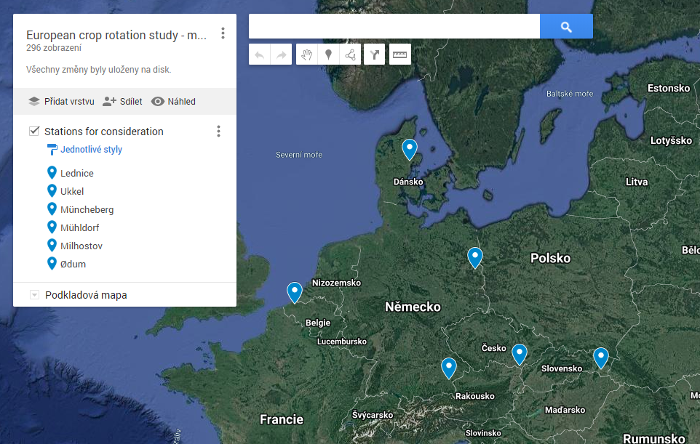

|  |  |  |  |
| --- | --- | --- | --- |
|  | Site | Country | Coordinates |
| 1 | Oedum | Denmark | 56.31192, 10.13425 |
| 2 | Muencheberg | Germany | 52.50691, 14.12816 |
| 3 | Muehldorf | Germany | 48.24577, 12.52198 |
| 4 | Ukkel | Belgium | 51.20934, 3.22469 |
| 5 | Milhostov | Slovakia | 48.66545, 21.70517 |
| 6 | Lednice | Czech Rep. | 48.79781, 16.79843 |

* **5 GCMs** (GFDL, HadGEM2, IPSL, MIROC5, NorESM1) in combination with 2 RCPs (2.6 and 8.5)
  + Weather files with transient climate change (1961-2010 measured, 2011-2080 synthetic); each GCM vs. RCP combination is represented by 20 realizations (01-20)
  + Corresponding CO2 atmospheric concentration is within the last column of the weather files at the beginning of each year.
  + For each prepared weather serie two types of meteorological files are distributed (within **“Weather”** folder): **“no_snow”** it is based directly on measurements and results of weather generator and **“snow_assumed”** – in this case moreover the SnowMAUS model (Trnka et al., 2010) was used to modify weather data due to expected influence of possible snow cover. If there is expected snow cover then the temperature and precipitation (assuming snow cover forming and snow melting) were modified.

**Snow cover should be assumed for all simulation:**

1. by the crop model itself (then “no_snow”)

or

2) using weather data modified by SnowMAUS (then “snow_assumed”).

* simulations for **2 soil profiles (see** **Europ_Crop_Rot_Soils.xlsx)** should be calculated at each of 6 station:

1. The same profile (kind of Cambisoil) for all stations (Universal soil, if abbreviated then as “univ”)
2. Corresponding site specific soil (if abbreviated, then as “spec”)

**Simulation scheme:**

* **Separate runs should by simulated as uninterrupted through period 1961-2080** (1961-1990 as spin-up period; 1991-2080 consequent period).
* **2 crop rotations scheme** (crops and cultivars are the same as for Czech Rep. study; in case of Maize use Cefran cultivar – i.e. based on calibration from Lednice and Verovany):

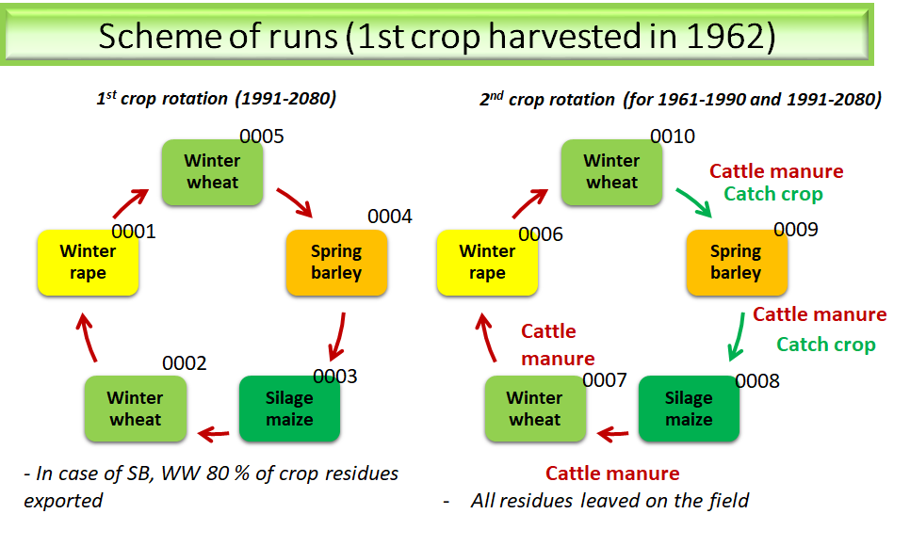

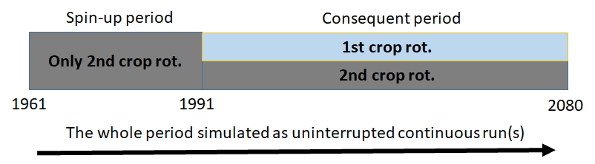

**Number of runs (for the period 1961-2080):**

**6 stations; 5 GCMs; 2 RCPs; 20 weather realizations; 2 soils; 2 crop rotations; 5 starting crops = 24 000 runs**

**Definition of agronomic management:**

Management should be used for sowing dates, fertilization dates and amount, timing for harvest and tillage. It is distributed as specified days and amounts.

(see: <ftp://Crop_rotations_modeling@ftp.czechglobe.cz/Europ_Crop_Rot/management>) (total 24 000 files describing the management for each run). It is divided into folders “spec” and “univ” based on soil profile, then for the stations.

Used abbreviations:

* sowing: Sowing date
* sowD: Day of the year for sowing
* harvY: year of harvest
* harvD: day of the year for the harvest (within harvY)
* till: tillage date (the depth is 20 cm).
* crop: cultivated crop (WRA – oilseed winter rape, WW – winter wheat, WRC – catch crop, SG – spring barley, SM –silage maize)
* Orgdat: date of organic fertilization
* Type: type of organic fertilization (now it is only RM for cattle manure in related cases)
* OrgN: Total N dose from manure application (in kg N/ha)
* NDat1 to NDat2: dates of mineral fertilization (up to three times during the season).
* N1 to N3: doses of mineral nitrogen per related application (kg N/ha)

Key for naming:

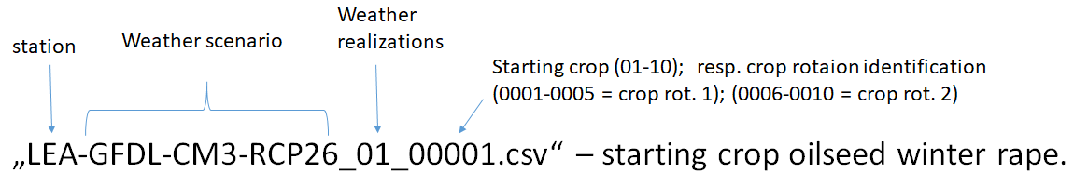

manure and tillage definition is within: ftp://Crop_rotations_modeling@ftp.czechglobe.cz/Europ_Crop_Rot/Manure_and_tillage_explanation.doc

**Initial simulation conditions:**

Initial soil conditions:

***3rd of January 1961***

**Nmin content** (kg Nmin/ha):

0-30cm 30

30-60cm 25

60-90cm 20

**Soil moisture 0-90cm**: Field capacity

**Corg** initialization in 1961 – according to defined soil profile where Corg is in % and 13% of soil organic matter is assumed as decomposable

**Outputs format and scheme:**

* it should be comma separated text files “.csv”
* For each of 24 000 runs two output files (.csv) should be delivered: 1) **Crop specific (1961-2080)** and 2) **yearly outputs (1961-2080)**.

For the papers, following outputs are required (in the quotes are the required “abbreviations” in the heading of each file; in the brackets is preferred format). Each crop or year on 1 line within .csv file.

**Crop specific outputs** (It should be comma separated text files “.csv”)**:**

* sowing date “sowing” (YYDDD or YYYYDDD)
* anthesis date “anthesis” (DDD)
* maturity data “matur” (DDD)
* harvest date “harv” (YYDDD or YYYYDDD)
* crop identification “crop” (WRA - winter rape, WW – winter wheat, SG – spring barley, SM – silage maize, WRC – catch crop)
* water and nutrient limited yields in kg/ha “yield” (*****)
* above ground biomass at harvest in kg/ha “biomass” (*****)
* root biomass at harvest in kg/ha “roots” (*****)
* Maximum leaf area index “LAImax” (**.*)
* Used fertilization in Kg N/ha “Nfertil” (***.*)
* Used irrigation in mm “irrig” (****) (*note: In this Phase all runs will be rainfed. This column will be here prepared for possible future exercises*)
* N-uptake at harvest in kg N/ha “N-uptake” (***.*)
* N in above ground biomass at harvest in Kg N/ha “Nagb” (***)
* Crop evapotranspiration under standard conditions ETc from sowing to harvest in mm “ETcG” (****)
* Actual evapotranspiration ETa from sowing to harvest in mm “ETaG” (****)
* Estimated transpiration from sowing to harvest in mm “TraG” (****)
* Sum of water percolation below depth 1,5 m from sowing to harvest in mm “PerG” (***)
* Soil water content at sowing in mm of available water for 0-30 cm “SWCS1” and 0-150 cm “SWCS2” (***)
* Soil water content at anthesis in mm of available water for 0-30 cm “SWCA1” and 0-150 cm “SWCA2” (***)
* Soil water content at maturity in mm of available water for 0-30 cm “SWCM1” and 0-150 cm “SWCM2” (***)
* Total soil N at harvest in kg/ha for 0-30 cm “soilN1” (***)
* Total soil N at harvest in kg/ha for 0-150 cm “soilN2” (***)
* Mineral soil N at harvest for 0-30 cm “Nmin1” (***)
* Mineral soil N at harvest for 0-150 cm “Nmin2” (***)
* N leaching below 150 cm from sowing to harvest in Kg N/ha “NleaG” (***)
* Average water stress parameter from sowing to maturity according to model “TRRel” (****)
* Average N stress parameter from sowing to maturity according to model “Reduk” (****)
* Number of days with ETa/ETc < 0.4 from sowing to anthesis „DryD1“ (***)
* Number of days with ETa/ETc < 0.4 from anthesis to maturity „DryD2“ (***)
* N in crop residues leaved on field except roots in Kg N/ha „Nresid” (*****)

If some output parameter is not available, indicator (**n.a.**) should be used.

**Yearly outputs** (It should be comma separated text files “.csv”):

* (for yearly totals hydrological type of year will be used so the values from the beginning of October to the end of September will be reported instead of 1st of January till end of December) (first year 1961 will be written within output files despite it is not whole hydrological year).

**Yearly outputs** file content:

* Year “Year” (YYYY)
* crop evapotranspiration under standard conditions from October to September in mm “ETcY” (***)
* actual evapotranspiration from October to September in mm “ETaY” (***)
* Transpiration from October to September in mm “TraY” (***)
* Sum of water percolation October-September below the depth 150 cm in mm “PerY” (***)
* Average soil water content October-September in mm of available water for 0-30 cm “SWCY1” and 0-150 cm “SWCY2” (***)
* Runoff October-September in mm “Runoff” (***)
* N leaching below the depth 150 cm October-September in Kg N/ha “NleaY” (***)
* Mineralization amount October-September in Kg N/ha “MINY” (***)
* Denitrification amount October-September in Kg N/ha “DENY” (***)
* Amonia volatilization amount October-September in Kg N/ha “VOLAT” (***)
* Soil organic carbon content for 0-30 cm in kg C/ha “SOC1” and for 0-150 cm “SOC2” for the September 30 of each year (******)

It should be delivered to ftp to “Results” into separate folder for used crop growth model and divided into the 2 folders according to soil “SPEC” soil and “UNIV” soil.

Example of outputs naming:

|  |  |  |
| --- | --- | --- |
| **Relevant input weather file:** | **Relevant output files:** | **Notes:** |
| CZLEDN~GFDL-CM3_RCP26_30~lq~trans-01.w6d *(01 at the end -> first realization of weather series)* | **C**LED-GFDL-RCP26_01_01.csv | **Crop specific output** file for the 1st realization of GFDL-RCP26 scenario; crop rotation 1*->* oilseed winter rape as starting crop sown at the autumn 1961 (harvested in 1962) |
|  | **Y**LED-GFDL-RCP26_01_01.csv | **Yearly output** file for the 1st realization of GFDL-RCP26 scenario; crop rotation 1*->* oilseed winter rape as starting crop sown at the autumn 1961 (harvested in 1962) |
|  | **C**LED-GFDL-RCP26_01_02.csv | **Crop specific output** file for the 1st realization of GFDL-RCP26 scenario; crop rotation 1*->* Winter wheat as starting crops sown in 1961 and harvested at 1962 |
|  | **Y**LED-GFDL-RCP26_01_02.csv | **Yearly output** file for the 1st realization of GFDL-RCP26 scenario; crop rotation 1*->* winter wheat as starting crops sown in 1961 and harv. at 1962 |
|  | **C**LED-GFDL-RCP26_01_06.csv | **Crop specific output** file for the 1st realization of GFDL-RCP26 scenario; crop rotation 2 and oilseed winter rape as starting crop sown at the autumn 1961 and harvested in 1962 |
|  | **Y**LED-GFDL-RCP26_01_06.csv | **Yearly output** file for the 1st realization of GFDL-RCP26 scenario; crop rotation 2 and oilseed winter rape as starting crop sown at the autumn 1961 and harvested in 1962. |
|  | … etc. |  |