**Methodology for study “Crop growth and soil processes modeling - the use of multi-model ensemble for crop rotations under recent and future climatic conditions”**

Aim:

**Phase 1** (divided into Step A, Step B) analysis focused on simulating effect of climate change on “real” crop rotations. In this way e.g. the ability of soils (in connection with climatic conditions and selected farming approach) to be source or sink of CO2 due to sequestration could be assessed. Simultaneously, expected trends in soil quality or soil water reserves could be assessed. Also expected yields (level and variability), above ground and root biomass will be estimated. The data, visualization methods and the whole chain of simulation results post-processing was developed and tested in the pilot study with Hermes model (e.g. Hlavinka et al., 2015).

Key steps:

**Step A (calibration)** **Model adjustment to the local conditions** using provided local appropriate soils, weather and crop data from three locations. The goal is to adjust model parameters for individual crops to fit as much as possible to local yield levels and agronomy practice. **Calibration is not meant to compare the model performance but to adjust models properties to the local condition using protocols that each modelling group routinely uses.** Combination of each defined year, crop and location should be simulated as a separate run (with defined initial soil moisture and mineral nitrogen content - see the file “crop_database_for_calibration_runs.xlsx”). There are data for 118 calibration runs (each year defined within one line separately) within mentioned Excel file (w. wheat - 50, barley - 29, maize - 26 and rape 13). Each run (both calibration and final runs) is assumed to be completely rainfed, without the influence of ground water.

Calibration runs:

* For each station specific soil profile will be used (defined within ***soil_description.xlsx*** file)
* Information about annual N deposition is defined for each of 3 locations (see last list of ***crop_database_for_calibration_runs.xlsx***).
* For the calibration, experimental data from ***crop_database_for_calibration_runs.xlsx*** file will be used (i.e. initial soil moisture and mineral nitrogen content, date of sowing, fertilization date and amount, observed phenology and yields). If the name of station is within grey cell, the year is not available for calibration. For initial soil moisture estimates SoilClim model (Hlavinka et al., 2011) was used considering C3 crop cultivation. Initial soil Nmin estimation is based on observed data within experimental locations in connection with previous experience based on Hermes model simulations.
* Extent of calibration database:

**Winter wheat** (cult. Samanta), 3 stations included, harvest years 1992-2008 (total of 50 runs)

* + Soil initial conditions estimated for the date 1st September

**Spring barley** (cult. Tolar), 3 stations included, harvest years 1997-2007 (total of 29 runs)

* + Soil initial conditions estimated for the date 1st November

**Silage maize** (cult. Cefran: Lednice 1999-2009, Věrovany 2002-2009; cult. Cingaro: Domaninek 2002-2009) (total of 26 runs)

* + Soil initial conditions estimated for the date 1st November

**Winter rape** (cult. Artus – for Domanínek 1999-2007, for Lednice 1999-2006, for Věrovany not available) (total of 13 runs)

* + Soil initial conditions estimated for the date 1st August

Study locations:

Calculations (calibration and final run 1961-2080) will be conducted at three locations (Fig. 1) within the Czech Republic: Lednice, Věrovany and Domanínek.

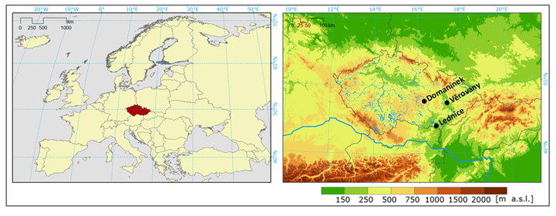

Fig. 1:

Table 1: List of the stations, their coordinates, altitudes, average annual temperatures and precipitation totals (±standard deviations).

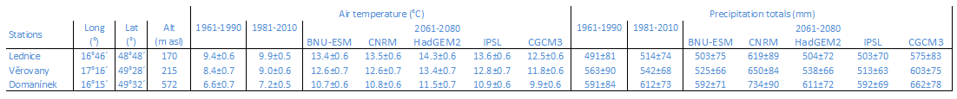

Weather will be represented by series for 1961-2080 (files with suffix “.w6d” containing daily solar radiation (MJ/m2/day), maximum and minimum temperature (°C), relative air humidity (%), wind speed (m/s), precipitation in (mm) and CO2 concentration (ppm) at the beginning of each year) generated by M&Rfi weather generator. The period 1961-2010 is represented by observed data. The period 2011-2080 is constructed using 5 scenarios based on 5 GCMs. Moreover variant “now” and “naw” will be prepared (now – means 1961-2010 measured, 2011-2080 the same statistical characteristics of climate data as 1981-2010 with increasing CO2; naw - means 1961-2010 measured, 2011-2080 the same statistical characteristics of climate data as 1981-2010 with increasing CO2 up to 2010 and after 2010 CO2 is constant). Each scenario (series 2011-2080) will be represented by 20 realizations.

Example for Domanínek - global circulation model “CNRM-CM5” RCP8.5 1st to 20th realization is named:

“DOM-CNRM-CM5-RCP85_01.w6d” to “DOM-CNRM-CM5-RCP85_20.w6d”

And examples for Věrovany and Lednice 1st realization is:

“VER-CNRM-CM5-RCP85_01.w6d” and “LED-CNRM-CM5-RCP85_01.w6d”.

And examples for “now” and “naw” 1st realization:

“DOM-now_01.w6d” and “DOM-naw_01.w6d”

For all prepared weather series two types of meteorological files will be distributed: **“no_snow_cover_assumed”** as it based directly on measurements and results of weather generator and **“snow_cover_assumed”** – in this case moreover the SnowMAUS model (Trnka et al., 2010) is used to modify weather data due to expected influence of possible snow cover. If there is expected snow cover, temperature and precipitation (assuming snow cover forming and snow melting) were modified. For these two types of weather series separate folders will be used (see the example of distributed data).

**Snow cover should be assumed for all simulation:**

1. by the crop model itself

or

2) using weather data modified by SnowMAUS.

Results from calibration runs (STEP A) should be delivered in format - **crop specific outputs.**

In case of calibration runs **crop specific outputs** (description below) files should be divided into four folders named: “Barley”, “Wheat”, “Maize” and “Rape”. The separate output files for each station should be named “CLED.CSV”, “CVER.CSV”, “CDOM.CSV”. And it should be comma separated text files “.csv”.

For the joint paper we will require following outputs describing calibration results:

* in the quotes are the required “abbreviations” in the heading of each file
* in the brackets is preferred format

**Crop specific outputs:**

* sowing date “sowing” (YYDDD or YYYYDDD)
* anthesis date “anthesis” (DDD)
* maturity data “matur” (DDD)
* harvest date “harv” (YYDDD or YYYYDDD)
* crop identification “crop” (WRA - winter rape, WW – winter wheat, SG – spring barley, SM – silage maize, WRC – catch crop)
* water and nutrient limited yields in kg/ha “yield” (*****)
* above ground biomass at harvest in kg/ha “biomass” (*****)
* root biomass at harvest in kg/ha “roots” (*****)
* Maximum leaf area index “LAImax” (**.*)
* Used fertilization in Kg N/ha “Nfertil” (***.*)
* Used irrigation in mm “irrig” (****) (*note: In the Phase 1 (both step A and step B) all runs will be rainfed. This column will be here prepared for future runs e.g. as Phase 2*)
* N-uptake at harvest in kg N/ha “N-uptake” (***.*)
* N in above ground biomass at harvest in Kg N/ha “Nagb” (***)
* Crop evapotranspiration under standard conditions ETc from sowing to harvest in mm “ETcG” (****)
* Actual evapotranspiration ETa from sowing to harvest in mm “ETaG” (****)
* Estimated transpiration from sowing to harvest in mm “TraG” (****)
* Sum of water percolation below depth 1,5 m from sowing to harvest in mm “PerG” (***)
* Soil water content at sowing in mm of available water for 0-30 cm “SWCS1” and 0-150 cm “SWCS2” (***)
* Soil water content at anthesis in mm of available water for 0-30 cm “SWCA1” and 0-150 cm “SWCA2” (***)
* Soil water content at maturity in mm of available water for 0-30 cm “SWCM1” and 0-150 cm “SWCM2” (***)
* Total soil N at harvest in kg/ha for 0-30 cm “soilN1” (***)
* Total soil N at harvest in kg/ha for 0-150 cm “soilN2” (***)
* Mineral soil N at harvest for 0-30 cm “Nmin1” (***)
* Mineral soil N at harvest for 0-150 cm “Nmin2” (***)
* N leaching below 150 cm from sowing to harvest in Kg N/ha “NleaG” (***)
* Average water stress parameter from sowing to maturity according to model “TRRel” (****)
* Average N stress parameter from sowing to maturity according to model “Reduk” (****)
* Number of days with ETa/ETc < 0.4 from sowing to anthesis „DryD1“ (***)
* Number of days with ETa/ETc < 0.4 from anthesis to maturity „DryD2“ (***)
* N in crop residues leaved on field except roots in Kg N/ha „Nresid” (*****)
* If some output parameter is not available, indicator (n.a.) should be used.

**Step B (final 120 years runs).** The **crop rotation itself based on cultivars and adjustment from Step A** will be conducted as 30 years spin up (1961-1990) uninterrupted rotations (for spin up period 2nd crop rotation should be used exclusively) and 90 year runs (1991-2080) using initial conditions (soil Corg pools, soil Nmin, soil moisture) from the end of spin up period. Two types of crop rotation will be simulated from 1991: one showing "biomass intensive" (i.e. 1st crop rotation) and other "best-practice" (2nd crop rotation). Former tries to maximize short term gain by taking most of the biomass out of the field while the second tries to preserves soil organic matter or even increase it. Each crop model should be then run with both crop rotation types for RCP scenario 8.5.

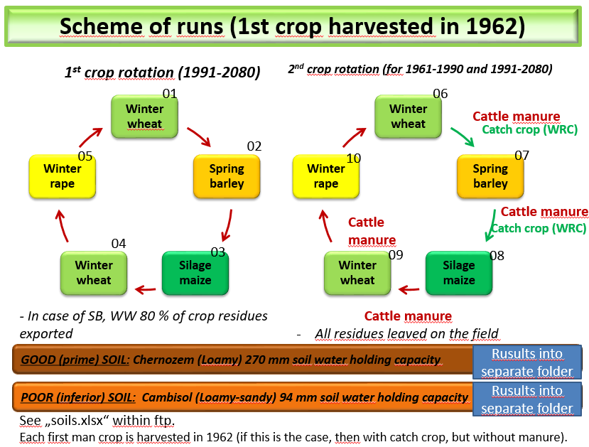

Fig 2: 01-10 indicate the crop rotation (1st crop rotation - CR1 = 01-05; 2nd rotation = CR2: 06-10) and starting crop of the whole simulations. **Each first main crop is harvested in 1962.**

(For more details and example see: <ftp://Crop_rotations_modeling@ftp.czechglobe.cz/management>)

All info for STEP B:

ftp account:

FTP Host:           [ftp.czechglobe.cz](http://ftp.czechglobe.cz/)  
FTP Port:           21 (default)  
Login Name:         Crop_rotations_modeling  
Password:           eiveingohl

* Corg initialization in 1961 – according to defined soil profile where Corg is in % and 13% of soil organic matter is assumed as decomposable
* Soil Moisture inicialization in 1961 – start from field capacity at the beginning of 1961
* Soil Mineral N inicialization in 1961– start from 40 kg Nmin/ha for 0-40 cm depth and 40 kg Nmin/ha for 40-150 cm at the beginning of 1961

For Step B (1961-1990 and 1991-2080) two crop rotations (CR 1 and CR 2) are defined and simulated. These rotations have the same duration (5 years cycle) and the same sequence of main crops: spring barley – silage maize – winter wheat – winter oil seed rape – winter wheat. In the case of CR 1, there are no assumed catch crops between the main crops; only mineral fertilization used and 80% of the crop residues are exported from the field after harvest (except silage maize and winter rape). For CR 2, the sequence of the main crops is the same as for CR 1, but between winter wheat and spring barley and between spring barley and maize, catch crops (abbreviated as WRC) should be simulated. The catch crop parameters should be adjusted to resemble the properties of vegetation (especially water consumption and biomass production) similar to those of oil-seed rape. In the case of CR 2, all the crop residues after harvest remained on the field. In addition to nitrogen mineral fertilizer, 40 tons of cattle manure is applied after the main crops (except after winter rape). **After the harvest of all the crops, tillage up to 20 cm was performed to incorporate the crop residues for both CR 1 and CR 2.**

For cattle manure specification

(see: ftp://Crop_rotations_modeling@ftp.czechglobe.cz/Automan_and_manure_explanation.doc)

The outputs from final runs will be the same as for calibration i.e. **Crop specific outputs** (with modified naming – see below). Moreover there will be separated files for annual outputs **Yearly outputs** (for more details see below). It should be divided into the folders (Good soil and Poor soil)

Automatic management should be used for sowing dates, fertilization dates and amount (as best agronomical practice), harvest and tillage.

It could be left on each modeller to adopt algorithm. Or it is distributed as specified days and amounts (if it is the case) – based on Hermes calculations.

(see: <ftp://Crop_rotations_modeling@ftp.czechglobe.cz/Automan_and_manure_explanation.doc>)

(for data according to HERMES see: <ftp://Crop_rotations_modeling@ftp.czechglobe.cz/management>)

**Yearly outputs** (It should be comma separated text files “.csv”):

* (for yearly totals hydrological type of year will be used so the values from the beginning of October to the end of September will be reported instead of 1st of January till end of December) (first year 1961 will be written within output files despite it is not whole hydrological year).

**Yearly outputs** file content:

- Year “Year” (YYYY)

- crop evapotranspiration under standard conditions from October to September in mm “ETcY” (***)

- actual evapotranspiration from October to September in mm “ETaY” (***)

- Transpiration from October to September in mm “TraY” (***)

- Sum of water percolation October-September below the depth 150 cm in mm “PerY” (***)

* Average soil water content October-September in mm of available water for 0-30 cm “SWCY1” and 0-150 cm “SWCY2” (***)
* Runoff October-September in mm “Runoff” (***)
* N leaching below the depth 150 cm October-September in Kg N/ha “NleaY” (***)
* Mineralization amount October-September in Kg N/ha “MINY” (***)
* Denitrification amount October-September in Kg N/ha “DENY” (***)
* Amonia volatilization amount October-September in Kg N/ha “VOLAT” (***)
* Soil organic carbon content for 0-30 cm in kg C/ha “SOC1” and for 0-150 cm “SOC2” for the September 30 of each year (******)

Example of Step B outputs naming: List of runs will be added.

|  |  |  |
| --- | --- | --- |
| **Relevant input weather file:** | **Relevant output files:** | **Notes:** |
| LED-CNRM-CM5-RCP85_01.w6d *(01 at the end -> first realization of weather series)* | **C**LED-CNRM-CM5-RCP85_01_01.csv | **Crop specific output** file for the 1st realization of CNRM-CM5-RCP85 scenario; crop rotation 1*->* winter wheat as starting crop sown at the autumn 1961 (harvested in 1962) |
|  | **Y**LED-CNRM-CM5-RCP85_01_01.csv | **Yearly output** file for the 1st realization of CNRM-CM5-RCP85 scenario; crop rotation 1*->* winter wheat as starting crop sown at the autumn 1961 (harvested in 1962) |
|  | CLED-CNRM-CM5-RCP85_01_02.csv | **Crop specific output** file for the 1st realization of CNRM-CM5-RCP85 scenario; crop rotation 1*->* spring barley as starting crops sown and harvested at 1962 |
|  | YLED-CNRM-CM5-RCP85_01_02.csv | **Yearly output** file for the 1st realization of CNRM-CM5-RCP85 scenario; crop rotation 1*->* spring barley as starting crops sown and harv. at 1962 |
|  | CLED-CNRM-CM5-RCP85_01_06.csv | **Crop specific output** file for the 1st realization of CNRM-CM5-RCP85 scenario; crop rotation 2 and winter wheat as starting crop sown at the autumn 1961 and harvested in 1962 |
|  | YLED-CNRM-CM5-RCP85_01_06.csv | **Yearly output** file for the 1st realization of CNRM-CM5-RCP85 scenario; crop rotation 2 and winter wheat as starting crop sown at the autumn 1961 and harvested in 1962. |
|  | … etc. |  |
| LED-CNRM-CM5-RCP85_02.w6d *(02 at the end -> second realizat. of weather series)* | CLED-CNRM-CM5-RCP85_02_01.csv | **Crop specific output** file for the 2nd realization of CNRM-CM5-RCP85 scenario; crop rotation 1; winter wheat as starting crops sown at the autumn 1961 and harvested in 1962 |
|  | YLED-CNRM-CM5-RCP85_02_01.csv | **Yearly output** file for the 2nd realization of CNRM-CM5-RCP85 scenario; crop rotation 1; winter wheat as starting crops sown at the autumn 1961 and harvested in 1962 |
|  | … etc | … etc |
| LED-naw_01.w6d  *(first realization for “naw” weather serie)* | CLED-naw_01_01.csv | **Crop specific output** file for the 1st realization of “naw”; crop rotation 1*->* winter wheat as starting crop sown at the autumn 1961 and harvested in 1962 |
|  | YLED-naw_01_01.csv | **Yearly output** file for the 1st realization of “naw”; crop rotation 1*->* winter wheat as starting crop sown at the autumn 1961 and harvested in 1962 |
| …. etc | … etc | … etc |

* **List of used weather data each covering period 1961-2080, from 2011 each scenario represented by 20 realizations.**

|  |  |
| --- | --- |
| climate scenarios (used RCP8.5) | |
| 1 | naw * |
| 2 | now * |
| 3 | MRI-CGCM3 (GCM) |
| 4 | IPSL-CM5A-MR (GCM) |
| 5 | HADGEM2-ES (GCM) |
| 6 | CNRM-CM5 (GCM) |
| 7 | BNU-ESM (GCM) |

**\* naw – means 1961-2010 measured, 2011-2080 the same statistical characteristics of climate data as 1981-2010 with increasing CO2 up to 2010 and after 2010 CO2 is constant**

**\* now - means 1961-2010 measured, 2011-2080 the same statistical characteristics of climate data as 1981-2010 with increasing CO2 according to RCP 8.5**

**For assumed CO2 concentrations see: ftp://Crop_rotations_modeling@ftp.czechglobe.cz/weather/RCP_85.co2**

* **List of runs (distributed within ftp as separate xls. file**

**References:**

Hlavinka, P., Kersebaum, K.Ch., Dubrovský, M., Fischer, M., Pohanková, E., Balek, J., Žalud, Z., Trnka, M., 2015. Water balance and drought stress for field crop rotations in present and future conditions. *Climate Research*, (under revisions)

Hlavinka, P., Trnka, M., Balek, J., Semerádová, D., Hayes, M., Svoboda, M., Eitzinger, J., Možný, M., Fischer, M., Hunt, E., Žalud, Z.,2011. Development and evaluation of the SoilClim model for water balance and soil climate estimates. *Agricultural Water Management* 98: 1249-1261.

Trnka, M., Kocmánková, E., Balek, J., Eitzinger, J., Ruget, F., Formayer, H., Hlavinka, P., Schaumberger, A., Horáková, V., Možný, M., Žalud,Z., 2010. Simple snow cover model for agrometeorological applications. *Agricultural and Forest Meteorology* 150: 1115–1127.