Improving the simulation of evapotranspiration in crop models across diverse environments

Background: Droughts are recurring natural hazards that directly or indirectly affect agriculture, food security, water supply and quality, terrestrial ecosystems. Accurate simulation of crop water use is essential for agriculture water management and understanding risks posed by drought stress under variable rainfall patterns. Despite its importance, model projections of crop evapotranspiration (ET) remain subject to high uncertainty. Previous work in semi-arid and Mediterranean environments found that the crop model median underestimated daily water use (Webber et al., 2025). It was suggested that this error was linked to an underestimation of atmospheric demand and inaccuracies in simulating peak LAI, especially when the canopy was fully developed and actively transpiring. These results were promising in that uncertainty was not primarily related to soil processes, which are complex to model. However, identifying opportunities to improve simulation of evaporative demands is also not straightforward as simulated ET interacts with many other growth processes. For wheat, very few studies have systematically evaluated the performance of crop models in simulating water use. This represents a significant gap in our ability to reliably project crop water needs under future scenarios and high uncertainty about future crop yields as climate change intensifies atmospheric water demand. A primary obstacle to improving such projections is a lack of high quality, observational ET data across diverse environments for model calibration and evaluation. Although eddy covariances methods are currently the most effective technique for measuring surface ET, such datasets are not widely available for arable agricultural systems (Bazzi et al., 2024; Saunders et al., 2018).
Goal and objectives: The overarching aim is to quantify wheat crop water use across world regions under climate change and quantify the implications for wheat yields. The specific objectives include to:
- Objective 1: improve crop models’ ability to simulate atmospheric water demand (reference crop ET, ET₀, and potential ET, ET_{p})
- Objective 2: evaluate crop models’ ET projections across a wide range of environments and production conditions
- Objective 3: project changes in wheat crop water demand and use and crop yield under climate change and quantify the degree of error in previous projections
Study overview: This study builds on the previous AgMIP wheat ET study, which evaluated model performance and assessed the conditions contributing the greatest errors in daily ET simulations for two environments. This study consists of three phases (Fig. 1). The first phase (Phase 1) focuses on improving approaches to simulate atmospheric demand (e.g, ET₀ and ET_{P}) through code comparison and sensitivity analysis supported by the Crop2mL platform. The results of Phase 1 are anticipated to be reported in a first paper, highlighting the value of Crop2ML in supporting model improvement and providing insights into parameter sensitivity across models and environments. In Phase 2, the improved models from Phase1 will be used to quantify model skill in simulating crop water use and growth for a range of environments in blind and full data steps (Fig. 2). The evaluation is across 22 globally distributed sites with differing levels of data availability. Beyond a benchmarking of individual model skill, an assessment of the ensemble skill will be conducted, as well an analysis of the drivers of model error. In the third phase (Phase 3), simulations across the AgMIP Wheat global sites will be used to assess water use and projected yields under climate change. The findings of Phases 2 and 3 are intended to be jointly reported in a second paper. A full overview of all datasets to be used are provided in Table 1.

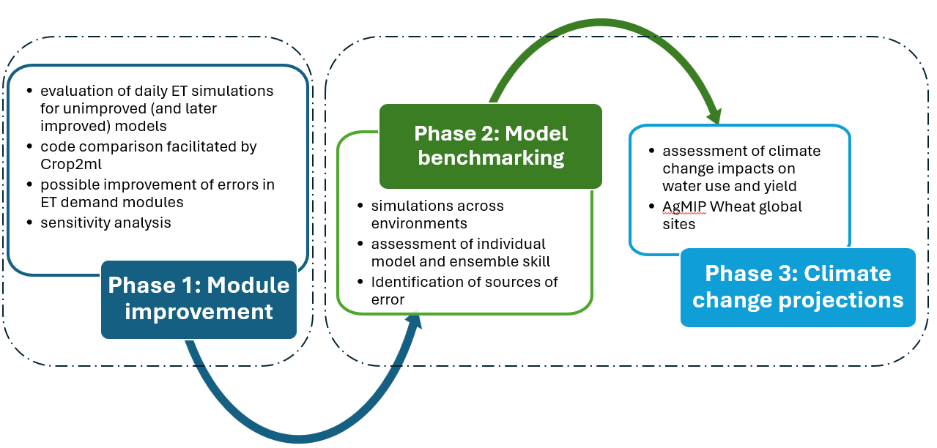
Figure 1. ET study overview showing the three planned studies covering model improvement, model performance benchmarking and a global impact assessment.

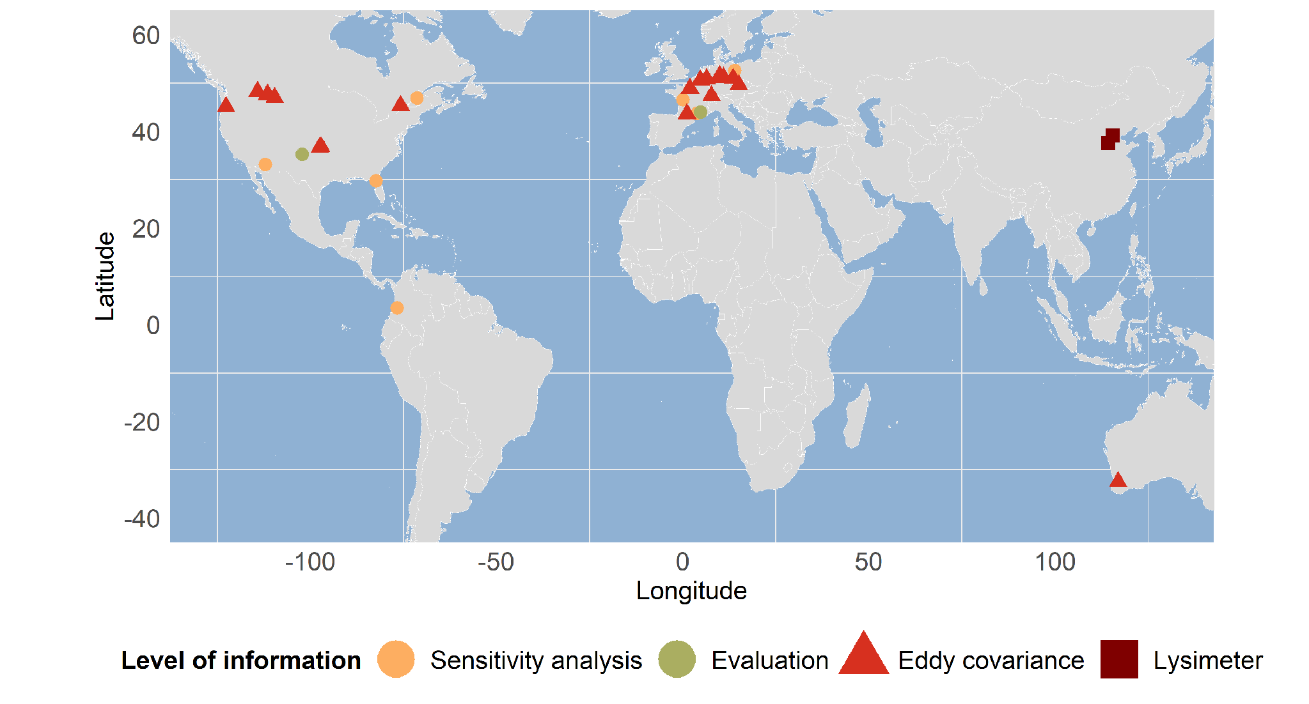
Figure 2. Locations to be simulated in the sensitivity analysis and evaluation of Phase 1 are shown as the orange and green circles, respectively. The various datasets to be used for benchmarking in Phase 2 are shown as red triangles and brown squares for lysimeter and eddy covariance stations, respectively.

Table1. Experimental datasets to be used in the various phases, indicating their purpose, and main data types.
Phase | Purpose | Site name | Types of data
1 | Evaluation | Bushland; Avignon | Crop growth, LAI, ET, env
1 | Sensitivity analysis | USGA; DEMU; COCA; FRLU; USMA; FROM; CAQC | Weather data
2 | Evaluation | CA-Ottawa; FR-Gri; Bushland; Avignon | Crop growth, LAI, phenology, ET, env
2 | Detailed benchmarking for water use and growth | BE-lon; DE-Geb; DE-Kli; CH-Oe2; DE-Rus; FR-Aur; FR-Lam; CZ-Krp; DE-Rns; AU-Queensland | Crop growth, LAI, ET, env
2 | Benchmarking for water use | CHN-Luancheng; CHN-Gucheng; US-MSR; US-MVM; US-MC1; US-Mj1; US-Wwt; US-Pon; US-ARM | ET
3 | Global assessment | 60 AgMIP Wheat study sites (Asseng et al., 2017) | Weather, soil, basic management

Simulation protocols: Protocols are available for each phase and provide detailed information about how to conduct the simulations, access datasets, format output variables and submit simulations. The various protocols will be updated and available at:
Phase 1:
https://docs.google.com/document/d/1Mluuzrq1X36YzOc7R5JqhrButTG9nQs1/edit?usp=drive_link&ouid=117829671140321734260&rtpof=true&sd=true
Phase 2:
https://docs.google.com/document/d/1BYlkdqemCUOUS-E3z-ih3XnemU9e82ym/edit?usp=drive_link&ouid=117829671140321734260&rtpof=true&sd=true
Phase 3:
https://docs.google.com/document/d/15AS72lTFh3wdMfK2cbKVEV8G6Y5B4nGk/edit?usp=drive_link&ouid=117829671140321734260&rtpof=true&sd=true

Proposed timeline
Phase | Item | Date
1 | Protocol launch | September 2026
1 | Draft paper | January 2027
2 | Protocol launch | March 2027
2 | All simulations complete | July 2027
3 | Protocol launch | July 2027
3 | Simulations complete | October 2027
3 | Draft paper | February 2028

Contacts: If you are interested to join the study, please contact Xinxin Chen and Heidi Webber at chen.xinxin@zalf.de and webber@zalf.de, respectively.

Asseng S, Martre P, Maiorano A, et al. Climate change impact and adaptation for wheat protein. Glob Change Biol. 2019; 25: 155–173. https://doi.org/10.1111/gcb.14481

