Master Student Guide – Python Essentials (Sets G, H, J)

Welcome
This guide is designed to help you succeed in the Python Essentials modules delivered across Sets G, H, and J. It explains the overall structure, weekly schedule, how to use the learning materials, and how to submit your work correctly. Following this guide will ensure you stay on track and meet all academic requirements.

Course Timeline (8 Weeks)
The course is structured into 4 modules, following a 1–2–3–2 week pacing model:
- Module 1: 1 week (2 classes)
- Module 2: 2 weeks (4 classes)
- Module 3: 3 weeks (6 classes)
- Module 4: 2 weeks (4 classes)
Readings are split across two classes to give you time to understand concepts and complete logbook entries. Labs and quizzes follow readings, and Micro Projects close each major module.
The following chart shows the 8-week plan for Sets G, H, and J:
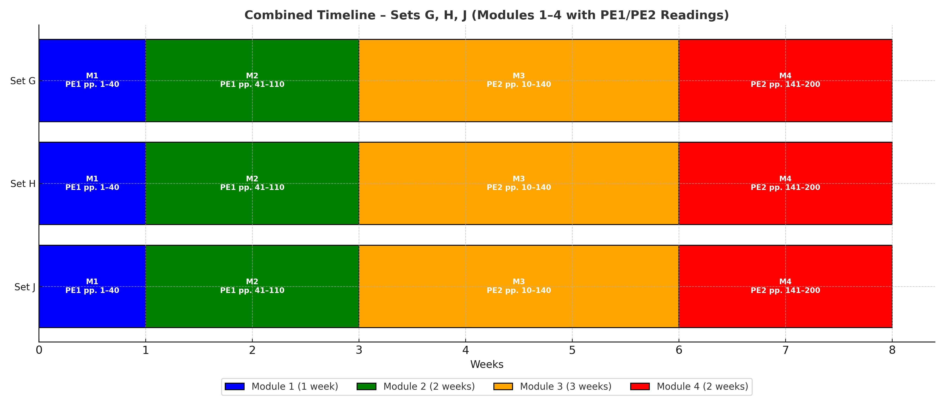

Learning Materials
- TaskSheets (DOCX): Self-guided activities with reading assignments (PE1/PE2), logbook prompts, and lab/project tasks.
- AnswerSheets (DOCX): Templates where you write your responses to labs and projects.
- Logbook (CSV): Record reading notes, page numbers, code experiments, and reflections.
- Rubrics: Show how your work will be graded, so you know what is expected.
- Instructor Solutions: Provided for review after deadlines, to compare with your work.

Submission Workflow
1. Complete the assigned TaskSheet and AnswerSheet for the current lab/project.
2. Record your reading notes and page numbers in the Logbook.
3. Save your code, test results, and screenshots in an evidence folder.
4. Use the Student App to generate a submission.json file (this proves authenticity).
5. Upload your submission.json and your evidence folder to D2L before the deadline.

Academic Integrity
All submissions must be your own work. You are required to provide evidence including logbook entries, screenshots, and test results. Dummy or AI-generated labs will not be accepted. Your instructor will use verification tools to cross-check all evidence and ensure fairness.

Weekly Checklist
Before each class, make sure you have:
- Completed the required PE1/PE2 readings (with page numbers noted in your logbook).
- Recorded at least two examples or reflections in your logbook.
- Prepared for an adaptive quiz (based on previous readings).
- Attempted any assigned labs or project tasks.
- Gathered your evidence files (code, tests, screenshots).
- Checked deadlines for D2L submissions.

Final Note
Stay consistent with your logbook, follow the TaskSheets carefully, and always submit complete evidence. If you encounter difficulties, reach out to your instructor early. This course is designed to help you develop strong foundational skills in Python and cloud-based learning practices.

