Q1.

Code:

|  |
| --- |
| ***package Q_01;***  ***public class Q_01 {***  ***public static void main(String[] args) {***  ***int a=10,b=20,c=30,x=10,y=5,r=7;***  ***//Q_01_a***  ***System.out.println("square root of B^2+4AC is : "+Math.sqrt( b*b+4*a*c ));***  ***//Q_01_b***  ***System.out.println("square root of X+4Y^3 is : "+Math.sqrt(x+4*(Math.pow(y,3))));***  ***//Q_01_c***  ***System.out.println("cube root of X*Y is : "+Math.cbrt(x*y));***  ***//Q_01_d***  ***System.out.println("area of a circle is : "+Math.PI*r*r);***  ***}***  ***}*** |

Output:

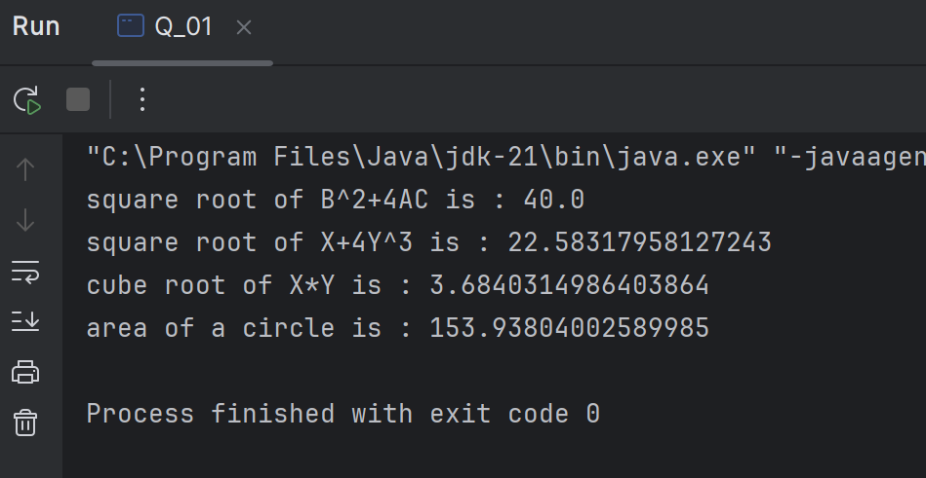

Q2.

Code:

|  |
| --- |
| ***package Q_02;***  ***import java.util.Scanner;***  ***public class Q_02 {***  ***public static void main(String[] args) {***  ***Scanner scanner= new Scanner(System.in);***  ***System.out.println("enter centermeter:");***  ***double c=scanner.nextDouble();***  ***double inch= c/2.54;***  ***int feet= (int) (inch/12);***  ***int binch = (int) (inch%12);***  ***System.out.println(feet+" :Feets and "+binch+":inches");***  ***}***  ***}*** |

Output:

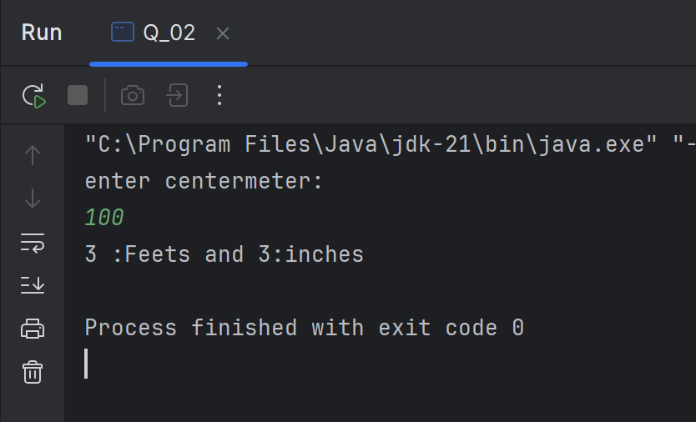

Q3.

Code:

|  |
| --- |
| ***package Q_03;***  ***import java.util.Scanner;***  ***public class Q_03 {***  ***public static void main(String[] args) {***  ***Scanner scanner= new Scanner(System.in);***  ***System.out.println("enter Celsius :");***  ***double c=scanner.nextDouble();***  ***double f= (1.8*c)+32;***  ***System.out.println("Fahrenheit: "+f);***  ***}***  ***}*** |

Output:

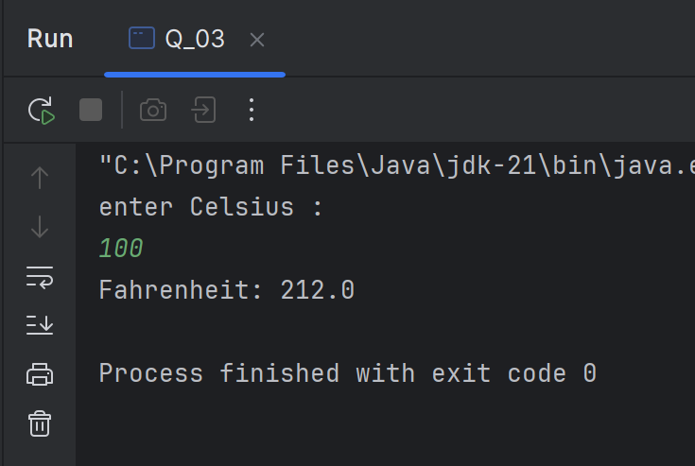

Q4.

Code:

|  |
| --- |
| ***package Q_04;***  ***import java.util.Scanner;***  ***public class Q_04 {***  ***public static void main(String[] args) {***  ***Scanner scanner= new Scanner(System.in);***  ***System.out.println("enter body weight in Pound(lb) :");***  ***double pound=scanner.nextDouble();***  ***double cal= pound*19;***  ***System.out.println("calories per day: "+cal);***  ***}***  ***}*** |

Output:

Q5.

Code:

|  |
| --- |
| ***package Q_05;***  ***import java.util.Scanner;***  ***public class Q_05 {***  ***public static void main(String[] args) {***  ***Scanner scanner= new Scanner(System.in);***  ***System.out.println("enter Fahrenheit :");***  ***double fah=scanner.nextDouble();***  ***double cel=(fah-32)/1.8;***  ***System.out.println("Celsius: "+cel);***  ***}***  ***}*** |

Output:

Q6.

Code:

|  |
| --- |
| ***package Q_06;***  ***import java.time.Year;***  ***import java.util.Scanner;***  ***public class Q_06 {***  ***public static void main(String[] args) {***  ***Scanner scanner= new Scanner(System.in);***  ***System.out.println("enter born year:");***  ***int year=scanner.nextInt();***  ***int currentYear = Year.now().getValue();***  ***int age= currentYear-year;***  ***System.out.println("You were born in "+year+" and will be (are) "+age+" this year.");***  ***}***  ***}*** |

Output:

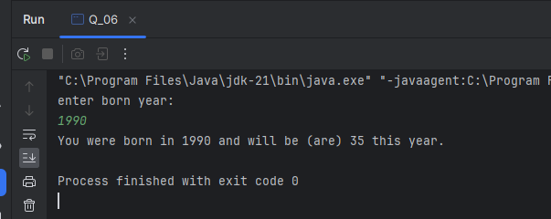

Q7.

Code:

|  |
| --- |
| ***package Q_07;***  ***import java.util.Map;***  ***import java.util.Scanner;***  ***public class Q_07 {***  ***public static void main(String[] args) {***  ***Scanner scanner= new Scanner(System.in);***  ***System.out.println("enter weight in KG:");***  ***int w=scanner.nextInt();***  ***System.out.println("enter height cm:");***  ***int h=scanner.nextInt();***  ***double bmi=w/Math.pow((double) h /100,2);***  ***if (bmi>20 && bmi<25)***  ***System.out.println("You BMI is Normal : "+bmi);***  ***else***  ***System.out.println("You BMI is : "+bmi);***  ***}***  ***}*** |

Output:

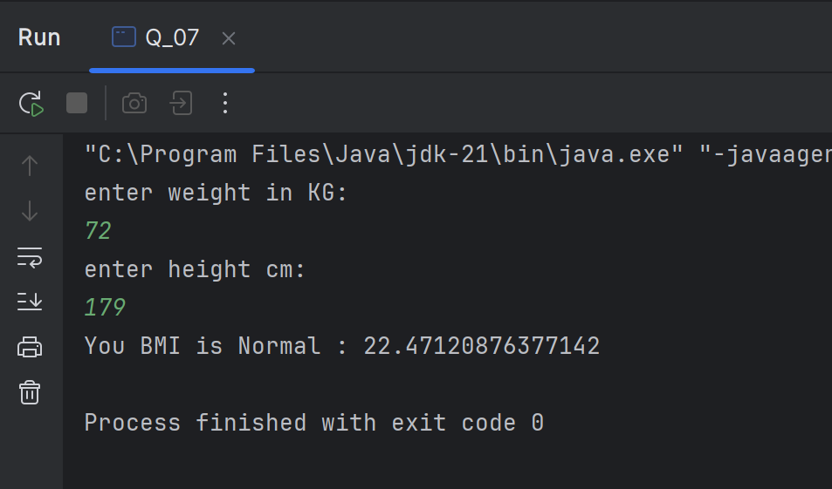

Q8.

Code:

|  |
| --- |
| ***package Q_08;***  ***import java.util.Scanner;***  ***public class Q_08 {***  ***public static void main(String[] args) {***  ***Scanner scanner = new Scanner(System.in);***  ***double pi=3.14;***  ***System.out.println("Enter sphere radius in cm:");***  ***double r= scanner.nextDouble();***  ***double v=((double) 4 /3)*(pi*Math.pow(r,3));***  ***System.out.println("The sphere volume is : "+v+" cm^3");***  ***}***  ***}*** |

Output:

Q9.

Code:

|  |
| --- |
| ***package Q_09;***  ***import java.util.Scanner;***  ***public class Q_09 {***  ***public static void main(String[] args) {***  ***Scanner scanner = new Scanner(System.in);***  ***System.out.println("Enter amount of invest doller:");***  ***int p= scanner.nextInt();***  ***System.out.println("Enter annual interest rate:");***  ***int r= scanner.nextInt();***  ***System.out.println("Enter No years:");***  ***int n= scanner.nextInt();***  ***double amount = p*Math.pow((1+((double) r /100)),n);***  ***double earn= amount - p;***  ***System.out.println("Amount earned after "+n+" years is : "+earn+" dollars");***  ***}***  ***}*** |

Output:

Q10.

Code:

|  |
| --- |
| ***package Q_10;***  ***import java.util.Scanner;***  ***public class Q_10 {***  ***public static void main(String[] args) {***  ***Scanner scanner = new Scanner(System.in);***  ***System.out.println("Input loan amount :");***  ***int lamount = scanner.nextInt();***  ***System.out.println("Input annual interest rate :");***  ***double arate = scanner.nextInt();***  ***System.out.println("Input loan period in years :");***  ***int lperi = scanner.nextInt();***  ***double monthlyInterestRate = arate / 100.0 / 12;***  ***int numberOfPayments = lperi * 12;***  ***double monthlyPayment = (lamount * monthlyInterestRate) / (1-Math.pow(1/(1+monthlyInterestRate),numberOfPayments));***  ***double totalPayment = monthlyPayment * numberOfPayments;***  ***System.out.println("Your monthly loan payment is : "+monthlyPayment);***  ***System.out.println("Your total loan payment is : "+totalPayment);***  ***}***  ***}*** |

Output:

