Data Management, Winter 2026/27 - Group Project
From Raw Race Results to a FAIR, Quality-Assured Knowledge Graph
Formula 1 World Championship results 1950-2025: FAIR assessment, data quality profiling, reproducible cleaning, property-graph analytics and an interactive dashboard

Group member | Presents
Chirag Adhikari | Component A - FAIR assessment and metadata design
Manohar Zalki | Component B - Data quality and profiling
Nicolas Bonilla | Component C - Data cleaning and pipeline

All three members worked jointly on every component; the table shows who presents each block.
SRH University | Submission date: [to be completed]
Repository: https://github.com/zalkimanohar/Formula1-Racing-Analytics (folders data_management_project and dashboard)
Interactive dashboard: streamlit run app.py in the dashboard folder, then http://localhost:8501 (Section 6)
Word count (main text, excluding tables, figure captions, references and appendices): 3,412. Component sections: A 493, B 446, C 420 words.

1. Introduction
Formula 1 has kept a classified result for every car since the first World Championship Grand Prix at Silverstone on 13 May 1950. The community-built Ergast database, now served by the Jolpica-F1 project after Ergast closed in 2024, is the de facto open source of these records and underpins countless analytics projects, including our group's own Formula1-Racing-Analytics repository. We chose it for three reasons. First, it is large and relational: the fact table holds 25,907 rows and 14 variables (one row per driver entry per Grand Prix, 76 seasons), linked to four reference tables (1,178 races, 82 circuits, 874 drivers and 214 constructors). Second, it contains genuine, non-trivial quality problems that come from 76 years of changing rules and from the way the files were exported. Third, drivers, teams, circuits and countries form a natural network, which makes the data well suited to property-graph modelling.
The domain also makes data management visible. Teams, broadcasters, journalists and a growing number of machine-learning projects that predict race outcomes all reuse these records, usually without asking how they were produced. A record that counts a retirement as '18th place' or a race twice does not stay local: it propagates into rankings, features and models. The dataset is therefore a realistic test case for the whole data-management life cycle, from assessing how findable and reusable the source is to delivering a documented, validated and linked product.
The raw package (racing_f1_data.zip) was downloaded by the group from the Jolpica API and mixes JSON Lines, pretty-printed JSON and CSV files. The same Ergast data are mirrored on Kaggle, an approved source type, and Component A evaluates both copies. Sprint races use a different session format and are out of scope; the analysis covers championship Grands Prix only.
All work follows one reproducible pipeline (Table 1). Step 0 flattens the archive into raw CSV files without changing a single value and records a SHA-256 manifest. Component B profiles the raw data and writes a quality issue register; Component C resolves every registered issue in an audited and validated cleaning pipeline; Component A assesses FAIRness and describes the cleaned package with standard metadata; the graph model is built from the cleaned data; and the last stage feeds an interactive dashboard (Section 6). One command (python run_all.py --from-scratch) rebuilds everything, dashboard included, in about 90 seconds, and two independent runs produce byte-identical files.
Table 1. Pipeline overview (run_all.py); every stage reads only the outputs of the stages before it.
Stage | Input | Output | Key result
0 Extraction | racing_f1_data.zip (93 files) | 5 raw CSV files + checksum manifest | 25,907 results, values unchanged
B Profiling | raw CSV files | issue register, profiles, 4 figures | 29 issues, 7 dimensions
C Cleaning | raw CSV + issue register | 5 clean CSV files, audit log, validation report | 25,873 rows, 55 gates passed
A FAIR & metadata | clean CSV + sources | F-UJI/RDA scores, DataCite, schema.org, PROV | RDA 54% -> 93%
Graph | clean CSV | NetworkX property graph, GEXF, metrics | 2,297 nodes, 30,141 edges
Dashboard | all outputs above | interactive web page (dashboard/) | 7 views, issue B29 found

1.1 Data engineering architecture
Figure 1 shows the data flow. It follows the layered design common in data engineering: an immutable raw zone (bronze) that keeps the source values and their lineage, a clean zone (silver) that is only written when every validation gate passes, and curated products (gold) that are served to people and machines: the FAIR metadata record, the property graph, the dashboard and this report. Five engineering principles run through it:
- Contracts, not conventions. The issue register is the contract between profiling and cleaning, and one schema module defines the columns that cleaning validates and that the metadata describes.
- Fail fast. Validation gates and exhaustive vocabularies stop the run instead of passing bad data on.
- Lineage everywhere. Every row keeps its source file and line; files carry SHA-256 checksums; a PROV-O graph records each transformation.
- Reproducible orchestration. One command rebuilds every artefact, and repeated runs are byte-identical.
- Tested decisions. Automated tests protect the choices that matter most, such as the order of key repair and de-duplication.
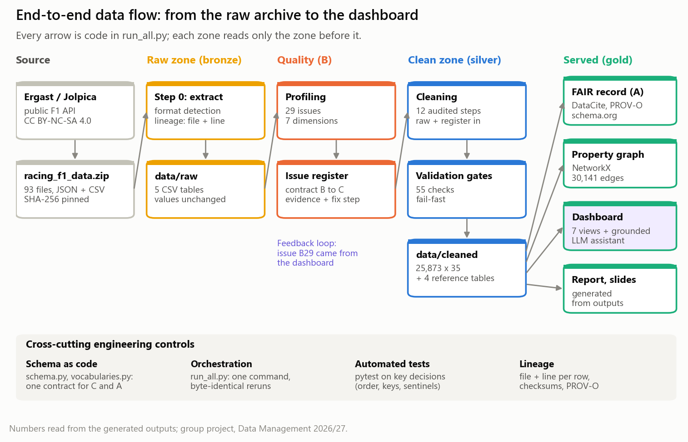
Figure 1. End-to-end data flow, from the raw archive through the raw, clean and served zones, with the cross-cutting engineering controls.

2. Component A - FAIR Assessment and Metadata Design
Prepared jointly by the group; presented by Chirag Adhikari.
Assessment. FAIRness was measured twice, independently. The automated F-UJI tool (version 4.0.1, metrics v0.8, as on the public f-uji.net service), run on a local server, tested the four places where the data can be obtained (Figure 2): the Jolpica API used for the download scored 11.5%, the group's GitHub repository 42.3%, the Kaggle mirror 84.6% and the group's Zenodo record of the raw archive 84.6%, reproducing the group's earlier web assessment exactly. Because F-UJI can only inspect what is already online, all 41 indicators of the RDA FAIR Data Maturity Model were also scored with written evidence, for the data as obtained and for our curated package (Figure 3). Overall maturity rises from 54% to 93% and the essential indicators met from 6/20 to 12/20; 'Findable' stays at level 0 until the curated package has its own DOI. F-UJI is reproducible but only sees machine-readable signals, while the RDA model also captures licences and provenance documented in human-readable form.
Gaps. Seven concrete gaps were documented with indicator, evidence and remedy (Appendix A, Table A.1). The three most important are:
- No persistent identifier - as obtained, the data are reachable only through mutable URLs (F-UJI FsF-F1-02MD = 0 for Jolpica, GitHub and Kaggle). Remedy (partly implemented): the group deposited the raw archive on Zenodo (DOI 10.5281/zenodo.23416916, byte-identical to our source, checksum verified); the curated package cites it and will receive its own DOI.
- Missing and conflicting licences - Jolpica licenses the data CC BY-NC-SA 4.0 and Ergast allowed only non-commercial use, yet the Kaggle mirror claims CC0, our repository declares MIT for everything and the Zenodo record CC BY 4.0. F-UJI rewards any licence, compatible or not. Remedy: data under CC-BY-NC-SA-4.0, MIT for code only, and the Zenodo licence corrected.
- No machine-readable metadata, provenance or controlled vocabularies - only a README, no checksums, country names such as 'UK' or 'Korea' and 136 free-text status values. Remedy (implemented): the records below, ISO codes and an eight-term status vocabulary.
Metadata record. The package is described by a DataCite 4.5 record, validated against the official XSD (Appendix A, Table A.3), a schema.org Dataset in JSON-LD for search engines, a Frictionless Data Package that declares primary and foreign keys, and a W3C PROV-O graph linking every output to the 15 audited cleaning activities. Variable definitions are generated from the same schema module that Component C validates against, so documentation and data cannot drift apart.
Persistent identifiers. The source archive is identified by its Zenodo DOI, cited as 'IsDerivedFrom' in every metadata record; the curated package receives its own DOI (a placeholder until deposit, never cited before minting), creators ORCID iDs and the institution a ROR identifier (candidate). For key variables, countries use ISO 3166-1 alpha-3 codes (ISO 3166-3 for former states such as East Germany), dates ISO 8601 and licences SPDX. Drivers, constructors and circuits were linked to Wikidata QIDs through their Wikipedia URLs, with coverage of 98.7%, 98.1% and 100%; the few failures exposed broken links, which were flagged for curation.
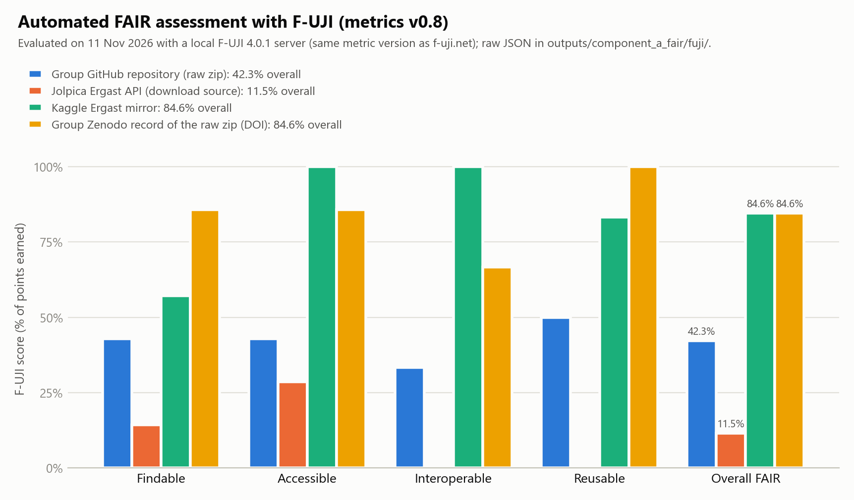
Figure 2. F-UJI automated FAIR scores (metrics v0.8) for the four locations of the data, including the group's Zenodo record of the raw archive (evidence: raw JSON in the ZIP).
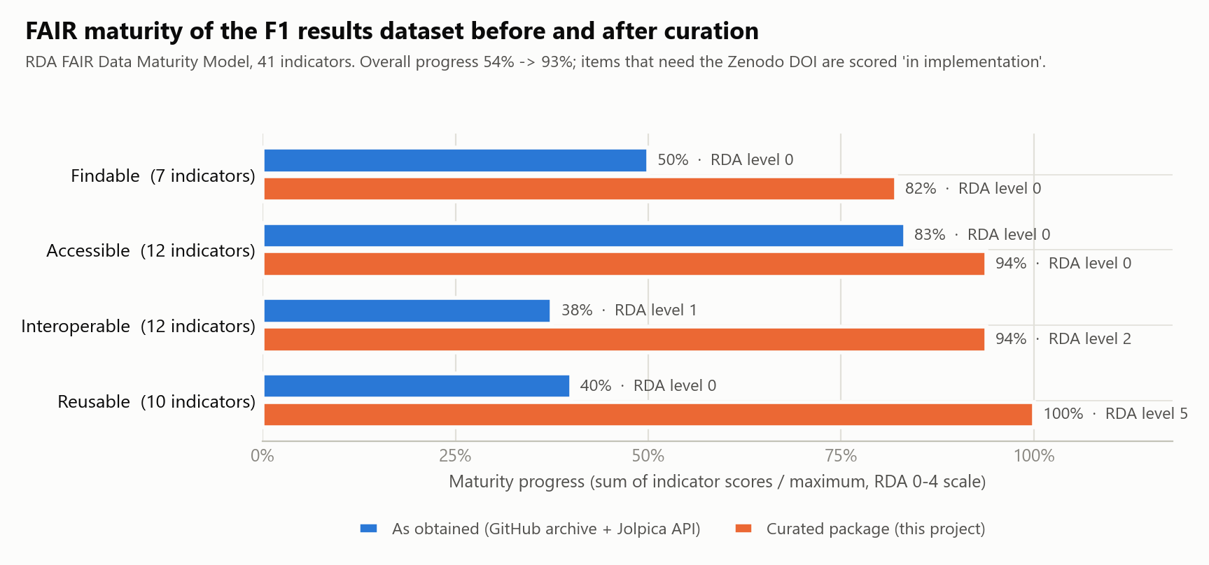
Figure 3. RDA FAIR Data Maturity Model: progress per area for the data as obtained and the curated package.

3. Component B - Data Quality and Profiling
Prepared jointly by the group; presented by Manohar Zalki.
Profiling. Every column of the five tables was profiled for type, completeness, uniqueness and distribution, and 29 quality rules were run. Each finding is stored in an issue register with dimension, severity, evidence down to file and line, root-cause hypothesis, downstream impact and the cleaning step that resolves it (Appendix B, Table B.1). 24 findings are errors across 7 dimensions, 6 of them high severity; 5 are documented non-errors. A further 14 rules, including referential integrity and plausible driver ages, passed, which is equally useful evidence. Structurally, the results table combines identifiers, six numeric measures and free-text fields, no single column is unique, and the package itself is inconsistent: five sprint files are pretty-printed JSON arrays while every other JSON file uses JSON Lines.
Completeness is deceptive. Only 18 cells of the results table are null, suggesting a 99.9% complete dataset, yet 9,913 values merely pretend to be data (Figure 4): 'position' is filled for 9,646 drivers who retired, withdrew or were disqualified, and 'grid' uses 0 for 267 cars without a grid slot. A model predicting results from grid positions would learn from retirements ranked '18th' and from a fictitious 'grid 0'.
Uniqueness needs domain knowledge. 23 rows of the 1960 United States GP were appended twice, and 11 rows of the 1960 Italian GP are copies whose season and round were blanked; they only appear as duplicates once the keys are restored. Conversely, 172 rows that share season, round and driver are not errors: in the 1950s a driver could take over a team-mate's car and be classified twice (Figure 5). Naive de-duplication would delete real history.
Consistency, validity, accuracy, timeliness. Status is free text with 136 values mixing laps behind with failure causes; countries use abbreviations; identifiers break the lowercase convention; integer keys are stored as floats; five races are duplicated. Points are not comparable across eras: a win earned 8, 9, 10, 25 or even 50 points (Figure B.1). All 270 statistical lap outliers are valid Indianapolis 500 results (Figure B.2). Timeliness is uneven across tables: the calendar already lists 24 races of 2026 without results, and the newest drivers and teams lack birth dates, nationalities or links. From 2023 the source no longer records why cars retired (B29), a break found later through the dashboard (Section 6).
Root causes and impact. Three causes explain the pattern: export artefacts (duplicated blocks, blanked keys, lowercased names), undocumented source semantics (position, grid 0) and genuine historical change (scoring rules, shared drives). For data science and AI the impact is concrete: inflated win and point counts, biased prediction targets, sparse one-hot features, failed joins with external sources and train/test leakage through duplicated rows.
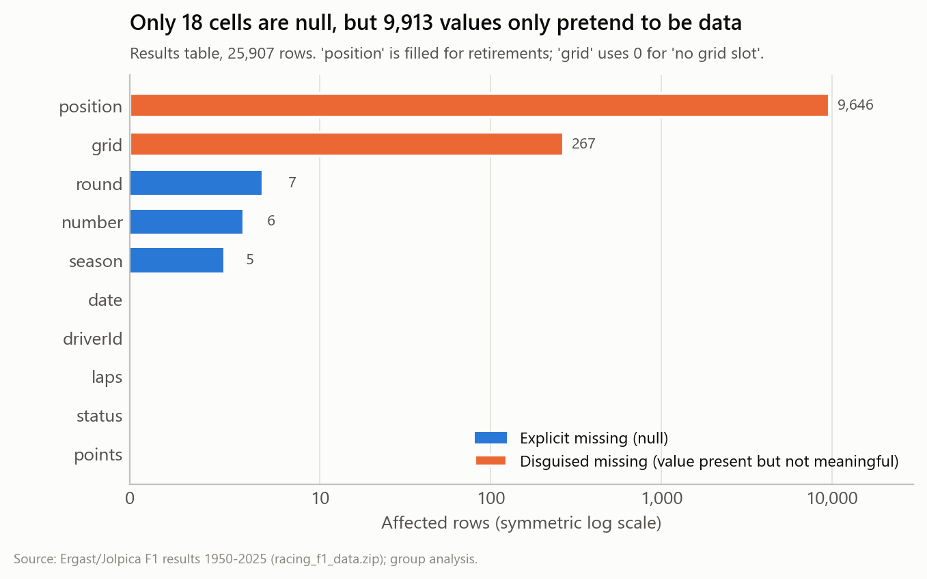
Figure 4. Explicit vs disguised missing values in the raw results table.
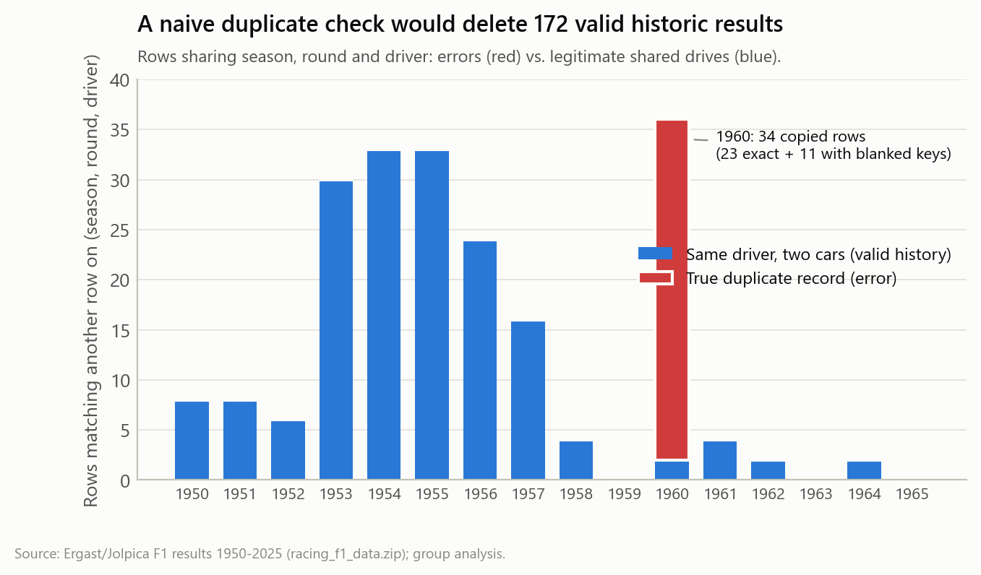
Figure 5. True duplicates vs legitimate shared drives among rows sharing season, round and driver.

4. Component C - Data Cleaning and Pipeline
Prepared jointly by the group; presented by Nicolas Bonilla.
Design and tools. The pipeline is written in Python (pandas) as twelve small, documented steps, each answering specific issues from the Component B register. Python was preferred to Tableau Prep because code can be version-controlled, reviewed and tested. The pipeline runs from the original archive with one command, is deterministic (two runs give byte-identical files) and 28 automated tests protect its key decisions. Every step writes an audit record: rows, changed cells and missing values before and after, and columns added (Appendix C, Table C.2). Each clean row keeps its source file and line, so any value can be traced back to the raw record.
Key decisions.
- Types first. A schema makes keys integers and dates real dates (C01).
- Order matters. Missing seasons (5) and rounds (7) are restored by deterministic lookup, from the file name and from races.csv, before de-duplication (C02); only then does exact matching find all 34 copies (C03). In the reverse order 11 duplicates survive, which a unit test documents.
- No invented values. No statistical imputation is used: the grid sentinel 0 becomes missing plus a flag (C05), and withdrawn entries keep a missing car number because none existed.
- Separate meanings. 'position' is kept as position_order, and a new classified_position is filled only for classified drivers (C06).
- Exhaustive vocabularies. 136 status values become 8 groups (C07) and countries receive ISO codes; any unmapped value stops the pipeline.
- Flag, don't delete. Indianapolis 500 rows and shared drives stay, flagged (C08, C11); points_normalised makes scoring eras comparable (C09).
Reference tables are de-duplicated (5 races, 4 circuits), one person stored under two identifiers is merged and recorded as an alias, names are title-cased and URLs use https (C10). The tables are joined with many-to-one validation, so no join can lose or multiply rows (C11).
Validation and result. 55 gates check schema, keys, foreign keys, vocabularies and ranges (C12); if one fails, nothing is published as clean. The final table has 25,873 rows (34 removed) and 35 documented columns. Of the 29 issues, 18 are fixed, 3 mitigated or flagged, 5 kept and documented, and 3 verified as non-errors (Figure 6).
Trade-offs. Rule-based title-casing cannot restore every spelling, so six names needed curated exceptions. Normalised points improve comparability but hide absolute values, so raw points are kept. The wider table (35 columns) is deliberate: flags preserve information that deletion would destroy. Strict gates make the pipeline fail on any new, unmapped status value, which costs convenience but guarantees that no unexpected category silently reaches an analysis.
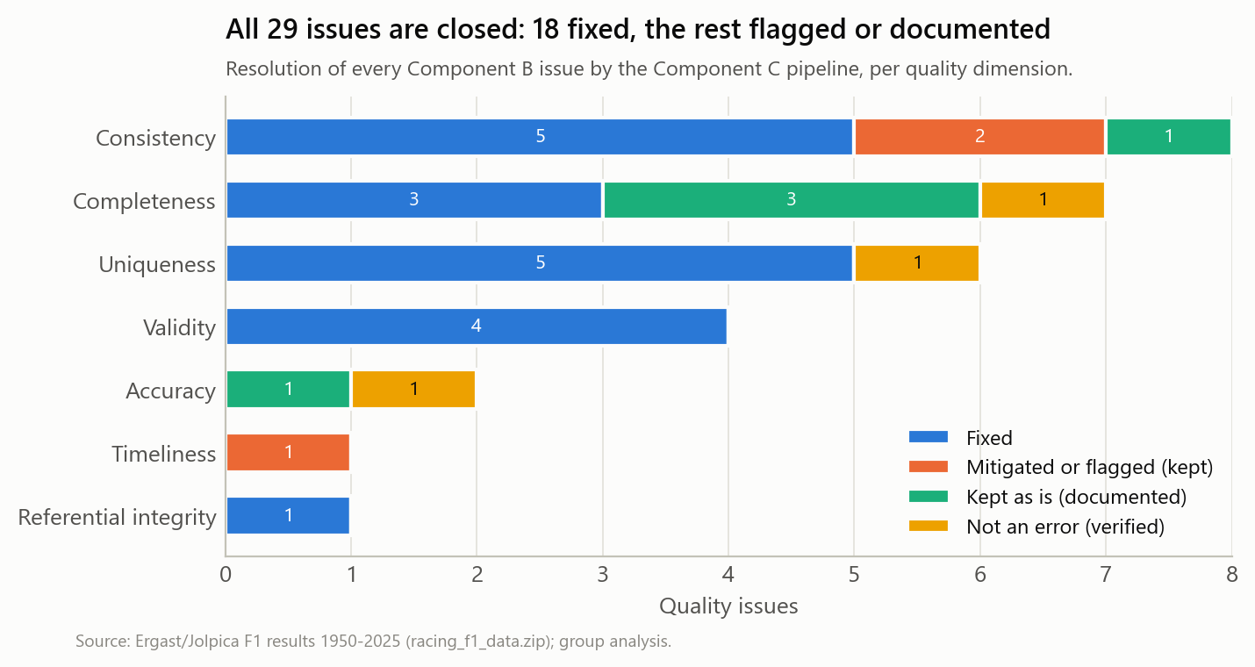
Figure 6. Resolution of the 29 Component B issues per quality dimension.

5. Graph Modelling

5.1 Property graph model
The cleaned data are modelled as a labelled property graph (Figure 7) with five node labels - Driver (817), Race (1,149), Constructor (203), Circuit (78) and Country (50) - and seven relationship types. RACED_IN connects a driver to a race and carries the result as properties (grid, classified position, points, normalised points, status group, car number), so the 25,873 results become edges rather than nodes. DROVE_FOR aggregates a driver's spell with a constructor (first and last season, races, points, wins); HELD_AT and LOCATED_IN place races on circuits and circuits in countries; HAS_NATIONALITY and REGISTERED_IN link drivers and constructors to countries through ISO codes. TEAMMATE_OF is a derived, undirected relationship between drivers who drove for the same constructor in the same race, weighted by the number of shared races. Node keys are the cleaned identifiers and Wikidata QIDs are node properties, so the graph inherits the interoperability work of Component A.

5.2 NetworkX implementation
The graph is built with NetworkX as a MultiDiGraph of 2,297 nodes and 30,141 typed edges and exported to GEXF for Gephi. Analytics run on the TEAMMATE_OF projection (714 drivers, 3,081 weighted links). Following Component B, the 11 Indianapolis 500 rounds are excluded from this projection: there the 'constructor' is a chassis builder used by dozens of independent entrants, which would create false team-mate links.

5.3 Analytics and interpretation
Connectivity and small world. The projection has 42 connected components; a giant component holds 663 drivers (92.9%) and 35 drivers never had a team-mate. Its average clustering coefficient is 0.41, against 0.014 for random graphs of the same size and density, while the average shortest path (4.8 links) stays close to the random benchmark (3.2): a small-world network (sigma = 19). Any two drivers of 75 years are on average fewer than five team-mate links apart; Juan Manuel Fangio reaches Max Verstappen in 8 steps (Juan Fangio - Jo Bonnier - Mario Andretti - Bruno Giacomelli - Andrea de Cesaris - Rubens Barrichello - Jenson Button - Sergio Pérez - Max Verstappen).
Betweenness centrality counts how often a driver lies on the shortest paths between others (Figure 8). The top drivers are not the most successful but the most connective: Jo Bonnier (0.150), Jack Brabham (0.147), Andrea de Cesaris (0.144), Mario Andretti (0.139), Riccardo Patrese (0.135). They combined long careers with many teams and therefore bridge generations; removing them would lengthen the paths between eras. Degree tells a different story, because the highest degrees belong to 1950s-60s drivers such as Stirling Moss (78 team-mates).
PageRank and assortativity. Weighted PageRank, which rewards links to well-connected drivers and long partnerships, ranks Jack Brabham, Graham Hill and Jo Bonnier highest, again early-era drivers. Degree assortativity is slightly positive (0.15): well-connected drivers tend to share teams with other well-connected drivers. The network diameter is 12 links, so even the most distant drivers of the giant component are connected through a dozen team-mate relationships.
Community detection with the Louvain method (modularity 0.70) finds 11 communities. Although the algorithm never sees a date, the large communities line up with eras (Figure 9): the 1950s around Stirling Moss, the 1960s around Jack Brabham and Graham Hill, the 1970s around Ronnie Peterson and Niki Lauda, the 1980s around Riccardo Patrese, two parallel 2000s groups (Barrichello and Schumacher; Alonso and Raikkonen) and the 2010s around Sergio Perez. Small communities capture short-lived teams such as Manor in 2015 (Figure D.1).
What the measures reveal about data quality. In the 1950s and 1960s the constructor field records the chassis make (Cooper, Maserati) shared by many private entrants, so early drivers receive inflated degree and PageRank. Network measures are only as valid as the meaning of the attributes they rest on - a direct link back to documenting semantics (A), profiling them (B) and defining 'team' explicitly (C).
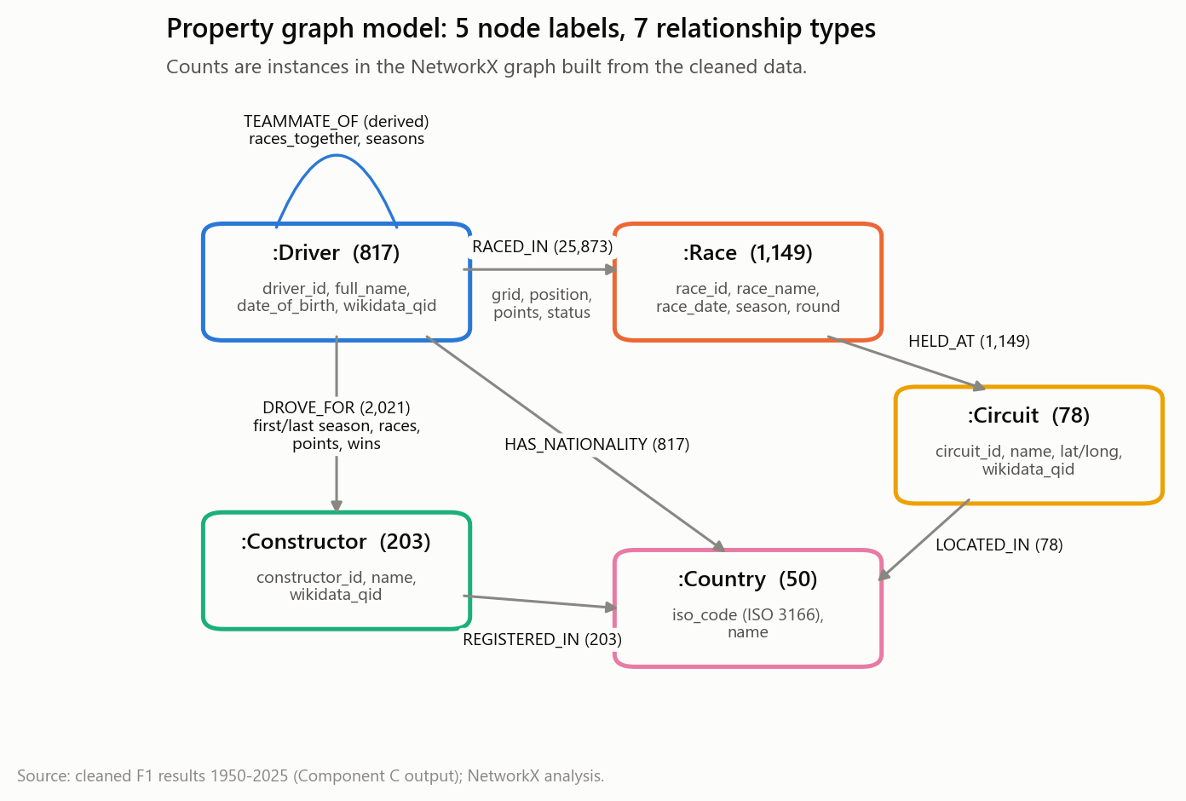
Figure 7. Property graph model with instance counts.
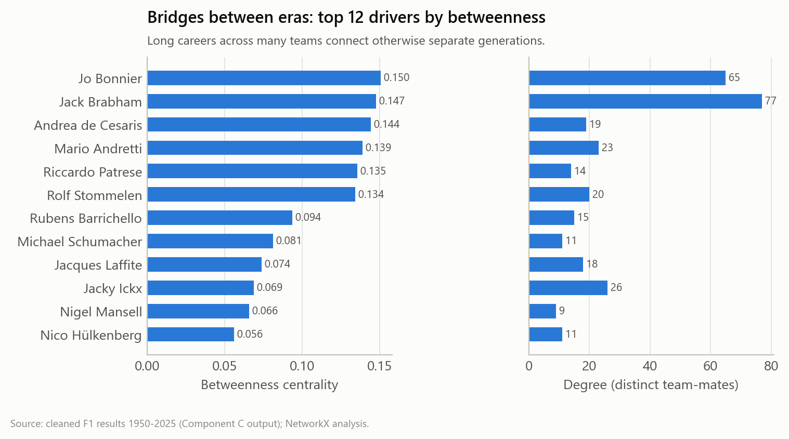
Figure 8. Top 12 drivers by betweenness centrality, with their degree.
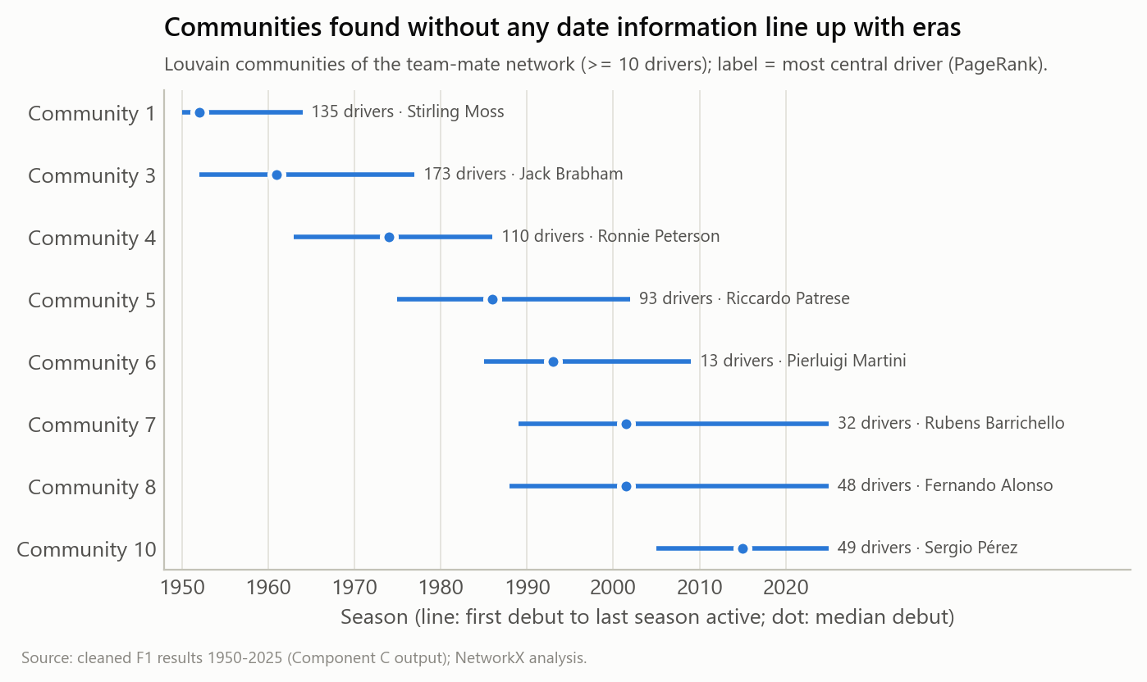
Figure 9. Louvain communities and the seasons their drivers were active.

6. The Interactive Dashboard
The project ends where its users begin: an interactive web dashboard (folder dashboard, opened with streamlit run app.py) that turns the validated outputs into seven views (Figure 10): constructor eras, an all-time timing tower with an era-adjusted score, a grid-to-finish heatmap, reliability over time, a 3D globe of the circuits, the team-mate network and a final view that explains how the data were checked, plus an assistant that answers questions about them (Section 6.1). It is not a separate product. Its data file is generated by build_web_data.py, which reads only the outputs of the components, and run_all.py calls it as its last step, so the dashboard can never show numbers that the validation gates have not passed (Table 2). Appendix H shows every view.
The dashboard also worked as a quality instrument. Its reliability view showed mechanical failures and accidents vanishing after 2022. The cause was not engineering: from 2023 the source records almost every retirement only as 'Retired', 89% of them in 2023 and all of them in 2024 and 2025. No completeness or uniqueness rule had flagged it, because every value was present and valid. The finding became issue B29 in the quality register, cause analyses are now limited to 1950-2022, and the chart marks the break instead of hiding it. Visual exploration is therefore part of profiling, not only of reporting.
Table 2. Each dashboard view and the project output it is built from.
Dashboard view | Project output it reads | What it shows
Eras, timing tower, grid, circuits | Cleaned results and reference tables (C) | points_normalised, classified_position, ISO codes
Reliability | status_group (C07) and issue B29 (B) | Break in cause recording marked at 2023
Team-mate network | TEAMMATE_OF projection and metrics (graph) | Communities, betweenness, shortest path
How the numbers were checked | Issue register (B), validation gates (C), RDA and PIDs (A) | 29 issues, 55 gates, RDA 54% -> 93%

6.1 Ask the Data: a Grounded Assistant
The last view lets users question the data in English or Spanish (Figure 11). It grows out of a prototype by Manohar Zalki (FastAPI, a local Llama 3 through Ollama, hybrid vector and graph retrieval and a machine-learning engine), rebuilt so that the language model never supplies a number. The service first finds the drivers, teams, circuits and seasons in the question, then gathers evidence: exact figures computed with pandas from the cleaned tables, each carrying its file, SHA-256, filter, row count and raw source line; team-mate chains from the graph; a podium-probability model; and the best of 1,326 documents generated from the project outputs. Llama 3 answers from that evidence only and cites it, and every figure in the answer is then looked up in the evidence. Official champions come from Wikidata (73 of 76 seasons) and are reconciled with our points: 1964 and 1988 disagree because only a driver's best results counted, a semantic trap that a plain sum of points gets wrong. The podium model uses only pre-race information, chooses among three learned models on 2014-2019 and is tested once on 2020-2025: its probabilities beat a grid-only baseline, but its top three picks call no more podium places than the grid order (Table 3), which we report rather than hide.
Table 3. Evaluation of the assistant and of its podium model (outputs/assistant/).
Check (25 benchmark questions, answers computed independently) | Result | Detail
Evidence contains the correct answer | 25 of 25 | median 0.01 s
Written answer contains the correct answer | 25 of 25 | Llama 3 8B, local
Answers whose figures are all found in the evidence | 25 of 25 | 49 of 49 figures
Answers citing their evidence | 25 of 25 | median 26 s per answer on a laptop CPU
Question outside 1950-2025 declined | yes | 2030 champion
Podium model, test 2020-2025: log loss / ROC AUC | 0.219 / 0.938 | grid-only baseline 0.254 / 0.915
Podium places called by the top three picks | 68% | 'front three finish on the podium' 68%

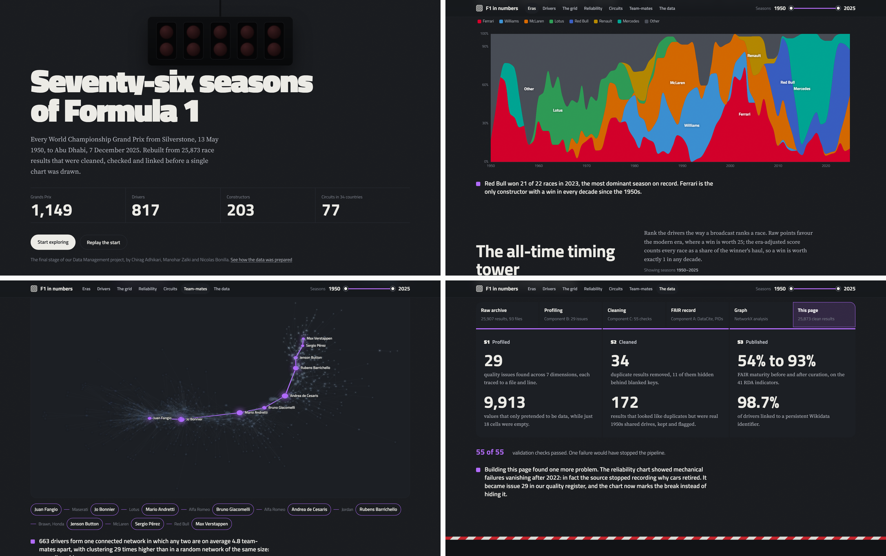
Figure 10. The interactive dashboard: start-light opening, constructor eras, the Fangio-to-Verstappen chain in the team-mate network, and the view that explains how the data were checked.
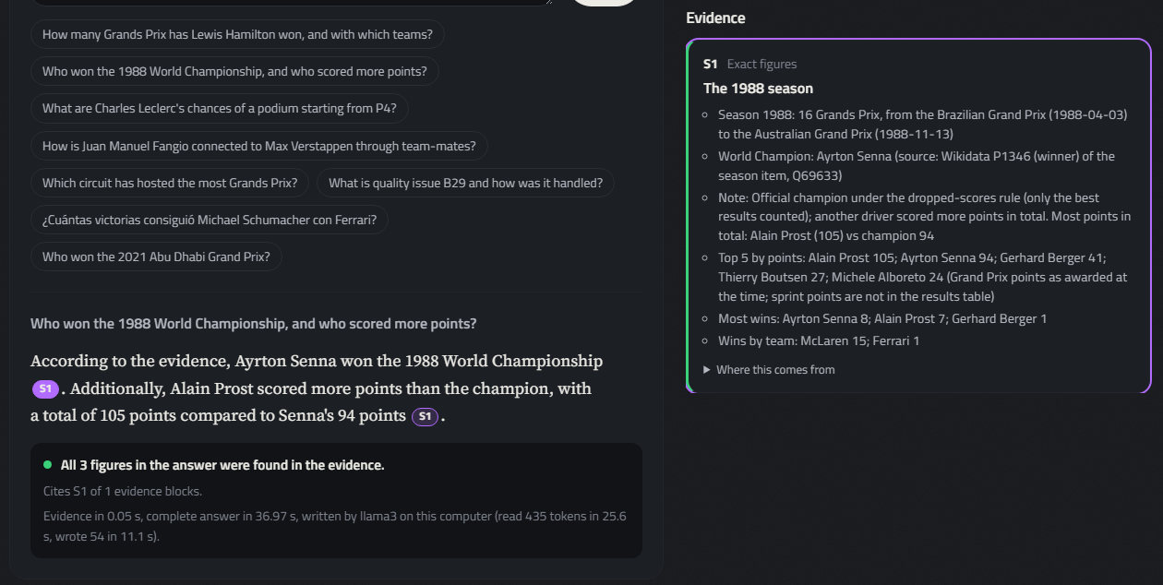
Figure 11. Ask the data: a question answered by the local Llama 3 from cited evidence (right), with the check that every figure in the answer appears in the evidence.

7. How the Components Connect
The components were designed as one chain with explicit contracts: the issue register is the interface between B and C (every issue names the cleaning step that resolves it, and C measures every issue again after cleaning), the schema module is shared by C and A, and the graph and dashboard read only validated output. Table 4 traces six findings through all components. The dependencies also ran backwards: the dashboard exposed issue B29, the graph analysis revealed that 'constructor' changes meaning over time, a semantic issue that profiling alone had not flagged and that now belongs in the metadata, and Component A's identifier lookup exposed broken links that Component C records for curation. Terminology is shared through the data dictionary, so 'classified position', 'shared drive' and 'status group' mean the same thing in every section.
Table 4. Six examples of how one finding flows through all components.
Finding (B) | Cleaning (C) | FAIR / metadata (A) | Graph and dashboard
Country abbreviations 'UK', 'USA', 'Korea' (B21) | ISO 3166 codes added (C10) | Interoperability gap G4 closed | Country nodes keyed by ISO code
Indy 500 lap outliers (B16) | Kept and flagged is_indy500 (C08) | Flag documented in dictionary | Excluded from TEAMMATE_OF projection
Duplicates with blanked keys (B06, B07) | Key repair before de-duplication (C02, C03) | Checksums and PROV provenance | No double-counted RACED_IN edges
Same driver under two IDs (B20) | Alias merged (C10) | Wikidata QIDs as PIDs | One Driver node per person
'position' set for retirements (B11) | classified_position separated (C06) | Semantics in data dictionary | Correct RACED_IN result property
Causes not recorded from 2023 (B29), found in the dashboard | Mapped to 'Retired (unspecified)' (C07) | Limitation documented | Dashboard marks the break

8. Conclusion
Lessons learned. First, quality is contextual: outliers, duplicates and record-count gaps were often valid history, so every automated rule needed domain verification before anything was deleted. Second, the order of operations matters, as the 11 hidden duplicates show. Third, the largest FAIR gaps were not in the values but around them: no identifier, an inconsistent licence and no provenance. Fourth, validation gates and an audit log turned cleaning from a series of manual edits into evidence an examiner can check. Fifth, generating documentation from code (data dictionary, metadata and this report's figures) kept every artefact consistent with the data, even when the pipeline changed late in the project. Sixth, looking at the data is itself a quality check: the dashboard found an issue that no automated rule had flagged.
Limitations. The seven short races of 2014-2025 match documented absences but should be confirmed against official FIA classifications. The RDA scores are a self-assessment, F-UJI can only test what is online, and the curated package's own DOI is not minted yet. Title-casing needed manual exceptions, a few Wikidata links are broken, the team concept is ambiguous before the 1970s, and sprint races were left out. Finally, the CC BY-NC-SA 4.0 licence inherited from the source restricts reuse: the curated data may support research and teaching, but not, for example, a commercial betting model.
Recommendations. We recommend depositing the curated package on Zenodo as a record derived from the raw archive's DOI, correcting that record's licence to CC BY-NC-SA 4.0, publishing the status vocabulary as SKOS, modelling 'team' separately from 'chassis', reporting the source defects (duplicated blocks, identifier case) upstream to Jolpica, and running the validation gates automatically whenever new race data arrive, so that quality is checked continuously rather than once.

References
Batini, C., & Scannapieco, M. (2016). Data and Information Quality: Dimensions, Principles and Techniques. Springer.
Blondel, V. D., Guillaume, J.-L., Lambiotte, R., & Lefebvre, E. (2008). Fast unfolding of communities in large networks. Journal of Statistical Mechanics, P10008.
DataCite Metadata Working Group (2024). DataCite Metadata Schema 4.5. https://schema.datacite.org/meta/kernel-4.5/
Devaraju, A., & Huber, R. (2021). An automated solution for measuring the progress toward FAIR research data. Patterns, 2(11), 100370.
Freeman, L. C. (1977). A set of measures of centrality based on betweenness. Sociometry, 40(1), 35-41.
Hagberg, A., Schult, D., & Swart, P. (2008). Exploring network structure, dynamics, and function using NetworkX. Proceedings of the 7th Python in Science Conference, 11-15.
Jolpica-F1 (2025). Jolpica-F1 API and Terms of Use. https://github.com/jolpica/jolpica-f1
Lebo, T., Sahoo, S., & McGuinness, D. (2013). PROV-O: The PROV Ontology. W3C Recommendation.
Rao, R. (2025). Formula 1 World Championship (1950-2024) [Data set]. Kaggle.
RDA FAIR Data Maturity Model Working Group (2020). FAIR Data Maturity Model: Specification and Guidelines. https://doi.org/10.15497/RDA00050
Wang, R. Y., & Strong, D. M. (1996). Beyond accuracy: What data quality means to data consumers. Journal of Management Information Systems, 12(4), 5-33.
Watts, D. J., & Strogatz, S. H. (1998). Collective dynamics of 'small-world' networks. Nature, 393, 440-442.
Wilkinson, M. D., et al. (2016). The FAIR Guiding Principles for scientific data management and stewardship. Scientific Data, 3, 160018.

Appendix A - FAIR Assessment and Metadata (Component A)
Table A.1. FAIR compliance gaps with evidence and actionable improvements.
Gap | Title | RDA indicators | Evidence | Improvement | Status
G1 | No persistent identifier for the data or metadata | RDA-F1-01D; RDA-F1-01M; RDA-F3-01M; RDA-A1-03D | F-UJI FsF-F1-02MD = 0 for the GitHub archive, the Jolpica API and even the Kaggle mirror; data are only reachable by mutable URLs. The group's Zenodo deposit of the raw archive (DOI 10.5281/zenodo.23416916, 16 Oct 2026) scores 1 and lifts the archive to 84.6% overall (F-UJI v0.8). | Use the Zenodo DOI as the identifier of the source archive (cited IsDerivedFrom and in PROV-O), and deposit the curated package as its own Zenodo record to mint a versioned DOI and a concept DOI; cite both in README and CITATION.cff. | Raw archive: implemented (DOI minted by the group, byte-identical to data/source). Curated package: prepared (DataCite record cites the raw DOI; own DOI placeholder).
G2 | Missing and conflicting licence information | RDA-R1.1-01M; RDA-R1.1-02M; RDA-R1.1-03M | Jolpica TERMS.md (27 Aug 2025): data licensed CC BY-NC-SA 4.0. The group's README declares 'MIT License' for everything; the Kaggle mirror declares CC0 although Ergast allowed non-commercial use only; the group's Zenodo record declares CC BY 4.0, which drops the non-commercial and share-alike conditions. F-UJI FsF-R1.1-01M = 0 for GitHub and Jolpica and 1 for Kaggle and Zenodo, because it checks that a licence is present, not that it is compatible. | License the data CC BY-NC-SA 4.0 (ShareAlike obliges it), add LICENSE-DATA with the SPDX id CC-BY-NC-SA-4.0 and the legal-code URI, keep MIT for code only, and attribute Jolpica-F1 and Ergast. | Implemented in DataCite rightsList, schema.org license and datapackage.json; the Zenodo record's licence must be corrected to CC BY-NC-SA 4.0 (a metadata edit, the DOI does not change).
G3 | No machine-readable, standard dataset metadata | RDA-F2-01M; RDA-F4-01M; RDA-I1-01M; RDA-R1-01M; RDA-R1.3-01M; RDA-R1.3-02M | Only a pipeline README; F-UJI FsF-F2-01M = 0/2 (GitHub, Jolpica); FsF-R1-01M = 1/2 (GitHub) and 0/2 (Jolpica). | Ship a DataCite 4.5 record (XML validated against the XSD), schema.org Dataset JSON-LD for search engines and a Frictionless Data Package with a full data dictionary. | Implemented.
G4 | Non-standard vocabularies inside the data | RDA-I2-01D; RDA-I1-02D | Country values 'UK', 'USA', 'UAE', 'Korea'; nationalities as lowercase demonyms including former states ('east german', 'rhodesian'); 136 free-text status values mixing laps-behind with failure causes. | Add ISO 3166-1 alpha-3 codes (ISO 3166-3 for former states), Wikidata QIDs, and an 8-category status vocabulary; publish the status vocabulary as SKOS. | ISO codes, QIDs and status groups implemented; SKOS publication proposed.
G5 | No provenance or integrity information | RDA-R1.2-01M; RDA-R1.2-02M | The repository never names Ergast or Jolpica as the source; no checksums; no record of transformations; the original Ergast terms page now returns 404. | Record derivation (DataCite IsDerivedFrom), SHA-256 checksums of every source and output file, the cleaning audit log, and a W3C PROV-O graph. | Implemented.
G6 | Unqualified and partly broken links to external entities | RDA-I3-01D; RDA-I3-02D | 861 of 864 driver URLs use http; 12 entities have no URL; 1 driver URL is a Wikipedia talk page (monarch); 2 constructor pages no longer exist (Hall, Turner). | Normalise to https and add Wikidata QIDs as persistent entity identifiers; flag unresolved links for manual curation. | Implemented (QID crosswalk in data/reference/).
G7 | No guarantee that metadata outlives the data | RDA-A2-01M | The Ergast API was shut down and is only mirrored by a volunteer project (Jolpica) that 'does not guarantee uptime'; GitHub repositories can be deleted. | Deposit in a certified repository (Zenodo/CERN) whose policy keeps metadata and a tombstone page after withdrawal. | Raw archive deposited in Zenodo by the group (16 Oct 2026); deposit of the curated package proposed.

Table A.2a. F-UJI 4.0.1 results (metrics v0.8); raw JSON responses in outputs/component_a_fair/fuji/ (an earlier run with metrics v0.5 is kept in fuji/metrics_v0.5/).
Resource | URL | FAIR % | F % | A % | I % | R %
github_repository | https://github.com/zalkimanohar/Formula1-Racing-Analytics | 42.31 | 42.86 | 42.86 | 33.33 | 50.0
jolpica_ergast_api | http://api.jolpi.ca/ergast/f1/ | 11.54 | 14.29 | 28.57 | 0.0 | 0.0
kaggle_ergast_mirror | https://www.kaggle.com/datasets/rohanrao/formula-1-world-championship-1950-2020 | 84.62 | 57.14 | 100.0 | 100.0 | 83.33
zenodo_raw_archive | https://doi.org/10.5281/zenodo.23416916 | 84.62 | 85.71 | 85.71 | 66.67 | 100.0

Table A.2b. RDA FAIR Data Maturity Model summary (41 indicators; per-indicator scores and evidence in rda_fair_assessment.csv).
Area | Indicators | Progress obtained % | Essential obtained | Level obtained | Progress curated % | Essential curated | Level curated
Findable | 7 | 50.0 | 1/7 | 0 | 82.1 | 2/7 | 0
Accessible | 12 | 83.3 | 5/8 | 0 | 93.8 | 5/8 | 0
Interoperable | 12 | 37.5 | 0/0 | 1 | 93.8 | 0/0 | 2
Reusable | 10 | 40.0 | 0/5 | 0 | 100.0 | 5/5 | 5
Overall | 41 | 53.7 | 6/20 |  | 93.3 | 12/20

Table A.3. Complete DataCite 4.5 metadata record of the curated dataset (JSON form; the equivalent XML validates against the kernel-4.5 XSD). The curated package's DOI and the ORCID iDs are placeholders until deposit; the source archive's DOI (IsDerivedFrom) is real.
DataCite property | Value
doi | 10.5281/zenodo.TO-BE-MINTED
prefix | 10.5281
suffix | zenodo.TO-BE-MINTED
creators | - name: Adhikari, Chirag; nameType: Personal; givenName: Chirag; familyName: Adhikari; nameIdentifiers: nameIdentifier: TO-BE-ADDED; nameIdentifierScheme: ORCID; schemeUri: https://orcid.org; affiliation: name: SRH University [campus and ROR to be confirmed]  - name: Zalki, Manohar; nameType: Personal; givenName: Manohar; familyName: Zalki; nameIdentifiers: nameIdentifier: TO-BE-ADDED; nameIdentifierScheme: ORCID; schemeUri: https://orcid.org; affiliation: name: SRH University [campus and ROR to be confirmed]  - name: Bonilla, Nicolas; nameType: Personal; givenName: Nicolas; familyName: Bonilla; nameIdentifiers: nameIdentifier: TO-BE-ADDED; nameIdentifierScheme: ORCID; schemeUri: https://orcid.org; affiliation: name: SRH University [campus and ROR to be confirmed]
titles | - title: Formula 1 World Championship Race Results 1950-2025: Curated and Quality-Assessed Dataset; lang: en  - title: Cleaned, FAIR-documented derivative of the Ergast/Jolpica-F1 race results; titleType: Subtitle; lang: en
publisher | name: Zenodo
publicationYear | 2026
subjects | - subject: Formula One; subjectScheme: Wikidata; schemeUri: https://www.wikidata.org/wiki/; valueUri: https://www.wikidata.org/wiki/Q1968; lang: en  - subject: auto racing; subjectScheme: Wikidata; schemeUri: https://www.wikidata.org/wiki/; valueUri: https://www.wikidata.org/wiki/Q5386; lang: en  - subject: sport; subjectScheme: Wikidata; schemeUri: https://www.wikidata.org/wiki/; valueUri: https://www.wikidata.org/wiki/Q349; lang: en  - subject: motorsport; lang: en  - subject: race results; lang: en  - subject: sports analytics; lang: en  - subject: data quality; lang: en  - subject: data cleaning; lang: en  - subject: FAIR data; lang: en  - subject: Ergast; lang: en
contributors | - name: Ergast Developer API; nameType: Organizational; contributorType: DataCollector  - name: Jolpica-F1; nameType: Organizational; contributorType: Distributor  - name: SRH University [campus and ROR to be confirmed]; nameType: Organizational; contributorType: HostingInstitution
dates | - date: 2026-11-11; dateType: Created  - date: 2026-10-15; dateType: Collected; dateInformation: Modification dates of the files in the raw archive  - date: 1950-05-13/2025-12-07; dateType: Other; dateInformation: Temporal coverage: first and last race day in the dataset
language | en
types | resourceTypeGeneral: Dataset; resourceType: Tabular sports results
relatedIdentifiers | - relatedIdentifier: https://api.jolpi.ca/ergast/f1/; relatedIdentifierType: URL; relationType: IsDerivedFrom; resourceTypeGeneral: Service  - relatedIdentifier: http://ergast.com/mrd/; relatedIdentifierType: URL; relationType: IsDerivedFrom; resourceTypeGeneral: Service  - relatedIdentifier: 10.5281/zenodo.23416916; relatedIdentifierType: DOI; relationType: IsDerivedFrom; resourceTypeGeneral: Dataset  - relatedIdentifier: https://github.com/zalkimanohar/Formula1-Racing-Analytics; relatedIdentifierType: URL; relationType: IsSupplementTo; resourceTypeGeneral: Software  - relatedIdentifier: https://www.kaggle.com/datasets/rohanrao/formula-1-world-championship-1950-2020; relatedIdentifierType: URL; relationType: References; resourceTypeGeneral: Dataset
sizes | - f1_race_results_clean.csv: 25873 rows, 7278022 bytes  - races_clean.csv: 1173 rows, 135632 bytes  - circuits_clean.csv: 78 rows, 10155 bytes  - drivers_clean.csv: 873 rows, 99662 bytes  - constructors_clean.csv: 214 rows, 17970 bytes
formats | - text/csv  - application/ld+json  - application/xml
version | 1.0.0
rightsList | rights: Creative Commons Attribution Non Commercial Share Alike 4.0 International; rightsUri: https://creativecommons.org/licenses/by-nc-sa/4.0/legalcode; rightsIdentifier: CC-BY-NC-SA-4.0; rightsIdentifierScheme: SPDX; schemeUri: https://spdx.org/licenses/; lang: en
descriptions | - description: Race results of every FIA Formula One World Championship Grand Prix from 1950-05-13 to 2025-12-07 (76 seasons, 1149 Grands Prix, 25,873 driver entries, 817 drivers, 203 constructor entries, 77 circuits in 34 countries). The dataset is a cleaned, documented derivative of the Ergast database as served by the Jolpica-F1 API. Duplicates, missing keys, sentinel values, inconsistent identifiers and free-text categories were resolved; legitimate historical shared drives were kept and flagged; ISO 3166 country codes and Wikidata identifiers were added.; descriptionType: Abstract  - description: Extracted from racing_f1_data.zip (Zenodo DOI 10.5281/zenodo.23416916; SHA-256 81b027c4221901d92d30ad7b76eacf22668d299098e5c16dcb391c91fd39c748) without modifying values, profiled across completeness, uniqueness, validity, consistency, accuracy and timeliness, and cleaned with a reproducible Python/pandas pipeline that logs before/after statistics for every step. Source code, audit log and quality report are part of the package.; descriptionType: Methods  - description: UTF-8 encoded CSV (RFC 4180), comma separated, header row, ISO 8601 dates. Primary key of the fact table: result_id. Column definitions in data_dictionary.csv and datapackage.json.; descriptionType: TechnicalInfo  - description: Points follow the scoring rules of each season; use points_normalised for cross-era comparisons. Indianapolis 500 rounds (1950-1960) are flagged with is_indy500. The raw archive this package is derived from has the DOI 10.5281/zenodo.23416916; the curated package is prepared for deposit in Zenodo as its own record, and the DOI shown for it is a placeholder until minted.; descriptionType: Other
geoLocations | 78 entries: 'Worldwide' plus one geoLocationPoint per circuit (77 points with latitude/longitude; listed in datacite_metadata.xml)

Table A.4. Wikidata QID coverage of entity identifiers.
entity_type | records | with_url | with_qid | qid_coverage_percent
circuit | 82 | 82 | 82 | 100.0
constructor | 214 | 212 | 210 | 98.1
driver | 874 | 864 | 863 | 98.7

Appendix B - Data Quality Profiling (Component B)
Table B.1. Quality issue register (evidence, root cause and impact per issue in quality_issues.md).
ID | Dimension | Table | Issue | Affected | % | Severity | Error | Resolved by
B01 | Completeness | results | Season missing | 5 | 0.019 | High | True | C02
B02 | Completeness | results | Round missing | 7 | 0.027 | High | True | C02
B03 | Completeness | results | Car number missing | 6 | 0.023 | Low | False | C01
B04 | Completeness | results | Disguised missing value: grid = 0 sentinel | 267 | 1.031 | Medium | True | C05
B05 | Completeness | results | Races with fewer entries than the season norm (2014+): verified, not data loss | 7 | 2.778 | Info | False | None (verified as genuine)
B06 | Uniqueness | results | Exact duplicate records | 23 | 0.089 | High | True | C03
B07 | Uniqueness | results | Hidden duplicates masked by missing keys | 11 | 0.042 | High | True | C02 + C03
B08 | Uniqueness | results | Natural-key collisions that are NOT errors (shared drives) | 172 | 0.664 | Info | False | C11 (flag is_shared_drive)
B09 | Validity | results | Identifier violates lowercase convention | 2 | 0.008 | Medium | True | C04
B10 | Validity | results | Incorrect storage types (integers stored as floats, dates stored as text) | 25907 | 100.0 | Medium | True | C01
B11 | Validity | results | 'position' is filled for drivers who were not classified | 9646 | 37.233 | High | True | C06
B12 | Consistency | results | Non-standard categorical values: free-text status | 25907 | 100.0 | Medium | True | C07
B13 | Consistency | results | Contradiction: retired ('R') but status says lapped finish | 26 | 0.1 | Low | True | C06 (flag status_position_conflict)
B14 | Consistency | results | Inconsistent text formatting (proper names stored in lowercase) | 25907 | 100.0 | Low | True | C10, C11
B15 | Consistency | results | Points not comparable across eras (scoring rules changed) | 8425 | 32.52 | Medium | True | C09
B16 | Accuracy | results | Statistical outliers that are valid (Indianapolis 500) | 270 | 1.042 | Info | False | C08
B17 | Referential integrity | results | Results that cannot be linked to a race | 11 | 0.042 | High | True | C02
B18 | Uniqueness | races | Duplicate race records | 5 | 0.424 | Medium | True | C10
B19 | Uniqueness | circuits | Duplicate circuits (exact copies and copies without ID) | 4 | 4.878 | Medium | True | C10
B20 | Uniqueness | drivers | Same person under two identifiers | 2 | 0.229 | Medium | True | C10
B21 | Validity | circuits | Country names not in a standard vocabulary | 19 | 23.171 | Medium | True | C10
B22 | Completeness | circuits | Missing coordinates | 1 | 1.22 | Low | True | Documented (kept missing)
B23 | Completeness | drivers / constructors | Missing attributes for newest entities | 12 | 1.103 | Low | True | Documented (kept missing)
B24 | Timeliness | races | Reference calendar ahead of the results snapshot | 24 | 2.037 | Low | False | C10 (flag has_results)
B25 | Consistency | drivers / constructors | Mixed URL schemes (http vs https) | 1073 | 45.933 | Low | True | C10
B26 | Consistency | drivers / circuits | Proper names stored in lowercase | 956 | 100.0 | Low | True | C10
B27 | Accuracy | circuits | Name differs from the official spelling | 2 | 2.439 | Low | True | Documented (kept, alias noted)
B28 | Consistency | source package | Mixed file formats in one package | 8 | 8.602 | Low | True | Step 0 (format detection in manifest)
B29 | Consistency | results | Retirement causes no longer recorded in recent seasons | 129 | 0.498 | Medium | True | C07 (mapped to 'Retired (unspecified)'; cause analyses limited to earlier seasons)

Table B.2. Root-cause hypotheses and downstream impact for the key issues.
ID | Root-cause hypothesis | Downstream impact on data science / AI
B04 | Source encodes 'pit-lane start / no grid slot' as 0 instead of null. | Grid-vs-result models treat 0 as pole-better-than-pole; mean grid is biased low; correlation with finishing position is distorted.
B06 | A block of rows was appended twice (copy/paste or a re-run of an append-only load). | Double-counts points and wins, inflates sample weight of one race, leaks identical rows across train/test splits.
B07 | The duplicated block of B06 was additionally damaged (keys blanked), so naive exact-match de-duplication misses it. | Same as B06; also shows that cleaning order matters (repair keys before de-duplicating).
B08 | Historic rule allowed a driver to take over a team-mate's car; each car is a separate classified entry. | Naive de-duplication on (season, round, driver) would delete real history; the correct key includes the car number.
B11 | Source semantics: 'position' is the order of finishing incl. retirements, not the official result. | Analyses that treat 'position' as the result (e.g. grid-vs-finish regressions, the project dashboard) count a retirement as e.g. 18th place, biasing targets for prediction models.
B12 | Status is recorded verbatim from race reports over 75 years without a controlled vocabulary. | One-hot encoding creates 136 sparse features; reliability analyses (DNF causes) cannot be aggregated.
B15 | Not a recording error: FIA scoring systems changed (1950, 1960, 1961, 1991, 2003, 2010, 2014 double points, 2019 fastest lap). | All-time rankings and models using raw points are dominated by the post-2010 era (25 points per win).
B16 | Indy 500 (200 laps, 1950-1960) counted for the championship under different rules. | Removing them as 'outliers' would delete valid history; keeping them unflagged skews lap-based features.
B21 | Abbreviations typed by hand; no ISO 3166 codes in the source. | Geo joins and choropleth maps fail (the dashboard map showed only 1 country); no interoperability.

Table B.3. Rules that were tested and passed.
Dimension | Rule | Violations | Result
Referential integrity | results.driverId exists in drivers | 0 | passed
Referential integrity | results.constructorId exists in constructors | 0 | passed
Referential integrity | races.circuitId exists in circuits | 0 | passed
Consistency | results.date equals races.date for the same race | 0 | passed
Consistency | results.raceName equals races.raceName | 0 | passed
Consistency | numeric positionText equals position | 0 | passed
Consistency | year of date equals season (where season present) | 0 | passed
Validity | no negative points, grid or laps | 0 | passed
Validity | points > 0 only for rows with a position | 0 | passed
Validity | all dates parse as ISO 8601 | 0 | passed
Accuracy | driver age at race between 16 and 60 years | 0 | passed
Accuracy | circuit coordinates within valid lat/long ranges | 0 | passed
Uniqueness | driverId unique in drivers | 0 | passed
Uniqueness | constructorId unique in constructors | 0 | passed

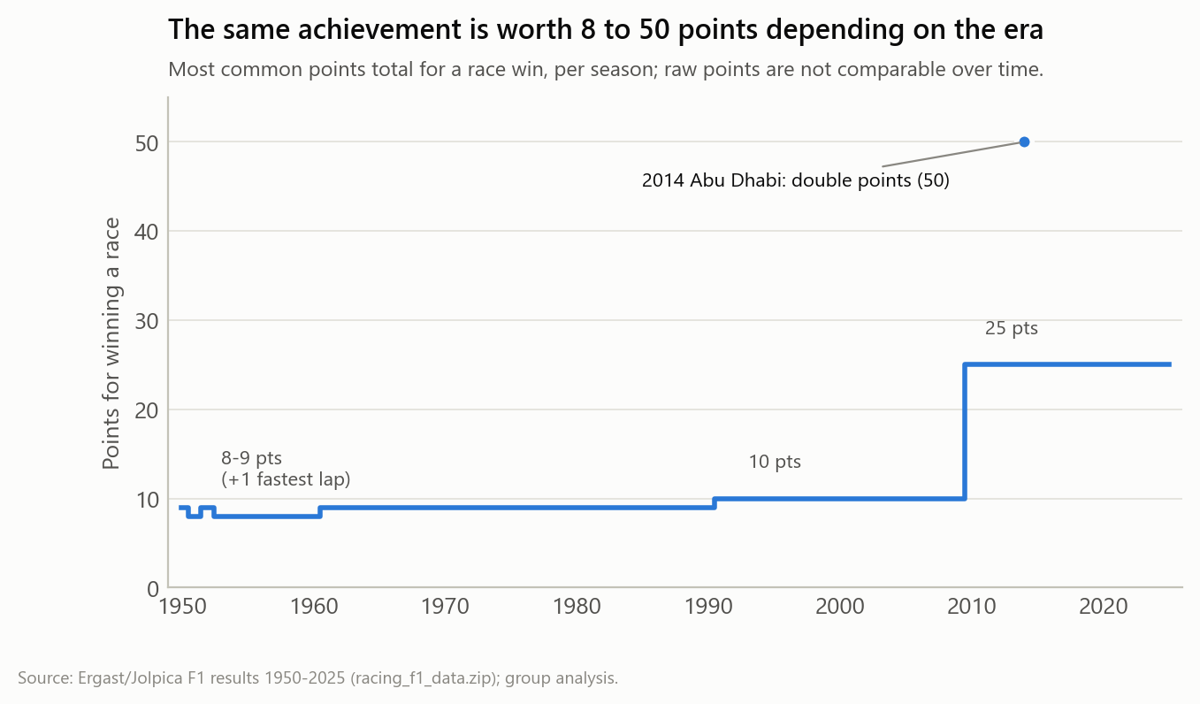
Figure B.1. Points for a race win by season: raw points are not comparable across scoring eras.
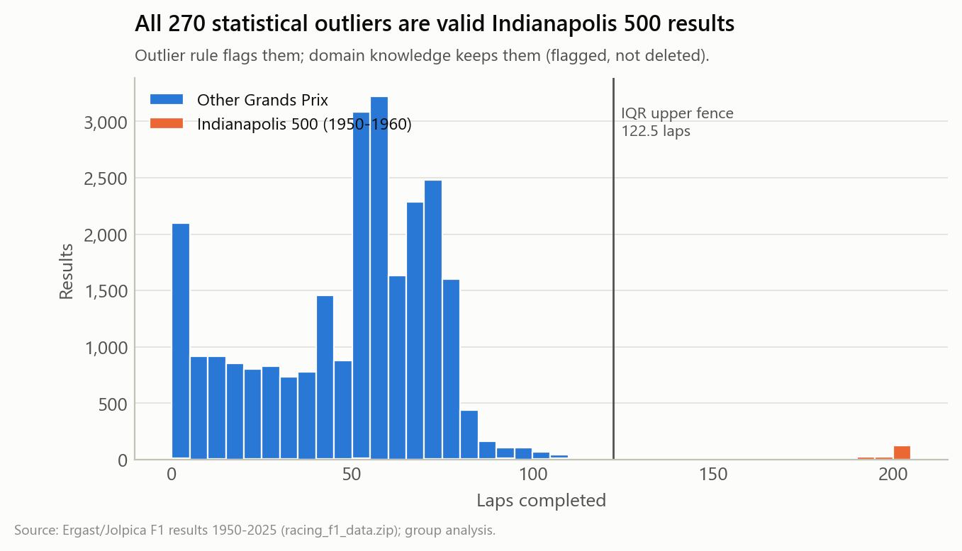
Figure B.2. Laps completed: every value beyond the IQR fence is a valid Indianapolis 500 result.

Appendix C - Cleaning Pipeline (Component C)
Table C.1. Issue resolution: every Component B issue measured again on the cleaned data.
ID | Dimension | Issue | Before | After | Resolution
B01 | Completeness | Season missing | 5 | 0 | Fixed
B02 | Completeness | Round missing | 7 | 0 | Fixed
B03 | Completeness | Car number missing | 6 | 6 | Kept missing (structurally not applicable)
B04 | Completeness | Disguised missing value: grid = 0 sentinel | 267 | 0 | Fixed (sentinel -> missing + flag)
B05 | Completeness | Races with fewer entries than the season norm (2014+): verified, not data loss | 7 | - | Not an error (verified)
B06 | Uniqueness | Exact duplicate records | 23 | 0 | Fixed
B07 | Uniqueness | Hidden duplicates masked by missing keys | 11 | 0 | Fixed (keys repaired before de-duplication)
B08 | Uniqueness | Natural-key collisions that are NOT errors (shared drives) | 172 | 337 | Not an error (kept and flagged)
B09 | Validity | Identifier violates lowercase convention | 2 | 0 | Fixed
B10 | Validity | Incorrect storage types (integers stored as floats, dates stored as text) | 25907 | 0 | Fixed (schema enforced)
B11 | Validity | 'position' is filled for drivers who were not classified | 9646 | 0 | Fixed (classified_position separated from position_order)
B12 | Consistency | Non-standard categorical values: free-text status | 25907 | 0 | Fixed (136 values -> 8 controlled groups; raw kept)
B13 | Consistency | Contradiction: retired ('R') but status says lapped finish | 26 | 26 | Flagged (kept)
B14 | Consistency | Inconsistent text formatting (proper names stored in lowercase) | 25907 | 0 | Fixed
B15 | Consistency | Points not comparable across eras (scoring rules changed) | 8425 | - | Mitigated (points_normalised added)
B16 | Accuracy | Statistical outliers that are valid (Indianapolis 500) | 270 | 270 | Not an error (kept and flagged)
B17 | Referential integrity | Results that cannot be linked to a race | 11 | 0 | Fixed
B18 | Uniqueness | Duplicate race records | 5 | 0 | Fixed
B19 | Uniqueness | Duplicate circuits (exact copies and copies without ID) | 4 | 0 | Fixed
B20 | Uniqueness | Same person under two identifiers | 2 | 0 | Fixed (1 alias recorded)
B21 | Validity | Country names not in a standard vocabulary | 19 | 0 | Fixed (ISO 3166 codes added)
B22 | Completeness | Missing coordinates | 1 | 1 | Kept missing (documented)
B23 | Completeness | Missing attributes for newest entities | 12 | 11 | Kept missing (documented)
B24 | Timeliness | Reference calendar ahead of the results snapshot | 24 | 24 | Flagged (has_results)
B25 | Consistency | Mixed URL schemes (http vs https) | 1073 | 0 | Fixed
B26 | Consistency | Proper names stored in lowercase | 956 | 0 | Fixed
B27 | Accuracy | Name differs from the official spelling | 2 | 1 | Kept (documented alias)
B28 | Consistency | Mixed file formats in one package | 8 | 0 | Handled at extraction (manifest)
B29 | Consistency | Retirement causes no longer recorded in recent seasons | 129 | 129 | Kept and documented (cause unknown in source; cause analyses limited to 1950-2022)

Table C.2. Audit log with before/after statistics per step (step details in audit_log.md).
Step | Name | Issues | Table | Rows before | Rows after | Cells changed | Missing before | Missing after
C01 | Enforce schema and data types | B10, B03 | results | 25907 | 25907 | 0 | 18 | 18
C02 | Repair missing keys by deterministic lookup | B01, B02, B17 | results | 25907 | 25907 | 12 | 18 | 6
C03 | Remove exact duplicates (after key repair) | B06, B07 | results | 25907 | 25873 | 0 | 6 | 6
C04 | Standardise identifiers | B09 | results | 25873 | 25873 | 2 | 6 | 6
C05 | Replace grid sentinel 0 with missing + flag | B04 | results | 25873 | 25873 | 267 | 6 | 273
C06 | Separate classification from finishing order | B11, B13 | results | 25873 | 25873 | 0 | 273 | 273
C07 | Standardise status into 8 groups | B12 | results | 25873 | 25873 | 0 | 9911 | 9911
C08 | Flag statistical outliers (keep valid extremes) | B16 | results | 25873 | 25873 | 0 | 9911 | 9911
C09 | Normalise points across scoring eras | B15 | results | 25873 | 25873 | 0 | 9911 | 9911
C10a | Clean races reference table | B18, B24, B25 | races | 1178 | 1173 | 1173 | 0 | 0
C10b | Clean circuits reference table | B19, B21, B22, B25, B26 | circuits | 82 | 78 | 174 | 4 | 2
C10c | Clean drivers reference table | B09, B20, B21, B23, B25, B26 | drivers | 874 | 873 | 3475 | 28 | 25
C10d | Clean constructors reference table | B21, B23, B25 | constructors | 214 | 214 | 426 | 2 | 2
C11 | Integrate into analysis-ready table | B08, B14 | results | 25873 | 25873 | 25873 | 9911 | 9911
C12 | Validation gates | all | results | 25873 | 25873 | 0 | 9911 | 9911

Table C.3. All 55 validation gates (C12).
Validation gate | Result
columns match schema (names and order) | passed
no missing values in required column result_id | passed
no missing values in required column race_id | passed
no missing values in required column season | passed
no missing values in required column round | passed
no missing values in required column race_name | passed
no missing values in required column race_date | passed
no missing values in required column circuit_id | passed
no missing values in required column circuit_name | passed
no missing values in required column circuit_locality | passed
no missing values in required column circuit_country | passed
no missing values in required column circuit_country_iso3 | passed
no missing values in required column driver_id | passed
no missing values in required column driver_name | passed
no missing values in required column constructor_id | passed
no missing values in required column constructor_name | passed
no missing values in required column constructor_nationality_iso3 | passed
no missing values in required column grid_position_missing | passed
no missing values in required column laps_completed | passed
no missing values in required column points | passed
no missing values in required column points_normalised | passed
no missing values in required column position_order | passed
no missing values in required column position_text | passed
no missing values in required column finish_category | passed
finish_category uses controlled vocabulary | passed
no missing values in required column status_raw | passed
no missing values in required column status_group | passed
status_group uses controlled vocabulary | passed
no missing values in required column is_shared_drive | passed
no missing values in required column is_indy500 | passed
no missing values in required column laps_outlier_iqr | passed
no missing values in required column status_position_conflict | passed
no missing values in required column source_file | passed
no missing values in required column source_line | passed
result_id unique | passed
natural key (season, round, driver_id, car_number) unique | passed
no exact duplicate records | passed
season within snapshot | passed
every race_id exists in races | passed
every circuit_id exists in circuits | passed
every driver_id exists in drivers | passed
every constructor_id exists in constructors | passed
identifiers are lowercase | passed
grid_position >= 1 when present | passed
classified_position missing for every non-classified result | passed
points_normalised within [0, 1] | passed
one winner share of 1.0 per race | passed
duplicate classified positions only occur in shared drives | passed
race names are not all-lowercase | passed
country codes present for every circuit | passed
races table: race_id unique | passed
circuits table: circuit_id unique and present | passed
drivers table: driver_id unique | passed
drivers table: no person under two IDs | passed
reference URLs use https | passed

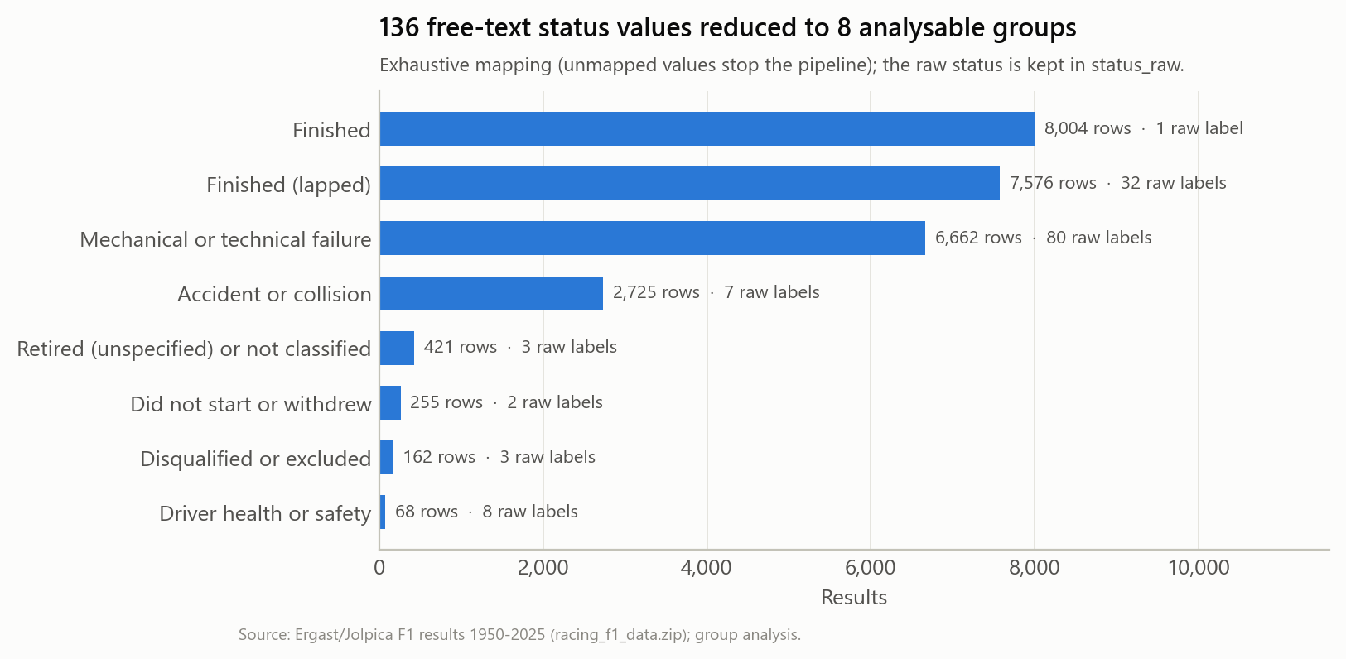
Figure C.1. Status standardisation: 136 raw values mapped to 8 groups.

Appendix D - Graph Metrics
Table D.1. Network-level metrics.
Metric (team-mate projection) | Value
drivers in projection | 714
teammate links | 3,081
density | 0.0121
connected components | 42
giant component drivers | 663
giant component share | 0.9286
isolated drivers | 35
average degree | 8.6303
average clustering giant | 0.4073
average shortest path giant | 4.8165
diameter giant | 12
random graph clustering | 0.0141
random graph shortest path | 3.1626
small world sigma | 18.9881
louvain communities | 11
modularity | 0.6967
degree assortativity | 0.1538

Table D.2. Top 12 drivers by betweenness centrality.
Driver | First | Last | Degree | Betweenness | PageRank | Community
Jo Bonnier | 1956 | 1971 | 65 | 0.1504 | 0.0094 | 3
Jack Brabham | 1955 | 1970 | 77 | 0.1474 | 0.0113 | 3
Andrea de Cesaris | 1980 | 1994 | 19 | 0.1443 | 0.005 | 5
Mario Andretti | 1968 | 1982 | 23 | 0.1387 | 0.0046 | 4
Riccardo Patrese | 1977 | 1993 | 14 | 0.1354 | 0.0055 | 5
Rolf Stommelen | 1970 | 1978 | 20 | 0.134 | 0.0029 | 4
Rubens Barrichello | 1993 | 2011 | 15 | 0.0936 | 0.0052 | 7
Michael Schumacher | 1991 | 2012 | 11 | 0.0812 | 0.0048 | 7
Jacques Laffite | 1974 | 1986 | 18 | 0.0738 | 0.0038 | 4
Jacky Ickx | 1967 | 1979 | 26 | 0.0688 | 0.0046 | 4
Nigel Mansell | 1980 | 1995 | 9 | 0.0658 | 0.0041 | 5
Nico Hülkenberg | 2010 | 2025 | 11 | 0.0561 | 0.0037 | 10

Table D.3. Louvain communities.
Community | Drivers | First debut | Median debut | Last active | Most central drivers (PageRank)
1 | 135 | 1950 | 1952.0 | 1964 | Stirling Moss; Maurice Trintignant; Louis Rosier
2 | 5 | 1954 | 1954.0 | 1955 | Leslie Marr; Don Beauman; John Riseley-Prichard
3 | 173 | 1952 | 1961.0 | 1977 | Jack Brabham; Graham Hill; Jo Bonnier
4 | 110 | 1963 | 1974.0 | 1986 | Ronnie Peterson; Niki Lauda; Carlos Reutemann
5 | 93 | 1975 | 1986.0 | 2002 | Riccardo Patrese; Michele Alboreto; Nelson Piquet
6 | 13 | 1985 | 1993.0 | 2009 | Pierluigi Martini; Gianni Morbidelli; Luca Badoer
7 | 32 | 1989 | 2001.5 | 2025 | Rubens Barrichello; Michael Schumacher; Lewis Hamilton
8 | 48 | 1988 | 2001.5 | 2025 | Fernando Alonso; Kimi Räikkönen; Jarno Trulli
9 | 2 | 2003 | 2003.5 | 2004 | Zsolt Baumgartner; Gianmaria Bruni
10 | 49 | 2005 | 2015.0 | 2025 | Sergio Pérez; Nico Hülkenberg; Daniel Ricciardo
11 | 3 | 2014 | 2015.0 | 2015 | Will Stevens; Roberto Merhi; Alexander Rossi

Table D.4. Shortest team-mate path from Juan Manuel Fangio to Max Verstappen.
From | To | Shared constructor | Races together
Juan Fangio | Jo Bonnier | maserati | 5
Jo Bonnier | Mario Andretti | lotus-ford | 1
Mario Andretti | Bruno Giacomelli | alfa | 15
Bruno Giacomelli | Andrea de Cesaris | alfa | 18
Andrea de Cesaris | Rubens Barrichello | jordan | 2
Rubens Barrichello | Jenson Button | brawn, honda | 70
Jenson Button | Sergio Pérez | mclaren | 19
Sergio Pérez | Max Verstappen | red_bull | 90

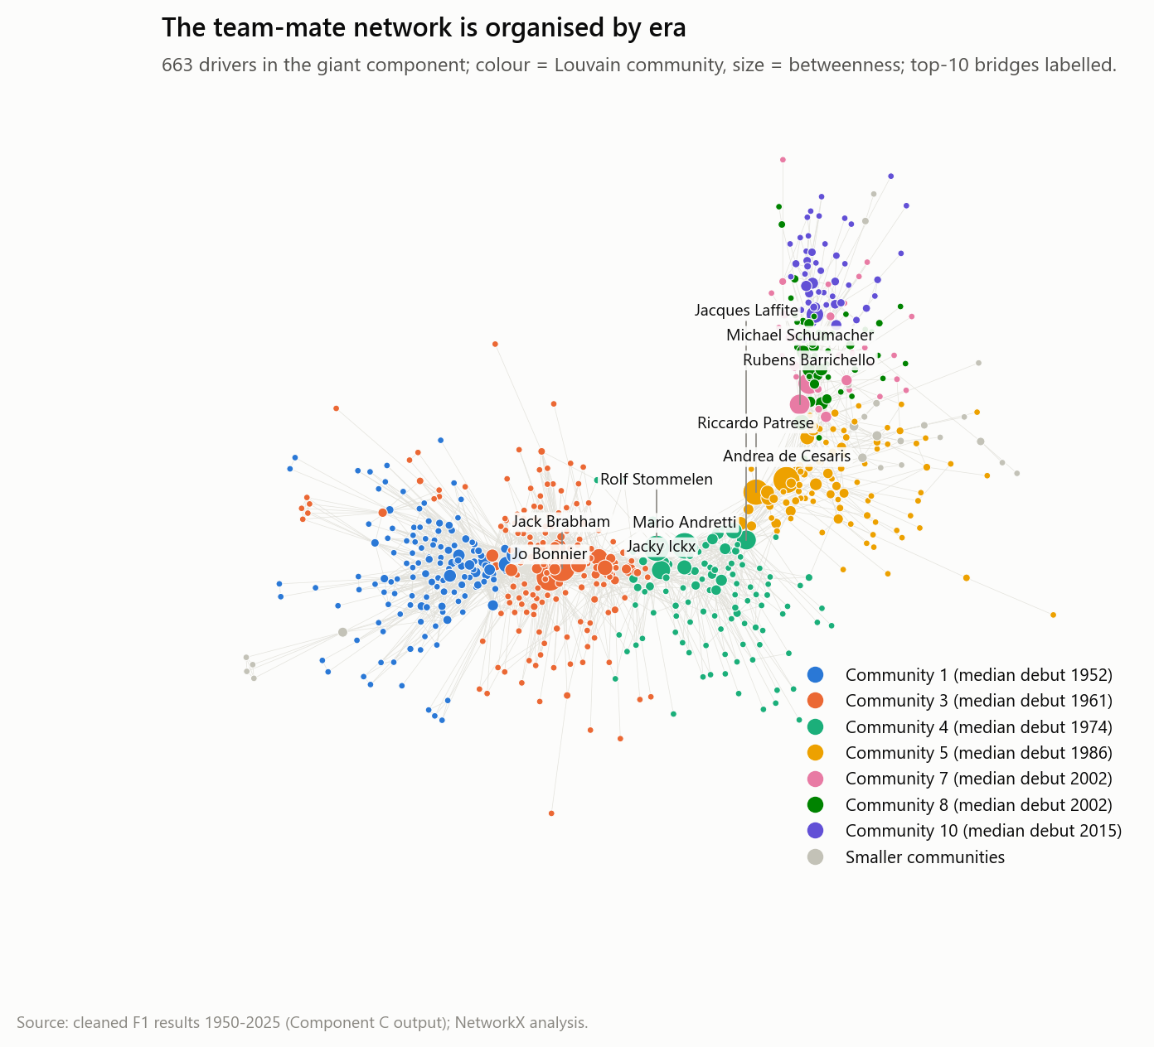
Figure D.1. Team-mate network (giant component) coloured by Louvain community; node size = betweenness.

Appendix E - Data Dictionary of the Cleaned Results Table
Table E.1. Variables of f1_race_results_clean.csv (all tables in data_dictionary.md).
Column | Type | Description | Nullable
result_id | string | Deterministic surrogate key: season_round_driverId_carNumber. | False
race_id | string | Identifier of the Grand Prix: season and round. | False
season | Int64 | Championship season (year). | False
round | Int64 | Round number of the race within the season. | False
race_name | string | Official Grand Prix name in title case. | False
race_date | date | Race day. | False
circuit_id | string | Circuit identifier (Ergast convention). | False
circuit_name | string | Circuit name in title case. | False
circuit_locality | string | City or locality of the circuit. | False
circuit_country | string | Country of the circuit; abbreviations expanded (UK, USA, UAE, Korea), other names kept as in source. | False
circuit_country_iso3 | string | Country of the circuit. | False
driver_id | string | Driver identifier, lowercase snake case. | False
driver_name | string | Driver full name in title case. | False
driver_nationality_iso3 | string | Driver nationality as a country code (ISO 3166-3 code for former states). | True
constructor_id | string | Constructor (team) identifier. | False
constructor_name | string | Constructor name. | False
constructor_nationality_iso3 | string | Constructor nationality as a country code. | False
car_number | Int64 | Race number of the car. Missing for some withdrawn entries. | True
grid_position | Int64 | Starting grid slot. Missing when the source used the sentinel 0 (pit-lane start or no grid slot). | True
grid_position_missing | boolean | True when the source grid value was the sentinel 0. | False
laps_completed | Int64 | Laps completed in the race. | False
points | float | Championship points awarded, as published for that season's rules. | False
points_normalised | float | Points divided by the highest points total awarded in the same race (0-1), comparable across scoring eras. | False
position_order | Int64 | Finishing order including retirements (source field 'position'). Not a classification. | False
classified_position | Int64 | Official classified finishing position. Missing when the driver was not classified. | True
position_text | string | Source classification code: a number, R, W or D. | False
finish_category | string | Classification outcome derived from position_text. | False
status_raw | string | Original free-text status (136 values). | False
status_group | string | Standardised status category. | False
is_shared_drive | boolean | True when the car or the driver appears more than once in the same race (historic shared drives). | False
is_indy500 | boolean | True for Indianapolis 500 rounds (1950-1960), which counted for the title but used different rules. | False
laps_outlier_iqr | boolean | True when laps_completed lies outside the 1.5 x IQR fences. | False
status_position_conflict | boolean | True when position_text says retired (R) but the status describes a lapped finish. | False
source_file | string | Lineage: source file inside racing_f1_data.zip. | False
source_line | Int64 | Lineage: line number inside the source file. | False

Appendix F - Reproducibility and Deliverables
Requirements: Python 3.11+, packages in requirements.txt. From the folder data_management_project run python run_all.py --from-scratch (about 70 s, no network needed), then python -m pytest -q and python -m src.build_report.
Table F.1. Map of the assignment deliverables.
Deliverable | Location in the ZIP
1 Joint written report | report/F1_Data_Management_Joint_Report.docx / .pdf
2 Python cleaning scripts | src/cleaning.py, src/vocabularies.py, src/schema.py, run_all.py, tests/
3 Tableau Prep flow | not used (pipeline fully in Python)
4 Metadata record | outputs/component_a_fair/datacite_metadata.xml/.json, schema_org_dataset.jsonld, datapackage.json, provenance_prov.jsonld
5 FAIR assessment evidence | outputs/component_a_fair/fuji/*.json, fig_a2_fuji_scores.png, rda_fair_assessment.csv, license_evidence/
6 Quality visualisations | outputs/component_b_quality/figures/*.png
7 Original + cleaned datasets | data/raw/f1_race_results_raw.csv, data/cleaned/f1_race_results_clean.csv (+ reference tables)
8 Graph files | src/graph_model.py, outputs/graph/.gexf, outputs/graph/figures/.png
Extra: interactive dashboard | dashboard/ (app.py, build_web_data.py, static/); screenshots in outputs/dashboard/
9 Individual reflection logs | submitted individually (drafts in report/reflection_drafts/)

Appendix G - Declaration of AI Tool Use
In line with the course rules, all use of AI tools is declared here. The group used Claude Code (Anthropic; models Claude Haiku 4.5 and Claude Opus 5.5) as an AI programming assistant, with the instructor's agreement for extensive use. It was used to: write and debug the Python code (extraction, profiling, cleaning, metadata generation, graph analytics, the interactive dashboard and this report builder); run the F-UJI tool locally and summarise its output; retrieve licence terms and Wikidata identifiers from primary sources; draft text for the report sections; and generate the figures.
The ask-the-data assistant (Section 6.1) also contains an AI model as part of the product: Meta Llama 3 (8B) and the nomic-embed-text embedding model, run locally through Ollama, so no data leave the computer. By design the language model only phrases answers: every figure comes from code over the validated data and is checked against the evidence after the answer is written, and its accuracy was measured on 25 benchmark questions whose answers were computed independently.
Human responsibilities: choosing the dataset and the analysis direction, reviewing every cleaning decision and its domain justification, checking that numbers in the text match the outputs, and editing each component section and the reflection logs, which remain the work of the responsible student. All factual claims (licences, F-UJI scores, historical events) were checked against the cited evidence files included in the ZIP.

Appendix H - Dashboard Gallery
Screenshots of the running dashboard (streamlit run app.py in the dashboard folder). Every number shown is read from the validated project outputs.
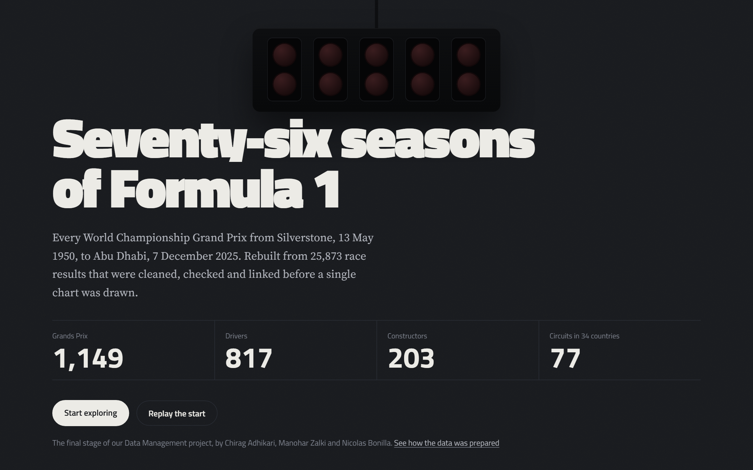
Figure H.1. Opening: the start-light sequence, then the key figures of the dataset.
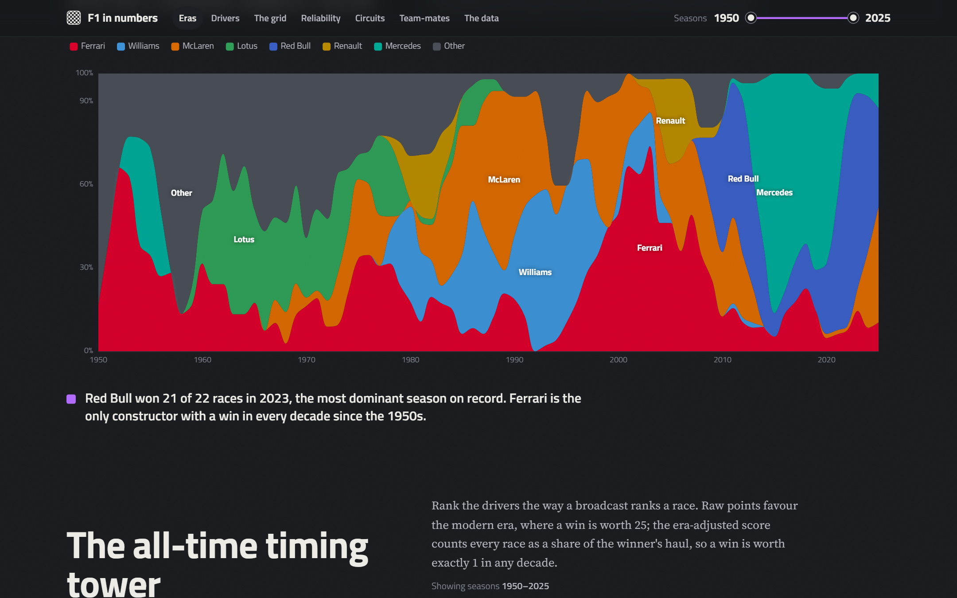
Figure H.2. Who ruled each era: share of wins by constructor per season, with the computed finding.
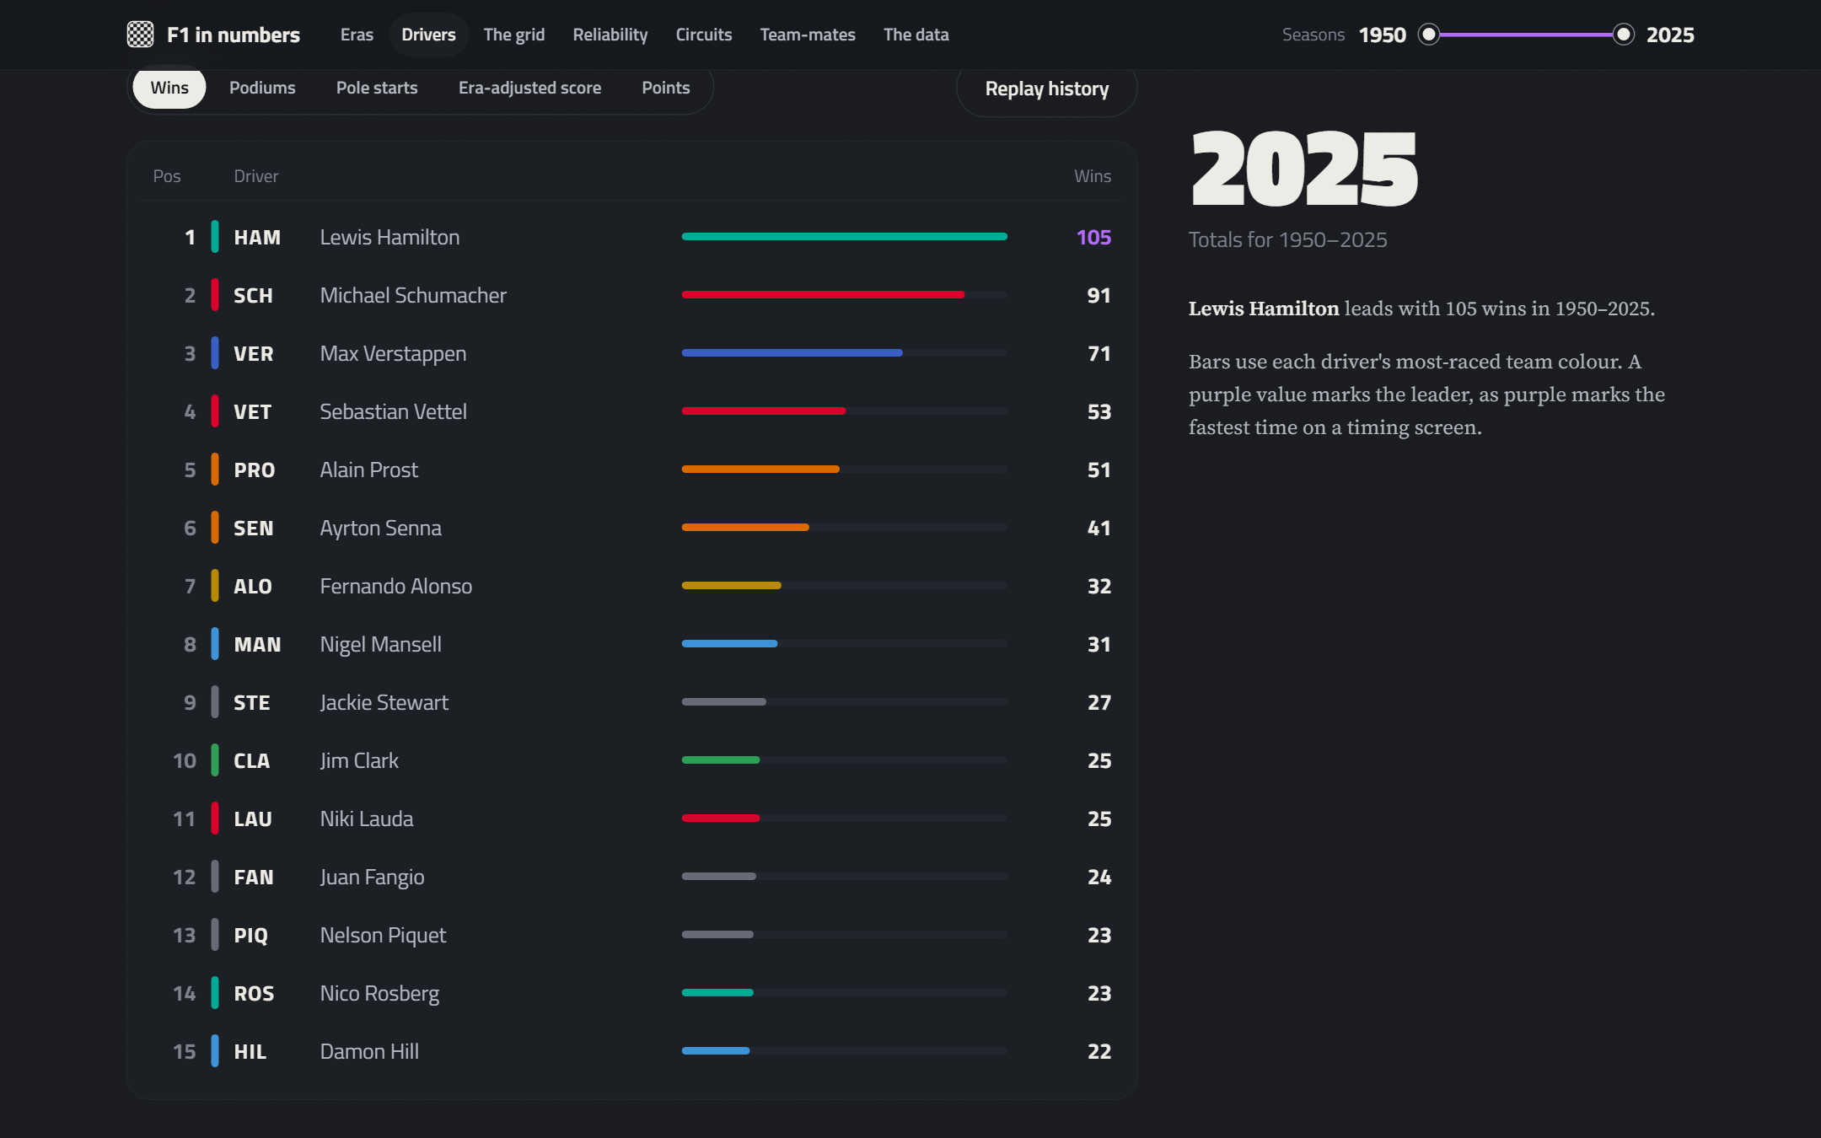
Figure H.3. The all-time timing tower: rank by wins, podiums, pole starts, era-adjusted score or points; replays season by season.
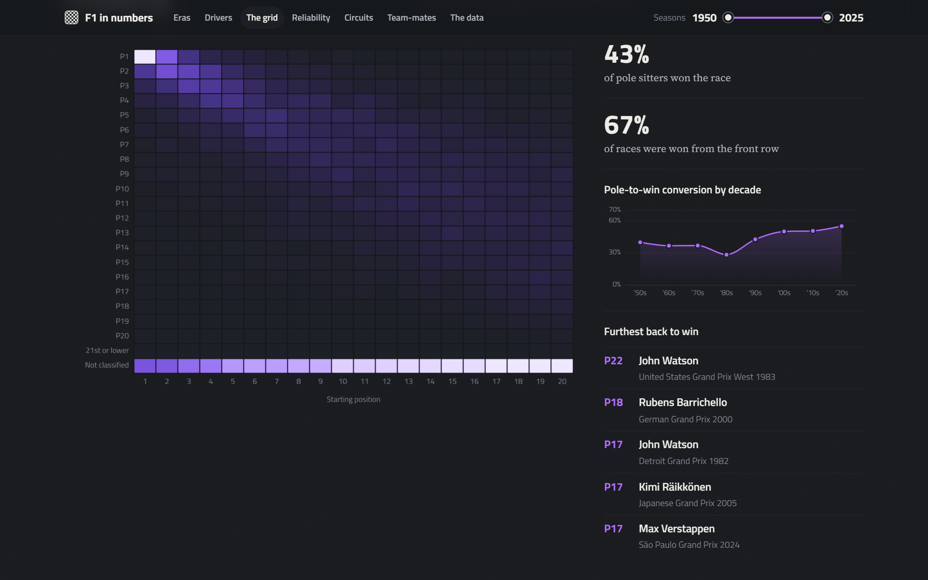
Figure H.4. Grid to finish: share of drivers from each starting slot finishing in each position, with pole conversion by decade and the furthest-back winners.
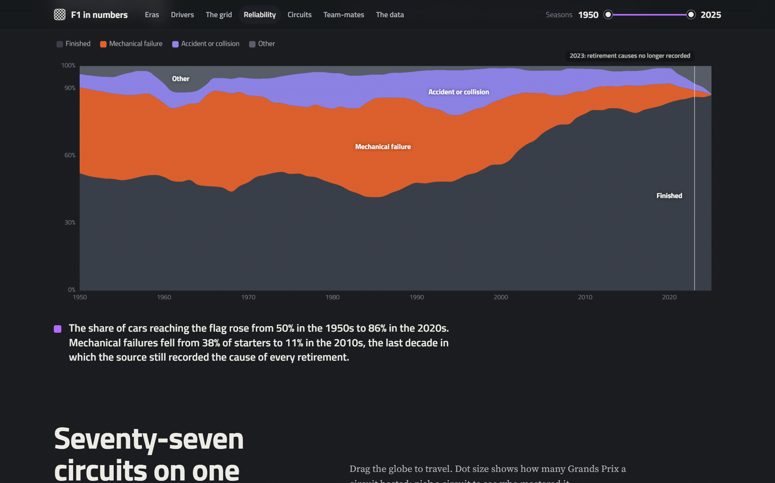
Figure H.5. Reliability: outcomes of every start, with the 2023 break in cause recording (issue B29) marked.
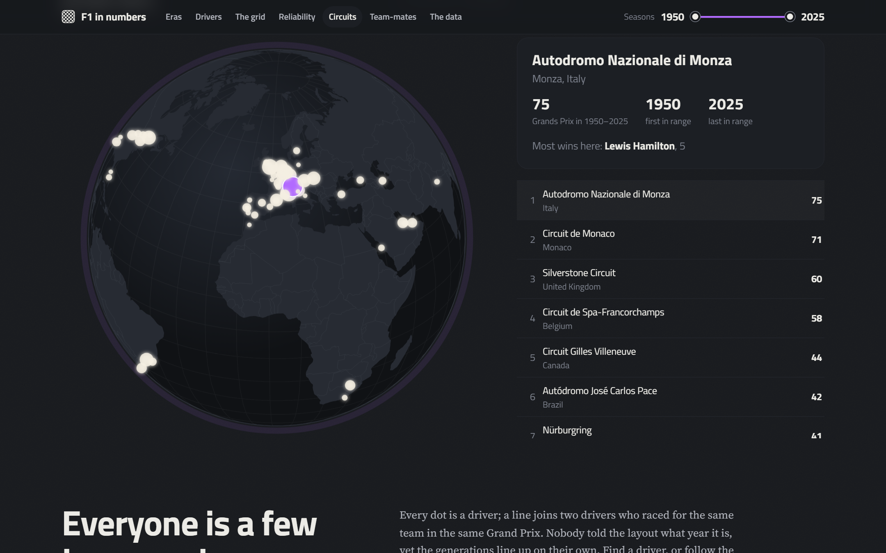
Figure H.6. Circuits: rotating globe and ranking by Grands Prix hosted.
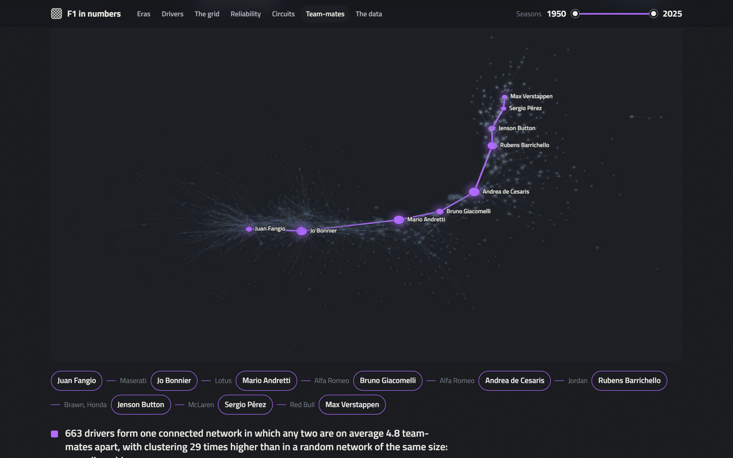
Figure H.7. Team-mate network with the shortest chain from Juan Manuel Fangio to Max Verstappen.
Figure H.8. Ask the data: the answer of the local Llama 3, its evidence with provenance and the figure check.
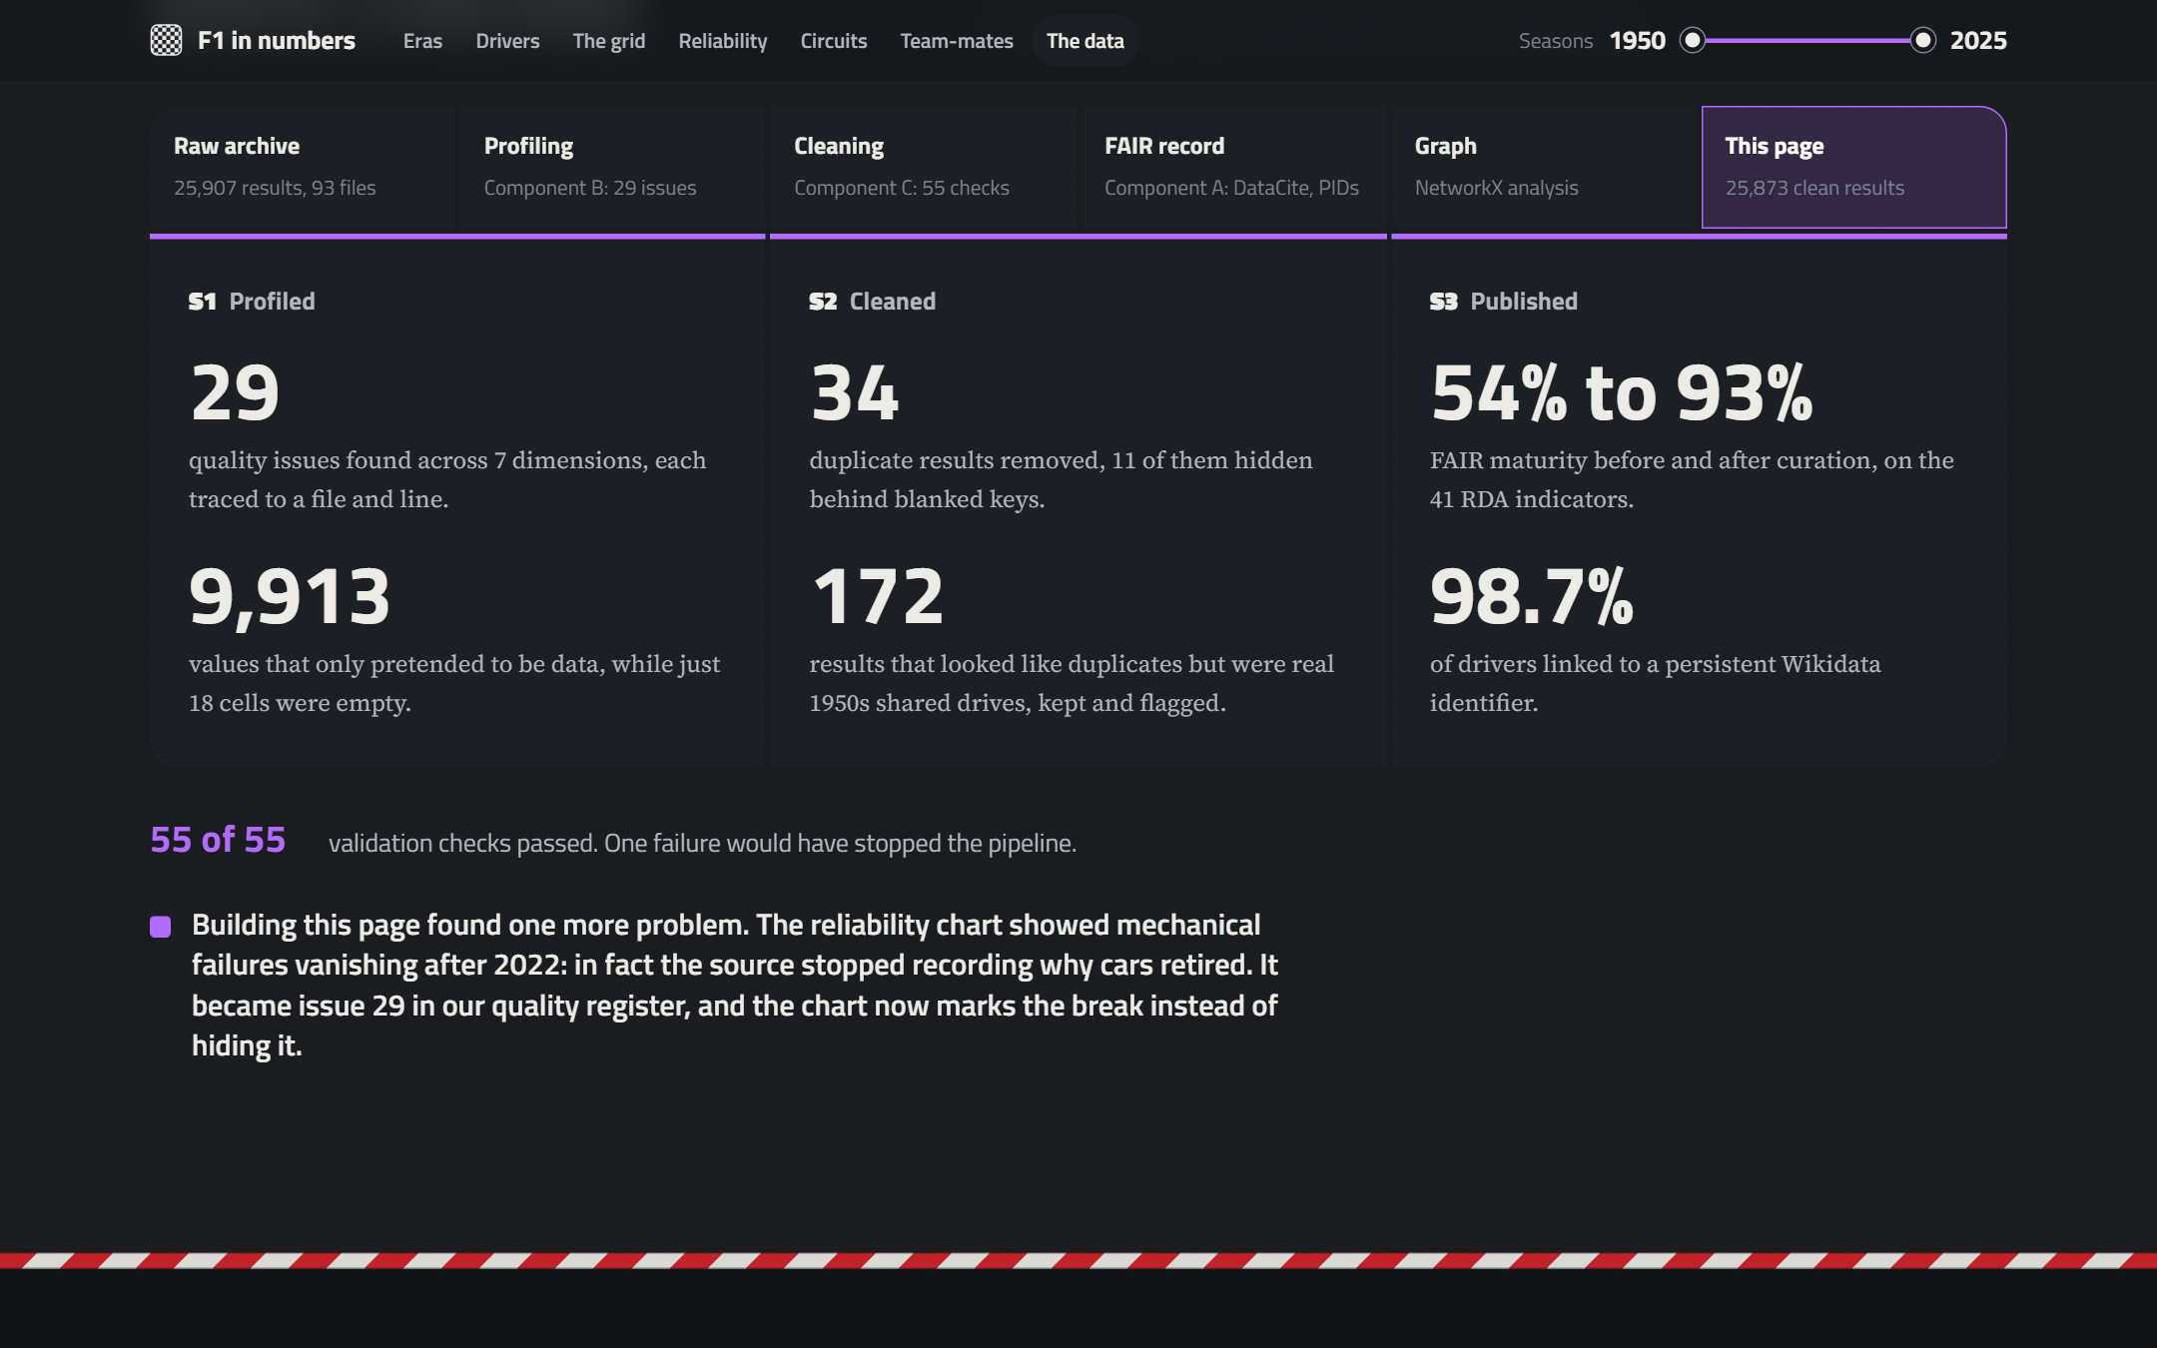
Figure H.9. How the numbers were checked: the project pipeline and its key results.

