Zachary Allin
Susma Basel
Jeremy Bower

Lab 06 – Reading SD Card Data over SPI

1.

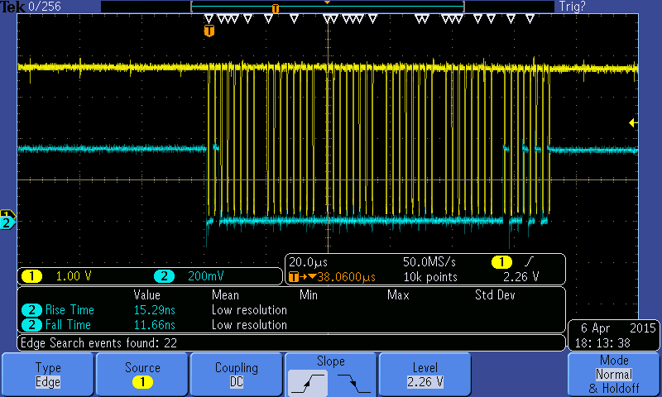
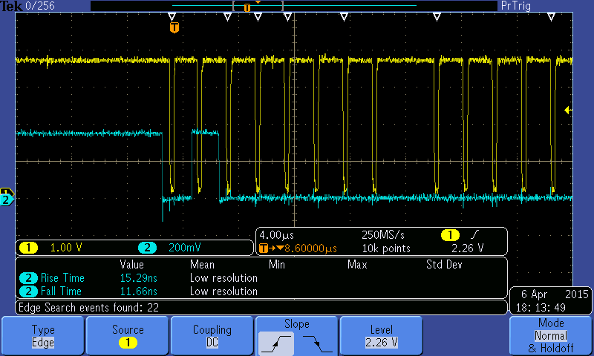

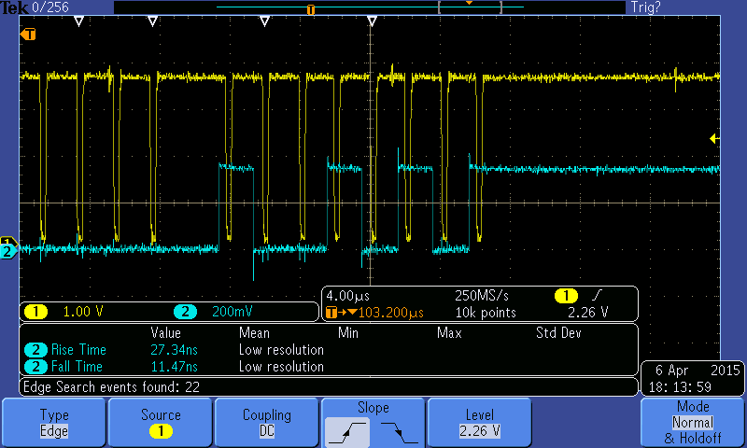

2.
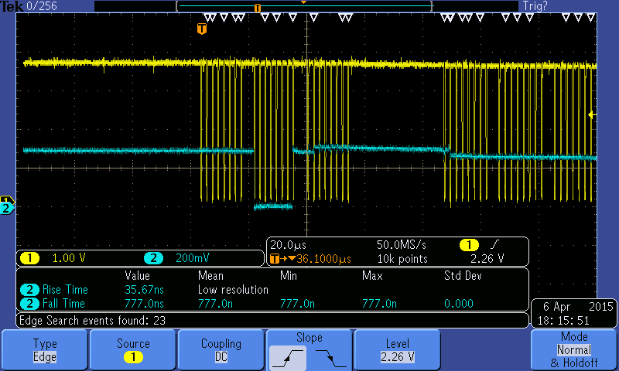

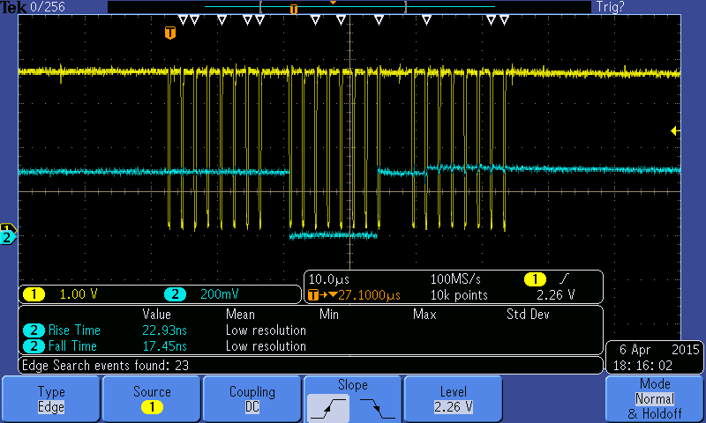

3. This part of the lab did not work correctly. The results we were receiving on the oscilloscope were inconsistent. Other teams in the class were seeing similar issues. Below are screenshots that we believe capture whatever data was transmitted from the blocks on the memory card.

