# Issue in execution of MWE2 workflow programmatically from an eclipse plugin (launched as an eclipse application)

## Issue Description:

* When MWE2Launcher API is used for executing MWE2 file from eclipse plugin 🡪 eclipse runtime class path is not considered
  + When the same code is invoked from a simple java application, all the dependencies of the eclipse plugin are considered and MWE2 workflow is successfully executed programmatically.

## 1.1 Demonstration of the issue:

To demonstrate this issue, I have created two eclipse plugins as shown in the below screenshot

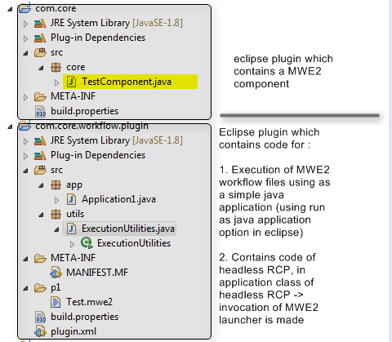

### Running java application to execute MWE2 workflow:

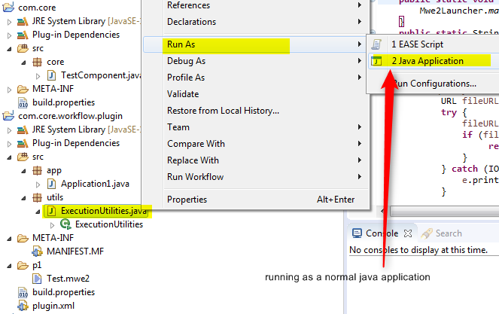

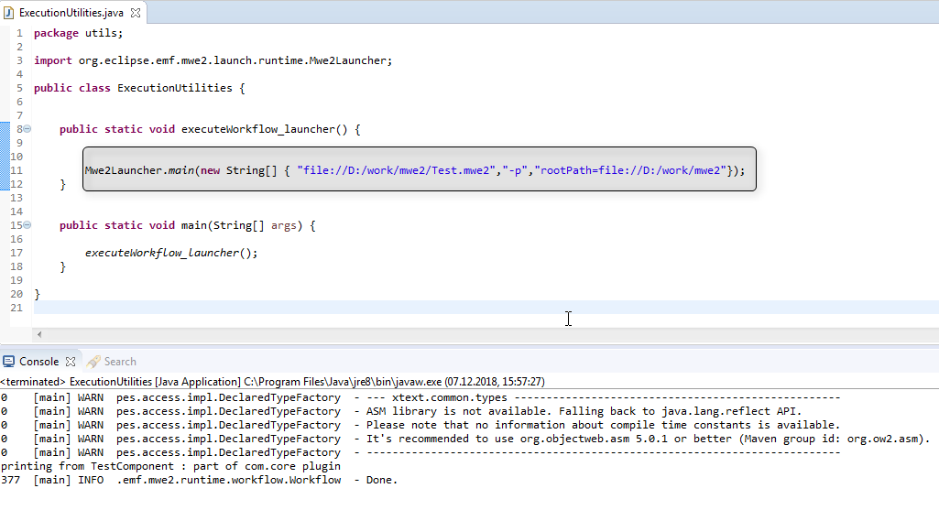

Figure 1 code for execution of MWE2Launcher

In this case, as java application -> MWE2 workflow file was successfully executed and the result is printed

### Running as eclipse application to execute MWE2 workflow

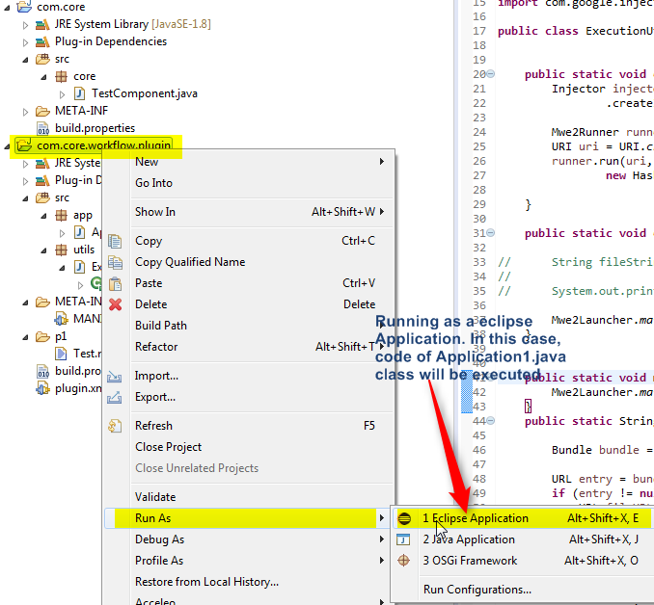

**On invoking as an eclipse application, MWE2Launcher has failed to consider the eclipse classpath and resulted in an Exception**. See below screenshot.

Reason here is that plugin dependencies were not considered.. Java class from a different plugin can not be resolved ☹ by MWE2Launcher (during the case it is executed from a Eclipse Application)

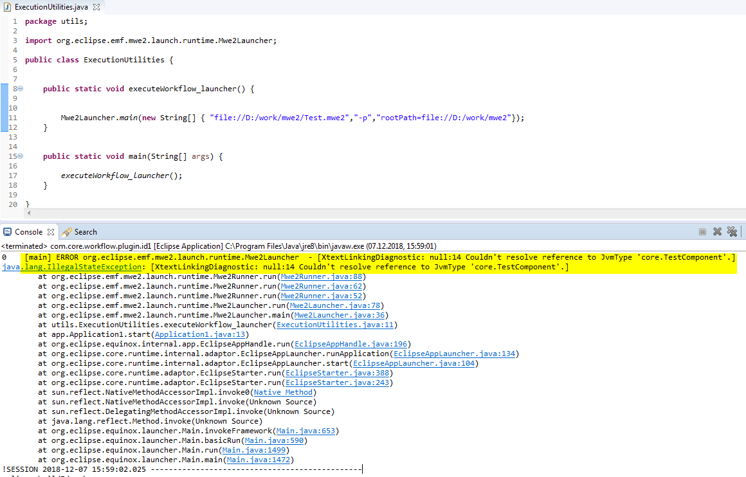

Result:

Based on the above results, it is clearly visible that MWe2Launcher API is behaving differently based on execution as a java application and as an eclipse application