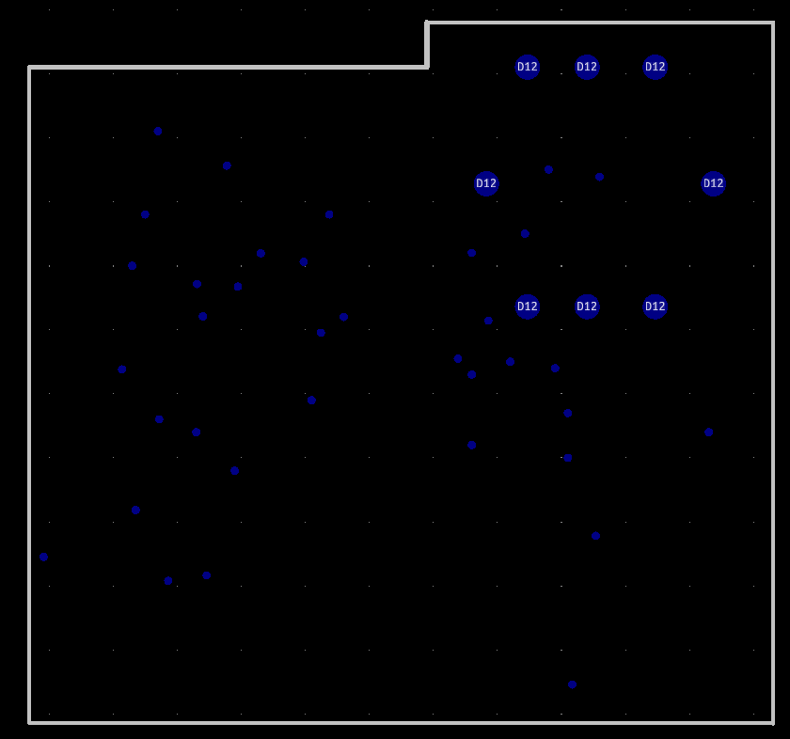
Fig: Drill with border line
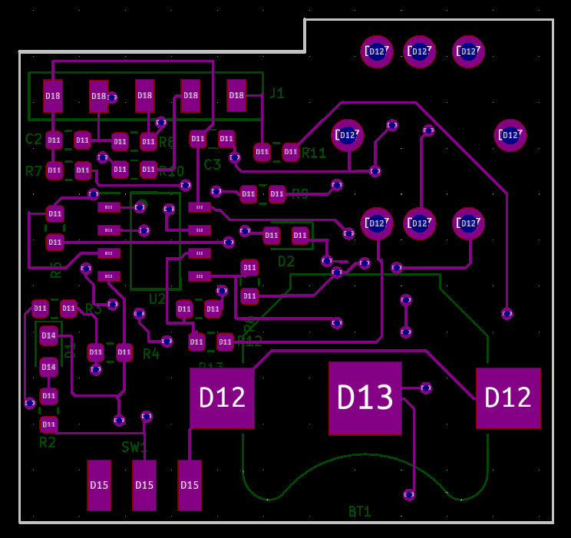
Top Layer
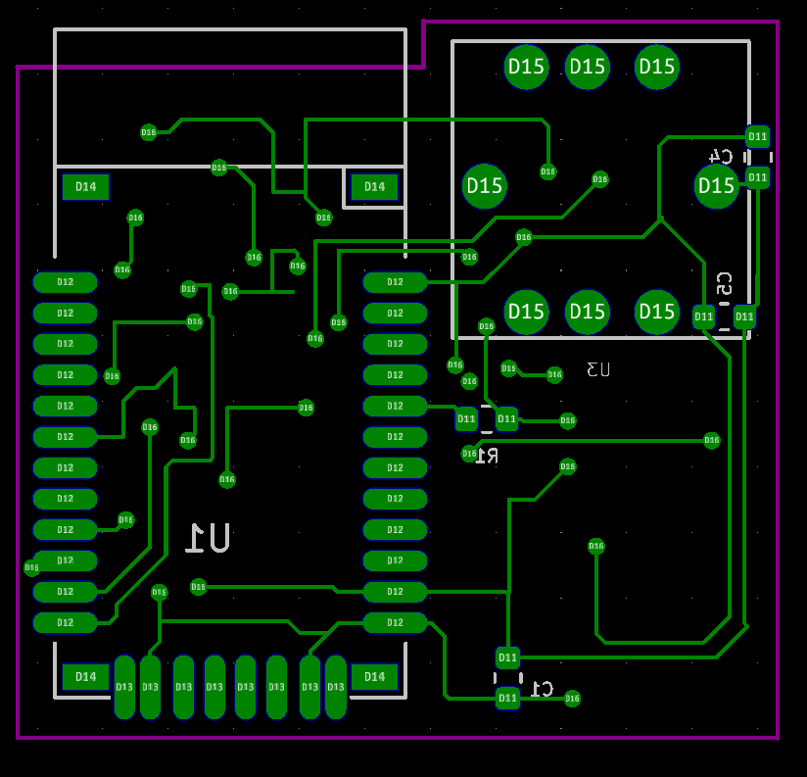
Bottom Layer

Application schematic of Max30102
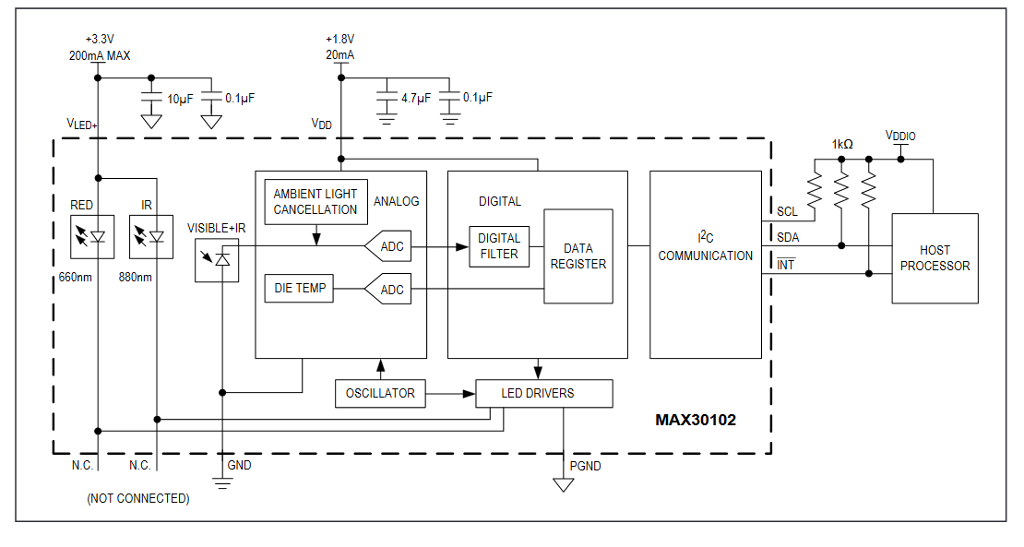
Schematic of Maxrefdes117
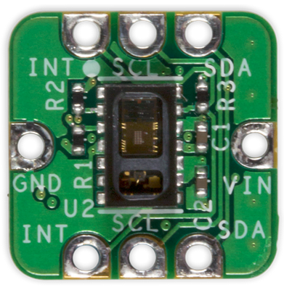
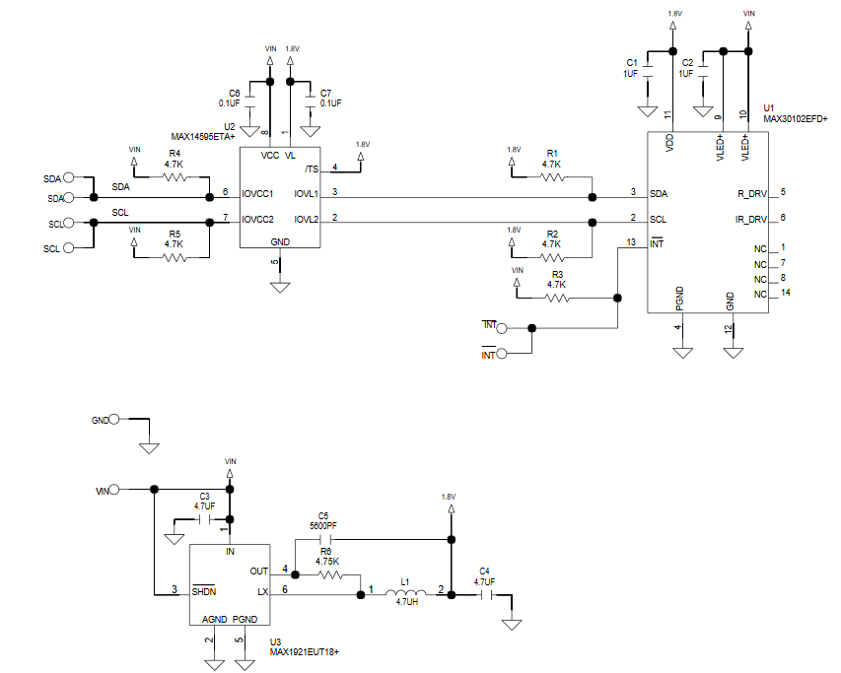

How to shutdown:
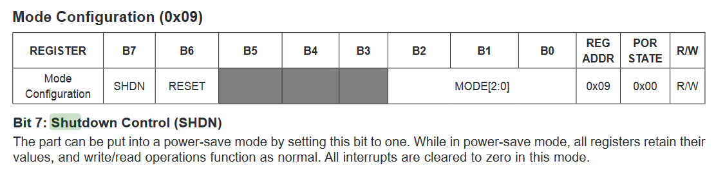
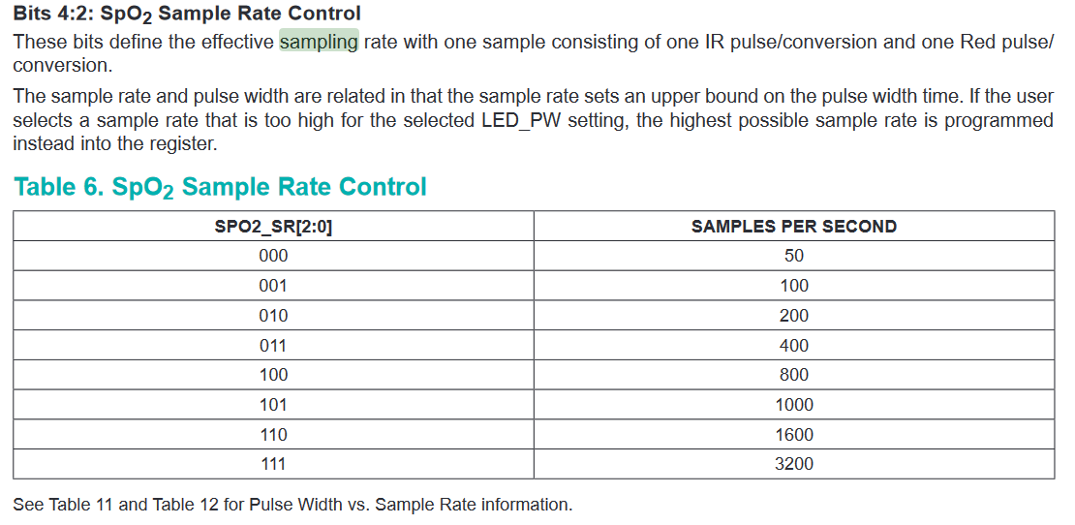

Sampling Rate control

ECG Annotation files are kept in Dropbox as pptx along with my annotation. For annotating with an expert
28 Excellent
30 Acceptable
30 Unacceptable

