Week 6 Deliverables – Terraform

1. Terraform Directory (VPC Infrastructure)
Created a terraform/ directory containing all Infrastructure as Code files used to provision AWS networking resources.
Files:
- providers.tf
- backend.tf
- vpc.tf
- variables.tf
- outputs.tf
- security-groups.tf
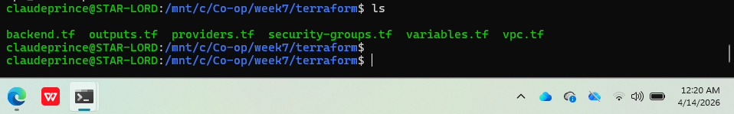

2. Remote State in S3
Configured Terraform to store its state remotely in an S3 bucket for persistence and consistency.
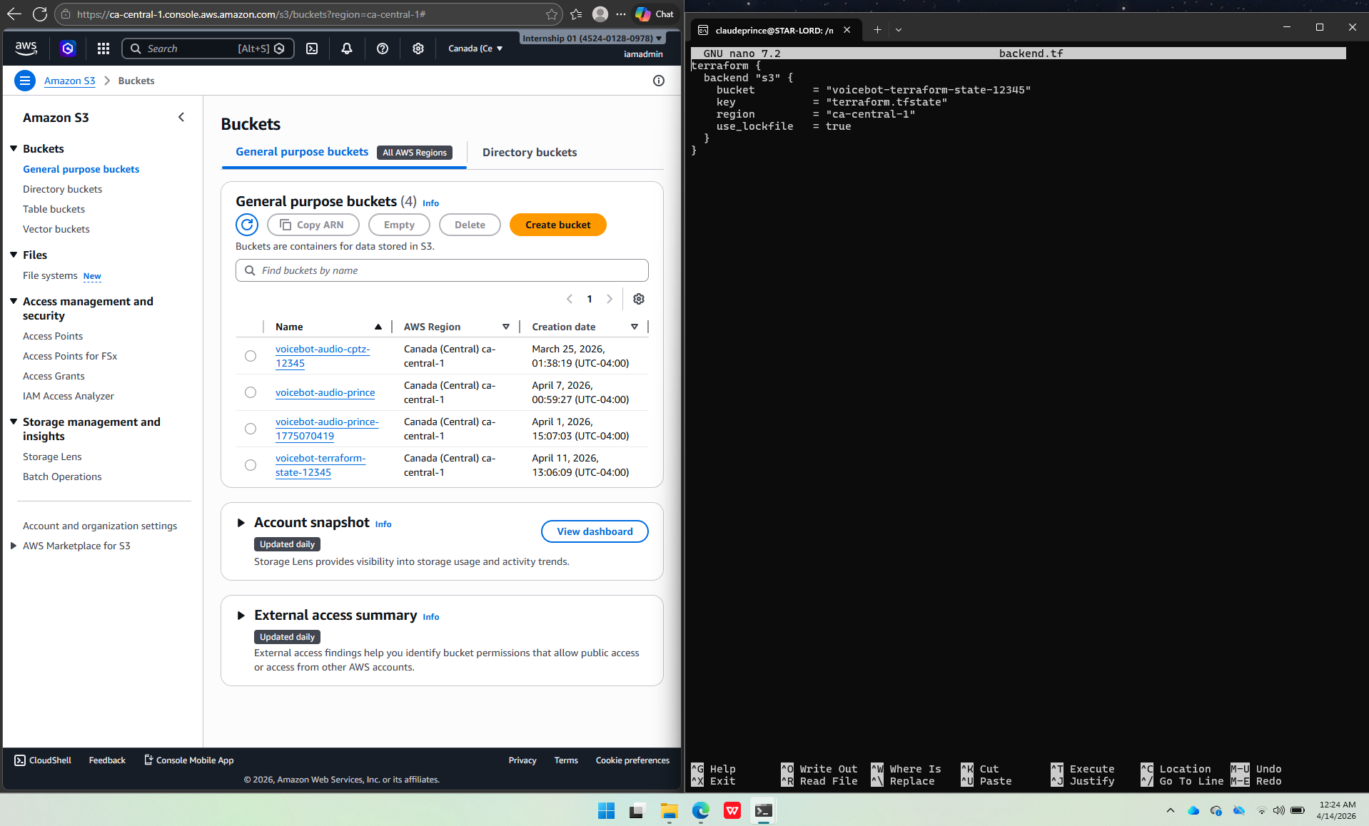

3. variables.tf and outputs.tf
Used variables.tf to define reusable configuration values (e.g., CIDR block).
Used outputs.tf to expose important values such as VPC ID and subnet ID after deployment.
Screenshots:
- variables.tf
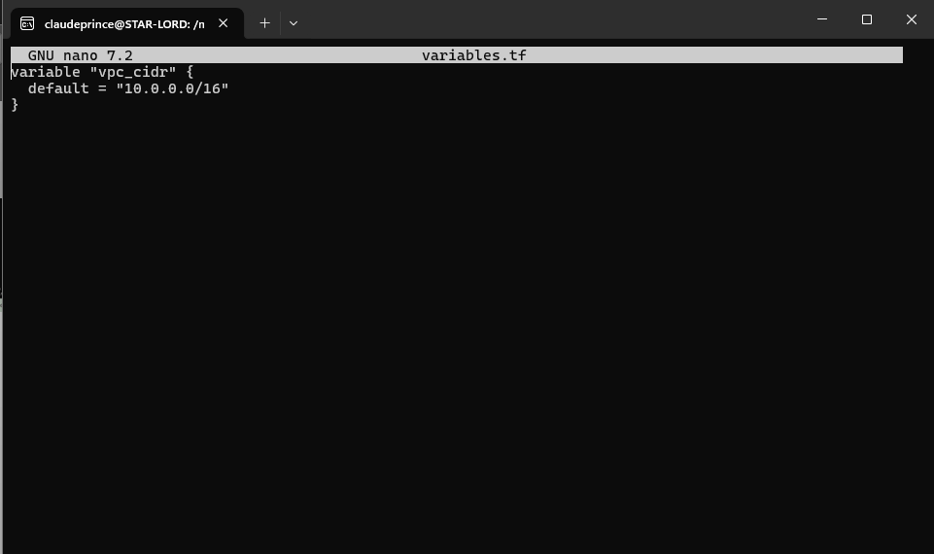
-

4. Terraform Workflow Documentation
Followed standard Terraform workflow:
1. terraform init
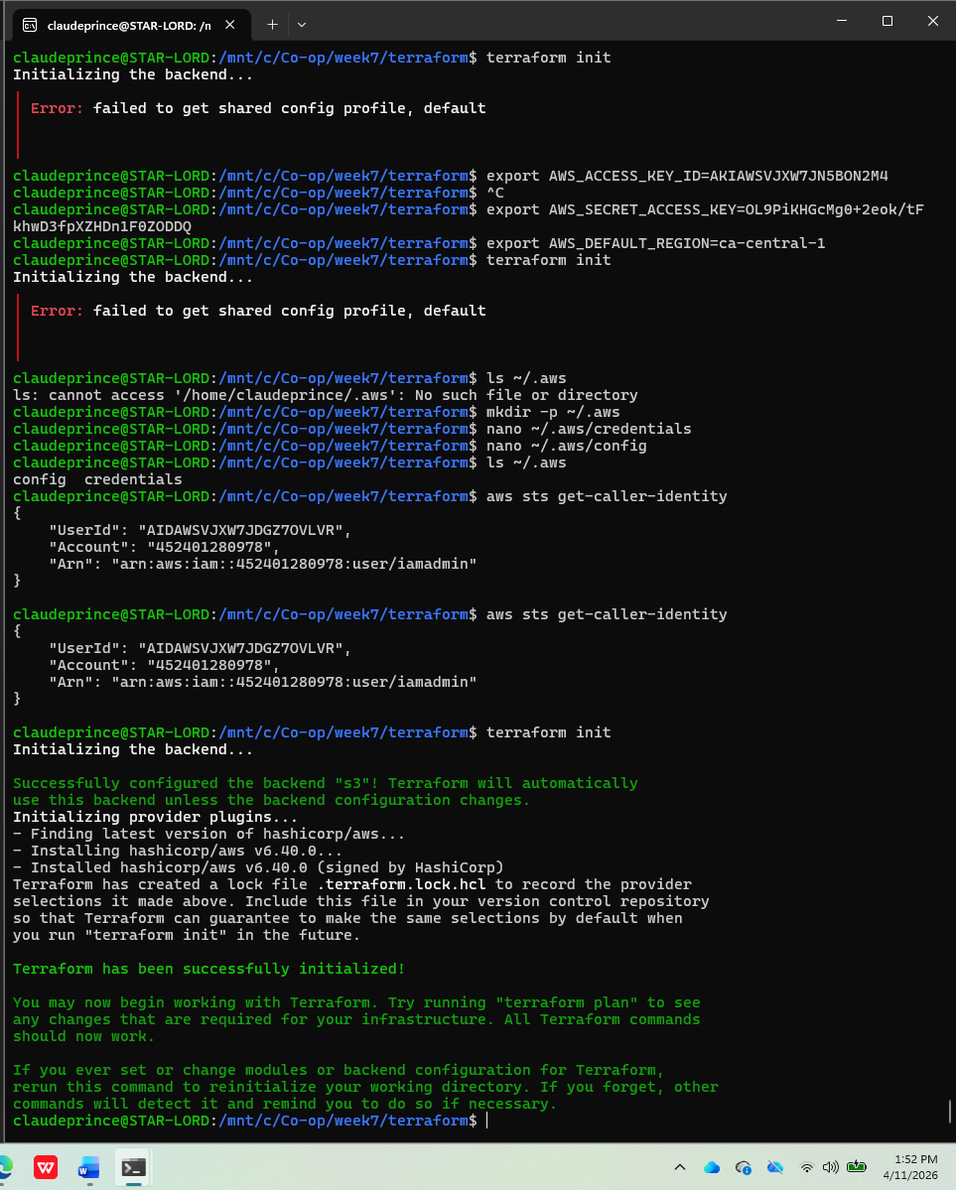
2. terraform apply
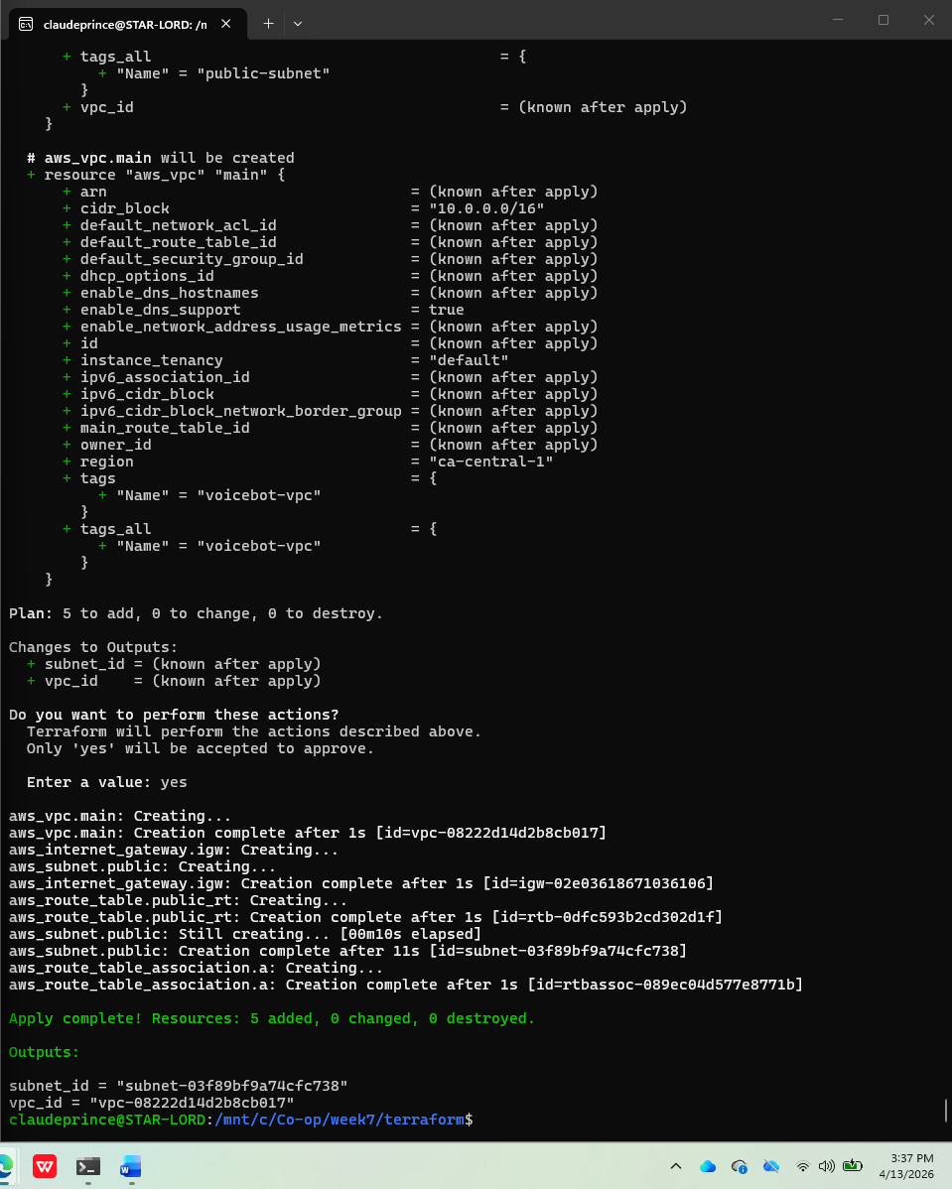
Security Groups Implementation
Description:
Implemented AWS Security Groups using Terraform to control inbound and outbound traffic to the infrastructure. Security groups act as virtual firewalls to protect cloud resources.
The configuration ensures that only necessary ports are open while maintaining secure access to the system.
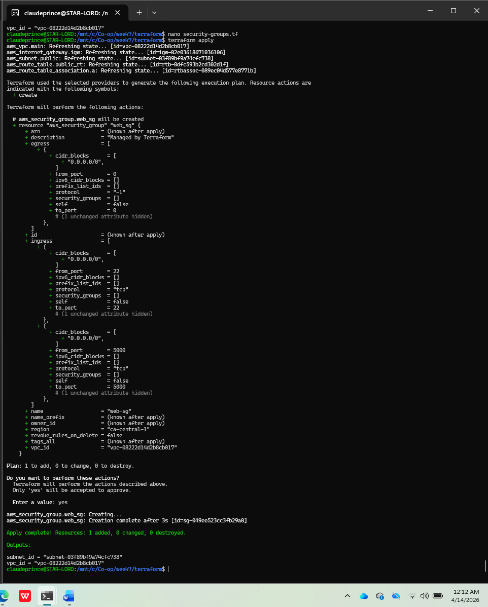

Conclusion
Successfully implemented Infrastructure as Code using Terraform, improving automation and efficiency in cloud resource management.

