Phase 3 – Week 7: Infrastructure as Code (Terraform)
Overview
In this phase, I successfully converted the infrastructure of the voicebot application into Infrastructure as Code (IaC) using Terraform. This includes networking, compute, storage, monitoring, and security components, all managed declaratively.

1. Complete Terraform Infrastructure
The project now includes Terraform configurations for:
- VPC (custom networking)
- Subnet (public)
- Internet Gateway
- Route Tables and associations
- EC2 Instance
- IAM Roles and Instance Profiles
- DynamoDB Table
- S3 Bucket
- CloudWatch Monitoring
- SNS Alerts
All resources are deployed using:
terraform init
terraform plan
terraform apply
Final result:
- Resources successfully created
- Infrastructure fully reproducible
- Outputs generated (VPC ID, Subnet ID)

2. VPC Module Implementation
To improve structure and reusability, the VPC configuration was modularized.
Module Location:
modules/vpc/
Module Files:
- main.tf → VPC, subnet, routing resources
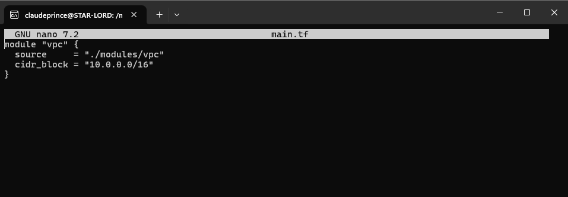
- variables.tf
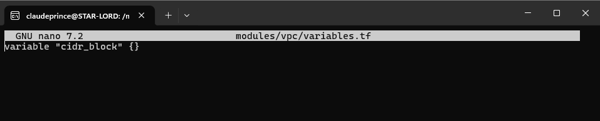

- outputs.tf → vpc_id, subnet_id

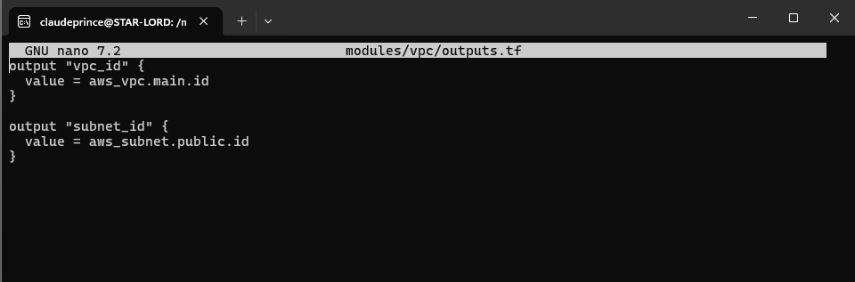

3. IAM Roles (Least Privilege)
An IAM role was created and attached to the EC2 instance using an instance profile.
Permissions Included:
- DynamoDB access (read/write)
- S3 access (limited scope)
- CloudWatch logging
Security Principle:
- Only required permissions were granted
- Avoided use of overly permissive policies

4. Compute (EC2)
An EC2 instance was provisioned using Terraform:
- Uses Amazon Linux
- Attached IAM role
- Runs application via user_data (optional)
- Placed inside the VPC module subnet
Example:
subnet_id = module.vpc.subnet_id

5. Storage
DynamoDB:
- On-demand billing
- Primary key configured
- Point-in-Time Recovery (PITR) enabled
S3:
- Bucket created for storage
- Versioning enabled
- Lifecycle rules configured

6. Monitoring (CloudWatch)
CloudWatch resources were created for observability:
Includes:
- Log Groups
- CPU utilization alarm
- DynamoDB monitoring

7. Alerting (SNS)
An SNS topic was configured:
- Connected to CloudWatch alarms
- Sends alerts when thresholds are exceeded

Terraform Workflow
- I wrote configuration files (.tf)
- Initialize Terraform:
terraform init
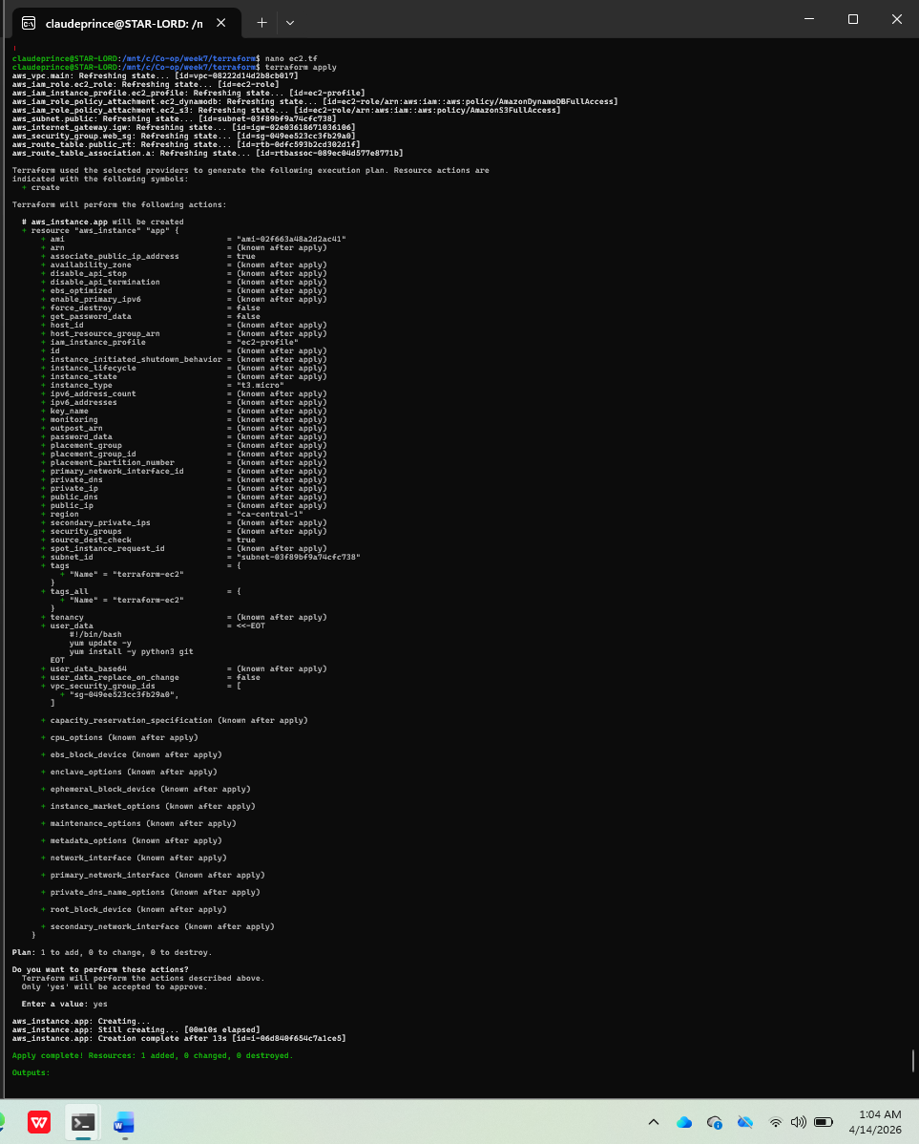
- Preview changes:
terraform plan
- Apply infrastructure:
terraform apply
- Verify resources in AWS Console

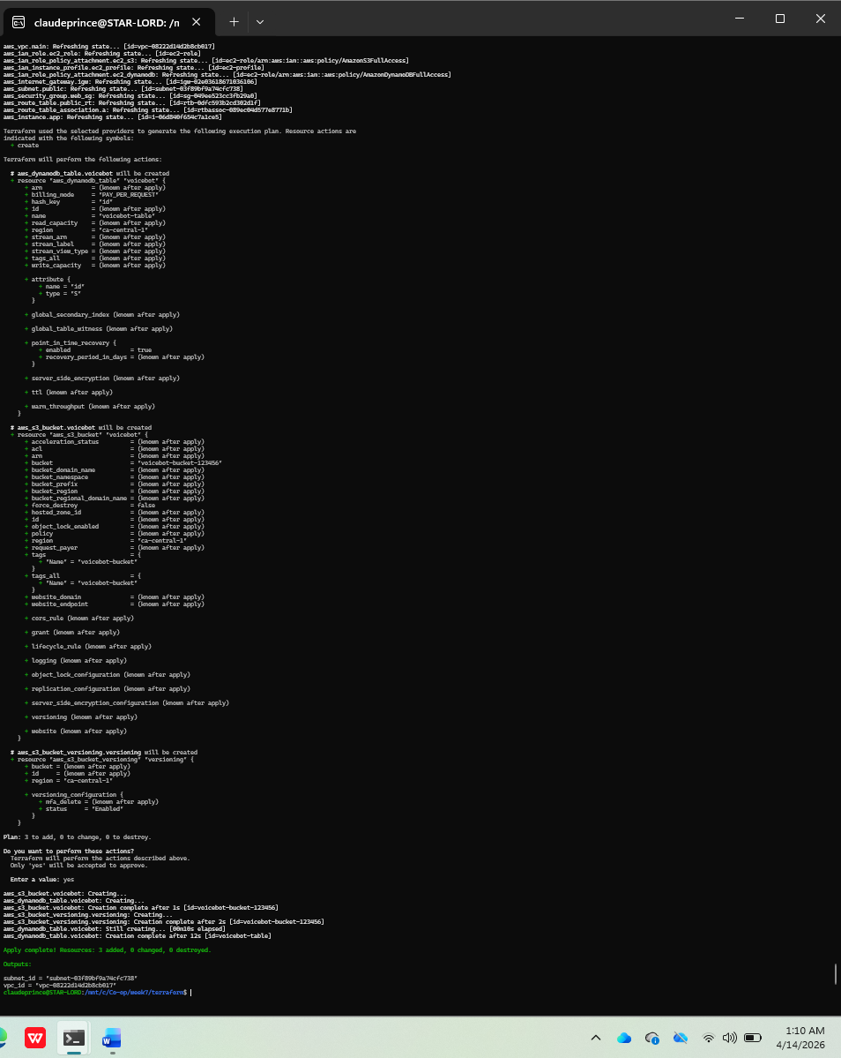

Conclusion
This phase successfully transformed the project into a fully automated infrastructure system using Terraform. The use of modules, IAM best practices, and monitoring ensures scalability, maintainability, and security.
The infrastructure can now be deployed, modified, or destroyed with a single command, demonstrating strong DevOps and Infrastructure as Code capabilities.

