**Problem # 1:**

Write a query to display the member id, member name and membership status who are all having life time membership. Hint: Life time membership status is  “Active”.

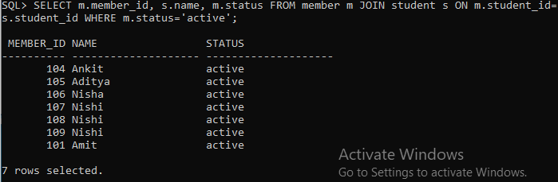

**Problem # 2:**

Write a query to display the member id, member name who have not returned the books. Hint: Book

return status is book_issue_status ='completed' or 'pending' or ‘canceled.

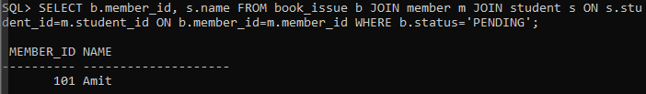

**Problem # 3:**

Write a query to display the member id, member name who have taken the book with book [code](http://examonline.today/mod/resource/view.php?id=795)

'B1101'.

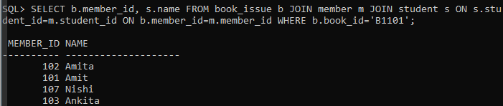

**Problem # 4:**

Write a query to display the book [code](http://examonline.today/mod/resource/view.php?id=795), book title and author of the books whose author name begins with 'H'



**Problem # 5:**

Write a query to display the total number of  books  by  each author available in library with alias name

‘NO_OF_BOOKS’.

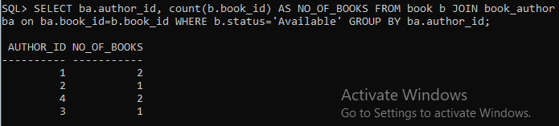

**Problem # 6:**

Write a query to display the number of books published by "dcbooks” with the alias name “NO_OF_BOOKS”.

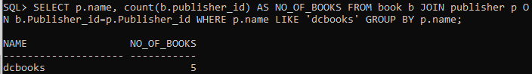

**Problem # 7:**

Write a query to display the book [code](http://examonline.today/mod/resource/view.php?id=795), book title of the books which are issued on the date "08-Mar-2022".

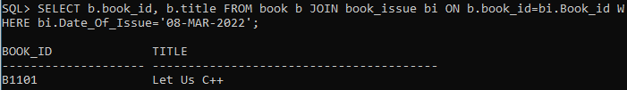

**Problem # 8:**

Write a query to display the member id, member name, date of registration and expiry date of the members whose membership expiry date is before APR 2021.

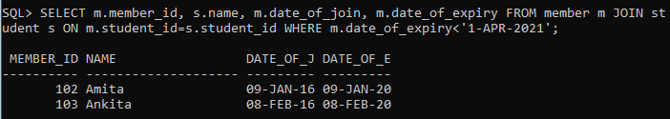

**Problem # 9:**

write a query to display the member id, member name, date of registration, membership status of the members who registered before "March 2021" and membership status is "closed"

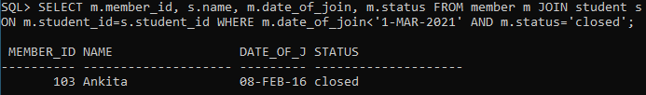

**Problem # 10:**

Write a query to concatenate book title, author and display in the following format.

Book_Title_is_written_by_Author

Example: Let Us C_is_written_by_Yashavant Kanetkar

Hint: display unique books. Use “BOOK_WRITTEN_BY” as alias name.

