# Create a dog model that stores name and age

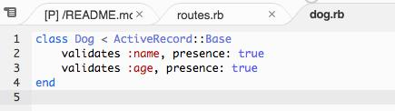

# Validate the dog has a name and age

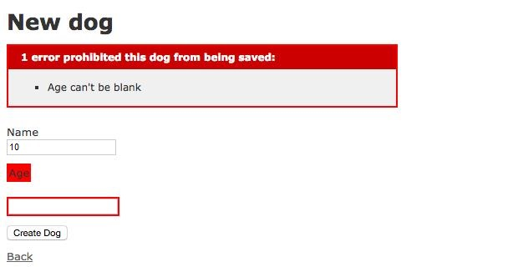

# Going to "/dogs" will go to an index view of all the dogs in the database

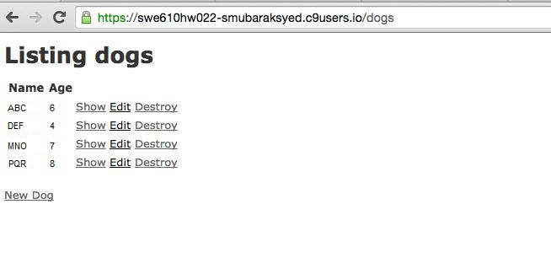

# Going to "/dogs/1" will go to a show view of the dog with id 1. This should work for any arbitrary id.

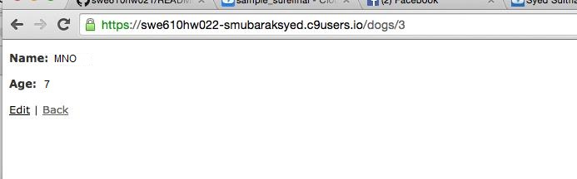

# Going to "/dogs/new" will go to a working form that will allow me to create a dog and redirect me to the new dogs show view.

