CYBERSECURITY INTERNSHIP
WEEK 1 — SECURITY ASSESSMENT REPORT

Field | Details
Intern Name | ______________________
Organization | DevelopersHub Corporation
Submission Date | 26th June, 2026
Application Tested | OWASP Juice Shop v20.1.1
Testing Environment | Windows — localhost:3000
Tools Used | OWASP ZAP, Browser DevTools, Manual Testing

1. Introduction
This report documents the security assessment performed on the OWASP Juice Shop web application as part of Week 1 of the DevelopersHub Cybersecurity Internship. The purpose was to identify security vulnerabilities using both manual testing techniques and automated scanning tools.

The OWASP Juice Shop is an intentionally insecure web application that contains real-world vulnerabilities commonly found in modern web applications, making it ideal for security training and assessment.

2. Application Setup
The OWASP Juice Shop was set up locally on a Windows machine using Node.js and Git. The steps performed were:

- Installed Node.js v24.17.0 and Git v2.54.0 on Windows
- Cloned the Juice Shop repository from GitHub using git clone
- Installed all dependencies using npm install
- Started the application using npm start — all 21 checks passed as SUCCESS
- Verified the application is accessible at http://localhost:3000

Tool | Version | Purpose
Node.js | v24.17.0 | Runtime environment for Juice Shop
Git | v2.54.0 | Cloning the repository from GitHub
OWASP Juice Shop | v20.1.1 | Target vulnerable web application
OWASP ZAP | v2.17.0 | Automated vulnerability scanner

Screenshot 1 — Node.js and Git version confirmation:
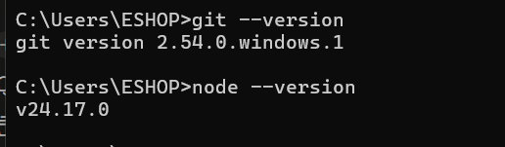
Figure 1: CMD showing node --version (v24.17.0) and git --version (2.54.0.windows.1)

Screenshot 2 — Juice Shop running in browser:
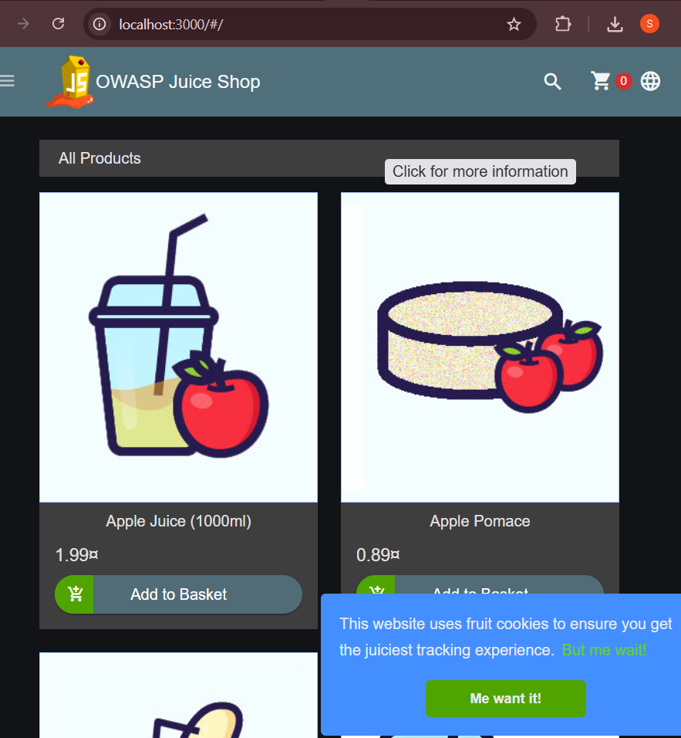
Figure 2: OWASP Juice Shop homepage successfully running at localhost:3000

Screenshot 3 — Application startup terminal output:
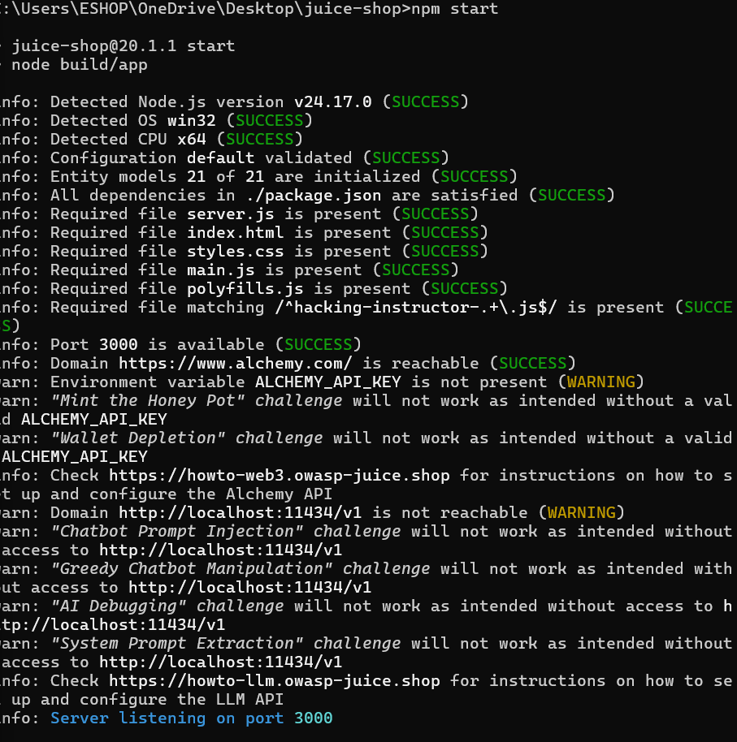
Figure 3: Terminal showing npm start with all checks reporting SUCCESS and server listening on port 3000

3. Vulnerability Assessment
Manual testing and automated scanning were performed to identify security vulnerabilities. A total of 12 vulnerabilities were discovered across the application.

3.1 Vulnerability #1 — Cross-Site Scripting (XSS)
Field | Details
Vulnerability Type | DOM-Based Cross-Site Scripting (XSS)
Location | Search Bar — localhost:3000/#/search
Severity | HIGH
Payload Used | <iframe src="javascript:alert(`xss`)">
Result | Script executed — DOM XSS Challenge solved
Impact | Cookie theft, session hijacking, page defacement, malware injection

Description: The search input field does not sanitize or encode user-supplied input before inserting it into the DOM. An attacker can inject malicious HTML or JavaScript that executes in the victim's browser, potentially stealing session cookies or performing actions on behalf of the victim.

Screenshot 4 — XSS Vulnerability Confirmed:
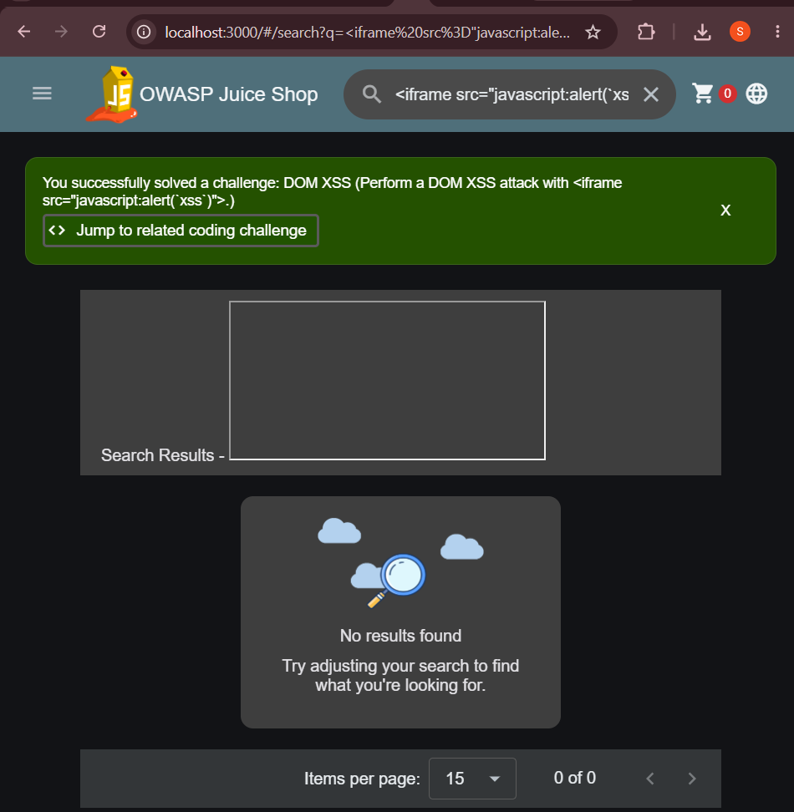
Figure 4: Green banner confirming 'You successfully solved a challenge: DOM XSS' after injecting the iframe payload in the search bar

3.2 Vulnerability #2 — SQL Injection
Field | Details
Vulnerability Type | SQL Injection — Authentication Bypass
Location | Login Page — Email input field
Severity | CRITICAL
Payload Used | ' OR 1=1--
Result | Successfully logged in as Administrator without any password
Impact | Full admin account takeover, access to all user accounts and order data

Description: The login form concatenates user input directly into a SQL query without parameterized statements. The payload ' OR 1=1-- modifies the query logic to always evaluate as true, completely bypassing password verification and granting full administrator access.

Screenshot 5 — SQL Injection Confirmed:
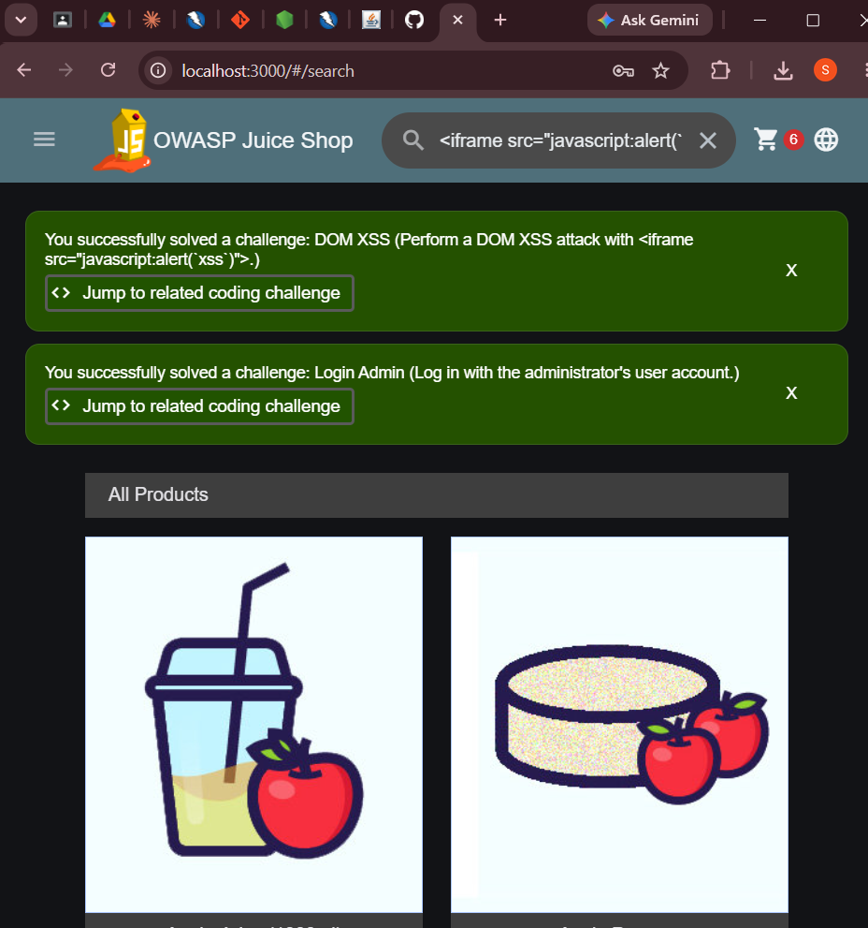
Figure 5: Two green banners confirming both DOM XSS and Login Admin challenges solved — logged in as administrator using SQL injection payload

4. OWASP ZAP Automated Scan
An automated vulnerability scan was conducted using OWASP ZAP v2.17.0 against the Juice Shop at http://localhost:3000. The scanner used both a traditional spider and an AJAX spider to discover all application endpoints before performing active vulnerability testing.

Screenshot 6 — OWASP ZAP Scan Running:
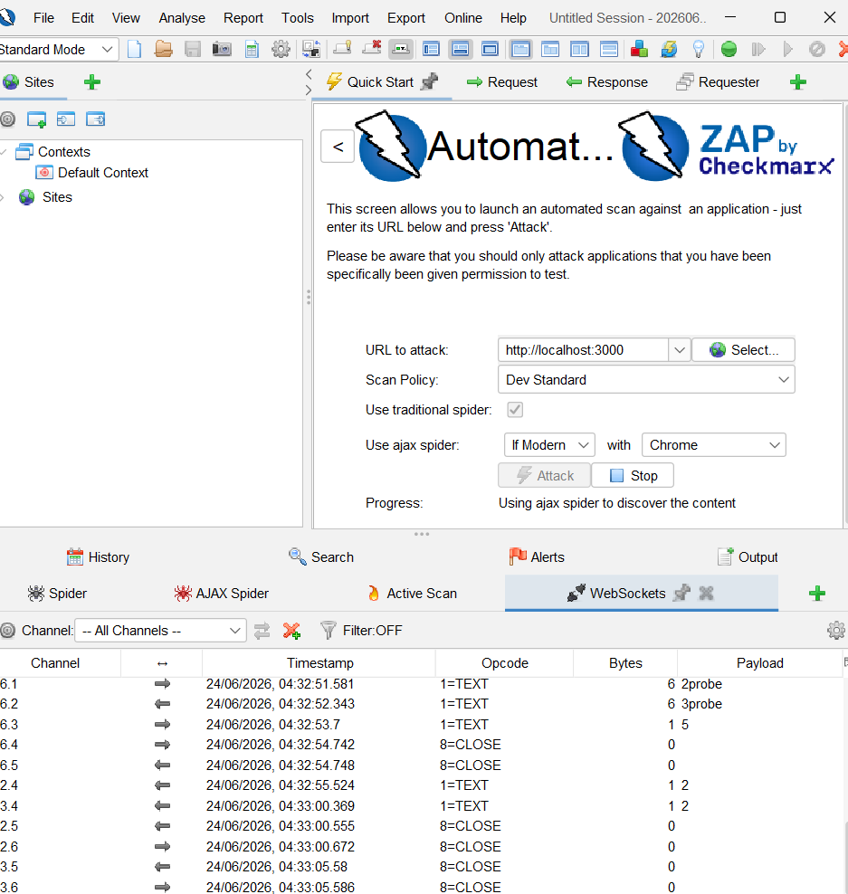
Figure 6: OWASP ZAP Automated Scan in progress — URL set to http://localhost:3000, Progress showing 'Using ajax spider to discover the content'

Screenshot 7 — OWASP ZAP Scan Complete — All Alerts:
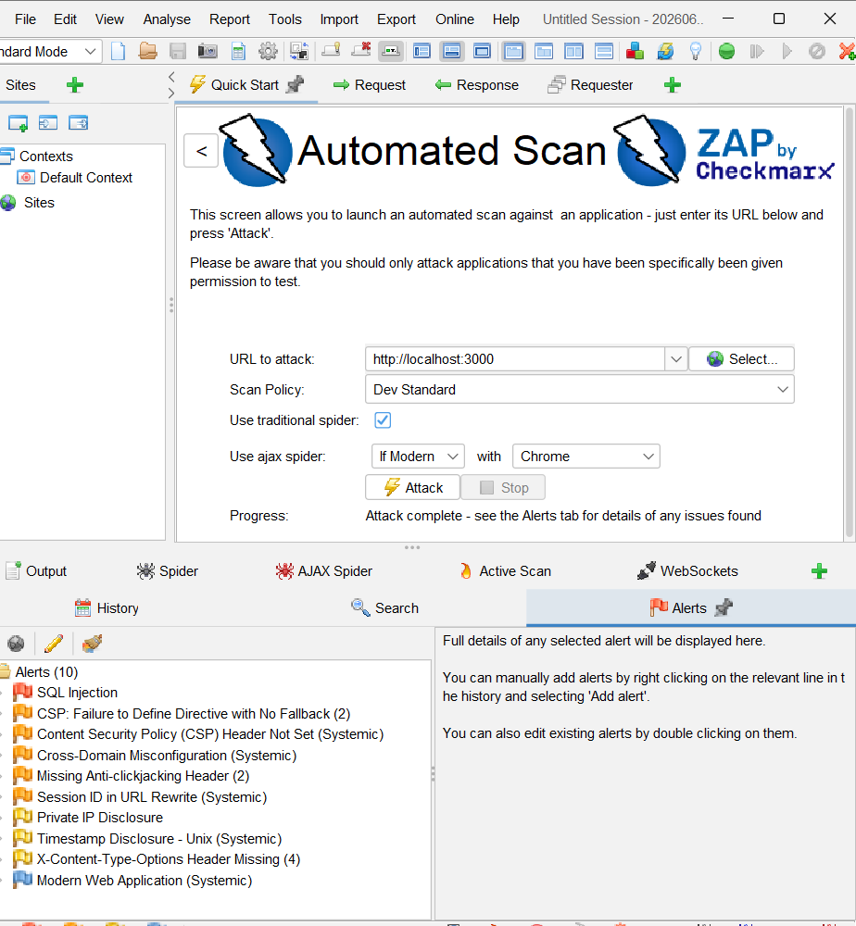
Figure 7: OWASP ZAP Alerts tab showing 10 vulnerabilities found — Progress: 'Attack complete - see the Alerts tab for details of any issues found'

The automated scan discovered 10 alerts. Full details are listed below:

# | Alert Name | Risk Level | Description
1 | SQL Injection | High | User input directly inserted into SQL queries without sanitization
2 | CSP: Failure to Define Directive with No Fallback | Medium | Content Security Policy missing fallback directives
3 | Content Security Policy (CSP) Header Not Set | Medium | No CSP header present to prevent XSS and injection attacks
4 | Cross-Domain Misconfiguration | Medium | Allows cross-domain requests that could expose sensitive data
5 | Missing Anti-clickjacking Header | Medium | No X-Frame-Options header set, allows clickjacking attacks
6 | Session ID in URL Rewrite | Medium | Session tokens exposed in URL, can be logged or stolen
7 | Private IP Disclosure | Low | Internal IP addresses revealed in server responses
8 | Timestamp Disclosure - Unix | Low | Server timestamps exposed, reveals internal system information
9 | X-Content-Type-Options Header Missing | Low | Missing header allows MIME-type sniffing attacks
10 | Modern Web Application | Informational | Application identified as modern Angular SPA framework

5. Findings Summary
A total of 12 vulnerabilities were identified during the Week 1 assessment — 2 from manual testing and 10 from OWASP ZAP automated scanning:

# | Vulnerability | Location | Severity | Method
1 | DOM-Based XSS | Search Bar | HIGH | Manual
2 | SQL Injection (Auth Bypass) | Login Page | CRITICAL | Manual
3 | SQL Injection | Multiple Endpoints | HIGH | OWASP ZAP
4 | CSP Header Not Set | All Pages | MEDIUM | OWASP ZAP
5 | Cross-Domain Misconfiguration | All Pages | MEDIUM | OWASP ZAP
6 | Missing Anti-clickjacking Header | All Pages | MEDIUM | OWASP ZAP
7 | Session ID in URL | Auth Flow | MEDIUM | OWASP ZAP
8 | Private IP Disclosure | HTTP Responses | LOW | OWASP ZAP
9 | Timestamp Disclosure | HTTP Responses | LOW | OWASP ZAP
10 | X-Content-Type-Options Missing | All Pages | LOW | OWASP ZAP

6. Conclusion
The Week 1 security assessment of the OWASP Juice Shop revealed multiple critical and high-severity vulnerabilities. The most dangerous findings were:

- SQL Injection on the login page — allowed complete administrator account takeover without any credentials.
- DOM-Based XSS in the search bar — enabled malicious script execution in any user's browser.
- Multiple missing security headers — left the application exposed to clickjacking and MIME sniffing attacks.

All identified vulnerabilities will be addressed in Week 2 through the implementation of input validation, parameterized queries, bcrypt password hashing, JWT authentication, and Helmet.js security headers.

Report prepared by: ______________________
Date: 26th June, 2026
DevelopersHub Corporation — Cybersecurity Internship

