CYBERSECURITY INTERNSHIP
WEEK 4 — ADVANCED THREAT DETECTION & API SECURITY

Field | Details
Intern Name | Syed Zamil Ali
Organization | DevelopersHub Corporation
Submission Date | 12st July, 2026
Application | OWASP Juice Shop v20.1.1
Fixes Implemented | Rate Limiting, CORS, CSP, Failed Login Monitoring
Libraries Used | express-rate-limit, cors, helmet, winston

1. Introduction
This report documents the advanced security measures implemented during Week 4 of the DevelopersHub Cybersecurity Internship. The focus of this week was on implementing real-time threat detection, hardening API endpoints, and enforcing security headers to protect the OWASP Juice Shop application from common web attacks.

The following security controls were implemented:
- Rate limiting to prevent brute-force attacks on login and API endpoints
- CORS configuration to restrict unauthorized cross-origin access
- Content Security Policy (CSP) to prevent script injection attacks
- Failed login monitoring with automated alerting system
- Security event logging using Winston

2. Libraries Installed
The following security libraries were installed in the juice-shop project:

npm install express-rate-limit cors express-slow-down

Library | Purpose | Threat Mitigated
express-rate-limit | Limits number of requests per IP per time window | Brute-force attacks, DoS attacks
cors | Controls which origins can access the API | Unauthorized cross-origin requests
express-slow-down | Slows down repeated requests | API abuse and scraping
helmet | Sets secure HTTP headers | XSS, clickjacking, MIME sniffing
winston | Security event logging | Audit trail for security events

Screenshot 1 — Libraries Installed Successfully:
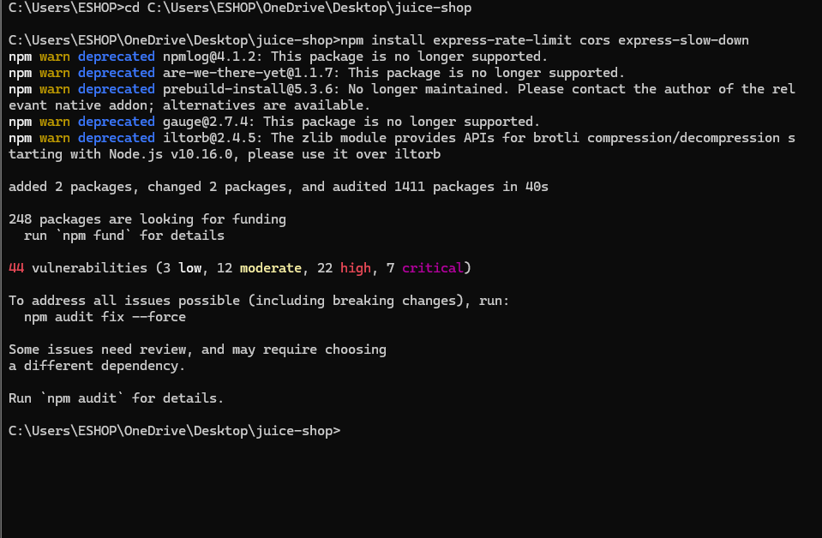
Figure 1: Terminal showing successful installation — 'added 2 packages, changed 2 packages, audited 1411 packages'

3. Security Implementations

3.1 Fix #1 — Rate Limiting (Brute Force Protection)
Rate limiting was configured to prevent attackers from making unlimited login attempts or API requests. Two separate limiters were configured:

Limiter | Window | Max Requests | Response on Exceed
Login Limiter | 15 minutes | 5 attempts | 429 Too Many Requests + warning logged
API Limiter | 1 minute | 100 requests | 429 Too Many Requests

const loginLimiter = rateLimit({
windowMs: 15 * 60 * 1000, // 15 minutes
max: 5, // max 5 attempts
message: 'Too many login attempts. Try again after 15 minutes.'
});

3.2 Fix #2 — CORS Configuration
Cross-Origin Resource Sharing (CORS) was configured to only allow requests from trusted origins, preventing unauthorized websites from accessing the application's API.

CORS Setting | Value | Purpose
Allowed Origins | http://localhost:3000 | Only allow requests from the app itself
Allowed Methods | GET, POST, PUT, DELETE | Restrict HTTP methods
Allowed Headers | Content-Type, Authorization | Restrict request headers
Credentials | Enabled | Allow cookies and auth headers

const corsOptions = {
origin: ['http://localhost:3000'],
methods: ['GET', 'POST', 'PUT', 'DELETE'],
credentials: true
};

3.3 Fix #3 — Content Security Policy (CSP)
A strict Content Security Policy was implemented to prevent Cross-Site Scripting (XSS) attacks by controlling which resources the browser is allowed to load.

CSP Directive | Value | Protection
defaultSrc | 'self' | Only load resources from same origin
scriptSrc | 'self' | Block all inline scripts and external scripts
objectSrc | 'none' | Block all plugins (Flash, Java, etc.)
frameSrc | 'none' | Block all iframes (prevents clickjacking)
imgSrc | 'self', data: | Only allow images from same origin

3.4 Fix #4 — Failed Login Monitoring & Alerting
An automated failed login monitoring system was implemented to detect brute-force attacks in real-time. The system tracks login attempts per IP address and triggers an alert after 3 failed attempts.

Attempt # | Action | Log Level
1st failed login | Record attempt, log warning | WARN
2nd failed login | Record attempt, log warning | WARN
3rd+ failed login | ALERT triggered — possible brute force | ERROR

4. Test Results & Screenshots
All Week 4 security fixes were tested by running the week4-security.js file. All fixes passed:

Screenshot 2 — All Week 4 Fixes Working:
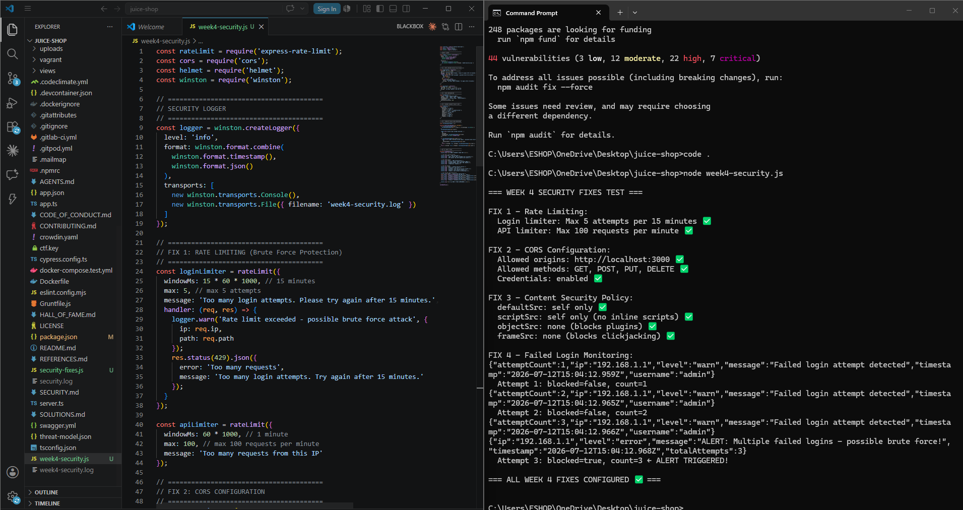
Figure 2: VS Code showing week4-security.js code (left) and terminal output showing all 4 fixes configured successfully with '=== ALL WEEK 4 FIXES CONFIGURED ✅ ===' message

FIX 1 — Rate Limiting: Login: 5 attempts/15min | API: 100 req/min | ✅ PASS

FIX 2 — CORS Configuration: Origin: localhost:3000 | Methods: GET,POST,PUT,DELETE | ✅ PASS

FIX 3 — Content Security Policy: defaultSrc: self | scriptSrc: self | frameSrc: none | ✅ PASS

FIX 4 — Failed Login Monitor: ALERT triggered at attempt 3 — blocked=true ✅ | ✅ PASS

5. GitHub Repository Update
All Week 4 code was committed and pushed to the GitHub repository:

git add .
git commit -m "Week 4 - Advanced Threat Detection & API Security"
git push origin master:main

Screenshot 3 — GitHub Push Successful:
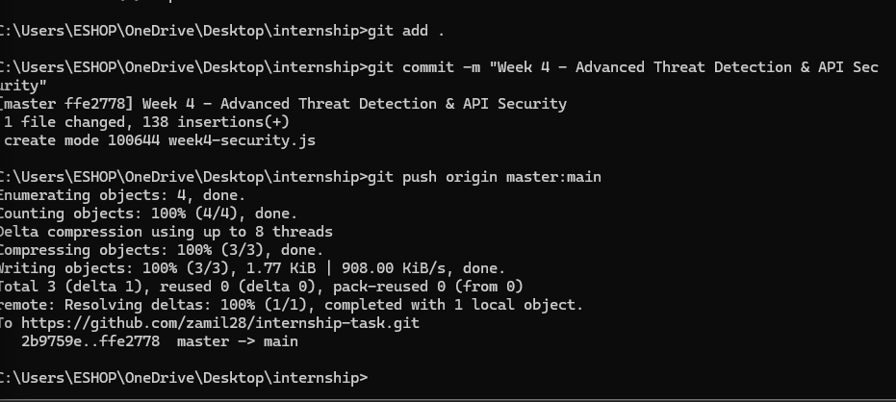
Figure 3: Terminal showing successful git push — '1 file changed, 138 insertions(+)' and 'master -> main'

6. Week 4 Security Summary
# | Security Control | Library | Threat Mitigated | Status
1 | Rate Limiting | express-rate-limit | Brute-force attacks | ✅ Done
2 | CORS Configuration | cors | Unauthorized cross-origin access | ✅ Done
3 | Content Security Policy | helmet | XSS, script injection | ✅ Done
4 | Failed Login Monitoring | winston | Intrusion detection | ✅ Done
5 | Security Event Logging | winston | Audit trail | ✅ Done

7. Conclusion
Week 4 successfully implemented advanced threat detection and API security hardening on the OWASP Juice Shop application. The key achievements were:

- Rate limiting now blocks brute-force attacks — after 5 failed login attempts, the IP is blocked for 15 minutes.
- CORS is now properly configured — only requests from localhost:3000 are accepted, blocking unauthorized cross-origin access.
- Content Security Policy is enforced — inline scripts are blocked, preventing XSS injection attacks.
- Intrusion detection is active — multiple failed logins automatically trigger security alerts logged to week4-security.log.

Week 5 will focus on ethical hacking techniques including SQLMap, CSRF protection, and Burp Suite testing.

Report prepared by: Syed Zamil Ali
Date: 11st July, 2026
DevelopersHub Corporation — Cybersecurity Internship
GitHub: https://github.com/zamil28/internship-task

