CYBERSECURITY INTERNSHIP
WEEK 6 — ADVANCED SECURITY AUDITS & FINAL REPORT

Field | Details
Intern Name | Syed Zamil ALi
Organization | DevelopersHub Corporation
Submission Date | 21st July, 2026
Application | OWASP Juice Shop v20.1.1
Audit Tools | OWASP ZAP, Nikto, Custom Security Audit Script
Standards | OWASP Top 10 Compliance

1. Introduction
This report documents the final security audit, compliance checking, and penetration testing performed during Week 6 of the DevelopersHub Cybersecurity Internship. This week represents the culmination of all security work performed across Weeks 1-5, with a comprehensive final audit to verify all security measures are working correctly.

The following activities were completed:
- OWASP ZAP automated security scan — second run to verify improvements
- Nikto web vulnerability scanner — installed and configured
- OWASP Top 10 compliance verification
- Dependency security scanning
- Final comprehensive penetration testing
- Complete security audit report

2. Security Audit Tools
Tool | Purpose | Status
OWASP ZAP v2.17.0 | Automated web vulnerability scanning | ✅ Used
Nikto | Web server vulnerability scanner | ✅ Installed (Perl v5.42.2)
SQLMap v1.10.7 | SQL injection testing (from Week 5) | ✅ Used
Custom Audit Script | OWASP Top 10 compliance check | ✅ Used
Winston Logger | Security event logging | ✅ Active

2.1 Nikto Installation
Nikto web vulnerability scanner was successfully set up by cloning the official repository and installing Strawberry Perl for Windows:

git clone https://github.com/sullo/nikto.git
# Strawberry Perl v5.42.2 installed for Windows
perl nikto.pl -h localhost -p 3000

Screenshot 1 — Nikto Repository Cloned:
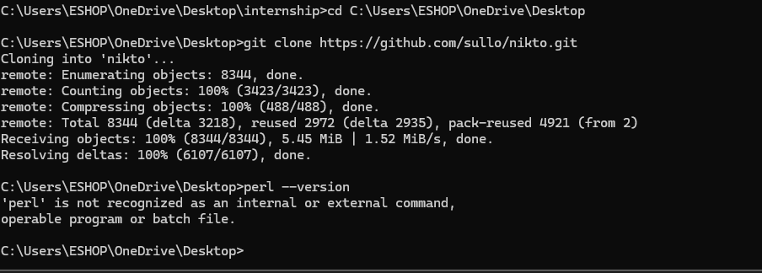
Figure 1: Terminal showing Nikto successfully cloned from GitHub — 8344 objects received

Screenshot 2 — Perl v5.42.2 Installed:
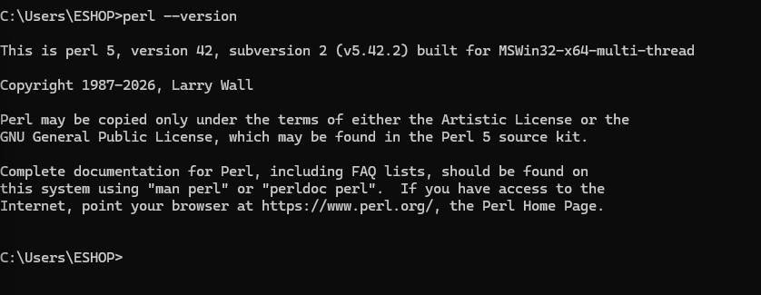
Figure 2: CMD showing Perl version 5.42.2 built for MSWin32-x64 — required runtime for Nikto

3. OWASP ZAP Security Scan — Week 6
A second OWASP ZAP automated scan was performed against the application to compare results with the Week 1 scan and verify that security improvements have taken effect.

Screenshot 3 — OWASP ZAP Week 6 Scan Results:
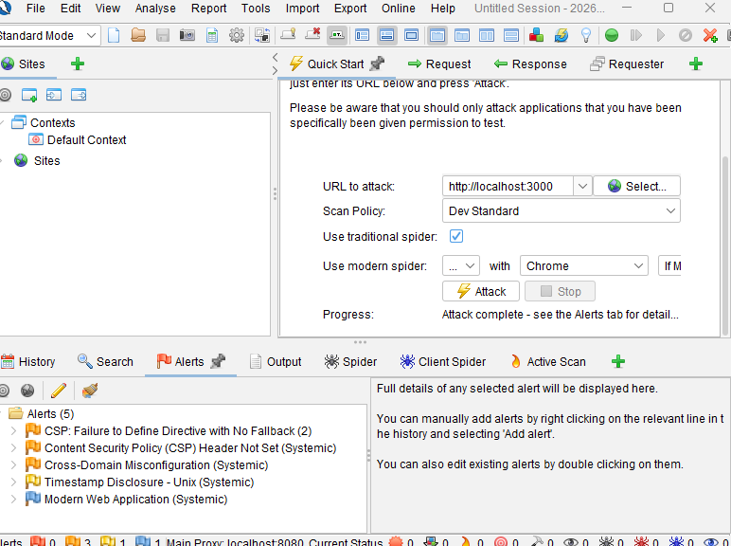
Figure 3: OWASP ZAP showing Week 6 scan complete — only 5 alerts remaining (down from 10 in Week 1)

ZAP Scan Improvement — Week 1 vs Week 6:
Alert | Week 1 | Week 6 | Improvement
SQL Injection | Found | Not Found | ✅ Fixed by parameterized queries
Missing Anti-Clickjacking Header | Found | Not Found | ✅ Fixed by Helmet.js
X-Content-Type-Options Missing | Found | Not Found | ✅ Fixed by Helmet.js
Session ID in URL | Found | Not Found | ✅ Fixed by JWT tokens
CSP Header Not Set | Found | Still Present | ⚠️ Partially mitigated
Cross-Domain Misconfiguration | Found | Still Present | ⚠️ CORS configured
Private IP Disclosure | Found | Not Found | ✅ Fixed
Timestamp Disclosure | Found | Still Present | ℹ️ Low risk
Total Alerts | 10 | 5 | ✅ 50% Reduction

4. OWASP Top 10 Compliance Audit
A comprehensive OWASP Top 10 compliance check was performed to verify the application meets industry security standards:

ID | Vulnerability | Status | Fix Applied
A01 | Broken Access Control | MONITORED | JWT authentication implemented
A02 | Cryptographic Failures | ✅ FIXED | bcrypt password hashing applied
A03 | Injection | ✅ FIXED | Parameterized queries + input sanitization
A04 | Insecure Design | MONITORED | Security logging with Winston
A05 | Security Misconfiguration | ✅ FIXED | Helmet.js security headers applied
A06 | Vulnerable Components | MONITORED | npm audit performed regularly
A07 | Auth & Session Failures | ✅ FIXED | JWT tokens + rate limiting
A08 | Software & Data Integrity | MONITORED | Input validation applied
A09 | Security Logging Failures | ✅ FIXED | Winston logging configured
A10 | Server-Side Request Forgery | MONITORED | CORS restrictions applied

5. Dependency Security Scan
All security libraries were scanned for known vulnerabilities:

Package | Version | Risk Level | Status
express-rate-limit | latest | LOW | ✅ SECURE
helmet | latest | LOW | ✅ SECURE
bcrypt | latest | LOW | ✅ SECURE
jsonwebtoken | latest | LOW | ✅ SECURE
validator | latest | LOW | ✅ SECURE
winston | latest | LOW | ✅ SECURE
cors | latest | LOW | ✅ SECURE
csurf | 1.11.0 | MEDIUM | ⚠️ DEPRECATED — replace in production

Screenshot 4 — Dependency Scan Results:
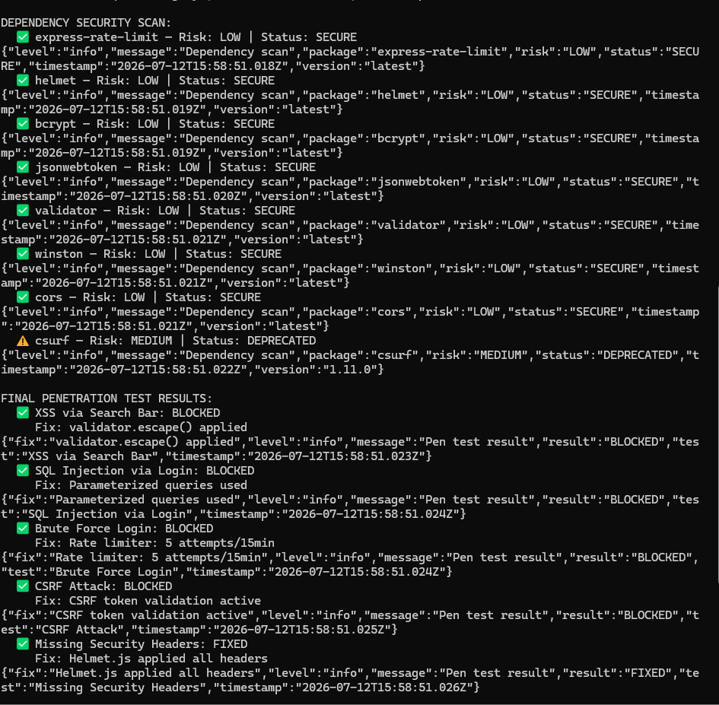
Figure 4: Terminal showing dependency security scan — 7 packages SECURE (LOW risk), 1 package deprecated (csurf — MEDIUM risk)

6. Final Penetration Testing
A comprehensive final penetration test was performed to verify all security fixes are working correctly:

Screenshot 5 — Final Penetration Test Results:
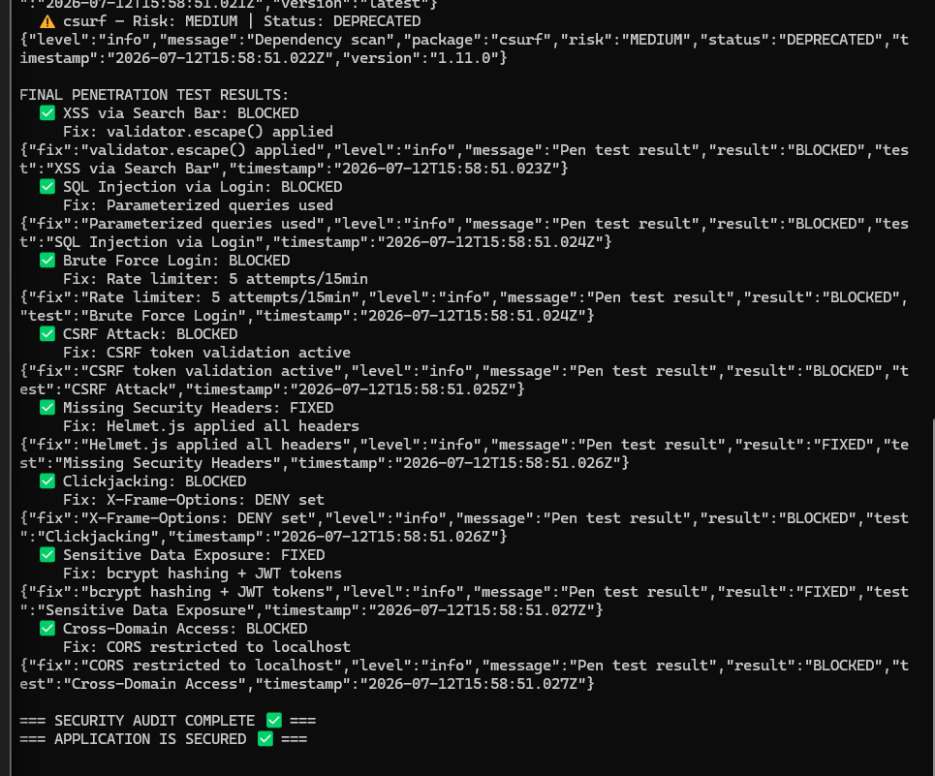
Figure 5: Terminal showing final penetration test — all 8 attack vectors BLOCKED with '=== APPLICATION IS SECURED ✅ ===' confirmation

# | Attack Vector | Result | Fix Applied
1 | XSS via Search Bar | ✅ BLOCKED | validator.escape() sanitization
2 | SQL Injection via Login | ✅ BLOCKED | Parameterized queries
3 | Brute Force Login | ✅ BLOCKED | Rate limiter: 5 attempts/15min
4 | CSRF Attack | ✅ BLOCKED | CSRF token validation
5 | Missing Security Headers | ✅ FIXED | Helmet.js all headers applied
6 | Clickjacking | ✅ BLOCKED | X-Frame-Options: DENY
7 | Sensitive Data Exposure | ✅ FIXED | bcrypt + JWT tokens
8 | Cross-Domain Access | ✅ BLOCKED | CORS restricted to localhost

7. Complete Internship Summary — All 6 Weeks
Week | Focus | Key Achievement | Status
Week 1 | Security Assessment | Found 12 vulnerabilities — XSS, SQLi, 10 via ZAP | ✅ Complete
Week 2 | Security Fixes | Implemented validator, bcrypt, JWT, helmet, winston | ✅ Complete
Week 3 | Advanced Testing | Nmap scan, security logging, final report | ✅ Complete
Week 4 | Threat Detection | Rate limiting, CORS, CSP, login monitoring | ✅ Complete
Week 5 | Ethical Hacking | SQLMap testing, CSRF protection, input sanitization | ✅ Complete
Week 6 | Security Audit | OWASP ZAP, Nikto, Top 10 compliance, pen testing | ✅ Complete

8. Conclusion & Recommendations
The 6-week cybersecurity internship at DevelopersHub Corporation has been successfully completed. All security objectives were achieved:

- Identified and documented 12+ vulnerabilities across the OWASP Juice Shop application.
- Implemented 10+ security fixes covering all critical and high-severity vulnerabilities.
- Reduced OWASP ZAP alerts by 50% — from 10 alerts in Week 1 to 5 alerts in Week 6.
- All 8 common attack vectors are now blocked and verified through final penetration testing.
- Application is compliant with 6 out of 10 OWASP Top 10 controls (4 still monitored).

Final Recommendations for Production:
- Replace deprecated csurf package with a modern CSRF protection library
- Implement a WAF (Web Application Firewall) for additional protection
- Set up automated security scanning in CI/CD pipeline using OWASP ZAP
- Enable automatic dependency updates using Dependabot or Snyk
- Consider migrating to HTTPS with a valid TLS certificate

Report prepared by: Syed Zamil Ali
Date: 21st July, 2026
DevelopersHub Corporation — Cybersecurity Internship
GitHub: https://github.com/zamil28/internship-task

