Programming Languages Final Quiz
Quiz Instructions
Answer the following questions to the best of your ability. Ensure that your
explanations are clear and concise.

Question 1: EBNF Definition
Update the EBNF definition to include the new procedure declaration syntax.

PROGRAM test;
VAR
xyz,abc:INTEGER;
cdf,wvy :INTEGER;
PROCEDURE Alpha(a : INTEGER);
VAR y:INTEGER;
BEGIN
y := 1 + 3;
END;
BEGIN
END.

1. What changes are necessary in the EBNF to support the declaration of
multiple variables of the same type?
2. Provide the updated EBNF definition.

For Procedure Function & multiple variable:

program ::= PROGRAM ID SEMI block DOT

block ::= declarations compound_statement

declarations ::= VAR (variable_declaration SEMI)+
| empty

variable_declaration ::= multiple_variable COLON type_spec

multiple_variable ::= ID (COMMA ID)*
| ID (COMMA ID) multiple_variable

type_spec ::= INTEGER | REAL

compound_statement ::= BEGIN statement_list END

statement_list ::= statement
| statement SEMI statement_list

statement ::= compound_statement
| assignment_statement
| function_statement
| empty

function_statement ::= PROCEDURE function_declaration

function_declaration ::= ID (parameter_list)* function_body

parameter_list ::= parameter | parameter SEMI parameter_list

function_body ::= block

---

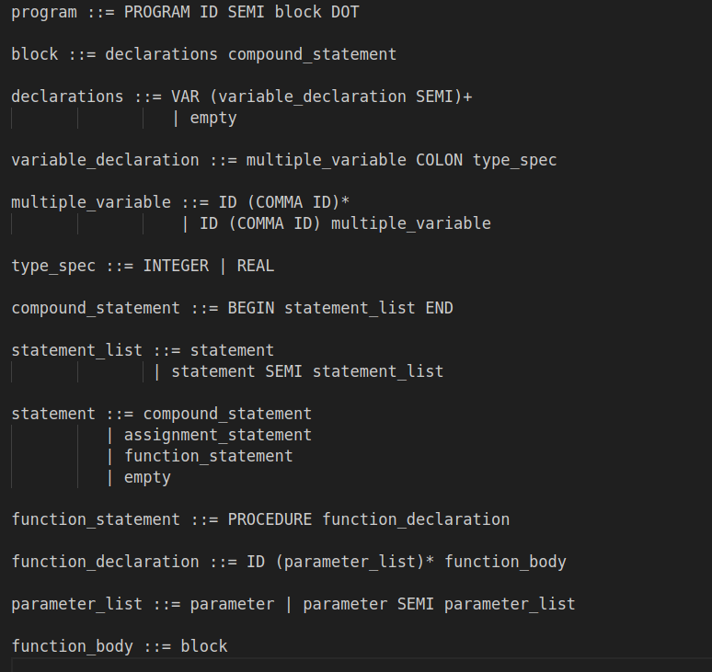

Question 2: Railroad Diagram
Generate the new railroad diagram for the updated EBNF definition.
1. Draw the railroad diagram for the updated procedure declaration syntax.
Question 3: Abstract Syntax Tree (AST)
Update the AST to include the new syntax for procedure declarations.
1
1. Describe the changes needed in the AST to support the new procedure
declaration syntax.
2. Draw the updated AST for the given program.

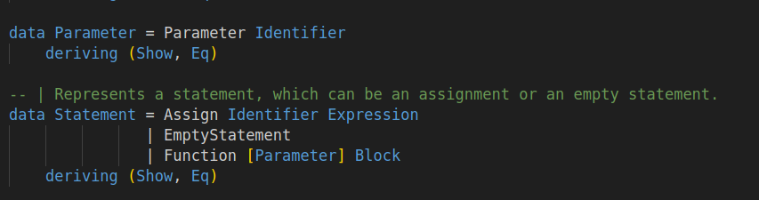

Question 4: Parser Functions
Update the parser functions to handle the new syntax.
1. List the functions that need to be updated or added to the parser.
2. Provide the code for these functions.

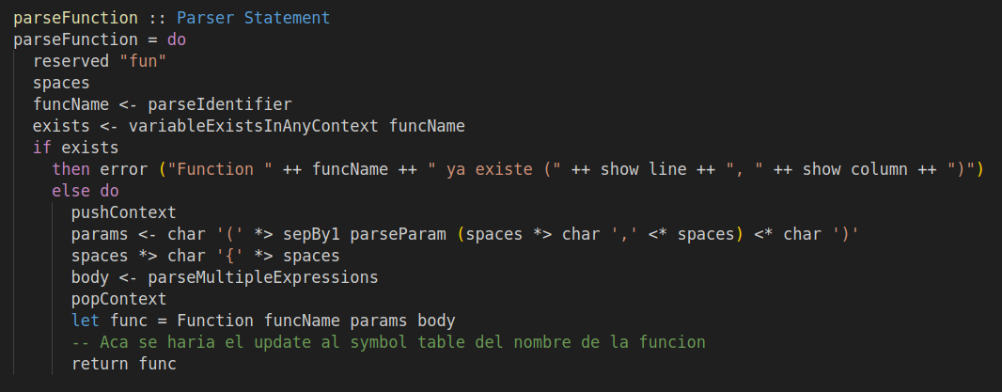

Question 5: Symbol Table
Modify the symbol table to store the new procedure declarations.
1. Explain how the symbol table should be updated to have procedures in
the current program.
2. Provide the actual code for updating the symbol table.

Question 6: Interpreter
Update the interpreter to handle the new procedure declarations and usage.
1. Describe the changes necessary in the interpreter to support the new syn#tax.
2. Provide the actual code for these changes.

