# Heroes of Pymoli Trends report:

Based on the information that I was able to gather through my research I was able to determine an interesting occurrence. Although the majority of the players are male the female players spend slightly more on average than the males (figure 1) But as expected the males bring in the majority of funds as their overall advantage in numbers covers the average increase from the females (Figure 2). Also of note is the small number of other category it is of such low quantity at this stage that we should not consider improving that market as it may just be errors in data entry.

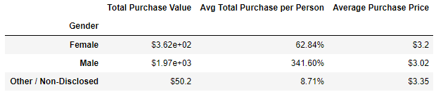Figure 1

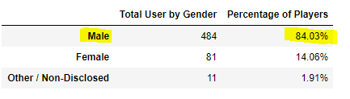Figure 2