Homework 1

Joaquin Rodriguez

8/22/2017

## 1

v <- seq(from = 1,to = 100,by = 2)

## 2

v <- as_tibble(v)  
v <-   
 v %>%   
 filter(., value > 60) %>%   
 filter(., value < 100)

## 3

v %>% var(.)

## value  
## value 140

## 4

df <- data.frame(c(2.27, 1.98, 1.69, 1.88, 1.64, 2.14),   
 c(8.28, 8.04, 9.06, 8.7, 7.58, 8.34))  
names(df) <- c("R", "H")  
  
df$V <- 1/3 * pi * df$R^2 * df$H

## 5

x <- c(3.15, -0.55, -0.35, 0.16)  
y <- c(2.93, -0.35, -0.25, -0.12)  
  
X <- matrix(  
 c(rep(1, 4), x),  
 ncol = 2  
)  
  
solve((t(X) %*% X)) %*% (t(X) %*% matrix(y))

## [,1]  
## [1,] 0.001483229  
## [2,] 0.914550657

#summary(lm(y ~ x))  
lsfit(x, y)

## $coefficients  
## Intercept X   
## 0.001483229 0.914550657   
##   
## $residuals  
## [1] 0.0476822 0.1515196 0.0686095 -0.2678113  
##   
## $intercept  
## [1] TRUE  
##   
## $qr  
## $qt  
## [1] -1.105000000 2.731595328 0.003732199 -0.318822892  
##   
## $qr  
## Intercept X  
## [1,] -2.0 -1.2050000  
## [2,] 0.5 2.9868169  
## [3,] 0.5 0.6032063  
## [4,] 0.5 0.4324559  
##   
## $qraux  
## [1] 1.500000 1.670167  
##   
## $rank  
## [1] 2  
##   
## $pivot  
## [1] 1 2  
##   
## $tol  
## [1] 1e-07  
##   
## attr(,"class")  
## [1] "qr"

## 6

library(MASS)  
  
data("cats")  
cats <- as_tibble(cats)

## 7

cats %>% count(Sex)

## # A tibble: 2 x 2  
## Sex n  
## <fctr> <int>  
## 1 F 47  
## 2 M 97

## 8

cats %>%   
 group_by(Sex) %>%   
 summarise(mean(Bwt))

## # A tibble: 2 x 2  
## Sex `mean(Bwt)`  
## <fctr> <dbl>  
## 1 F 2.359574  
## 2 M 2.900000

cats %>%   
 group_by(Sex) %>%   
 summarise(sd(Bwt))

## # A tibble: 2 x 2  
## Sex `sd(Bwt)`  
## <fctr> <dbl>  
## 1 F 0.2739879  
## 2 M 0.4674844

## 9

freqover2.5 <-   
 cats %>%   
 mutate(., Over2.5 = ifelse(Bwt > 2.5, T, F)) %>%   
 group_by(Sex) %>%   
 count(Over2.5) %>%   
 spread(., key = Over2.5, value = n) %>%   
 mutate(., Proportion = `TRUE` / sum(`TRUE`, `FALSE`))

## 10

catsM <-   
 cats %>%   
 filter(., Sex == "M") %>%   
 list(.)  
  
catsF <-   
 cats %>%   
 filter(., Sex == "F") %>%   
 list(.)

## Generate Distributions and Sample Means

set.seed(10)  
distributions <-   
 tribble(  
 ~f, ~params,  
 "rnorm", list(n = 1000),  
 "rexp", list(n = 1000),  
 "rbinom", list( n = 1000, size = 1, p = 0.1)  
 )  
  
distributions <-   
 distributions %>%   
 mutate(distr = invoke_map(f, params))  
  
sampling <- function(df, n) {  
 result <- vector("double", 2000)  
 for(i in 1:2000) {  
 result[[i]] <-   
 df %>%  
 sample(n, replace = T) %>%   
 mean  
 }  
 return(result)  
}  
  
  
distributions <-   
distributions %>%   
 mutate(samp3 = map(.$distr, sampling, 3),  
 samp10 = map(.$distr, sampling, 10),  
 samp100 = map(.$distr, sampling, 100)  
 )   
  
  
df <-   
 distributions %>%   
 .$samp3 %>%   
 as.data.frame()  
  
names(df) <- c("rnorm","rexp","rbinom")  
  
df <- gather(df)  
df$n <- 3  
  
df1 <-   
 distributions %>%   
 .$samp10 %>%   
 as.data.frame()  
  
names(df1) <- c("rnorm","rexp","rbinom")  
df1 <- gather(df1)  
df1$n <- 10  
  
df <- bind_rows(df,df1)  
  
df1 <-   
 distributions %>%   
 .$samp100 %>%   
 as.data.frame()  
  
names(df1) <- c("rnorm","rexp","rbinom")  
df1 <- gather(df1)  
df1$n <- 100  
  
df <- bind_rows(df,df1)

## Normal Distribution

df %>%   
 filter(key=="rnorm") %>%   
 ggplot() +   
 geom_histogram(aes(x=value,y=..density..), position="identity") +   
 geom_density(aes(x=value,y=..density..)) +  
 facet_grid(.~n, scales = "free") +  
 ggtitle('Central Limit Theorem',   
 subtitle = 'The distributions of the means seem to always be bell shape')

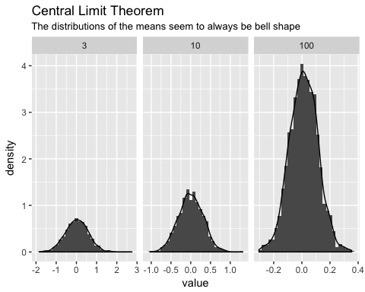

## Exponential Distribution

df %>%   
 filter(key=="rexp") %>%   
 ggplot() +   
 geom_histogram(aes(x=value,y=..density..), position="identity") +   
 geom_density(aes(x=value,y=..density..)) +  
 facet_grid(.~n, scales = "free") +  
 ggtitle('Central Limit Theorem',   
 subtitle = 'The distributions of the means are bell shaped when sample is > 30')

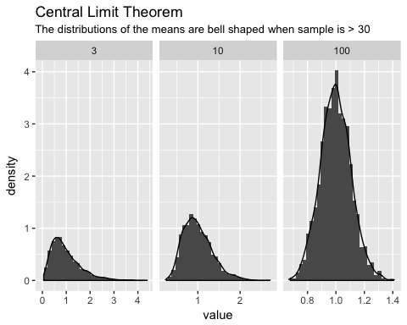

## Binomial Distribution

df %>%   
 filter(key=="rbinom") %>%   
 ggplot() +   
 geom_histogram(aes(x=value,y=..density..), position="identity") +   
 geom_density(aes(x=value,y=..density..)) +  
 facet_grid(.~n, scales = "free") +  
 ggtitle('Central Limit Theorem',   
 subtitle = 'The distributions of the means are bell shaped when sample is > 30')

