TSDZ2 Parameter Configurator guide, 5.6 version
TSDZ2 open source firmware v20.1C.6-update-3 and TSDZ8 (mstrens version)
modified version of 20 beta 1 (C)
adapted to the stock displays, VLCD5 - VLCD6 - XH18
Before using the software, carefully refer the following instructions and the display user manual.
The configurator is a graphical interface to set and modify the firmware parameters according to your needs. Refer the laws of your country and customize the parameters accordingly.
To use the program you need to install the Java Runtime Environment, have the ST-LINK V2 programmer or a clone and the connection cable to the motor.
It is also necessary to install in the root of C: \ , "SDCC Compiler" to compile the firmware (version 4.1.0 or higher) and "ST Visual Programmer" to flashing the motor.
If these software are not installed directly in C: \, set the correct path in the compile_and_flash.bat file.
With “ST Visual Programmer“, back up the original firmware, 3 hex files, one for each tab.
Start the configurator by double-click on the "JavaConfigurator.jar" file.
Check the type of motor, battery and display is correct.
The mandatory parameters to be configured to ensure correct operation are highlighted in red.
Caution. Change the values within the expected range, incorrect values can cause unpredictable behavior.

The configurator is organized into tabs and sections.

Tab 1 – Basic settings

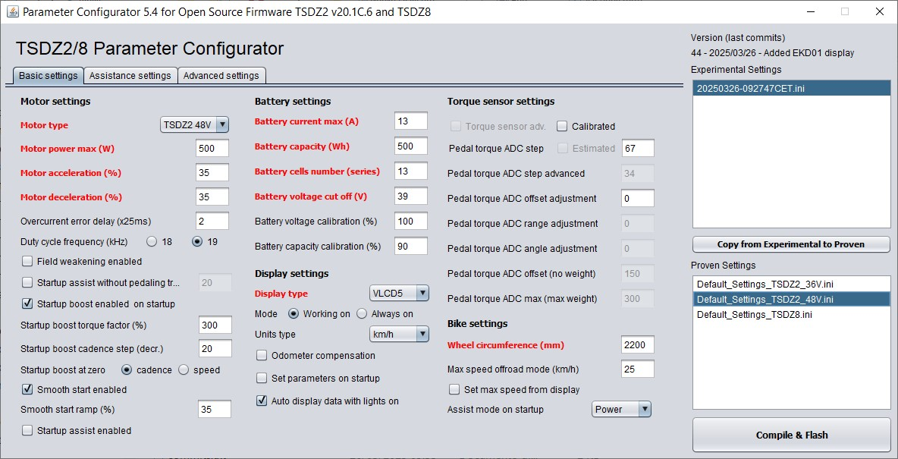
1 - Motor settings
- Motor type
Choice of motor type TSDZ2 (TSDZ2B) 48V or 36V, or TSDZ8 (mstrens version).
Read the motor plate data.
Caution. It is not the battery voltage.

- Motor power max (W)
Motor power limit in OFFROAD mode.
Warning: must be lower than the maximum power that the battery can deliver in Watts.
The maximum current used as a limit is the minimum value between "Battery current max" and the one calculated with "Motor power max" / "Battery voltage".

- Motor acceleration (%)
Acceleration of the motor.
As a first setting, use low values, then gradually increase if necessary.
Consider the values in the table as maximum values.
Set carefully, aware that setting a higher value than necessary can cause greater stress on the transmission.
Recommended values: 36 Volt motor, 36 volt battery = 35
36 Volt motor, 48 volt battery = 5
36 Volt motor, 52 volt battery = 0
48 Volt motor, 36 volt battery = 45
48 Volt motor, 48 volt battery = 35
48 Volt motor, 52 volt battery = 30
- Motor deceleration (%)
Motor deceleration. Set to zero, the maximum deceleration ramp is active (slowest stop), if set to 100% the minimum deceleration ramp is active (fastest stop).
Recommended values 25-45.
- Overcurrent error delay (x25ms)
Overcurrent error trip delay, in 25ms steps.
Valid values ​​1 to 5, recommended 2.
Overcurrent error prevents damage to the controller and the blue gear.
Increase only in case of unwanted trips.
- Duty cycle frequency (kHz)
Choice 18 kHz or 19 kHz.
With 18 kHz you get to a maximum cadence of 110 rpm, with the best performance.
With 19 kHz instead, you get to a cadence of almost 120 rpm, but you lose efficiency (about -1%).
To reach the maximum cadence, field weakening must be enabled.
- Field weakening enabled
Enabled/Disabled.
The field weakening function increases the motor cadence (up to 120 RPM when possible) but there is also a loss of efficiency.
If enabled, the field weakening is automatically activated when the PWM value reaches 100% and the cadence exceeds 90 rpm.
- Start-up assist without pedaling
Enabled / Disabled.
It can also be enabled / disabled from the display as an alternative to “Lights mode 2”, see section “Lights configuration”.
Assistance begins by simply pushing on the pedals without turning them.
It is recommended to use this function with the brake sensors installed and enabled.
The minimum thrust needed to start the assistance is adjusted with the next parameter.
By setting “Pedal torque ADC offset adjustment” with a negative value, this feature is disabled (safety).
Caution, by enabling the BOOST function at the same time, the effect increases!
This can cause greater transmission stress.

- Start-up assist without pedaling threshold
Sensitivity to start assistance without pedal rotation.
As a first setting, use low values, then gradually increase if necessary.
Set to 100% just apply a minimum torque to the pedals.
Recommended values 10-30.
- Startup boost enabled on startup
Enable the BOOST function at power on.
It can also be enabled / disabled from the display.
The BOOST function increases assistance when starting and at low cadence in "Power assist" mode.
Caution, by enabling BOOST and "Start-up assistance without pedaling" at the same time, the effect increases! This can cause greater transmission stress.

- Startup boost torque factor (%)

It is used to increase the starting assistance and at low cadence.

“Startup boost” must be enabled. Available only in "Power assist" mode.

It works both with standing start and with resuming pedaling in motion (to choose).

The value of this parameter is the percentage increase in torque applied to the pedals with cadence = 0.

This value gradually decreases as the cadence increases, depending on the next parameter.

Set carefully, aware that setting too high a value can cause greater stress to the transmission.

Recommended value 250, maximum 500.

- Startup boost cadence step

It is used to calculate the decrease in the boost torque factor as the cadence increases, until extinction.

Recommended value 25. Limits from 10 to 50, higher value = shorter effect.

- Startup boost at zero (cadence or speed)

Startup Boost Mode:

- Cadence It intervenes both starting from a standstill and resuming pedaling with the bike in motion.

- Speed It only intervenes starting from a standstill, recommended for motors with coaster brake.

Startup boost explanatory chart.





- Smooth start enabled

Enabled / Disabled.

Enables the “Smooth start” function.

Choice available in Torque and Hybrid modes.

In Cadence mode it is always enabled.

It is used to attenuate the power at the start when using high assistance levels.
- Smooth start ramp (%)

Setting the “Smooth start” ramp, at zero the maximum ramp is active (slower start)., set to 100% the minimum ramp is active (faster start).

In Cadence mode the maximum value is 35.
- Startup assist enabled
Enabled / Disabled. It is used for starting from a standstill on steep climbs, or to maintain assistance where pedaling is difficult.
If enabled, it is activated with the lights on by pressing the "Walk Assist" button. Holding it down maintains the maximum power reached, preventing a decrease in assistance when the pedal is in the vertical position or when you stop pedaling.
It functions similarly to the throttle, but you must pedal to start.
The function can also be used while pedaling.
To stop the function, release the button.
For the speed limit with the function activated, see the next parameter.
The power delivered depends on the level of assistance and the thrust on the pedals.

Warning, if “Startup assist” is enabled, “Walk assist” is only available with the lights off.
- Startup assist speed limit enabled

Enabled: The same speed limit as “Walk assist” is used.

Disabled: The speed limit of the current mode, Street or Offroad, is used.

2 - Battery settings
- Battery current max (A)
Maximum battery current in Amperes.
Set the maximum current that the battery can deliver. Consult the characteristics of the battery.
Maximum recommended value 12 A for 48 V motor, 16 A for 36 V motor.
The maximum value is limited internally by the software to 18 A.
The maximum value can take a lower value, see next parameter.
If you set a value near to the maximum, consider installing a temperature sensor.

- Battery capacity (Wh)
Total battery capacity in Watt hours.
Calculate the capacity by multiplying the rated voltage by Ah.
Example: a 36 Volt, 17.5 Ah battery has a nominal capacity of 630 Wh..

- Battery cells number
Number of battery cells in series.
This value can be an integer from 7 to 14. 7 for 24 V battery; 10 36 V; 13 48 V; 14 of 52 V.

- Battery voltage cut off (V)
Cut-off voltage for low battery.
If the under-load voltage drops below this value, the controller will automatically lower the current so as not to drop below the minimum voltage limit.
Set this value by checking the characteristics of the cells from the battery.
Example: a 36 Volt battery, 2.9 Volt cut-off voltage x 10 cells = 29 Volt.
Higher values decrease the autonomy but increase the battery life.

- Battery voltage calibration (%)
Parameter to correct the voltage value shown on the display. Example, with a fully charged battery of nominal 36V, the voltage should be close to 42V, if it is lower try to increase the parameter one unit at a time until reading 42V, vice versa if the voltage is higher, the parameter must be decreased.
- Battery capacity calibration (%)

Parameter for setting the actual battery capacity.

Calibration procedure: With the battery fully charged, check the percentage on the display, it must be 99.9%.

At this point, use the bike until the battery is completely exhausted.

Check the residual percentage and calculate the effective percentage value (100 - residual value). Set the

parameter with this value. Example, final residual percentage 8%, effective capacity 92% (100 – 8).

4 - Display settings
- Display type
Choose the type of stock display used.
Choice between VLCD5, VLCD6, XH18, 850C (6-pin connector, TSDZ2 protocol).
- Display mode

- Working on Enables the display to turn off after 5 minutes of inactivity.

- Always on The display is always on. This parameter is alternative to the previous one.
- Units type (km/h or mph)
Unit of measurement for speed and odometer.
The same setting must also be made on the display.
Warning: The maximum value that can be displayed with the setting in mph is 62.4 (99.9/1.6), so for the variables that exceed this value, the scale changes. Example: the maximum value of the residual battery percentage is 99.9%. With Units type in km/h, 99.9 is displayed, while with mph, 9.9 is displayed.
The “alternative mph” choice is designed for VLCD6, where the km/mile conversion is not present.
Warning, with VLCD6 the km already traveled are not converted into miles, only the new ones added.
It is possible to use “alternative mph” also for other types of displays, setting them in km/h and “alternative mph” in the configurator, thus avoiding the inconvenience of the scale change.
Be careful though, by changing the display from mph to km/h, the value of the odometer in miles is converted to km, only the new routes are added in miles.
By making this choice with a new display, this inconvenience does not exist.
Of course the speed value on the display is in mph, but the label remains in km/h.
- Odometer compensation
Enable the compensation of the kilometers added when viewing the data.
Even when the bike is stationary, all data sent to the display increase the odometer.
By enabling this function, the distance added and not traveled is recovered, during this operation the speed displayed while driving remains at zero until the kilometers have been balanced.
- Set parameters enabled on startup
Enables the setting of the parameters at power on.

It can also be enabled / disabled from the display.

To change the parameters, see the display's operating manual.
- Auto display data with lights on
Enables the automatic display of data in sequence, when the lights are turned on.
It can also be enabled / disabled from the display.

The type of data, the number of data, the order of the sequence and the display times of each individual data are set in the "Display advanced settings".

4 – Torque sensor settings
- Torque sensor advanced (on startup)
How to use torque sensor calibration at power on.
It can also be enabled / disabled from the display.

To use this parameter, it is necessary to perform the calibration procedure by entering the data in the configurator (“Pedal torque ADC offset” and “Pedal torque ADC max”).
The operation changes according to the "Calibrated" and "Estimated" settings.

"Calibrated" enabled and "Estimated" disabled.
- With "Torque sensor advanced" enabled, the motor works with the calibration parameters. If different from zero, "Pedal torque adc range adjustment" and "Pedal torque adc angle adjustment" are also used, they optimize the response of the torque sensor.
- With "Torque sensor advanced" disabled, the motor works without calibration.

"Calibrated" enabled and "Estimated" enabled.
With these settings you can get two different assistance profiles, available in all modes.
- With "Torque sensor advanced" enabled, the motor runs with the calibration parameters. If different from zero, "Pedal torque adc range adjustment" and "Pedal torque adc angle adjustment" are also used, they optimize the response of the torque sensor.
These are the parameters to use if you want to set two assistance profiles.
- With "Torque sensor advanced" disabled, the motor runs with the alternative calibration.
"Pedal torque adc range adjustment" and "Pedal torque adc angle adjustment" are ignored.
However, if they are set to zero, the assistance is the same as with "Torque sensor advanced" enabled.

"Calibrated" disabled and "Estimated" enabled.
- With "Torque sensor advanced" enabled, the motor runs without calibration.
- With "Torque sensor advanced" disabled, the motor runs with the alternative calibration.
"Pedal torque adc range adjustment" and "Pedal torque adc angle adjustment" are ignored.

"Calibrated" is disabled and "Estimated" is disabled.
The motor always runs without calibration, regardless of the "Torque sensor advanced" setting.
- Calibrated
Enabled / Disabled. Enable only after having entered the actual values of “Pedal torque ADC offset” and “Pedal torque ADC max”, obtained from the calibration. Enabling without having entered the correct parameters can lead to unpredictable operations. For calibration see the operating manual of the display.
Caution. The ADC values of the torque sensor over time may change, check periodically.
To use the entered parameters, it will also be necessary to enable "Torque sensor advanced".
- Pedal torque ADC step
Conversion factor of the torque applied to the pedal.
Used only with “Torque sensor adv” disabled.
It is used to calculate the correct ratio between the assistance factor and the human power (only in "Power assist"), and to obtain a correct value of the human power to be shown on the display
A weight calibration is provided (see specific instructions). After calibration, enter the actual value.
Alternatively, an estimated value can be calculated, see next parameter.
The value of "Pedal torque ADC step" is inversely proportional to the ADC range of the torque sensor.
If the human power display is of no interest, this parameter can be used to change the ratio when calculating the assistance% values at all levels (only in "Power assist" mode).

- Estimated
Enabled/Disabled. Available only after enabling the torque sensor calibration and entering the actual values of "Pedal torque ADC offset" and "Pedal torque ADC max".
With this function it is possible to calculate an estimated value of “Pedal torque ADC step“ for a weight of 24kg. The value is less accurate than that obtained with calibration, but it is adequate for the purpose.
Warning, by modifying the “Pedal torque ADC step” value, You may also need to change the % values ​​of the assistance levels in "Power assist" mode.

- Pedal torque ADC step advanced
Conversion factor of the torque applied to the pedal.
It has the same function as “Pedal torque ADC step”, but is only used with “Torque sensor adv” and “Calibrated” enabled.
It is important for a correct calculation of human power. Do not use to change the amplification of the assistance levels, for this purpose use "Pedal torque ADC range adjustment".
Also for this parameter, an optional calibration with weight is provided (see specific instructions).
The value of "Pedal torque ADC step advanced" is constant, independent of the ADC range of the torque sensor.

- Pedal torque ADC offset adjustment
Parameter for adjusting the ADC offset of the torque sensor. Value from -20 to +14.
When you need to increase the sensitivity at the start, for example with a hand-bike, set a negative value. Caution, too low a value can cause an undesired start and / or a delayed stop of the motor.
If, on the other hand, you want to decrease the sensitivity at the start, set a positive value.
With a negative value, it is advisable to disable “Assist without pedaling” and “Startup boost”.
Warning: the operation of this parameter changes depending on the settings of “Torque sensor advanced”, “Calibrated” and “Estimated”.
"Torque sensor advanced" enabled and "Calibrated" enabled.
With "Torque sensor advanced" and "Calibrated" enabled, the motor runs with calibration.
The value of “Pedal torque ADC offset adjustment” is recalculated and is proportional to the range obtained with “Pedal torque ADC range adjustment”, furthermore the effective width of the range is also recalculated, to obtain a constant maximum value.
So the effect obtained by “Pedal torque ADC offset adjustment” is always the same, regardless of the setting of “Pedal torque ADC range adjustment”.
"Torque sensor advanced" disabled and "Estimated" enabled.
With "Torque sensor advanced" disabled and "Estimated" enabled, the motor runs with the alternative (simplified) calibration.
The value of “Pedal torque ADC offset adjustment” is a constant referring to a range remapped to 160, this does not change the effect obtained by “Pedal torque ADC offset adjustment”, but it affects the effective width of the range. Example: with “Pedal torque ADC offset adjustment” at -5, the effective range is 155 (160 – 5), while with “Pedal torque ADC offset adjustment” at +5, the effective range is 165 (160 + 5).
"Torque sensor advanced" enabled and "Calibrated" disabled, or "Torque sensor advanced" disabled and "Estimated" disabled.
With these settings the engine runs without calibration.
The value of “Pedal torque ADC offset adjustment” is a constant with no relation to the range width. Therefore, the effect obtained by “Pedal torque ADC offset adjustment”, with the same setting, can be very different, depending on the raw range of the torque sensor. Example: “Pedal torque ADC offset adjustment” set to -5, with a raw range of 160 it affects 3.1%, with a raw range of 80 it affects 6.2%, with a raw range of 40 it affects 12.5%. This must be taken into account, by setting a lower value, proportional to the raw range.
Using the motor without calibration is not recommended.

- Pedal torque ADC range adjustment
Parameter for adjusting the ADC range of the torque sensor. Value from -20 to +20.
A negative value decreases the amplification of the range, a positive value increases it.
This change takes effect at all levels in modes that use the torque sensor.
It is necessary to first enable the torque sensor calibration and enter the actual values of “Pedal torque ADC offset” and “Pedal torque ADC max”. The range value is fixed at 160 (133 with -20, 186 with +20).
Only available with "Torque sensor advanced" and "Calibrated" enabled.

- Pedal torque ADC angle adjustment
Parameter for adjusting the initial angle of the torque sensor curve. Value from -20 to +20.
Try with zero value, then adjust to “feel”. With negative value, more gradual response and less consumption. With positive value, more reactive but with higher consumption. See the explanatory chart.
This change takes effect at all levels in modes that use the torque sensor.
It is necessary to first enable the torque sensor calibration and enter the actual values of “Pedal torque ADC offset” and “Pedal torque ADC max”. With positive value, it is advisable to disable "Startup boost".
Only available with "Torque sensor advanced" and "Calibrated" enabled.


Red curve, angle adj = - 20. Green curve, angle adj = 0. Blue curve, angle adj = 20.

- Pedal torque ADC offset (no weight)
ADC value of the torque sensor without any push on the pedals.
It is obtained from the calibration procedure to be carried out on the display.
Do not use to change the sensitivity of the torque sensor at the start, for this purpose use “Pedal torque ADC offset adjustment”.

- Pedal torque ADC max (max weight)

ADC value of the torque sensor with the maximum thrust applied to the pedal (cyclist standing, on the right pedal in horizontal position). It is obtained from the calibration procedure to be carried out on the display.

Do not use to change the amplification of the torque sensor range, for this purpose use "Pedal torque ADC range adjustment".

5 - Bike settings
- Wheel circumference (mm)
This parameter is used to calculate the speed and kilometers traveled.
Enter the wheel perimeter in millimeters.
Indicative values:
26-inch wheel = 2050 mm
27-inch wheel = 2150 mm
27.5 inch wheel = 2215 mm
28-inch wheel = 2250 mm
29-inch wheel = 2300 mm
It is recommended to measure the actual perimeter and check the distance traveled with GPS.

- Max speed (km/h or mph)

Speed ​​limit in “Offroad Mode”, in km/h or mph depending on the unit of measurement chosen.

As the speed approaches the limit value, the motor gradually reduces power until it stops.

Notice, if “Set max speed from display ”function is enabled, this limit is ignored and replaced by the one set on the display. Find out about your country's legal restrictions regarding speed limits.
- Set max speed from display
Enable the speed limit set on the display.
The limit of the "Max speed" parameter is ignored.
The speed limit always remains active in STREET mode.
Notice, when the speed limit on the display is lower than that in STREET mode, the one on the display
has priority.
Example:
- display limit 30 km/h, STREET limit 25 km/h, limit used 25 km/h
- display limit 20 km/h, STREET limit 25 km/h, limit used 20 km/h

For setting the limit, consult the manual of your display.
- Assist mode on startup
Assist mode at power on.
Choice between Power, Torque, Cadence, eMTB, Hybrid modes.
Cruise mode cannot be set at power on, but only changed on the display.
Hybrid mode is a combination of Torque and Power assistance modes.
This provides excellent assistance at low cadence, typical of Torque mode, and the extension of Power mode at high cadence.
The assistance parameters are the same as those used in the two modes, combined at the same level.

Tab 2 – Assistance settings
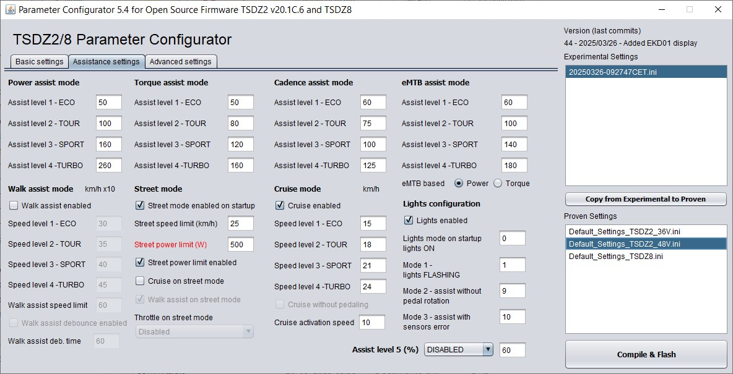
6 – Power assist mode
“Power assist” is an assistance mode proportional to the power on the pedals.
- Assist level 1 - ECO
- Assist level 2 - TOUR
- Assist level 3 - SPORT
- Assist level 4 - TURBO
Set assistance levels according to your needs. Values in percentages, maximum 500%.
For example, applying 100 Watt to the pedals, with 300% assistance, the motor delivers 300 Watt.
These assistance parameters are also used in the high-cadence hybrid mode.
7 – Torque assist mode
“Torque assist” is an assistance mode proportional to the torque on the pedals.
- Assist level 1 - ECO
- Assist level 2 - TOUR
- Assist level 3 - SPORT
- Assist level 4 – TURBO
The power delivered by the motor is proportional to the applied torque and the set assistance values.
Set assistance levels according to your needs. Relative values, maximum 254.
These assistance parameters are also used in the low cadence hybrid mode.
8 – Cadence assist mode
“Cadence assist” is an assistance mode dependent on the movement of the pedals, it uses only the cadence sensor and not the torque sensor.
- Assist level 1 - ECO
- Assist level 2 - TOUR
- Assist level 3 - SPORT
- Assist level 4 – TURBO
The power supplied by the motor depends partly on the assistance values set and partly on the cadence of
the pedals. Values ​​in W / 2, maximum 254.
For example, setting 50 the motor outputs 102 Watts at cadence 1, ((50+1) x 2 = 102 W), 220 Watts at cadence 60 ((50+60) x 2 = 220 W).
Note: the motor power is still limited by Motor power max (W) and Battery current max (A).
It is recommended to use this assistance mode with the brake sensors installed and enabled.
9 – eMTB assist mode
“eMTB assist” is an assistance mode with progressive percentage of the torque on the pedals.
- Assist level 1 - ECO
- Assist level 2 - TOUR
- Assist level 3 - SPORT
- Assist level 4 – TURBO
The power delivered by the motor is progressively proportional to the applied torque.
Relative values, maximum 254.
Higher values ​​correspond to a more reactive assistance, faster to reach the maximum motor power.
- eMTB based (power or torque)
- power: progressive assistance is proportional to the power on the pedals.
- torque: Progressive assistance is proportional to the torque on the pedals (same as previous versions).
10 – Walk assist mode
- Walk assist
Enables the use of the walk assist.
Notice. It must also be enabled in the hidden display menu.
“Walk assist” is an assistance mode when you want to accompany the bike on foot up to 6 km/h.
Activated with the dedicated button, consult the manual of your display.
- Assist level 1 - ECO
- Assist level 2 - TOUR
- Assist level 3 - SPORT
- Assist level 4 – TURBO
For each level, you set the speed to reach and maintain, in km/h x10 or in mph x10.
Maximum value 60 (6.0 km/h) or 37 (3.7 mph). Try low values ​​and gradually increase.
Recommended values ​​from 25 to 45 (2.5 to 4.5 km/h) or 15 to 28 (1.5 to 2.8 mph).
Starting "Walk assist" there will be an overrun of the set speed, this is an auto calibration.
It is used to define the ratio between wheel speed and motor revs, and to calculate the maximum power required in those conditions of use (gear ratio and slope to be overcome), then it stabilizes at the set speed.
The adjustment is made on the motor revolutions, therefore it remains constant even when setting undetectable speed values.
If necessary, it is possible to repeat the auto calibration, release the button and press again.
The set speed may not be reached due to the power limitation.
With speed sensor problems, walk assist does not work properly.
By enabling “Assist with error” on the display, walk assist will work like previous versions, without speed control.
- Walk assist speed limit
Maximum speed limit in walk assist mode, in km/h x10 or mph x10.
Please inquire about the legal restrictions regarding the speed limit. Maximum value in EU 6 km/h.

- Walk assist debounce enabled
Enable the debounce time on the walk assist button.
Useful on rough terrain, when a rebound can cause the button to be released unwanted.
Available only with brake sensors installed and enabled.

- Walk assist deb. time
Debounce time value on the walk assist button.
It is recommended to set this time as low as possible, slightly higher than that necessary for the activation of
the walk assist.
Caution, the assistance remains active after releasing the button for the set time.
To stop assistance during this time, change the level.
With display XH18 and VLCD5 it stops only when moving to the upper level.
In any case it is interrupted by passing to level 0-OFF.

11 – Street mode
- Street mode enabled on startup
Enable STREET mode at startup.
It can also be enabled / disabled from the display.
The STREET mode is a function that can be configured as a legal driving mode, it is possible to limit the
speed and power of the motor.
Find out about your country's legal restrictions regarding speed limit and motor power.

- Street speed limit (km/h or mph)
Speed limit in km/h or mph, according to the unit of measurement chosen, when STREET mode is enabled.
As the speed approaches this limit value, the motor gradually reduces power until it stops.
This speed limit can be replaced by the one set on the display when the “Set max speed from display” function is enabled.

- Street power limit (W)
Maximum motor power limit in watts when STREET mode is enabled.

- Street power limit enabled
Enable the power limit in STREET mode.
- Cruise on street mode
Enable Cruise in STREET mode. It must also be enabled in the “Cruise mode” section.
In Street mode, “Cruise without pedaling” is always disabled, see Cruise mode section.
Only available with brake sensors installed and enabled.
If disabled, set the Cruise mode on the display, the “Cadence assist” mode is activated.
- Walk assist on street mode
Enable walk assist in STREET mode.
Disable when “Walk assist debounce enabled” is enabled.

- Throttle on street mode
Enable the throttle, if installed, in STREET mode.
Choice conditioned by the “Throttle mode” setting in the “Other function settings” section.
Only available with brake sensors installed and enabled.
12 – Cruise mode
- Cruise enabled
Enable Cruise mode.
“Cruise assist” is a speed control assist mode. It can only be selected on display.
Regarding use, please check the legislative restrictions in your country.
- Speed level 1 - ECO
- Speed level 2 - TOUR
- Speed level 3 - SPORT
- Speed level 4 – TURBO
The value set in the levels is the target speed to be maintained, in km/h or mph.
The power supplied by the motor adjusts itself to maintain the chosen speed.
Speed may not be reached due to limited motor power.
The speed limits seen above have priority.
Carefully read the function of the next parameter.

- Cruise without pedaling
Disabled.
The cruise activation mode is subordinated to the movement of the pedals.
Speed is maintained only with minimal pedal movement.
By stopping pedaling the motor stops. It is the default mode.
It can be compared to the “Cadence assist” mode, the difference is that changing the level does not change the power supplied by the motor but the speed to be achieved.
Enabled.
You can maintain your speed even without turning the pedals by pressing the walk assist button.
By releasing the button and stopping pedaling, the motor stops.
It can be compared to an throttle with speed variation in steps. Increasing the level increases the speed,
decreasing it decreases, at 0-OFF the motor stops.
Available only with brake sensors installed and enabled.
Not available in STREET mode.
- Cruise activation speed
Minimum speed limit for activating cruise mode, in km/h.
Below this value, assistance in “Cadence assist” mode is active.
Warning: with “Cruise activation speed” set to zero and “Cruise without pedaling” enabled, by pressing the Walk assist button the motor starts from a standstill even without pedal movement.
It can be considered an emergency mode. Only to return home in the event of a broken freewheel on the crown side or the pedal axle. Available only in OFFROAD mode.
The operation is comparable to an throttle, find out about the legislative restrictions in your country.
13 – Lights configuration
- Lights
Enable the use of lights, on and off, via the lights button.
It is recommended to disable if the lights are not installed.
- Lights mode on startup
Mode of operation of the lights at startup.
See below the various modes and their codes.
This value can be different from the 3 selectable in the display menu.
- Lights mode 1
- Lights mode 2
- Lights mode 3
Configuration of the light modes, selectable from the menu on the display.
Find out about regulatory compliance in your country.
Choose the 3 preferred modes among the 9 available.
With light control ON:
0 - on
1 - flashing
2 - on and fast flashing when braking
3 - flashing and on when braking
4 - flashing and fast flashing when braking
5 - on and on during braking also with light control OFF
6 - on and fast flashing when braking even with the light control OFF
7 - flashing and switched on when braking even with the light control OFF
8 - flashing and fast flashing when braking even with the light control OFF
The braking modes are only available with the brake sensors installed.

- Alternative functions to the configuration of the lights
If the brake sensors are not installed, the usable light modes are only: 0 = on, 1 = flashing, for this just configure "Lights mode1”.
“Lights mode 2” and “Lights mode 3” can then be used to set other functions on the display.
Lights mode 2
9 – “Start-up assistance without pedaling”, to enable/disable assistance at start without rotating the pedals.
Lights mode 3
10 – “Assistance with sensors error”, to enable assistance even in the presence of an error caused by a sensor failure. Of torque, cadence or speed.
It is not possible to enable it in the configurator but only on the display. It is always disabled when switched on. Once enabled, you can save it to eeprom on display if you want.
14 – Assist levels 5 (%)
Setting the fifth assistance level for displays that support it.
- DISABLED, for displays with 4 levels.
- BEFORE ECO: if the fifth level position is before ECO (example DZ41).
- AFTER TURBO: if the fifth level position is after TURBO (example EKD01).

Choosing BEFORE ECO, the levels are in this order:
1-fifth, 2-ECO, 3-TOUR, 4-SPORT, 5-TURBO.
The assistance parameters of the fifth level are a % of ECO, so it must be less than 100.
The parameters must be set on levels 2 to 5.
Choosing AFTER TURBO, the levels are in this order:
1-ECO, 2-TOUR, 3-SPORT, 4-TURBO, 5-fifth.
The fifth level assistance parameters are a % of TURBO, so it must be greater than 100.
The parameter setting must be done on levels 1 to 4.

Tab 3 – Advanced settings

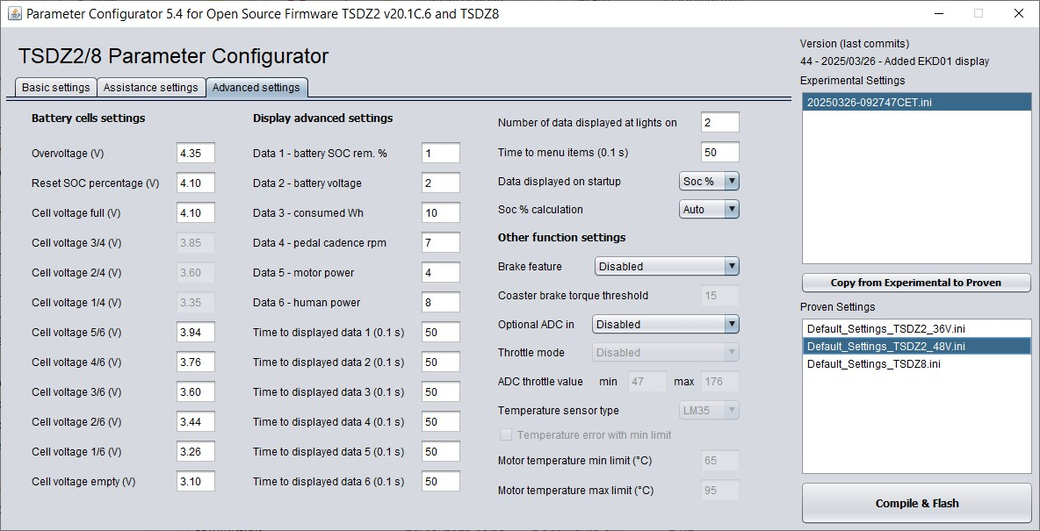
15 – Battery cells settings
- Overvoltage (V)
Value beyond which the error E08-ERROR_OVERVOLTAGE is displayed.
Possible if you set the wrong number of cells in series.
The unit of measurement of this and subsequent parameters is in Volts (of each single cell).

- Reset SOC percentage (V)
Value for automatic reset to 99.9% of the percentage of residual capacity, with battery fully charged.
Recommended values from 4.10 to 4.15, otherwise with lower values, after a short turn, if the voltage does not fall below this value, when it is switched on again it resets to 99.9 again. If the battery is not fully charged and the voltage is lower than this value, the reset is not automatically activated. If desired, it can be done manually by activating the procedure provided. Or by setting “SOC% calculation” to Auto.

- Cell voltage full (V)
Minimum voltage value to display the complete battery charge status, 4 bars with VLCD6 and XH18 display, 6 bars with VLCD5.

- Cell voltage 3/4 (V)
- Cell voltage 2/4 (V)
- Cell voltage 1/4 (V)
Voltage values to display intermediate charge states.
From 1 to 3 bars, for VLCD6 and XH18 displays.

- Cell voltage 5/6 (V)
- Cell voltage 4/6 (V)
- Cell voltage 3/6 (V)
- Cell voltage 2/6 (V)
- Cell voltage 1/6 (V)
Voltage values to display intermediate charge states.
From 1 to 5 bars, for VLCD5 displays.

-Cell voltage empty (V)
Voltage value to display the state of the completely discharged battery, 0 bars.
Warning, this is the no-load voltage without load, it is not the cut-off value.
For all these parameters, check the technical characteristics of the cells used.

16 – Display advanced settings
- Data 1
- Data 2
- Data 3
- Data 4
- Data 5
- Data 6
Configuration of the data shown on the display.
Choose the data to be displayed, in the type and in the preferred order among those available.
0 – motor temperature, only with sensor installed (° C)
1 - remaining battery charge (%)
2 - battery voltage (Volt)
3 - battery current (Amp)
4 - power absorbed by the motor (Watt / 10)
5 - throttle adc value (8 bit)
6 - torque sensor adc value (10 bit)
7 - pedal cadence (rpm)
8 - human power (Watt / 10)
9 - torque sensor range (10 bit)
10- consumed Wh
11- Motor ERPS
12- Duty cycle PWM%

- Time to displayed data 1 (0.1 s)
- Time to displayed data 2 (0.1 s)
- Time to displayed data 3 (0.1 s)
- Time to displayed data 4 (0.1 s)
- Time to displayed data 5 (0.1 s)
- Time to displayed data 6 (0.1 s)
If the "Automatic data display with lights on" function is enabled, the selected data is displayed in sequence when the lights are switched on.
These are the display times of each single data. The maximum value is 255 = 25.5 seconds.
By setting a time to zero, the data is displayed continuously, without time limit.
You can interrupt the data display by turning off the lights.
Changing the level before the end of the time takes you to the next data.
If the “Set parameters” function is enabled, the code and status of the selected parameter is first displayed and after the selected data.
- Number of data displayed at lights on
Number of data displayed automatically when the lights are turned on.
Value from 1 to 6.
- Time to menu items (0.1 s)
Time limit between the first pressure of the light button (on) and the second of confirmation (off), in the procedure for setting the parameters, if enabled.
It is also the time within which, after confirmation and with flashing code, it is possible to pass to the next parameter.
Beyond this time, if the parameter change is not confirmed, the “Auto display data with lights on” function is activated, if enabled.
It is also the display time of the selected data at power on.

- Data displayed on startup
Choice of data to be displayed at power on.
Available data: None = no data, Soc% = residual battery percentage, Volts = battery voltage.
- Soc % calculation
Choice of the method for calculating the remaining battery percentage.
Auto - soc%, calculation with Wh used.
Automatic reset at power on, when the soc% calculated with Wh used is different from that calculated with the voltage (+/- 15%), useful when you put a battery that is not fully charged.
Wh - soc% calculation with used Wh, reset only with fully charged battery (100%) or manual.
Volts - soc%, calculation with battery voltage, it is less accurate than the previous ones.
It can be useful if you have two batteries of different capacities
To obtain a correct correspondence between soc% and voltage, it may be necessary to calibrate the values of “Cell voltage x / x”, as for the bars.
17 – Other function settings
- Brake feature
Available choices:
- Disabled
Feature disabled.
- Brake sensor
Enables the use of brake sensors when installed.
It also allows you to enable functions where the use of sensors is necessary: ​​walk assist debounce time, cruise mode without pedal movement, throttle.
For safety, with the sensors installed, even with the feature disabled or set to other choices, activating the brakes always stops the motor.
- Coaster brake
Enable if you have a coaster brake motor type.
For safety, with this choice, the “Throttle mode”, “Walk assist” and “Cruise without pedaling” are disabled.
- Temperature switch
Enable if you install an on/off thermostat (NO max 85°C) instead of the brake sensor.
When the temperature is exceeded, the motor stops and the error message E06 OVERTEMPERATURE is displayed.
In theory, you can install both (brake sensor and on/off thermostat, with contacts in parallel), but the error message will also be displayed when braking.
- Coaster brake torque threshold
Sensitivity of the coaster brake, when pushing the pedals backwards.
The “Brake sensor” function must be set to “Coaster brake”. Please note that if you change the value of “Pedal torque ADC offset adjustment”, you may need to change this as well.
- Optional ADC in
Available choices:
- Disabled
Function disabled, if throttle or temperature sensor are not installed.
- Throttle
Enable the throttle only if it has been installed.
Only available with brake sensors mounted and enabled.
Regarding the use, find out about the legislative restrictions in your country.
At level 0-OFF the throttle is disabled.
Notice, the throttle is an alternative to the temperature sensor.
Both cannot be installed!
- Temperature sensor
Enable only if the temperature sensor has been installed.
Notice, the temperature sensor is an alternative to the throttle.
Both cannot be installed!
- Throttle mode
How to use the throttle, find out about the legislative restrictions in your country.
The installation of brake sensors is recommended.
At level 0-OFF the throttle is deactivated.
Available choices:
- Disabled
Throttle disabled.
- Pedaling
The throttle works by pedaling.
When you stop pedaling, the motor stops.
- 6 km/h only
The throttle is only active up to 6 km/h, even without pedaling.
- 6 km/h & pedaling
The throttle is enabled up to 6 km/h without pedaling, above 6 km/h it is necessary to pedal.
- unconditional
The throttle is always enabled, without conditions.
How to use the throttle, find out about the legislative restrictions in your country.
- ADC throttle value min
- ADC throttle value max
Throttle ADC input adjustment ranges, relative minimum and maximum values.
Check the “adc throttle (8 bit)” values ​​on the display, with the throttle at minimum and maximum.
- Temperature sensor type
Available choices:
- LM35
- TMP36
- Temperature error with min limit
If enabled, the error code E06 – ERROR OVERTEMPERATURE is displayed when the minimum temperature limit is exceeded. If disabled, when the maximum limit is exceeded.
Available only with temperature sensor installed and enabled.
- Motor temperature min limit
Set the temperature from which the motor protection will start, limiting its power.
The power gradually decreases until the maximum temperature limit, then the motor stops.
- Motor temperature max limit
Set the maximum motor temperature. At this temperature the motor will be turned off.
Values ​​in degrees Celsius.
18 – Compile & Flash
Notice. PC and motor must be connected via ST-LINK V2.
Make sure that ST Visual Programmer is closed.
By clicking the “Compile & Flash” button starts a series of operations automatically.
- A timestamp.ini file is created with the current settings in the “experimental settings” folder.
- The config.h file is saved with the new parameters.
- A "Command prompt" window opens.
- The files of the previous compile are deleted.
- The compile starts and when it is done, the main.ihx file is created.
- Flashing the main.ihx program file in the motor controller.
- Flashing the data.ihx data file empty, to delete the old data in the eeprom memory.
- When the operations are completed without errors, the "Command prompt" window closes automatically.

At the end, once the procedure is complete, click on "Eject device" at the bottom right next to the clock and disconnect the cable between the PC and motor.
Caution. During programming, the display must be off!
By clicking the "Compile & Flash" button without connecting the PC to the motor, there will be an error message in the "Command prompt" window, but all files will still be created and saved for later use.
In Windows Explorer, the timestamp.ini file can be moved to the "Proven Settings" folder and renamed, for example "mySetting.ini", for better recognizability.
Now you can do it directly in the configurator, select the name of the file to copy in the “Experimental settings” list, click on the “Copy from Experimental to Proven” button and enter the name of the new ini file. It is also possible to overwrite an existing ini file, before clicking on “Copy from Experimental to Proven”, select the name of the file to overwrite in the “Proven settings” list, you will be asked for confirmation.
In the configurator window, at the top right, the release date, number and description of the last "commit" on the GitHub repository are specified.
To get the latest version, check if there are any other commits after the release date and if subsequent changes are of interest.
19 – Compile HEX file
If the motor type selection is TSDZ8, the button label changes to “Compile HEX file”.
Clicking it compiles the TSDZ8_config.hex file in the files_to_flash folder, to be used with the OSF mstrens version.

