**Laboratory 9: Implementation of an advanced calculator**

In this lab, you will be working with the GUI interface to implement a calculator that will do many of the functions of a scientific calculator. This will help you learn the math’s functions available in Java and how to perform the complex mathematical calculations.

<https://docs.oracle.com/javase/8/docs/api/java/lang/Math.html>

**Probable layout of the calculator**

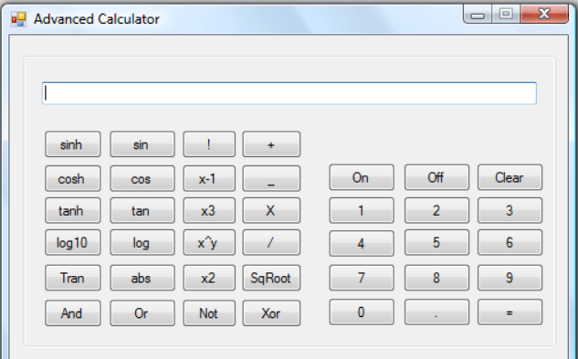

**Part I: Implement five basic arithmetic operations**

* Addition
* Subtraction
* Multiplication
* Division
* Inverse

**Part II: Implement five trigonometric operations**

* Sin
* Cos
* Sinh
* Cosh
* Tanh

**Part III: Implement five miscellaneous operations**

* Square root
* Square
* Cube
* x^y
* absolute

**Part IV: Requirements**

Your program must use at least the following Swing components:

* JTextArea
* JButton
* JPanel

<https://docs.oracle.com/javase/tutorial/uiswing/examples/components/index.html#ComboBoxDemo>

You are also required to use an appropriate Layout Manager(s) for aligning all your Swing components properly.

<https://docs.oracle.com/javase/tutorial/uiswing/layout/visual.html>