MTG Hub Blog
2026-03-24

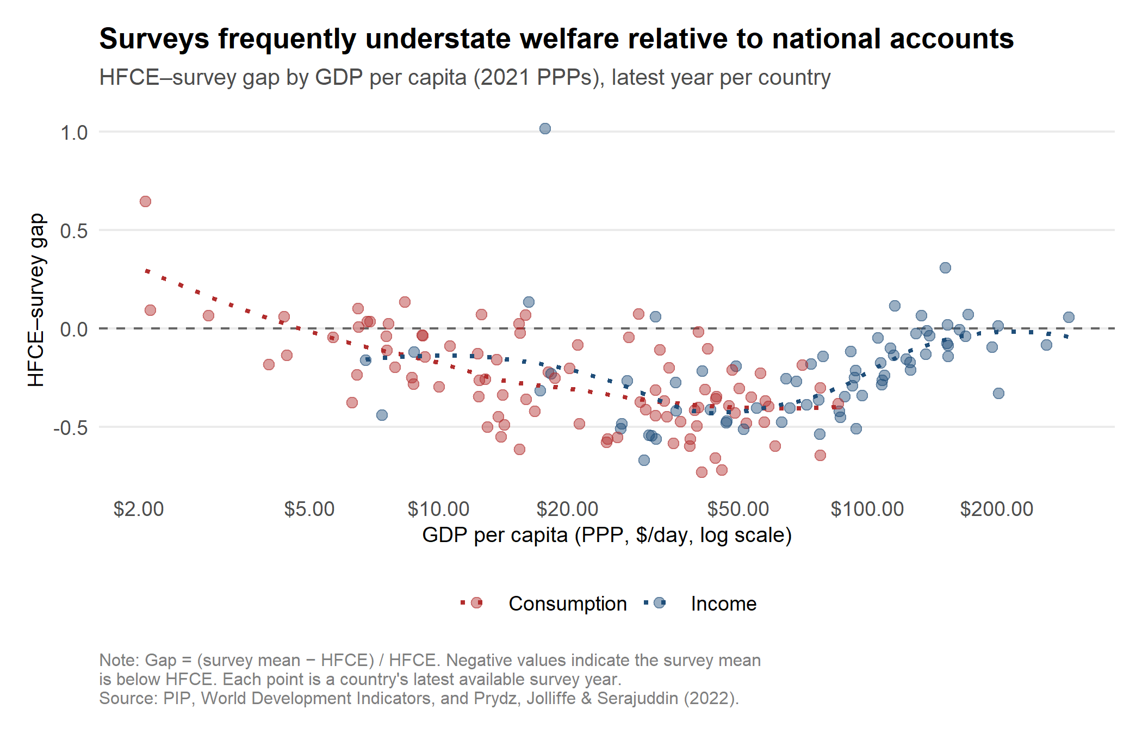
Figure 5: The NA–survey welfare gap across countries
Estimates of average per capita consumption and income from national accounts can differ substantially from corresponding measures of consumption and income from household surveys. With additional country-year data and updated to 2021 PPPs, this dataset builds on Prydz, Jolliffe, and Serajuddin (2022) to identify the magnitude of the gap between survey and national account means and to utilize this gap to correct for the “missing top”.
Using over 2,000 household surveys matched to national accounts data since 1990, the means obtained from surveys are 26% lower on average compared to corresponding means from national accounts as measured by Household Final Consumption Expenditure (HFCE). The gap between survey means and GDP per capita is much larger (55% on average). There is a U-shaped pattern between a country’s GDP per capita and the gap, where the gap is smaller for countries with lower GDP per capita, but widens as GDP per capita increases, before narrowing again for high-income countries (Figure 5).
One potential explanation for the large gap between surveys and national accounts is that surveys disproportionately fail to fully capture the consumption and incomes of the richest households and hence are “missing” from the distribution captured by the survey. To explore this concept and its potential implications, Prydz, Jolliffe, and Serajuddin (2022) follow the adjustment methodology by Chandy and Seidel (2017) and attribute half of the survey–national account mean gap to the “missing” rich. If the richest individuals are missing from the distribution captured by surveys, adjustment approaches to include them, whilst minimal on poverty rates, will have large implications on the level of inequality.
Outlier countries with data issues or where the survey mean is drastically higher than the national account mean have been removed from Figure 5.
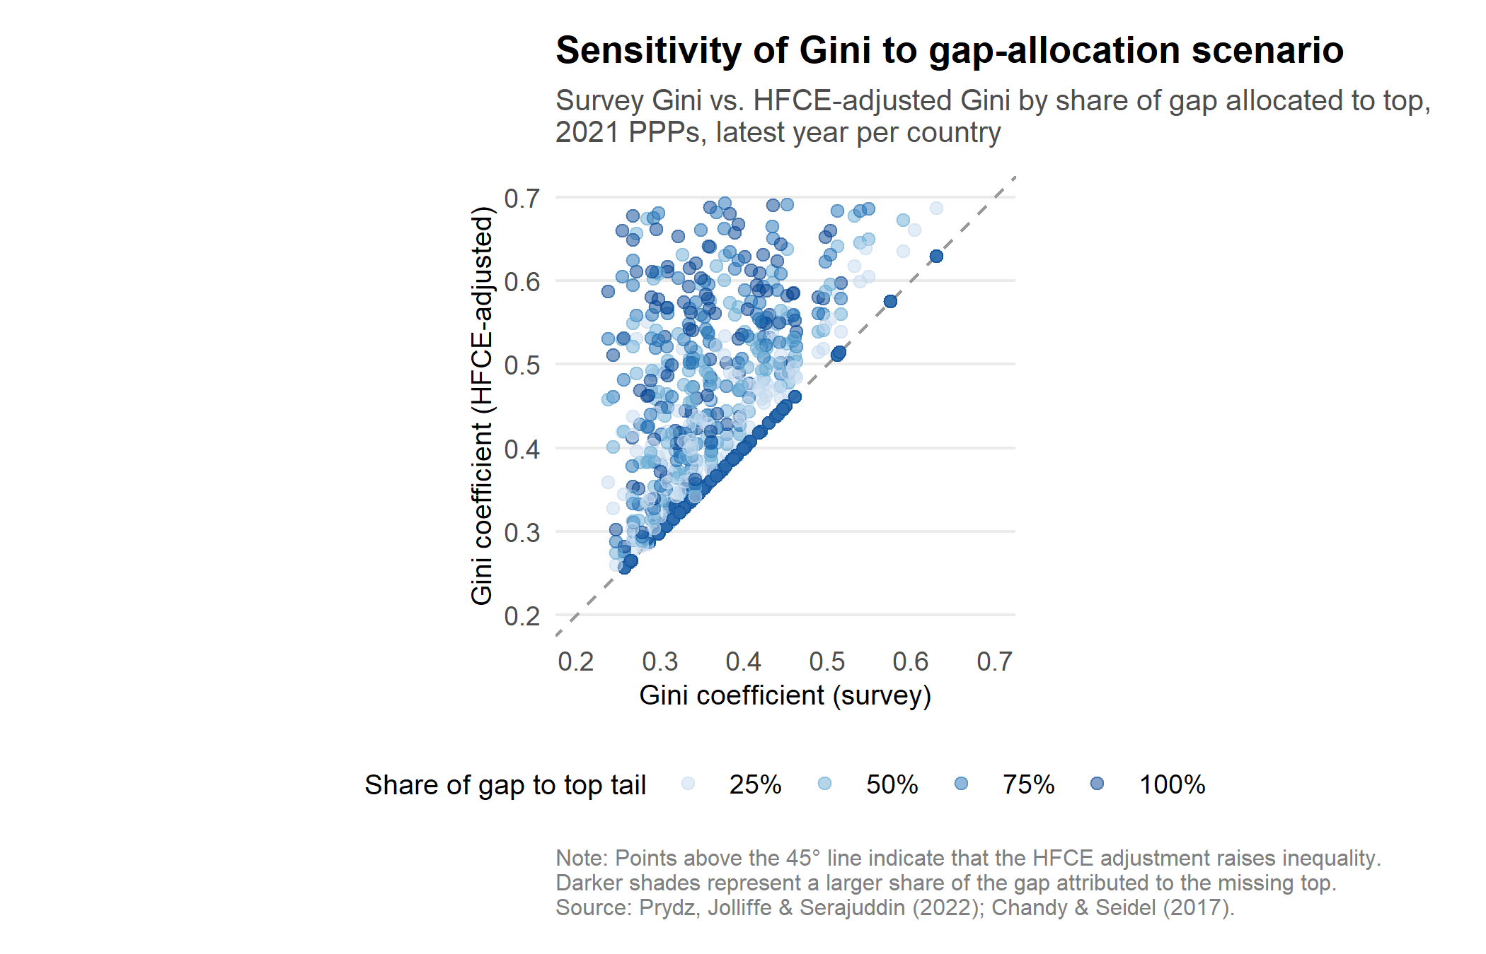
Figure 6: Sensitivity of the Gini to the share of the HFCE gap allocated to the top
Figure 6 presents the differences in the Gini depending on whether 25%, 50%, 75%, or 100% of the survey–national account gap is attributed to the missing top. The average increase in the Gini by attributing 25% of the survey-HFCE gap is 14%, whilst attributing the entire gap to the very rich increases the Gini by 40% on average. Estimates that vary the attributed share in 5 percentage point increments are available for download.
It is important to note that while comparisons between the PIP and alternative estimates within a given year and dataset are informative, comparisons across years or across methods should be made with caution. Each method uses a different data vintage, different survey years, and different underlying assumptions. The value of the Innovation Hub lies not in ranking methods but in making these choices--and their consequences--visible.
Explore the PIP Innovation Hub: [link forthcoming]
The authors gratefully acknowledge financial support from the UK Government through the Data and Evidence for Tackling Extreme Poverty (DEEP) Research Program.

