
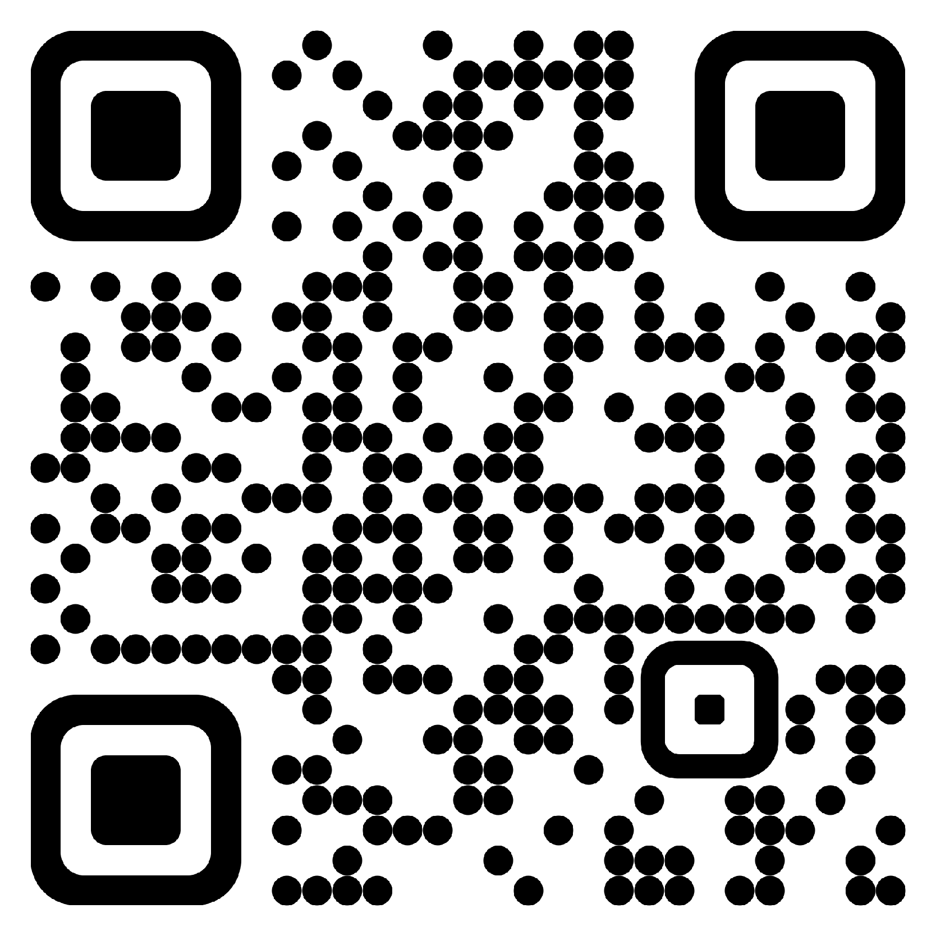
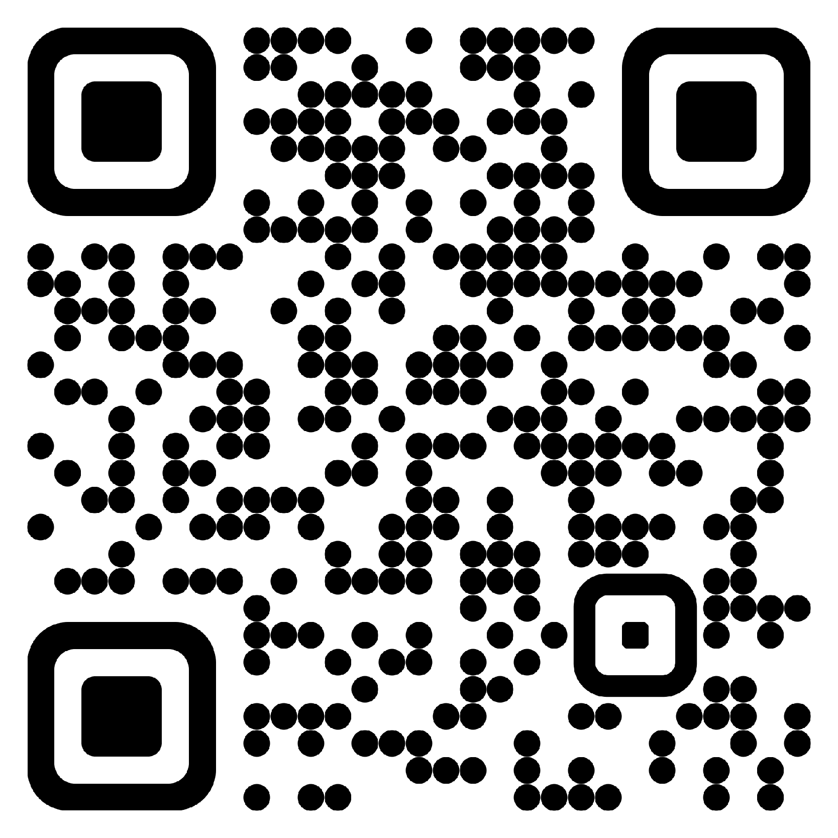

￨Alexander DeRieux⟩
 | Quantum AI { Scientist, Engineer, Developer }
 | alexander.derieux@gmail.com | • | GitHub: zanderman | • | LinkedIn: alexderieux

Objectives |  | Ph.D. candidate and industry professional with research experience in quantum computing, machine learning, software engineering, space systems, game theory, and wireless communications. Interested in designing quantum-native artificial intelligence systems that naturally leverage uniquely quantum properties to facilitate learning and operation within the quantum domain.
Security Clearance |  | Cleared for Top Secret Information and granted access to Sensitive Compartmented Information based on a Tier 5 Investigation completed in 7/2024.
Education |  | Doctor of Philosophy in Electrical Engineering – Bradley Fellow [ 8/2022 – Expected 12/2026 ]  Virginia Polytechnic Institute and State University, Blacksburg, Virginia  Dissertation Title: “Quantum-Native Artificial Intelligence: Architectures and Algorithms”  Dissertation Committee: Walid Saad (chair), Harpreet Dhillon, Jeffrey Reed, Jamie Sikora, Wayne Scales  GPA: 3.91
Master of Science in Electrical Engineering | [ 1/2021 – 8/2022 ]
Virginia Polytechnic Institute and State University, Blacksburg, Virginia
Thesis Title: “Transformer Networks for Smart Cities: Framework and Application to Makassar Smart Garden Alleys”
Thesis Committee: Walid Saad (chair), Harpreet Dhillon, Thinh Doan
GPA: 3.91

Bachelor of Science in Electrical Engineering, Minor in Mathematics – cum laude | [ 8/2012 – 5/2016 ]
Virginia Polytechnic Institute and State University, Blacksburg, Virginia
In Major GPA: 3.437, University GPA: 3.407

Bachelor of Science in Computer Science – cum laude | [ 8/2012 – 12/2016 ]
Virginia Polytechnic Institute and State University, Blacksburg, Virginia
In Major GPA: 3.793, University GPA: 3.456

Employment Experience |  | Graduate Research Assistant (GRA) [ 8/2021 – Present ]  Wireless@VT, Virginia Polytechnic Institute and State University  Quantum machine learning (QML) research with a focus on designing quantum-native artificial intelligence (AI) systems that leverage unique quantum mechanical properties to facilitate learning and operation naturally within the quantum domain.  Classical ML research with application to smart cities, wireless communications, optimization, and game theory. Developed AI architectures and techniques to facilitate heterogeneous multi-task learning (HMTL) in smart garden alleys with diverse datasets.
Graduate Teaching Assistant (GTA) | [ 1/2021 – 12/2021, 08/2022 – 05/2023 ]
Bradley Department of Electrical and Computer Engineering, Virginia Polytechnic Institute and State University
Professional mentor and graduate administrator for the Electrical Engineering Major Design Experience (MDE) undergraduate capstone course. Manage grading student individual project notebooks (IPN), designing new course assignments relative to industry experience, and developing software for automating course administration tasks with integration of Canvas LMS REST API.

Electronics Engineer | [ 2/2017 – 9/2024 ]
U.S. Naval Research Laboratory (NRL), Washington DC, TS/SCI clearance
Research, design, and develop space-system technologies for the U.S. Navy in the areas of rocketry, communications, optics, software engineering, networking, tactical network modeling, surveillance and tracking, Positioning, Navigation, and Timing (PNT), and Precise Time and Time Interval (PTTI) theory and applications.

Electrical Engineering Co-op | [ 7/2012 – 2/2017 ]
U.S. Naval Research Laboratory (NRL), Washington DC, Secret clearance
Created an off-the-shelf system for high altitude naval vessel tracking. Designed image processing algorithms to identify naval vessels and their location using Python and OpenCV. Wrote technical documentation and how-to guides for various projects.

Publications |  | A. DeRieux and W. Saad, “QnRL: Quantum-Native Reinforcement Learning”, June 2026, arXiv: arXiv:2606.08276. doi: 10.48550/arXiv.2606.08276.  A. DeRieux and W. Saad, “eQMARL: Entangled Quantum Multi-Agent Reinforcement Learning for Distributed Cooperation over Quantum Channels”, in Proc. Of The Thirteenth International Conference on Learning Representations (ICLR), Singapore, April 2025. doi: 10.48550/arXiv.2405.17486.  M. Kim, A. DeRieux, and W. Saad, “A Bargaining Game for Personalized, Energy Efficient Split Learning over Wireless Networks”, in 2023 IEEE Wireless Communications and Networking Conference (WCNC), Glasgow, United Kingdom, March 2023, pp. 1-6. doi: 10.1109/WCNC55385.2023.10118601.  A. C. DeRieux, W. Saad, W. Zuo, R. Budiarto, M. D. Koerniawan, and D. Novitasari, “A Transformer Framework for Data Fusion and Multi-Task Learning in Smart Cities”, Nov. 2022, arXiv: arXiv:2211.10506. doi: 10.48550/arXiv.2211.10506.  A. C. DeRieux, “Transformer Networks for Smart Cities: Framework and Application to Makassar Smart Garden Alleys”, M.S. Thesis, Virginia Tech, Aug. 2022, Available: http://hdl.handle.net/10919/111788.
Selected Featured Articles |  | N. Frank and V. Tech, “Quantum entanglement could connect drones for disaster relief, bypassing traditional networks,” Phys.org. Dec. 2025. Available: https://phys.org/news/2025-12-quantum-entanglement-drones-disaster-relief.html  S. Andrea, “Virginia Tech announces new Institute for Advanced Computing in the Washington, D.C., area.” May 2025. Available: https://news.vt.edu/content/news_vt_edu/en/articles/2025/05/provost-dc-institute-for-advanced-computing.html  K. Roeder, “Virginia Tech opens $1B innovation campus in Alexandria,” Technical.ly. March 2025. Available: https://technical.ly/civic-news/virginia-tech-innovation-campus-alexandria/
Professional Service |  | Reviewer, IEEE Journals and Conferences  Peer Mentorship [ 2021 – Present ] Research direction, academic planning, software development and deployment, dataset management, high-performance computing and Linux system tutorials, presentation and paper reviews, etc.  University and Department Tours [ 2021 – Present ] Alexandria, VA; Arlington, VA; Blacksburg, VA
Speaking Engagements |  | Rising Star Seminar [ 2026 ] George Mason University, Fairfax, VA  ICEX Digital Innovator Accelerator [ 2026 ] Virginia Tech Institute for Advanced Computing, Alexandria, VA  Virginia Tech Bradley Fellowship Banquet [ 2026 ] Virginia Tech, Blacksburg, VA  International Delegations [ 2025 – 2026 ] Virginia Tech Institute for Advanced Computing, Alexandria, VA  Virginia Tech Institute for Advanced Computing Showcase Events [ 2025 – Present ] Alexandria, VA  Fellowship Panels [ 2022 – Present ] Alexandria, VA; Arlington, VA; Blacksburg, VA  Quantum and Artificial Intelligence Research Presentations [ 2021 – Present ] Alexandria, VA; Arlington, VA; Blacksburg, VA  International Conference on Learning Representations (ICLR) [ 2025 ] Singapore  AWS Quantum Networks Workshop (QNW) [ 2023 ] Beverly, MA  C-Tech² Workshop [ 2022 ] Virginia Tech, Blacksburg, VA  International Laser Ranging Service (ILRS) Technical Workshop [ 2019 ] Stuttgart, Germany  NRL Research Presentations and Performance Reviews [ 2010 – 2024 ] Washington, DC
Selected Research &  Projects |  | QnRL: Quantum-Native Reinforcement Learning [ 6/2026 ]  Developed a novel framework dubbed quantum-native reinforcement learning (QnRL) that natively learns conditional distributions naturally in Hilbert space via superimposed and entangled quantum states, and a novel quantum amplitude kickback (QuAK) algorithm that enables comparing the n-th power of the m-th moment of multiple superimposed distributions.
eQMARL: Entangled Quantum Multi-Agent Reinforcement Learning for Distributed Cooperation over Quantum Channels | [4/2025]

Developed a novel quantum multi-agent reinforcement learning framework for distributed actor-critic systems that facilitates cooperation over a quantum channel and eliminates local observation sharing via a quantum entangled split critic.

A Bargaining Game for Personalized, Energy Efficient Split Learning over Wireless Networks | [ 3/2023 ]

Developed a novel personalized split learning framework for choosing the cut layer that can optimize the tradeoff between the energy consumption for computation and wireless transmission, training time, and data privacy.

Smart Garden Alleys | [ 1/2021 – 8/2022 ]
Joint effort with VT and University of Colorado Boulder. Designed machine learning frameworks with data fusion to grow "smart" garden alleys in Makassar City, Indonesia in to bolster city health, food production, economics, tourism, and urban planning.

SmartStockRL: Intelligent Stock Trading using Traditional and Deep Q-Learning | [ 10/2021 – 12/2021 ]
Research effort exploring the application of traditional and deep Q-learning Reinforcement Learning (RL) algorithms in dynamic stock trading environments. Developed both model-based and model-free Q-learning algorithms in conjunction with a custom stock simulation environment in OpenAI Gym.

LyricAI: Using LSTMs to Write Religious Music | [ 4/2021 – 5/2021 ]
Joint research effort exploring the ethical implications of AI-generated religious song lyrics. Developed two Recurrent Neural Network (RNN) architectures fusing Long Short-Term Memory (LSTM) and Encoder/Decoder models for pure next-word prediction and syllable-count next-word prediction natural language processing (NLP) tasks.

Skills & Abilities |  | Artificial Intelligence (AI) / Machine Learning (ML) |  | Quantum Computing
 |  | - Reinforcement Learning (RL) / Multi-Agent Reinforcement Learning (MARL)  - Generative Modeling / Natural Language Processing (NLP)  / Time-series Forecasting / Regression / Classification  / Multi-Task Learning / Adversarial Learning / etc.  - Multi-Arm Bandits (MAB) / Multi-Agent Multi-Arm Bandits (MAMAB)  - Game Theory / Optimization  - Transformers / Attention Mechanisms / Generative Adversarial Networks (GANs) / Convolutional Neural Networks (CNNs) / Recurrent Neural Networks (RNNs) / etc. |  | - Quantum Artificial Intelligence (QAI) / Quantum Machine Learning (QML)  - Quantum Neural Networks (QNNs) / Quantum Generative Adversarial Networks (QGANs)  - Quantum Information Theory / Entanglement / etc.  - Quantum Circuits / Variational Quantum Circuits (VQCs)  - Quantum Simulation  - Quantum Internet / Quantum Networks / Quantum Communications
 |  | Programming Languages | APIs / Frameworks / Packages / Tools
 |  | - Python  - C / C++ / C#  - MATLAB  - JavaScript / TypeScript / HTML / CSS  - Java / Rust / Go  - Fortran  - LaTeX | - Python packages: JAX / FLAX / TensorFlow / PyTorch / Gymnasium  / PennyLane / Qiskit / Cirq / TensorFlow Quantum / Torch Quantum  / NumPy / Pandas / SciPy / Scikit-Learn / Matplotlib / Seaborn / Flask / NetworkX  / BeautifulSoup / OpenCV / Pillow / PyQt / Pytest / UV / Pipenv / Pyenv / Requests  / WandB / etc.  - Webapp packages: React.js / Electron.js / Cesium.js / Bootstrap  - Grafana / Canvas LMS
Software Skills | Electronics
- SLURM for high performance computing systems  - Microservices: Docker / Singularity / Podman / Kubernetes  - Continuous Integration and Continuous Delivery (CI/CD)  - Version control: Git / GitHub / GitLab / SVN  - Databases: InfluxDB / MongoDB / MySQL / SQLite / GraphQL / Redis  - TCP / UDP Networking  - Operating Systems & Apps: Linux / macOS / Windows / iOS / Android | - Soldering  - Breadboarding  - Eagle PCB design  - Digital signal processing (DSP)  - Software-defined radio (SDR)  - Microcontrollers: Raspberry Pi / Arduino / STM32  / PIC32

Professional Organizations |  | Eta Kappa Nu (HKN), IEEE Honor Society [ 2021 – Present ]  IEEE [ 2021 – Present ]

