
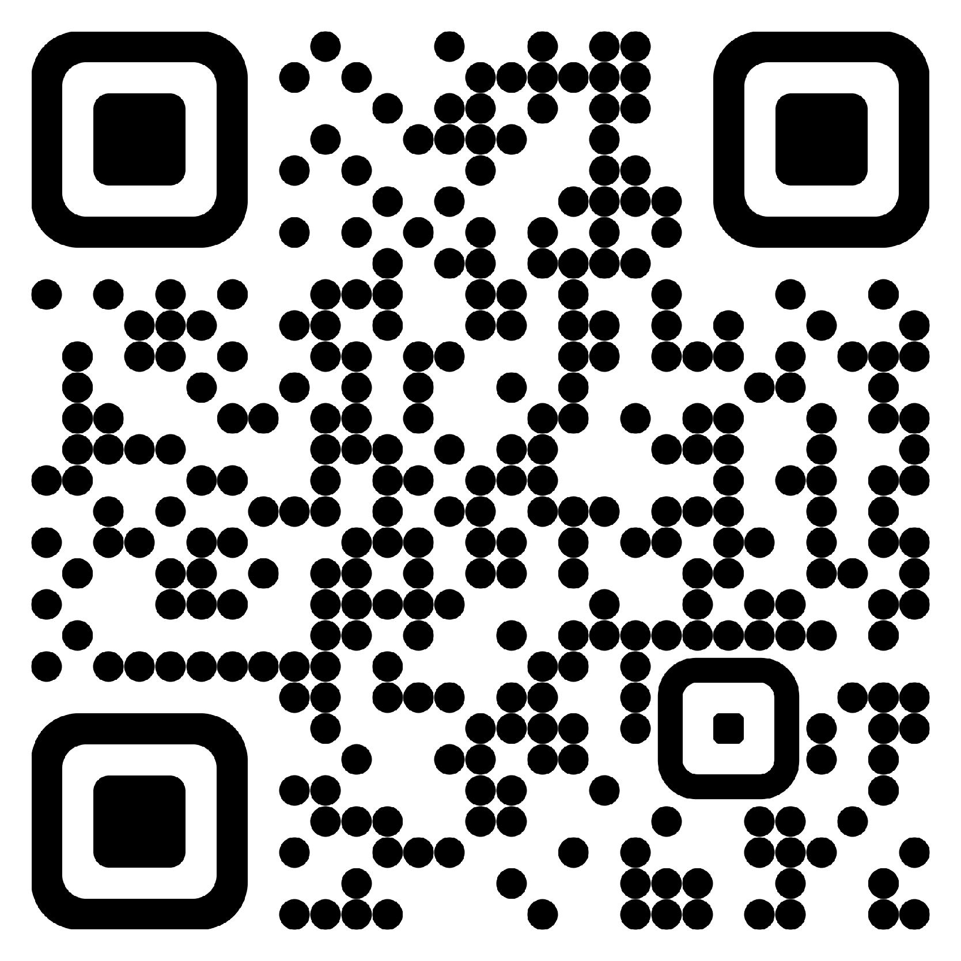
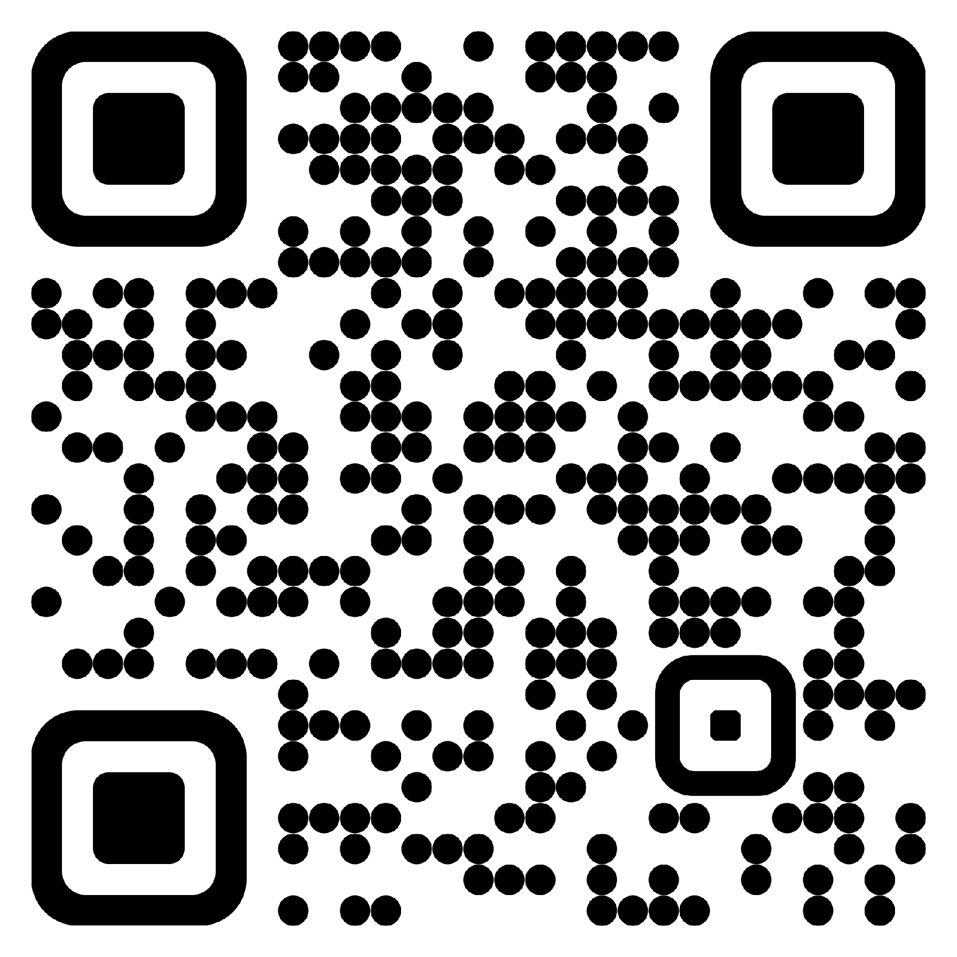

￨Alexander DeRieux⟩
 | Quantum AI { Scientist, Engineer, Developer }
 | alexander.derieux@gmail.com | • | GitHub: zanderman | • | LinkedIn: alexderieux

Objectives |  | Ph.D. candidate and industry professional with research experience in quantum computing, machine learning, software engineering, space systems, game theory, and wireless communications. Interested in designing quantum-native artificial intelligence systems that naturally leverage uniquely quantum properties to facilitate learning and operation within the quantum domain.
Security Clearance |  | Cleared for Top Secret Information and granted access to Sensitive Compartmented Information based on a Tier 5 Investigation completed in 7/2024.
Education
  Doctor of Philosophy in Electrical Engineering – Bradley Fellow | [ 8/2022 – Expected 12/2026 ]
  Virginia Polytechnic Institute and State University, Blacksburg, Virginia
  Dissertation Title: “Quantum-Native Artificial Intelligence: Architectures and Algorithms”
  Dissertation Committee: Walid Saad (chair), Harpreet Dhillon, Jeffrey Reed, Jamie Sikora, Wayne Scales
  GPA: 3.91
Master of Science in Electrical Engineering | [ 1/2021 – 8/2022 ]
Virginia Polytechnic Institute and State University, Blacksburg, Virginia
Thesis Title: “Transformer Networks for Smart Cities: Framework and Application to Makassar Smart Garden Alleys”
Thesis Committee: Walid Saad (chair), Harpreet Dhillon, Thinh Doan
GPA: 3.91

Bachelor of Science in Electrical Engineering, Minor in Mathematics – cum laude | [ 8/2012 – 5/2016 ]
Virginia Polytechnic Institute and State University, Blacksburg, Virginia
In Major GPA: 3.437, University GPA: 3.407

Bachelor of Science in Computer Science – cum laude | [ 8/2012 – 12/2016 ]
Virginia Polytechnic Institute and State University, Blacksburg, Virginia
In Major GPA: 3.793, University GPA: 3.456

Employment Experience
  Graduate Research Assistant (GRA) | [ 8/2021 – Present ]
  Wireless@VT, Virginia Polytechnic Institute and State University
  Quantum machine learning research with a focus on designing quantum-native artificial intelligence systems that leverage unique quantum mechanical properties to facilitate learning and operation naturally within the quantum domain.
  Classical machine learning research with applications to areas of smart cities, wireless communications, optimization, and game theory. Developed artificial intelligence architectures and techniques to facilitate heterogeneous multi-task learning (HMTL) in smart garden alleys with diverse data sources.
Graduate Teaching Assistant (GTA) | [ 1/2021 – 12/2021, 08/2022 – 05/2023 ]
Bradley Department of Electrical and Computer Engineering, Virginia Polytechnic Institute and State University
Professional mentor and graduate administrator for the Electrical Engineering Major Design Experience (MDE) undergraduate capstone course. Manage grading student individual project notebooks (IPN), designing new course assignments relative to industry experience, and developing software for automating course administration tasks with integration of Canvas LMS REST API.

Electronics Engineer, TS/SCI clearance | [ 2/2017 – 9/2024 ]
U.S. Naval Research Laboratory (NRL), Washington DC
Research, design, and develop space-system technologies for the U.S. Navy in the areas of rocketry, communications, optics, software engineering, networking, tactical network modeling, surveillance and tracking, Positioning, Navigation, and Timing (PNT), and Precise Time and Time Interval (PTTI) theory and applications.

Electrical Engineering Co-op, Secret clearance | [ 7/2012 – 2/2017 ]
U.S. Naval Research Laboratory (NRL), Washington DC
Created an off-the-shelf system for high altitude naval vessel tracking. Designed image processing algorithms to identify naval vessels and their location using Python and OpenCV. Wrote technical documentation and how-to guides for various projects.

Science and Engineering Apprenticeship Program (SEAP), American Society for Engineering Education (ASEE) | [ 6/2010 – 7/2012 ]
U.S. Naval Research Laboratory (NRL), Washington DC
Participated in 3 consecutive 8-week summer internships. Developed alternative modes of satellite propulsion using natural and induced magnetic fields. Created custom payload deployment systems for small satellites. Designed an off-the-shelf system for controlling robotic arms used in spacecraft docking and other tele-operation applications.

Publications |  | A. DeRieux and W. Saad, “QnRL: Quantum-Native Reinforcement Learning,” June 2026, arXiv: arXiv:2606.08276. doi: 10.48550/arXiv.2606.08276.  A. DeRieux and W. Saad, “eQMARL: Entangled Quantum Multi-Agent Reinforcement Learning for Distributed Cooperation over Quantum Channels,” in Proc. Of The Thirteenth International Conference on Learning Representations (ICLR), Singapore, April 2025. doi: 10.48550/arXiv.2405.17486.  M. Kim, A. DeRieux, and W. Saad, “A Bargaining Game for Personalized, Energy Efficient Split Learning over Wireless Networks,” in 2023 IEEE Wireless Communications and Networking Conference (WCNC), Glasgow, United Kingdom, March 2023, pp. 1-6. doi: 10.1109/WCNC55385.2023.10118601.  A. C. DeRieux, W. Saad, W. Zuo, R. Budiarto, M. D. Koerniawan, and D. Novitasari, “A Transformer Framework for Data Fusion and Multi-Task Learning in Smart Cities,” Nov. 2022, arXiv: arXiv:2211.10506. doi: 10.48550/arXiv.2211.10506.  A. C. DeRieux, “Transformer Networks for Smart Cities: Framework and Application to Makassar Smart Garden Alleys,” M.S. Thesis, Virginia Tech, Aug. 2022, Available: http://hdl.handle.net/10919/111788.
Patents |  | A. DeRieux and W. Saad, “Quantum-Native Reinforcement Learning,” U.S. Provisional Patent Application No. 63/996,320, filed March 4, 2026. Patent pending.
Featured Articles |  | N. Frank and V. Tech, “Quantum entanglement could connect drones for disaster relief, bypassing traditional networks,” Phys.org. Dec. 2025. Available: https://phys.org/news/2025-12-quantum-entanglement-drones-disaster-relief.html  N. Frank, “How quantum entanglement can advance disaster relief, communication methods,” Dec. 2025. Available: https://news.vt.edu/content/news_vt_edu/en/articles/2025/12/quantum-entanglement-disaster-relief-eqmarl.html  S. Andrea, “Virginia Tech announces new Institute for Advanced Computing in the Washington, D.C., area.” May 2025. Available: https://news.vt.edu/content/news_vt_edu/en/articles/2025/05/provost-dc-institute-for-advanced-computing.html  K. Roeder, “Virginia Tech opens $1B innovation campus in Alexandria,” Technical.ly. March 2025. Available: https://technical.ly/civic-news/virginia-tech-innovation-campus-alexandria/
Speaking Engagements |  | Rising Star Seminar [ 2026 ] George Mason University, Fairfax, VA  ICEX Digital Innovator Accelerator [ 2026 ] Virginia Tech Institute for Advanced Computing, Alexandria, VA  Virginia Tech Bradley Fellowship Banquet [ 2026 ] Virginia Tech, Blacksburg, VA  International Delegations [ 2025 – 2026 ] Virginia Tech Institute for Advanced Computing, Alexandria, VA  Virginia Tech Institute for Advanced Computing Showcase Events [ 2025 – Present ] Alexandria, VA  Fellowship Panels [ 2022 – Present ] Alexandria, VA; Arlington, VA; Blacksburg, VA  Quantum and Artificial Intelligence Research Presentations [ 2021 – Present ] Alexandria, VA; Arlington, VA; Blacksburg, VA  Guest Lecture, Quantum Machine Learning [ 2025 ] University of Vermont  International Conference on Learning Representations (ICLR) [ 2025 ] Singapore  AWS Quantum Networks Workshop (QNW) [ 2023 ] Beverly, MA  C-Tech² Workshop [ 2022 ] Virginia Tech, Blacksburg, VA  International Laser Ranging Service (ILRS) Technical Workshop [ 2019 ] Stuttgart, Germany  NRL Research Presentations and Performance Reviews [ 2010 – 2024 ] Washington, DC
Professional Service |  | Reviewer  - IEEE Transactions on Artificial Intelligence (TAI)  - IEEE Transactions on Mobile Computing (TMC)  - IEEE Transactions on Machine Learning in Communications and Networking (TMLCN)  - IEEE International Conference on Quantum Computing and Engineering (QCE)  - IEEE Middle East Conference on Communications and Networking (MECOM)  - IEEE International Symposium on Personal, Indoor and Mobile Radio Communications (PIMRC)  - IEEE International Performance Computing and Communications Conference (IPCC)  Peer Mentorship [ 2021 – Present ] Research direction, academic planning, software development and deployment, dataset management, high-performance computing and Linux system tutorials, presentation and paper reviews, etc.  University and Department Tours [ 2021 – Present ] Alexandria, VA; Arlington, VA; Blacksburg, VA  Tutoring via Eta Kappa Nu [ 2021 ] Electrical and Computer Engineering, Computer Science, and other varied non-technical subjects.
Research &  Projects
  QnRL: Quantum-Native Reinforcement Learning | [ 6/2026 ]
  Developed a novel framework dubbed quantum-native reinforcement learning (QnRL) that natively learns conditional distributions naturally in Hilbert space via superimposed and entangled quantum states, and a novel quantum amplitude kickback (QuAK) algorithm that enables comparing the n-th power of the m-th moment of multiple superimposed distributions.
eQMARL: Entangled Quantum Multi-Agent Reinforcement Learning for Distributed Cooperation over Quantum Channels | [4/2025]

Developed a novel quantum multi-agent reinforcement learning framework for distributed actor-critic systems that facilitates cooperation over a quantum channel and eliminates local observation sharing via a quantum entangled split critic.

A Bargaining Game for Personalized, Energy Efficient Split Learning over Wireless Networks | [ 3/2023 ]

Developed a novel personalized split learning framework for choosing the cut layer that can optimize the tradeoff between the energy consumption for computation and wireless transmission, training time, and data privacy.

Recurrent Neural Network (RNN)-Based Generative Adversarial Learning for Secure Wireless Networks | [ 12/2022 ]

Developed a novel generative adversarial network (GAN) framework for enhanced detection of malicious attacks in wireless networks via a non-cooperative game to synthesize and identify nefarious in-phase and quadrature-phase (IQ) waveforms.

Attention Networks for Stock Market Prediction | [ 5/2022 ]

Developed a pure-encoder attention-based Transformer architecture coupled with time-vector embedding schemes for highly performant multi-feature sequence transduction for high-frequency financial trading applications.

Transformer Networks for Smart Cities: Framework and Application to Makassar Smart Garden Alleys | [ 1/2021 – 8/2022 ]
Joint effort with VT and University of Colorado Boulder. Designed machine learning frameworks with data fusion to grow "smart" garden alleys in Makassar City, Indonesia to bolster city health, food production, economics, tourism, and urban planning.

SmartStockRL: Intelligent Stock Trading using Traditional and Deep Q-Learning | [ 10/2021 – 12/2021 ]
Research effort exploring the application of traditional and deep Q-learning Reinforcement Learning (RL) algorithms in dynamic stock trading environments. Developed both model-based and model-free Q-learning algorithms in conjunction with a custom stock simulation environment in OpenAI Gym.

LyricAI: Using LSTMs to Write Religious Music | [ 4/2021 – 5/2021 ]
Joint research effort exploring the ethical implications of AI-generated religious song lyrics. Developed two Recurrent Neural Network (RNN) architectures fusing Long Short-Term Memory (LSTM) and Encoder/Decoder models for pure next-word prediction and syllable-count next-word prediction natural language processing (NLP) tasks.

Capstone: MITRE | [ 8/2016 – 12/2016 ]
Created ‘ERIS’, a wearable emergency responder information system for first responders in the field. Developed companion applications for Android mobile, Android Wear-powered Moto 360 smartwatch, and Android-powered Recon Jet heads-up display. Collaborated in a 5-person team using face-to-face and virtual meetings. Employed use of GitHub for version control. Learned ethnography and project demonstration techniques towards both technical and non-technical audiences.

Research & Projects cont.
  Capstone: General Motors & VTTI | [ 8/2015 – 5/2016 ]
  Created a wireless off-the-shelf device for interfacing with vehicle OBDII system. Developed companion Linux and mobile application software for wireless data acquisition and interaction. Learned project management, project documentation such as request for proposal, and customer relations from instructors that have extensive backgrounds in the corporate world.
RadioPi: RTL-SDR Communication Systems | [ 1/2015 – 5/2015 ]
Developed a RTL-SDR receiver system called ‘RadioPi’ to process local FM transmissions. Signal processing algorithms are written in Python using GNURadio API and custom signal blocks. Design elements include the Raspberry Pi, USB RTL-SDR antenna, and breadboard circuitry for user interface.

Mobile Application Development | [ 7/2015 – 08/2015 ]
Developed ‘Velo’, an Android mobile and wearable application that navigates exclusively using onboard GPS modules, thus bypassing the need for wireless data. Users can log on using Facebook and store their routes to local SQLite and online SQL databases using AWS. Crash detection is implemented using onboard gyroscope and accelerometer sensors, notifying a set of emergency contacts of your situation upon detection of the crash.

Skills & Abilities |  | Artificial Intelligence (AI) / Machine Learning (ML) |  | Quantum Computing
Skills & Abilities |  | - Reinforcement Learning (RL) / Multi-Agent Reinforcement Learning (MARL)  - Generative Modeling / Natural Language Processing (NLP)  / Time-series Forecasting / Regression / Classification  / Multi-Task Learning / Adversarial Learning / etc.  - Multi-Arm Bandits (MAB) / Multi-Agent Multi-Arm Bandits (MAMAB)  - Game Theory / Optimization  - Transformers / Attention Mechanisms / Generative Adversarial Networks (GANs) / Convolutional Neural Networks (CNNs) / Recurrent Neural Networks (RNNs) / etc. |  | - Quantum Artificial Intelligence (QAI) / Quantum Machine Learning (QML)  - Quantum Neural Networks (QNNs) / Quantum Generative Adversarial Networks (QGANs)  - Quantum Information Theory / Entanglement / etc.  - Quantum Circuits / Variational Quantum Circuits (VQCs)  - Quantum Simulation  - Quantum Internet / Quantum Networks / Quantum Communications
 |  | Programming Languages | APIs / Frameworks / Packages / Tools
 |  | - Python  - C / C++ / C#  - MATLAB  - JavaScript / TypeScript / HTML / CSS  - Java / Rust / Go / Ruby  - Fortran  - LaTeX | - Python packages: JAX / FLAX / TensorFlow / PyTorch / Gymnasium  / PennyLane / Qiskit / Cirq / TensorFlow Quantum / Torch Quantum  / NumPy / Pandas / SciPy / Scikit-Learn / Matplotlib / Seaborn / Flask / NetworkX  / BeautifulSoup / OpenCV / Pillow / PyQt / Pytest / UV / Pipenv / Pyenv / Requests  / WandB / etc.  - Webapps: React.js / Electron.js / Cesium.js / Bootstrap / Jekyll  - Grafana / Canvas LMS
Software Skills | Electronics
- SLURM for high performance computing (HPC) systems  - Microservices: Docker / Singularity / Podman / Kubernetes  - Continuous Integration and Continuous Delivery (CI/CD)  - Version control: Git / GitHub / GitLab / SVN  - Databases: InfluxDB / MongoDB / MySQL / SQLite / GraphQL / Redis  - TCP / UDP Networking  - Operating Systems & Apps: Linux / macOS / Windows / iOS / Android | - Soldering  - Breadboarding  - Eagle PCB design  - Digital signal processing (DSP)  - Software-defined radio (SDR)  - Microcontrollers: Raspberry Pi / Arduino / STM32  / PIC32

Professional Organizations |  | Eta Kappa Nu (HKN), IEEE Honor Society [ 2021 – Present ]  IEEE [ 2021 – Present ]
Fellowships, Honors & Awards |  | Bradley Fellowship, Virginia Tech, Bradley Department of Electrical and Computer Engineering [ 2022 – Present ]  Dean’s List  Virginia Tech: Fall 2013, Spring 2014, Spring 2015*, Fall 2015, Spring 2016*, Fall 2016*, where (*) = with distinction  Germanna Community College: Fall 2011, Spring 2011, Spring 2012  Academic Honors  Virginia Tech: Spring 2016, Fall 2016  Germanna Community College: Fall 2010  SEAP, ASEE  2011 – 2nd Place Intern Project Presentation Award, Space Systems  2010 – 1st Place Intern Project Presentation Award, Space Systems
Leadership & Activities |  | Resident Advisor, employment, Virginia Tech [ 8/2016 – 12/2016 ] Managed a residence hall floor of 37 undergraduate students. Scheduled and coordinated weekly events among residential staff and residents of multiple hall communities. Resolved conflicts amongst residents and residential staff. Documented nightly hall inspections and important student conduct information.
 |  | Academic Tutor, employment, Germanna Community College [ 1/2012 – 5/2012 ] Developed bookkeeping and interpersonal skills by working in a tutoring office at the community college. Tutored all academic levels in the subjects of Math, English, Physics, Chemistry, Computer Programming, French, and Economics.
 |  | Chi Alpha Campus Ministries [ 2012 – 2023 ] Co-led life groups of 8+ students and organized multi-group events within the ministry.
 |  | Church Audio-Visual (AV), Information Technology (IT), and Experience Teams [ 2020 – 2024 ] Volunteer at my local church to serve on the AV, IT, and experience teams.
 |  | Virginia Tech Fencing Club [ 2013 – 2014 ] Trained in the Epee fencing style and competed in tournaments.
Interests & Hobbies |  | World Travel: Singapore, Belgium, Canada, France, Germany, Mexico, Netherlands, U.S. & Hawaii.
Interests & Hobbies |  | Porsche Enthusiast: Lover of Porsche sports cars and mechanics.
 |  | LEGO collector and builder: Passion for bricks and minifigs.
 |  | Dancing: Intermediate level dance skill with passion for Latin, Swing, and Ballroom styles.

